Second LACCEI International Latin American and Caribbean Conference for Engineering and Technology (LACCET’2004)
“Challenges and Opportunities for Engineering Education, Research and Development”
2-4 June 2004, Miami, Florida, USA

LOGISTICS OF EXPERIENCE: MEASURING THE BENEFITS OF SUPPLY CHAIN COOPERATION TRHOUGH INVENTORY MANAGEMENT STRATEGIES

Diana Paola Sánchez Silva, Ing
Escuela Colombiana de Ingeniería, Bogotá D.C., Colombia
diana_paolasanchez@hotmail.com

Enrique Romero Motta, Ing
Escuela Colombiana de Ingeniería, Bogotá D.C., Colombia
enrirom@colomsat.net.co

ABSTRACT
One of the main problems that the Supply Chains are facing has to do with generating a high customer satisfaction through an appropriate inventory management strategy. In order to solve this situation the supply chain managers has implemented some collaboration techniques as CPFR and quick response methods like VMI (Vendor Managed Inventory) or 3C (Commonality, Capacity and Consume). In this paper we’ll discuss a comparison model between those techniques and a new cooperation approach called Hybrid Method, which was designed by the authors as a new inventory management strategy using an spreadsheet simulation model (also created by the authors) looking for the cooperation benefits as a function of inventory management policies.

KEYWORDS
Pull, Push, Variability, Supply Chains, inventory

INTRODUCTION

The supply chain management on different companies uses many optimization models to guarantee the synchrony and integration within them. This integration must be beyond of the collaboration between echelons itself looking for a logistic synchrony through operational union with other firms that are working with the same creation value principles, that is a company that are looking for a cooperation system more than a collaboration system. Next we will present the principles of two of the most representative quick response inventory models (VMI and 3C) based on collaborative strategies and a new approach for supply chain design under variability conditions called Hybrid Model. Next we show the impact of this strategy with a study case through spreadsheet simulation software developed by the authors using visual basic programming language.

LITERATURE REVIEW

Vendor Management Inventory (VMI)
Matt, Johnson and Davis defined the Vendor Management Inventory policies as special quick response case based on push principles. In this model the supplier manages inventory for the retailer, it takes responsibility for setting target inventory levels and making restocking decisions.
By receiving electronic messages with sales information or warehouse shipments, the supplier assumes responsibility for replenishment retail inventory in the required quantities.
This strategy tries to reduce the effect made by demand variability changing the order frequency for getting a smooth inventory flow reducing the investment on holding it and improving the resource utilization such as transport an production resources.
But the supplier and its customers needs to “speak the same language” for getting the goals written above. That means all of the participants of VMI relation must have a common information platform or at least some kind of software and hardware combination that can translate the messages between them. Some of those solutions are quite expensive and in some cases confidential information must be shared.

3C (Commonality, Consume and Capacity)
One of the models that apply the concepts developed by integrated manufacturing theory on earlies 90’s and pull principles is 3C. Its name comes from the model’s components, Commonality, Capacity and Consume. The main objective of it is to make possible that all the materials that are demanded for the supply chain on the different echelons are available for it use. The 3C provides a high level service with a relative reduced inventory investment. Under 3C philosophy the supply chain echelons are considered as points of consumptions (POC’s). Then main function of the POC’s are guaranteed the material availability. The POC’s are classified into three categories: Points of Stock (POS), Points of Order (POO) and Point of Consumption (POC). The last ones represent the mixing case of the other two. The supply chain design under 3C follows these steps:
Step 1 Characterization of the Chain: This step consists of visualizing the general dimensions of the chain and the points of consumption’s (stock, order, consumption) definitions.
Step2 Determining the capacity of the chain: The second step consists on finding the overall capacity as well as the specific capacity of the each one of the point of consumptions defined above.
Step 3 The step rule to control flow through supply chain: This step consists of defining the materials movement from one POC to another through the consumption registered at the POC.
Step 4 Supply Chain Optimization rule: The last step is optimizing the inventory investment throughout the supply chain exploiting to the fullest the commonality that is present in the chain.
Finally the inventory is balanced according with an ABC classification which is called on 3C Fast and Slow Classification. As the supply chain goal is move money as fast as it can and not materials, this classification focused on those products that provided more potentially benefits. In addition the 3C model manages the planning system for the materials need it for producing the products and not on the finished goods. The supplier’s lead time has its impact only at startup, buying the maximum quantity (called Qo). In a MTO business, the lead time depends only on the load of the system and the time for satisfying the order (process times). There is a law related with the Lead time expressed through the factory physics principles. “Law 12: The manufacturing lead time for a routing that yields a given service level is an increasing function of both the mean and variance of the cycle time of the routing”¹
This law suggests that the manufacturing (supplier’s) lead times must be calculated as a given cycle time plus a fudge factor, and this factor will depends on the cycle time variance, that means the larger cycle time variance the larger the factor will be to achieve a service level.
In a MTO environment in order to keep the customer lead times short, the cycle time must be short, in other words the variance and mean of the cycle time must be maintained low.

Hybrid Model
As the name says this model is a combination of both push and pull models. Takes the operation of 3C (Pull based system), and the planning strengths of push systems. The Hybrid model is based on the factory physics principles (as the first approach for calculating its parameters). Around 1990, Mark L. Spearman and William Hopp, professors of Northwestern University, developed a theory based on physics applied to production lines analysis called factory physics. They show an important relation between work in process (inventory) and the cycle time to process it through a law called Little’s Law.
Applying Little’s Law and some principles based on it they developed a model based on pull principles but with a constant work in process called CONWIP, which gives high service levels (measured through a variable called throughput) with less inventory on the production line. When a job is finished a new job is released on the production line. Then the CONWIP level is defined by the time that a material takes to go through the bottleneck expressed through the little’s law. In addition Spearman and Hopp makes a planning pull framework called Conveyor Model. This planning methodology (also based on Little’s Law) works as follows: A pull system maintains a fairly steady WIP level, so the speed of the line and the time to go through it are relative constant over time. So in order to keep the condition above described, two variables must be defined. First the practical production rate (rp) and second the minimum practical lead time (Tp), that is the anticipated throughput and the average minimum time to traverse the line. Using Little´s Law the CONWIP Level can be calculated (W=rpXTp). Then this level will be used for locating and calculating buffer sizes.

MODEL DEVELOPMENT
For simulation purposes we chose the follow supply chain structure (Fig 1a, 1b)

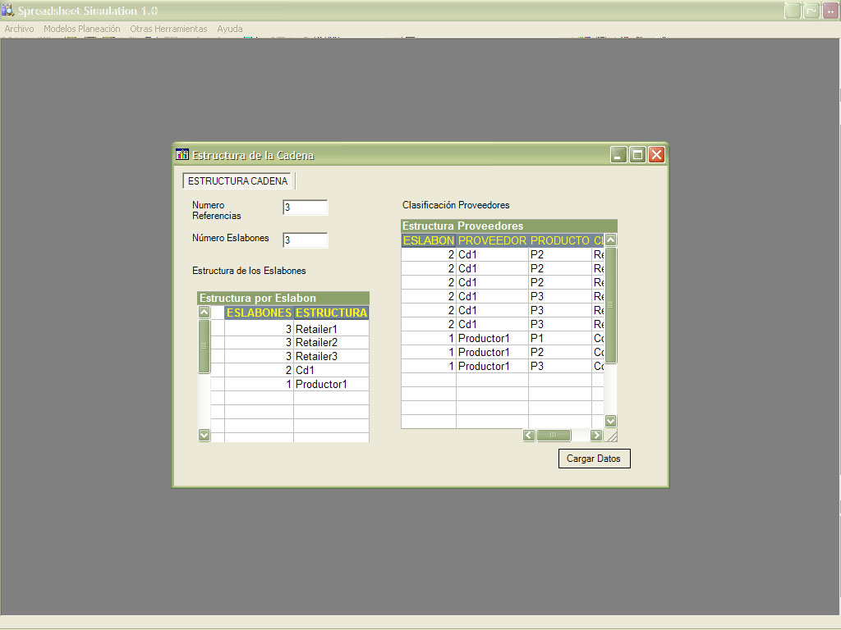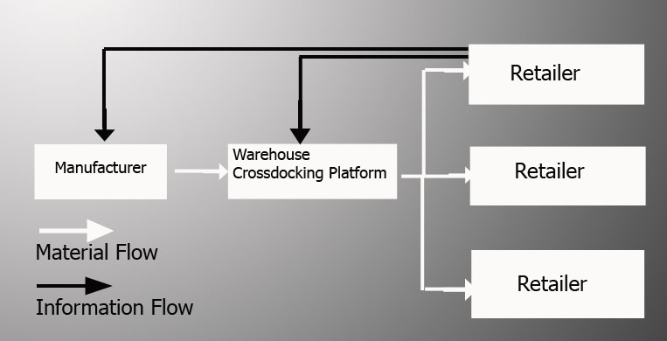
Fig 1a Screenshot Spreadsheet Simulation Software Fig1b Supply Chain Structure

The structure has three echelons. The upstream echelon has one manufacturer; the second one has one Warehouse with cross docking Platform (no storage) and the last one (downstream) echelon has three retailers. This structure is also known as arborescent system with no inventory on the warehouse.
VMI Model
We use an inventory policy developed by Jan Holstrom and Riika Kaipia called Optional Replenishment System (Fig 3) which is a variation of general periodic review systems.
Under this policy every (R) days the inventory is checked; if the inventory level is equal or less than the reorder point (r) orders are generated. The order size is calculated in relation with the maximum inventory level (S). Using this policy a similar DRP model can be developed, with centralized (in this case on the manufacturer) decisions about the whole inventory system. Finally the manufacturer uses a MRP model for its own replenishment process.The parameters are calculated as follows (see Fig 2a):
Ss (Security Stock) = Z * σ where Z: Security Factor based on expected service level and a Normal Distribution, σ= demand standard deviation during replenishment lead time,
ROP (Reorder Point) =DF*(RT+RI)/PL + Ss where PL=52*5/Number of forecasted Periods
DF=demand average during replenishment lead time, RT= Lead Time, RI = Review Time, PL= Planning Horizon Length. The Model is based on the next issues: Independent Demand on retailer level that is, the same reference a different retailer is considered different SKU, Related Costs and lead time are deterministic and the same issues for MRP systems such as MPS (Master Production Scheduled), BOM and inventory data.
Security Stock
Reorden Point
Inventory Level
Review Time
Lead Time
Q2
Q0
Q1
Q1
Q2
Q2
Inventory level
Review Time
Lead Time
Qmax o >
Fig 2a Optional Replenishment System (VMI Model) Fig 2b 3C Inventory Model

3C Model
The model is based on three key variables:
Capacity: Calculated through the MSR (Maximum Sales Rate adjusted with the service level called Table of Pulls) Commonality: Here a variable called RBILL (Rate of Bill) must introduce as a planning driver for the model. As we described on the past sections 3C uses the planning functions over the parts and not over the finished product itself, so that’s why the model uses this variable (RBILL) defined as maximum consume per part, per day. Consumption: The consumption is the control flow rule for the model. Depends of consumption on past periods a new order will be generated (see Fig 2b).
Hybrid Model
Under this model the inventory policy works like a quick response method with a continuous review system but there is no a reorden point. Every time that the buffer goes down the Critical Level, called here as a Conwip Level, an order equal to the consumption that took place on the above period is generated. Then the buffer size can be more stable. If the variability changes in order to regulate this movement, the buffer size will change. The factory physics says that the first approach for calculating the conwip level for a production line is the Critical wip (Wo) that shows a relation between the Natural Process Time and rate without variability on this calculation. We use a quite similar formula but adjusted with a combine variability coefficient mixing both sources: Flow variability and Lead Time variability (both of them distributed normally). We use an approach developed by Kingman for calculating the cycle time as follows: Formula 1:CTq=(Ca²+Ce²)/2*(u/1-u)*Te, where Ca²=Arrival Square coefficient variation, Ce²=Process time Square Coefficient Variation, U=Utilization, Te=Mean Service Time. Next using Little’s Law the conwip level can be calculated as follows:
Formula 2:WIP=TH*CT, Now applying the factory physics definition for cycle time we can define it:
CT=CTq +Te plus a special factor called Safety Lead Time. This factor is calculated for service level s as: Zs* σ_{CT}, where Zs is the value given for s in a standard normal table.
This definition is so similar with the definition of security stock on any inventory policy. The important issue here is to understand the components of lead time for single process. Now we can define the cycle time on an echelon as the combine variance of the different times involved on it. That is we can extend the definition for the echelon’s time making an additional adjustment. This adjustment must be applied to the safety lead time for regulating the variability’s effect. As we can see here the variability in chain depends of the independent variability conditions of the suppliers so if the supplier’s lead time are independent between each other and are normally distributed the convolution formula can be used for estimating the common deviation but if is not the case this calculation could be more complicated. In this case the simulation can be a great tool for estimating the general buffer size.
Finally the formula for calculating the Conwip level making some adjustments can be expressed as follows: Formula 3:WIP=TH*(CTq+Te+SFL)
As we explained above this approximation must be used assuming that the lead times are normally distributed and independent but just work for a single chain with two levels. If we can use this for a multiechelon system we have to make the last adjustment that means use the cumulative variability instead the flow variability. So the arrival square coefficient variation for the second echelon must be calculated as a function of predecessor departure variability echelon. Using the approximation developed by Hopp and Spearman we can calculate the departure square coefficient variation as:
Formula 4: Cd²=u²*Ce²+(1-u²)*Ca² , where, Cd²=Departure Square Coefficient Variation. For Ce², Ca² and u same definitions as we used on Formula2. If u is close to 1 the station never waits for a job to work on and the departure time will be the same as the process time and if u is close to 0 the system is lightly loaded and the departure time will be the arrival time because the station must wait a lot of time for another arrival to work on. So the Formula 4 is intermediate case. The last step is the “optimization rule” expressed by 3C Model. Exploiting the communality at the parts level we can get the same service level with fewer inventories (as we explained on 3C section). So it is possible to use the same definition but a process level, that’s the cooperation’s definition. The objective using commonality at process level represents an additional improvement on inventory investments for the whole supply chain because this kind of commonality works directly with reductions on lead time variability as we explained before. Notice that one of main components of the lead time is the variability factor. If this factor is less than 1 we will have an important improvement but if this factor is higher than 1 we will have a lead time increased. On the startup we use the conveyor model for calculating the initial buffer at the part level using the expected variability (that is the push part of the Hybrid Model). We also must consider the factory physics law: “Pay me now, pay me later: If you cannot pay for variability reduction, you will pay in one or more of the following ways: Long Cycle times and high wip levels, Wasted Capacity (low utilization of resources) and lost throughput”
This law expressed the consequences of not consider variability on supply chain design.

RESULTS
We developed simulation software based on spreadsheet simulation concepts for making this comparison.
The simulation’s length was 25 weeks (5 days per week), with two scenarios: low variability and high variability for the supply chain shown on fig 2.The products characteristics are defined on Table1.

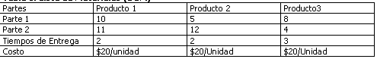Table 1. Product Information

As measure indicators we use fill rate, and inventory turns for each echelon. For VMI model some suppositions were made. First the order cost is constant and standard holding inventory cost. The lead time is 3 weeks and constant for VMI model and 3C Model. For Hybrid Model the lead time is normally distributed with mean of 3 and standard deviation of 1. The figure 6 shows the inventory movement for

Fig 6 3C and VMI Inventory Movement High Variability Retail level

VMI model(left graphic). Is important to notice the variation of it and the replenishment policy (every three weeks an order is generated). This variation is translated to the upstream echelons causing the bullwhip effect. As we see here if the variability is higher the model can experiment more inconvenient for smooth the variability’s effect. The figure 6 shows 3C inventory movement model. The 3C model presents and smoothed movement increasing on the first weeks but finally at the last weeks closing to Qmax level (is also a high quantity). The model presents a buffer against the demand variability (but not the lead time variability). And we know the variability has a cumulative effect, so for long runs we can have problems with material availability. Is important to notice the existent relation between 3C buffer size with the lead time and review time size. For long lead times and long review times the model can be unstable and can be broken making backorders. The figure 7 shows the Hybrid Model inventory movement

Fig 7 Hybrid Model Inventory movement high variability

The inventory movement is more stable on high variability scenario because of its pull nature, and as we see on the figure 8 the right planning buffer size with expected variability conditions results on smoothed adaptation of the buffer size, so the results of it is control the bullwhip effect on upstream echelons. The model’s strength is the planning processes at each one of the echelons that belongs to the same chain. For further papers we will discuss and APS Model for calculating the buffer size under uncertainty conditions.

CONCLUSIONS

- The pure push systems have serious problems because of the forecast accuracy. The only way to correct this is increasing the security stock in order to preserve the same service level.
- Some products can experiment better performance with push strategies than pull strategies, which means we have mix the strategies as the same way that we classified inventory policies depending of product turns.
- The pull models require a high class supplier (continuous replenishments sources) that make possible availability all the time, but is also possible add some planning strategies for adjusting the model to supplier’s reality.
- For using models like VMI, 3C and even Hybrid Models the companies must do important investments on technology, for getting real time information; otherwise the accuracy of the model is reduced in a high level.
- The main idea behind the hybrid model is understand and manage the lead time variability working together with that companies with the same add value principle. Changing the classical definition of competence for intelligent alliance getting a better lean logistics.

REFERENCES

Bowersox Donald J., Closs David J., Cooper Bixby,2002 “Supply Chain Management”, pp 31 – 66 , pp 283 – 327.
Hopp Wallace J., Spearman Mark L.,1996 “Factory Physics”, pp. 186- 335, 378 – 420 y 554 – 588.
Silver Edward, Peterson R, 1985 “Decision Systems for Inventory Management and Production Planning”, pp. 471 – 517.
Ranada Miguel, 1999,“3C a Proven Alternative to MRPII For Optimizing Supply Chain Performance”
Fredendall Lawrence D.,2001 “Basics of Supply Chain Management”, pp. 13 – 215.
Goldratt Eliyahu, Fox Robert E., 1993 “The Race”
Banks Jerry, 2000 “Handbook of Simulation” Cap 7-10
Waller Matt, Johnson Eric, Davis Tom, 2001 “Vendor Managed Inventory in the Retail Supply Chain” White paper publish by Journal of Business Logistics
Kaipia Riikka, Holmstrom Jan, 2001, “On the way to supply chain collaboration- measuring the benefits of information sharing”,White paper.

