Sixth LACCEI International Latin American and Caribbean Conference for Engineering and Technology (LACCEI’2008)
“Partnering to Success: Engineering, Education, Research and Development”
June 4 – June 6 2008, Tegucigalpa, Honduras.

Developing Global Competencies through the Engineering Curriculum in the Americas

Ivan E. Esparragoza
The Pennsylvania State University, Media, PA, USA, iee1@psu.edu

Maria Larrondo-Petrie
Florida Atlantic University, Boca Raton, FL, USA, petrie@fau.edu

Abstract
Recently there has been an urgent call to academia to educate the Global Engineer. The Engineering for the Americas (EftA) initiative has focused attention on producing engineers that would facilitate the flow of work and human resources across the Western Hemisphere. The IV Summit of the Americas recognized the importance of the initiative and the Organization of American States (OAS), Engineering for the Americas, the U.S. Trade and Development Agency (USTDA) and World Federation of Engineering Organizations (WFEO) organized the Engineering for the Americas Symposium in 2005 in Lima, Peru. The Symposium focused on the needs of the productive sector for engineering graduates and capacity building; quality assurance in engineering education; and country planning for financing of upgrades to engineering education. The Final Report urges the academic sector to boost its collaboration with industry to develop a change in paradigm to educate the Engineer of the 21st Century, which they describe as a world class engineers, leaders, visionaries, and entrepreneurs, committed to the social environment and with a clear sense of the common good; an engineer who helps to create himself/herself, not look for work but create it. This paper presents different initiatives that can be embedded in the engineering curriculum to facilitate the development of the global competencies that future engineers of the Americas will need to be competitive in the global market.
Keywords: global competencies, collaborative projects, undergraduate research, assessment tools.
- Introduction
The Engineering for the Americas (EFTA) initiative is an academic, industrial and government grass roots effort that has evolved over the past five years. Its aim is to enhance engineering and technology education in the Western Hemisphere, and to strive for mutual recognition of engineering graduates across national boundaries and cross-border trade agreements, facilitating the flow of work and human resources throughout the hemisphere to optimal locations for distributed economic development (Jones, 2005). The IV Summit of the Americas recognized the importance of the initiative and the Organization of American States (OAS), Engineering for the Americas (EFTA), the U.S. Trade and Development Agency (USTDA) and World Federation of Engineering Organizations (WFEO) organized the Engineering for the Americas Symposium (2005) at the end of last year in Lima, Peru. The Symposium focused on the needs of the productive sector for engineering graduates and capacity building; quality assurance in engineering education; and national planning for financing of upgrades to engineering education. The Final Report calls for educational reforms at the regional level that include the needs of the productive sector and preparing new engineers with attributes certified by transparent accreditation systems, which will further professional mobility, investments levels, and therefore economic development. The Final Report urges the academic sector to boost its collaboration with industry to develop a change in paradigm to educate the engineers of the 21st Century, which they describe as world class engineers, leaders, visionaries, and entrepreneurs, committed to the social environment and with a clear sense of the common good; an engineer who helps to create himself/herself, not look for work but create it.
In 2004 the National Academy of Engineers published The Engineer of 2020 (2004), followed in 2005 by Educating the Engineer of 2020 in 2005. The National Academies was asked by representatives of the U.S. Senate and House of Representatives to formulate strategies policymakers could propose so the U.S. can successfully compete, prosper, and secure the global community of the 21st century. The resulting report, Rising above the Gathering Storm was published in 2006.
In June 2006, the American Society of Engineering Education International Division met and expressed concern that Educating the Global Engineer was not a strategy presented in the National Academies report Rising above the Gathering Storm, and will be organizing sessions at the next ASEE annual conferences on this topic. The Engineering for the Americas Symposium’s Final Report urges the academic sector to develop a change in paradigm to educate the Engineer of the 21st Century, and in particular to focus on this Hemisphere. The European Union has defined and facilitated multi-national educational experiences important to capacity development in their area, but this has not been done for this Hemisphere. This brings political, economic and cultural challenges that must be explored and resolved.
This critical call for a change in paradigm in engineering education to create the Global Engineer, and in particular the Engineer for the Americas, is coming from all sectors, and clearly requires defining and facilitating experiences that would result in the Global Engineer. This paper will discuss different initiatives that can be adopted, adapted and implemented in the engineering curriculum develop and enhance global competencies in the Western Hemisphere. This manuscript will explore four dimensions: educational content and delivery, internationalization, culture of research, and quality assurance.
- Global Competencies
By definition, competencies are the knowledge, skills, aptitudes and abilities required to perform specific functions with certain level of excellence.
A global engineer is a graduate with technical knowledge, analytical skills, creative abilities, ethical values and social responsibility who has a clear understanding of the dynamics of globalization and the impact of the interconnection of global issues in the economy, culture, politics, and environment of local communities. A global engineering is a person who is capable of acting locally but thinking globally; a person who accepts and respects diversity.
It is evident that the future engineer has to have a new set of attributes to be competitive in the global market. The National Academy of Engineers (2004) identified the following characteristics for the engineer 2020:
- Strong analytical skills.
- Practical ingenuity - skill in planning, combining, and adapting.
- Creativity (invention, innovation, thinking outside the box, art).
- Communication.
- Business and management.
- Leadership.
- High ethical standards and professionalism.
- Dynamism, agility, resilience, and flexibility.
- Lifelong learners.
In addition to these attributes, a global engineer is a professional who:
- knows the fundamentals and dynamics of globalization;
- understands, accepts and appreciates diversity;
- is able to work in multinational corporations;
- is able to work in multicultural/multinational teams;
- is able to communicate and socialize with people of different cultures;
- is knowledgeable in other language;
- is able to use the technology for communication, exchange ideas and solve problems;
- is an entrepreneur;
- is an ambassador.

Those characteristics and attributes described above should be translated into learning objectives and outcomes expressed in terms of knowledge, skills and attitudes needed to become world-class engineers. Global competencies are the result of an adequate integration of the learning experiences resulting from an effective curriculum which is based on appropriate learning objectives and outcomes. Figure 1, which is a modified version of the hierarchal relationship graph presented by Jones et al (2002), shows the relationship between learning experiences and the development of competencies, and the transformation from a local freshman student with basic foundation, and personal qualities and traits, to a world-class engineer through the development of knowledge, skills and attributes with a global scope to be competitive in the worldwide market.

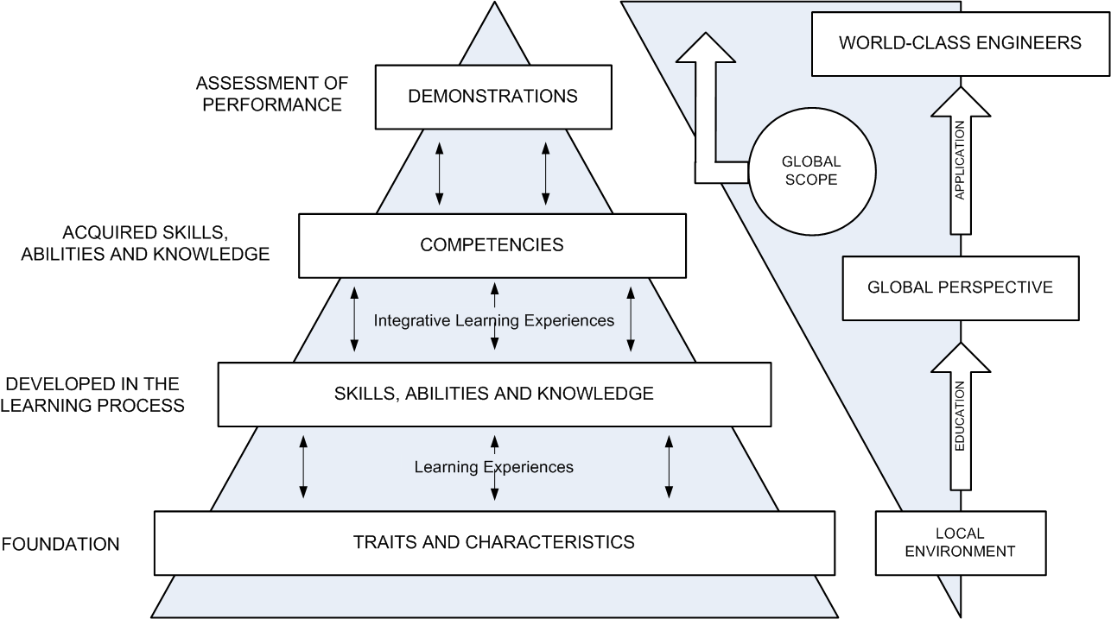

Figure 1: Hierarchy of post-secondary outcomes in perspective with the global engineering education.
- Engineering Curriculum
The engineering curriculum must be developed according to the learning objectives and outcomes established for the program, and must be also in agreement with the mission and goals of the institution. Those institutions interested in educating the engineer 2020 or the new engineer for the Americas should review the learning objectives and the desired outcomes and reflect them in the curriculum and the content of the courses. The basic steps to effectively transform an engineering program for the education of world-class engineers with knowledge, skills, attitude and sensitivity to attend the local and worldwide needs are shown in Fig. 2.
The process starts by reviewing the engineering program mission. The mission should reflect the primary goal of the program and its global scope. Then the educational objectives and the program outcomes should be revised to include those attributes that world-class engineers will need after graduation. The next step is to identify the accreditation criteria for the program under consideration to be sure that those standard requirements are properly addressed in the curriculum. The final step is to map the program outcomes to the educational objectives, the accreditation criteria, and the courses to guarantee that all the competencies are properly covered in the curriculum.
A complete mapping process must include the three professional components of any engineering program and not limited only to the engineering topics component since all the parts contribute to the development of global competencies. According to ABET, the engineering curriculum should have three professional components:
- College level mathematics and basic sciences, some with experimental experience, appropriate to the discipline.
- Engineering topics, consisting of engineering sciences and engineering design appropriate to the field of study.
- General education component that complements the technical content of the curriculum and is consistent with the program and institution objectives.

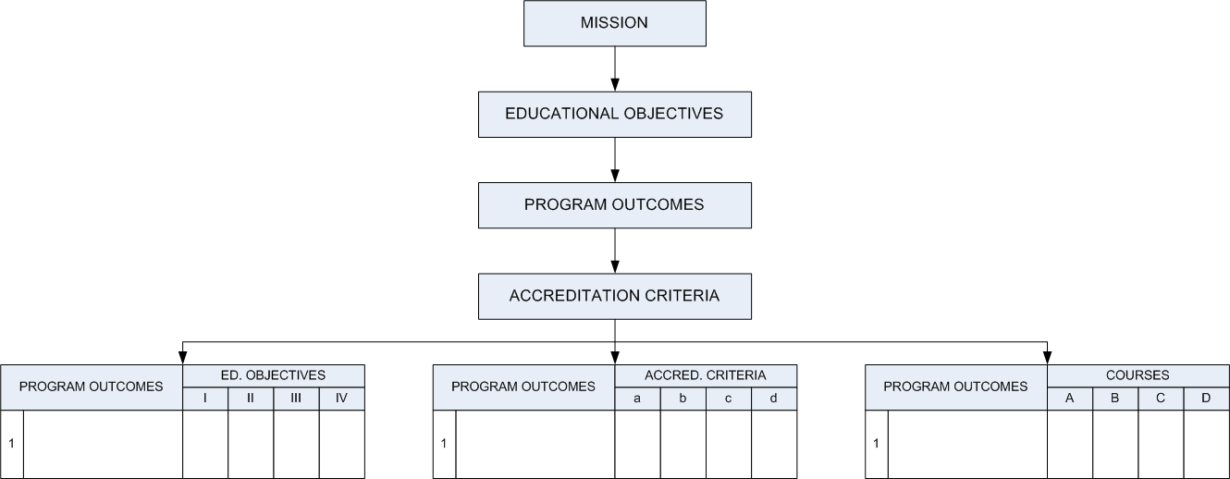

Figure 2: A Engineering program content structure
Table 1 presents an overview of the engineering curriculum components and the competencies that might be targeted in each field.
Table 1. Global competencies that might be developed in each engineering professional component
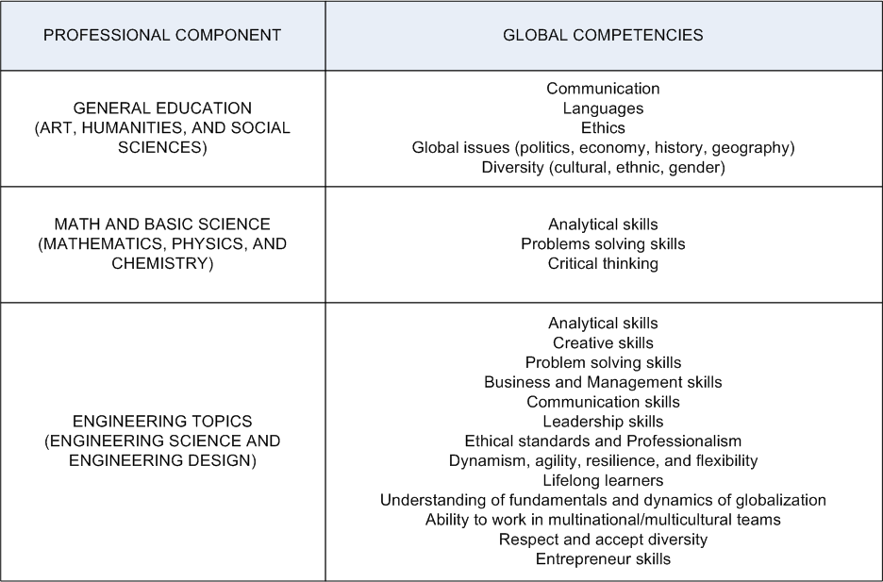
It is evident from Table 1 that global competencies can be developed at different levels and at different components of the engineering curriculum. It is also evident that some of the global competencies can be targeted in two different areas and at two different levels. This will allow introducing, developing, mastering and reinforcing those competencies. However, only one dimension, the engineering topics, is under the responsibility of the engineering program per se. The other two components, general education, and math and science, are traditionally under the responsibility of other colleges. Due to this, it is the responsibility of the engineering programs to ensure that the global competencies are considered in the courses and activities that are part of the engineering topics component of the curriculum.
Each course included in the engineering curriculum should have its objectives, competencies, content and activities associated to the program objectives, outcomes, and accreditation criteria. It is actually at the course level where the skills pyramid starts building. Through the courses, the competencies are introduced, developed, mastered and reinforced. Therefore, the challenge for many institutions interested in educating engineers with global competencies is how to structure the engineering programs for that purpose without implying extensive and costly changes. The answer to that challenge is not that complicated. The most significant change is to embrace the concept of the necessity of a transformation in the paradigm of engineering education to form world-class engineers. As can be seen in Table 1, many of the competencies required for the global engineers are already embedded in the traditional engineering curriculum. The changes required are related to the teaching methodology, and the activities adapted and adopted for the proposed goal. It is fundamental to integrate a global perspective and international experiences into the engineering curriculum
- Integrating Global Competencies into the Curriculum
As mentioned before, the goal of this paper is to provide some basic tools to facilitate the transition from the traditional engineering curriculum to a curriculum designed to educate world-class engineers; engineers capable of being competitive in a global market; engineers capable of acting locally by thinking globally; engineers capable to create enterprises and generate wealth for the region.
Many academic institutions in the Americas are avid of implementing an engineering curriculum that allows their students to develop the necessary knowledge, and skills to be successful in the rapid changing world. This paper summarized some of the initiatives that can be adopted and adapted to educate world-class engineers for the Americas. Most of the ideas presented here resulted from the working groups created during the workshop sponsored by the National Science Foundation (NSF) on the Engineering Education Challenge for the Americas held on Tampico Mexico, May 29 to June 1, 2008 collocated with the 5th Latin American and Caribbean Conference on Engineering Education 2008.
  - Engineering Courses
The new engineers require more than just the analytical knowledge and skills traditionally taught in an engineering program. Hence, the engineering curriculum should strengthen creative thinking, entrepreneurial and leadership skills, and ethical and professional behavior. It should also foster the teamwork and communication skills, and the understanding of the role of technology in the global economy and its ethical implications. The following courses or concepts should be adopted in any engineering program:
Engineering Design: the object of this course is to study engineering design methodology, and the decision making approach concerning the creation and development of technical innovations using team design projects. This course should also study design communication methods including graphical, oral, and written. Multinational collaborative projects can be easily incorporated in this course.
Engineering Entrepreneurship: the object of this course is to study fundamental principles of entrepreneurship including the understanding and analysis of opportunities, designing of new products, development of a business plan, commercializing strategies.
Engineering Leadership: the object of this course is to study leadership concepts, principles and theories through discussion and projects. International projects can be easily incorporated in this course.
  - Integration and Collaboration
It is critical to foster integration of universities across the Americas by sharing resources, and exchanging programs, students, and faculty. This integration will facilitate the multinational collaboration required to provide international experiences to the students by means of:
Collaborative Global Design Projects: Students participating in these projects work collaboratively with students geographically located in another country while solving an engineering design problem. These are usually short term projects that can be easily incorporated in any of the courses mentioned before, especially in Engineering Design, or also considered as senior design projects or capstone projects.
Collaborative Global Research Projects: They are very similar to the collaborative design projects except that these projects are usually at a much higher level and demand a more in depth research activity. They usually last for more than one semester and require more interaction between the participants. Most of the time requires travel to visit the lab and/or partners abroad.
Service Learning Projects: They are projects having a direct impact in a community with a particular need. Any of the two projects described before could fall under this category; however, service learning projects could or could not be associated with a particular course. This is an initiative that could be incorporated to the curriculum as an independent study or special project.
E-Learning, Distance Education: Another form to collaborate is by means of distance education. A course can be developed in one institution and be delivered on-line to different partners abroad. This facilitates not only the use of technology for communication but also the experience of working in an international setting.
- Conclusions
It is clear that the engineering curriculum can be adapted to incorporate global competencies without compromising other engineering competencies. The global competencies complement the knowledge and skills already covered in the traditional engineering curriculum. The world-class engineer is not a super engineer or an engineer that has to develop an enormous amount of skills. The new engineer is a professional with knowledge and abilities beyond the analytical engineering. The responsibility of the academia is to change the paradigm of engineering education to start providing opportunities to educate creative engineers with a global vision, ethical standards, and management skills to be competitive in the worldwide market. These new leaders should be responsible for the technological changes and the economic growth of the region.
- Acknowledgement
This work was partially supported by the National Science Foundation (NSF) Grant No. 0715263.
References
Accreditation Board for Engineering and Technology (ABET), http://www.abet.org
American Society of Engineering Education International Division Business Meeting Minutes, ASEE Annual Conference, Chicago, Illinois, 19 June 2006.
Final Report, Engineering for the Americas Symposium: Capacity Building for Job Creation and Hemispheric Competitiveness, Lima, Peru, 29 November – 2 December 2005.
http://www.oest.oas.org/engineering/espanol/documentos/Informe_Final_ENG.pdf
Jones, E, Voorhees, R, Paulson, K. (2002). Defining and assessing learning: Exploring competency-based initiatives. Washington, DC: Council of the National Postsecondary Education Cooperative. Publication NCES 2002159.
Jones, R.C. (2005). International S&T Initiatives for African Development, WFEO Committee on Capacity Building Report to the National Academies. http://www7.nationalacademies.org/guirr/1Jones.ppt#256
National Academies of Engineering of the National Academies, The Engineer of 2020: visions of engineering in the new century, National Academies Press, Washington, DC, 2004.
National Academies of Engineering of the National Academies Educating the engineer of 2020: adapting engineering education to the new century, National Academies Press, Washington, DC, 2005.
Rising above the Gathering Storm: Energizing and Employing America for a Brighter Economic Future, National Academies Press, Washington, DC, Pre-Publication Version February 2006.
http://darwin.nap.edu/books/0309100399/html/R1.html
Workshop on the Engineering Education Challenge for the Americas. Tampico, Mexico, May 29 to June 1, 2007. http://www.engr.de.psu.edu/Ivan/NSFWorkshop.pdf

Authorization and Disclaimer
Authors authorize LACCEI to publish the paper in the conference proceedings. Neither LACCEI nor the editors are responsible either for the content or for the implications of what is expressed in the paper.

