The University of Florida as a Destination for Energy Management: A New Program for Latin America and the Caribbean

Jonathan F. K. Earle, Ph.D.
College of Engineering, University of Florida, Gainesville, FL 32611, USA
jearle@eng.ufl.edu

Cristián Cárdenas-Lailhacar, Ph.D.
Dept. Industrial & Systems Engineering, University of Florida, Gainesville, FL 32611, USA
cardenas@ise.ufl.edu
Abstract
In today’s energy addictive world the efficient use of energy, alternative and new fuels, has become a daily concern all over the planet. Every day our industrialized society requires more and more energy, bringing more environmental problems, with limited efforts to reduce them. This clearly calls for a new generation of well prepared engineers that can help our world to minimize these problems and their potential dramatic consequences through energy management, research, etc. The solution to the energy crisis requires global collaborative efforts.

To address these issues, a new International Industrial Energy Management (IIEM) program that is currently being created at the University of Florida College of Engineering (UF-COE), is described here. The main goals of IIEM are to help manufacturing facilities become more energy efficient, to prepare energy engineers, and to educate the society on energy issues. Currently, this program considers: implementation of Industrial Energy Assessments Centers in Engineering Colleges in Universities in Latin America and the Caribbean (LAC), Summer Workshops, Conferences, New Degrees in Energy Management at both the Undergraduate and Graduate levels, Collaborative Research, Software Development, Energy Practicum, Students and Faculty Exchange, etc. The program addresses a myriad of areas and levels of interest so as to connect the LAC region through this new engineering initiative for the Americas.

The UF-IIEM is a global program, and as a consequence our efforts have been focused on research, attending meetings, contacting and visiting faculty in LAC. As a result, we have established collaborative agreements, at both university and college of engineering levels, with universities in Jamaica, Venezuela, Colombia, Ecuador, Peru, and Chile. In addition, funding has been obtained to establish an Industrial Energy Assessment Center at Universidad Privada del Norte, in Perú, an International Industrial Energy Management Consulting course in Chile with Pontificia Universidad Católica de Chile. Additional activities are an Energy Conference in Colombia and Ecuador, and an Energy Practicum with Universidad Católica Andrés Bello (Venezuela) at UF, among others. We conclude that the UF-IIEM program is really the destination for Energy Management as it benefits all participating universities, their students, faculty, local industry, and the society. This is a program that has been designed to present opportunities for participation and collaboration to the LAC region, through membership of LACCEI.

Keywords
Industrial Energy Management Program, Global Collaboration.

1. Introduction

In today’s world economy the new player is Energy. Its impact is becoming more and more an issue over its use, availability and consequences of its use. A healthy economy certainly relies not only on the abundance of resources but also on their quality for reduced environmental impact, cleanness, and affordability. Much can be said about these, and many are the examples, but they all converge to the same conclusion: we must stop our tremendous dependence on energy.

One of the new players in the energy era is tourism. Immediate consequences are suffered by those affected by natural disasters as power and energy supply gets interrupted. The myriad of possibilities and variations of energy situations in the world, and particularly in Latin America and the Caribbean (LAC) regions, is the reason why some countries have a particular source of energy, but are lacking on others (biomass, oil, coal, natural gas, etc.). In this picture, we must understand that the world is growing, not at an even pace all over, but in ways that means that more and more energy will be required as time goes by. For example, the state of Florida in the United States of America (USA), is the 2nd largest net generator of electricity and its demand is estimated to grow 58% by the year 2020. Moreover, Florida is the 3rd largest consumer of gasoline and the 7th largest user of natural gas in the USA. We believe that LAC countries are not very different.

To bring focus to these issues, a new International Industrial Energy Management (IIEM) program is currently being created at the University of Florida College of Engineering (UF-COE). The main goals of IIEM are to help manufacturing facilities to become more energy efficient, to prepare energy engineers, to educate the society on energy issues, to promote the exchange of ideas and technology on energy conservation and environmental impact issues. Currently, this program considers: implementation of Industrial Energy Assessments Centers in Engineering Colleges in Universities in LAC, Summer Workshops, Conferences, New Degrees in Energy Management at both the Undergraduate and Graduate levels, Collaborative Research, Software Development, Energy Practicum’s, Students and Faculty Exchange, etc. The program addresses a myriad of areas and levels of interest so as to connect the LAC region through this new engineering initiative for the Americas.

With this program we intend to unite the diverse energy expertise of the LAC region, addressing critical issues of today and beyond. Make the region an example of energy efficiency, utilization, and environment protection, to create a significant energy impact that is the precursor of energy sustainability in the region. This impact will have immediate consequences as it considers technology transfer through applications, extension, education, etc. It will certainly consider the issues of policies through interdisciplinary collaboration, research, and education.

Recently, the University of Florida created the Florida Institute of Sustainable Energy (FISE), to provide leadership in a systems approach to achieve sustainable energy generation, distribution, and usage and become the external gateway for energy research at UF. This considers research at an interdisciplinary level, education programs, marketing of new UF technology, etc. Through these programs we pretend to identify later on, areas of strength, gaps, new areas of research, collaboration opportunities, etc. We consider that the University of Florida has these strengths in place, and is in a position to share them through the creation of this International Industrial Energy Management (IIEM) program.

In this context communication and exchange of ideas is a main issue, and consequently we hereby propose the creation of a Latin American and Caribbean Energy International (LACEI) journal. It will address topics of interest in the region, and the world, such as Energy Education, Renewable Energy Sources, Biomass, Ethanol, Hydrogen, Industrial Efficiency, Case Studies, Solar, Eolic, Geothermal, Fuel Cells, Cogeneration, HVAC, Policies, Economics, Global Warming, etc. In summary all those topics that are related and of interest that comes out of the LAC community research, under the umbrella of LACCEI. We are aware of the fact that these goals involve collaborative projects that will require our ability to attract research funding in an international and multidisciplinary fashion. For this, we believe that the IIEM program is a good start and should be a good umbrella and a vehicle for use to develop and catapult the energy management issues of the region in a collaborative form. The proposed program structure is shown in Figure 1, and each activity is succinctly described in the sections below.

UF International Industrial
Energy Management Program
Industrial Energy
Assessment Centers
Minor Certificate & Masters Degree in EM
Workshops & Conferences
Energy Practicum
Student & Faculty
Exchange
Study Abroad
Research Collaboration
Latin American and Caribbean Energy International (LACEI) Journal

Figure 1. The University of Florida International Industrial Energy Management (IIEM) program structure. The dashed line box shows the proposed Latin American and Caribbean Energy International (LACEI) journal is with dashed lines as this is a proposal of this work.

2. Program Goals and Essentials

Some of the essentials of this program is that it should be bi-directional in all of its components, not an easy task as the main barriers are commitment and funding. The goal is to attract potential future graduate students, and build research infrastructure. The time of participation may vary according to the program and partner universities. The time abroad should be fully integrated in the curriculum, and participation should not delay the time of graduation. Some programs offer or should offer participation certificates: this increases our curriculum and is good for our students’ resumes. Instead of bringing foreign students to UF, we should recognize the possibility that a number of courses could be offered at the local University by UF faculty, and vice-versa. This has proven to work just fine for IFAS faculty teaching in universities as ESPOL (Guayaquil, Ecuador).

The University of Florida College of Engineering is a well established institution with eleven departments, ten of which offer undergraduate and graduate degrees (Master and Ph.D), and the 11th (Biomedical) offering only graduate degrees. In addition, Minors are offered in sales engineering, materials science, computer engineering, biomechanics, and electrical engineering. The college is currently ranked in the top 20 among public peer institutions in the US. All departments have top programs with faculty conducting cutting edge research.

The college has a variety of highly trained faculty and researchers who through the International Engineering Program offer additional opportunities to our students. They represent the foundation upon which the college is built. In addition the college currently offers international programs, including study abroad opportunities for undergraduate and graduate students.

An International Engineering Program (IEP) program is designed to emphasize that our faculty is prepared to perform collaborative research with partner institutions abroad, give lectures at international meetings, and develop and deliver a strong engineering curriculum. The IEP at UF-COE encompasses new programs and courses, and will modify some already in place, so as to give them an international component that offers a more global education to our students. It is designed to challenge the UF College of Engineering and its faculty to offer new programs to students all over the world. In this case, the accent will be on the LAC region, so as to attract the best students from the region through the offer of new and innovative programs.

3. LAC Industrial Energy Assessment Centers

The University of Florida Industrial Assessment Center (UF-IAC) is an existing program with an established record of quality performance. During the past 16 year’s, the UF-IAC has cost-effectively improved the energy efficiency, waste minimization and operations efficiency of over 400 small and medium-sized manufacturing plants in Florida, Southern Alabama, and southeast Georgia.

The Department of Industrial and Systems Engineering at the University of Florida proposes to assist in initiating IAC’s at local universities in Latin America and the Caribbean. This assistance will be in the form of providing the necessary training and continuing support to establish the local IAC. The project also calls for a strengthening of current academic relations between LAC universities and the University of Florida. The new center (each country can have one or more than one IAC, or partner with other Local University) will assess local manufacturing facilities in the located country, so to identify opportunities for becoming more competitive in the global manufacturing marketplace. To accomplish this, the Local University (LU) Industrial Assessment Center (LU-IAC) will be established at the LU campus. The LU-IAC will perform 12 assessment days of effort at properly sized manufacturers during its first year of operation, increasing to 15 or more assessment days in the following and subsequent years. An assessment day being defined as one on-site day visit. Each assessment of a selected manufacturing facility will include a thorough analysis of all forms of energy consumption, waste generation and productivity and preparation of specific Assessment Recommendations (AR’s) of identified opportunities for improvement.

The major focus of the LU-IAC will be to serve the needs of manufacturers in their city and country. These needs relate chiefly to energy, waste and productivity associated with the manufacturing processes as well as other aspects of a manufacturer’s operations and housekeeping. This will be accomplished through plant site visits, and by analyzing the operating characteristics and energy, waste, and productivity efficiency of manufacturing facilities; identify, quantify, and recommend specific opportunities to conserve energy, reduce waste, and improve productivity; and report the findings to the manufacturer in writing, together with estimates of their savings, implementation costs, and payback periods. Students will participate in all phases of data collection, analysis and report preparation, with the IAC director being responsible for the quality of the reports produced.

The plant under consideration is required to supply a complete set of cost and quantity of consumption records for all of the forms of energy and water used at that location. In addition, information on utility rate structures is obtained for electric, gas, other energy sources as well as water and sewage utility services. Rates for any other supplies/services, such as solid waste disposal, are also obtained. In some cases the plant allows the necessary information to be obtained from their utility or other supplier. Other information obtained in advance of the site visit includes: a sketch of the plant layout; the plant operations schedule showing operating hours and shift information; a general description of the manufacturing operations; and, if available, a list of the major processes and equipment. Charts of the plant consumption and costs are prepared to display trends in usage.

As of this date, we are establishing an Energy Management Center at Universidad Privada del Norte in Peru. Currently we are working to develop partnerships with Universities in Jamaica, Brazil, Ecuador, Venezuela, and Chile. These relationships represent the foundation of a continuing relationship between universities, encourages collaboration between researchers, and benefits the students and the society as a whole.

4. Workshops and Conferences

Instead of bringing international students to UF, we recognize the importance and the need for a number of courses to be offered at the local University by UF faculty. This has proven to work very well for UF’s Institute of Food and Agricultural Sciences (IFAS), where faculty teach in universities such as ESPOL (Guayaquil, Ecuador). In this area we have been providing related courses at UF, bringing faculty and researchers from LAC.

Energy Conferences are currently being organized, in collaboration with faculty from LAC local universities in Colombia, Peru, Chile, Ecuador and Venezuela. We believe that these conferences are of the utmost importance, since they represent the culmination of research work in countries within the region, and are also the beginning of increasing collaboration in the field among institutions and their researchers.

5. Energy Practicum

We are developing new courses and experimental energy management laboratories that will start this year in the format of Industrial Energy Management Practicum’s. These are nothing but laboratories in the subject, with the corresponding theoretical background, special industrial guests, and tours to selected manufacturing facilities. We are currently starting to work with Universidad Católica Andrés Bello (Caracas – Venezuela). Two additional universities will join the program on 2008, Universidad Privada del Norte (Trujillo – Peru), and Escuela Superior Politécnica del Litoral (Guayaquil – Ecuador).

6. The Study Abroad Program

It is clear that exchange programs with other countries (Universities) in Europe, Latin America and the Caribbean, Asia, etc., should be established. We are currently seeking Universities, hopefully with the equivalent of ABET certified programs, with which to establish programs of mutual interest.

One of these programs is the Industrial Assessment Centers in Industrial and Systems Engineering departments. It includes working collaborations with exchange students and research/development projects with a few universities abroad: Chile, Ecuador, Mexico, Venezuela, Germany, Spain, Austria, Thailand, Australia, etc.

The protocol we followed is based on the establishment of relationships among colleagues abroad, by attending meetings and conferences, etc. Universities like the University of Florida, which has a considerable population of diverse students and faculty from Latin American and Caribbean Region, have the advantage of the diversity. These students and faculty provides strength to our programs, they are native speakers, know the countries, the culture, and has the contacts that are needed to establish the relationships sought. In other words, an introspective analysis, combined with partnership abroad, is certainly a good avenue for new programs and their success.

7. Students and Faculty Exchange

As a result of our efforts and the establishment of the programs mentioned above, we have received visits from faculty and students from several LAC countries, including Puerto Rico (1), Jamaica (2), Venezuela (5), Colombia (2), Ecuador (5), Peru (3), and Chile (3) have visited us. Their visit has been conducive to one Ph.D. thesis and two Professional Engineering theses at Universidad Catolica Andres Bello (Venezuela), a Ph.D. joint thesis Universidad Pontificia Bolivariana (Colombia), and two Professional Engineering thesis at Escuela Politecnica del Litoral (Ecuador). In addition, we have a student from Venezuela working on his Masters degree, and are directing two doctoral students at Universidad Catolica Andres Bello (Venezuela), a Masters degree in Universidad de Santiago (Chile), and a Professional Engineering thesis at Universidad de Viña del Mar (Chile).

8. Minor Certificate and Masters Degree in Energy Management

These programs are based on the definition of Energy Management. This is, on “the use of engineering and economic principles to control the cost of energy to provide needed services in buildings and industries”.

The Minor in Industrial Energy Management requires 16 to 19 credit hours, depending on the electives chosen. The program is divided in core and elective courses. New courses that fulfill the requirements of knowledge and expertise in the current times are to be introduced. This minor provides the academic background for a career in energy management. It is designed such that students can work towards, and suggest solutions to, the ever increasing energy problems in the world. The environmental issues associated with energy consumption, population growth, climate influence, ozone layer depletion, technology, etc. are considered. This is a multidisciplinary program that provides a focus on applied energy management knowledge, the environment, technology and skills. A high GPA is of course required. This Minor will be offered to students in the Industrial and Systems Engineering department, and later it will be offered to all UF-COE students. We are confident that the minor will prove to be popular.

The Masters degree in Energy Management, currently under review, is designed to incorporate engineering courses being offered in all UF-COE departments. To obtain this degree, students will be required to successfully complete 30 credit hours (core and elective courses), all from a list of courses that provide a focus on a variety of applied energy, energy management knowledge, technology, and skills. Students could choose between the thesis and a non-thesis option. This Masters program in Energy provides the academic background for a career in energy management. Graduates from this program will be equipped to address issues related to consumption, population growth, climate impact, ozone layer depletion, etc. Being a multidisciplinary program, particular importance is devoted to research, environment, new technology, etc. New course are being developed, including the course: New Trends and Advances in Energy.

Both programs are considered to be multidisciplinary, and provide a focus on applied energy management, the environment, new technology and research skills. The program is expected to be the pre-requisite for a future Ph.D. program in Energy, or Energy and the Environment.

9. Research Collaboration

Each of the thesis mentioned above have resulted in research collaborations with faculty in LAC, papers published in leading journals, and conferences.

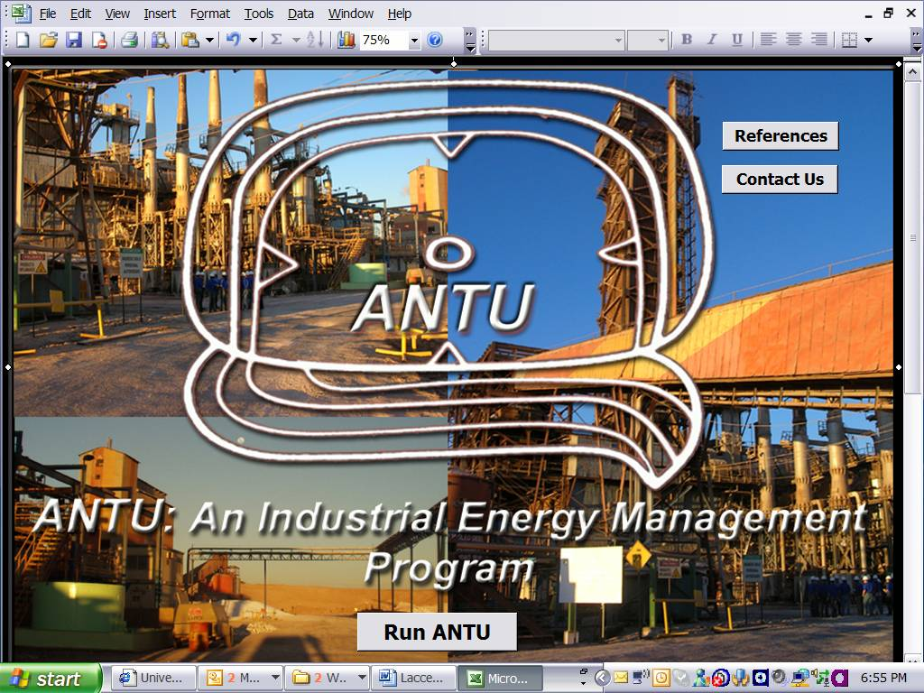

Figure 2. A view of the Main window of ANTU, which means Sun (from which all the energy in the earth comes) in Araucano, the language of one of the native Chilean Indian tribes (that the Spanish could not conquer). Currently, engineering work is facilitated by availability of a variety of software. In this program we are developing a package that is based on the need to account for energy accounting in industry. ANTU is a package that enables the user to account for energy consumption in a given facility or process, according to all the equipment considered that consumes energy (any source). After entering the corresponding data, energy consumption is calculated and then “Balanced” against current energy bills. As a result ANTU will generate a report with graphs, pie charts, energy savings opportunities, and an equipment list. The capabilities of the software makes it unique in the energy management arena, as it can assist in identifying savings opportunities in each equipment area, without having to make any major changes in production. Optimization of operations is currently part of our research that will allow us to introduce an optimization protocol that will attempt to solve the global minimum energy consumption problem. Obviously, the quality of the manufactured product will not be affected, only the energy used to manufacture it. The main window of the ANTU Software is shown in Figure 2.

10. Latin American and Caribbean Energy International (LACEI) Journal

As mentioned before, we believe that communication and exchange of ideas is are of permanent importance, and consequently we hereby propose the creation of a Latin American and Caribbean Energy International (LACEI) Journal. The objective of the journal is to address topics of interest written by researchers of the region, and the world. Topics should include Energy Education, Renewable Energy Sources, Biomass, Ethanol, Hydrogen, Industrial Efficiency, Case Studies, Solar, Eolic, Geothermal, Fuel Cells, Cogeneration, HVAC, Policies, Economics, Global Warming, etc. In summary all those topics that are related and of interest that comes out of the LAC community research, under the umbrella of LACCEI.

11. Conclusions

We have shown the results of our efforts to establish collaborative agreements, at both university and college of engineering levels, with universities in Jamaica, Venezuela, Colombia, Ecuador, Peru, and Chile. In addition, we discussed how our efforts have been successful through funding the establishment of an Industrial Energy Assessment Center at Universidad Privada del Norte, in Perú, an International Industrial Energy Management Consulting course in Chile with Pontificia Universidad Católica de Chile, preparation of international meetings and courses.

Internationalization, globalization, collaboration, students, faculty, researchers, programs, exchange, conferences, ideas, development, etc. incorporate the possibilities which exist for meaningful interactions in out focus on engineering education for the Americas. We are not only a university that does some work with this focus, but we have certainly made some progress, and developed programs and expertise that we are willing to share. We believe that these programs, even if they are not the final solution, can contribute to the solutions’ of many of our societies problems. In this context, better prepared engineers to solve one of the most serious problems our world is facing, Energy usage.

Finally, it is conferences like the International Latin American and Caribbean Conference for Engineering and Technology, organized by LACCEI that sets the stage and open more possibilities of collaboration, for the benefit of our students and our society as a whole. In summary, “Developing Entrepreneurial Engineers for the Sustainable Growth of Latin America and the Caribbean: Education, Innovation, Technology and Practice”, is not a cliché, but it rather reflects the spirit and concerns of today for the engineers of tomorrow.

References

Jonathan Earle and C. Cardenas-Lailhacar, Preliminary Results of the University of Florida College of
Engineering Projection to Latin America and the Caribbean. LACCEI 2006, Mayagüez, Puerto Rico. June 2006.

Jonathan Earle and C. Cardenas-Lailhacar, Projecting the University of Florida College of Engineering to Latin America and the Caribbean. LACCEI 2005, Cartagena de Indias, Colombia. June 2005.

