Deterministic Thermal Fracture Life Analysis
of a Visco-elastic Cylinder

Hossein Rahemi, PhD
Professor, Department of Engineering and Technology
Vaughn College of Aeronautic and Technology
86-01 23rd Avenue, Flushing, NY, 11369-USA
Email hossein.rahemi@vaughn.edu

Abstract

Hollow Cylindrical structures such as a nuclear reactor containments, storage tanks, and solid rocket motor are often subjected to environmental temperature variations, which adversely influence mechanical properties such as strength, relaxation modulus, and fracture toughness. Environmental temperature changes produce cyclic thermal stresses in cylindrical structures. The thermal stress fluctuations may result in growth of a nascent crack in the body. Due to the random nature of thermal stresses, mechanical properties are time and temperature dependent. As a result crack growth will also be random.

Here, a visco-elastic cylinder, modeled as a two-layer consisting of a visco-elastic inner layer in a thin elastic case, will be investigated. A finite element analysis will be carried out to determine temperature and thermal stress distribution through the cylindrical wall. Green's integral will be used to determine the crack tip stress intensity factor. The Forman crack growth rate relation, that provides crack extension in cyclically loaded structures, will be used to determine the crack propagation as the crack travels through the varying stress field.

Since the stress distribution through the cylindrical wall is not uniform, a step-by-step finite element analysis will be carried out to determine stress intensity and crack growth as the crack travels through the varying stress field. Because of asymmetry in the cross section due to the existence of an initial crack, a two-dimensional finite element formulation is used for thermal analysis. The 2D analysis will take into account the stress distribution at the growing crack tip.

Here, life of the visco-elastic cylinder is defined as the number of cycles (daily cycle) that are required for an existing crack, to reach a critical crack length.

Keywords

Visco-elastic cylinder, finite element thermal analysis, crack propagation, life analysis

1. Introduction

Structures are often subjected to environmental temperature variations which adversely influence mechanical properties such as strength, relaxation modulus and fracture toughness. The thermal stress fluctuations may result in the growth of a nascent crack in the body. Hence, a study that leads to the analysis of crack propagation and structural failure is valuable for service life analysis of engineering structures.

The objective of this paper is to study the deterministic thermal fracture of a solid propellant rocket motor modeled as a two-layer cylinder consisting of a visco-elastic inner layer in a thin elastic case (Fig. 1).

Because of asymmetry in the cross section due to the existence of an initial crack a two-dimensional finite element formulation is used for thermal analysis. The 2D analysis will take into account the stress distribution at the growing crack tip (Rahemi, 1992). Because of the progressing crack, the boundary conditions may change

after each cycle. To consider this effect, the crack region may be divided into as many small elements as possible (Fig. 2). To overcome difficulties of changing geometry of the finite element mesh as the crack propagates, the program will generate x and y coordinates of each element by assigning the number and the size of subdivisions on r and θ (Fig. 2).

Using the Forman Crack growth rate relation (Forman, 1967), the daily crack growth produced by these thermal stresses will be evaluated for a given initial crack length; the life of the cylinder is defined as the time (number of cycles) required by such a growing crack to reaches its critical length.

Case

Propellant

Air
R₁
R₂

Initial crack (a)
R₃

a Figure 1. Representation of a solid propellant with
an initial crack

2. Finite Element Formulation

Here, a two-dimensional thermal finite element analysis (Rahemi, 2006; Reddy, 2006) is carried out to take into account the effect of stress distribution at the growing crack tip. In general, thermal analysis of the solid rocket motor involves two parts: 1) temperature distribution analysis, 2) thermal stress analysis. The solution for the temperature distribution is obtained from the time-dependent heat conduction equation (Holman, 2002; Kakac and Yener 1985), while the thermal stress distribution is determined from the solution of the equilibrium equations (Sechler, 1968).

The partial differential equation for the two-dimensional heat conduction problem can be expressed as

$γ(\frac{∂^{2}T}{∂x^{2}}+\frac{∂^{2}T}{∂y^{2}})=\frac{∂T}{∂t}$ (1)
Where $γ$is the thermal diffusivity and T is the temperature of the body at x and y coordinates. The geometric and thermo-elastomechanical properties of the structure are presented in Table 1.

Table 1. Geometrical and Thermo-Elastomechanical Properties

Material | Radius(in) | Diffusivity, γ (in²/hr) | Poisson’s Ratio, μ | Elastic Modulus, E (psi) | Coefficient of Thermal Expansion, α (in/in/ºF)
Air | 1.875 | 100.28
Propellant | 4.320 | 4.351 | 0.495 | * | 5.9 x 10⁻⁵
Steel | 4.400 | 49.04 | 0.300 | 30 x 10⁶ | 6.5 x 10⁻⁶
* - Varies with time and temperature

The finite element form of the heat conduction equation (Reddy, 2006) can be expressed as

$\left[K^{e}\right]\left\{T\right\}+\left[M^{e}\right]\left\{\overset{\text{.}}{T}\right\}=\left\{F^{e}\right\}$ (2)

Where $k_{\text{ij}}^{e}=\int_{Ω^{(e)}}{γ(\frac{∂φ_{i}}{∂x}}\frac{∂φ_{j}}{∂x}+\frac{∂φ_{i}}{∂y}\frac{∂φ_{j}}{∂y})\text{dx}\text{}\text{dy} ∧ M_{\text{ij}}^{e}=\int_{Ω^{(e)}}{φ_{i}φ_{j}}\text{dx}\text{}\text{dy} ∧ F_{i}^{e}=−\int_{Γ^{(e)}}{{qφ}_{i}}\text{ds}$

Here, q = flux on the exposed boundary; $φ_{i}$and $φ_{j}$are interpolation functions which depend on element type.
The structure is exposed to an outside temperature, which varies as a function of time according to the relation

$T_{(t)}=5\text{.}\text{56}\text{Sin}(\frac{2π}{\text{24}}(t+2))+\text{22}\text{.}\text{22}\text{Sin}(\frac{2π}{\text{8760}}(t+\text{4600}))−\text{17}\text{.}\text{78}$ (3)

Where $T_{(t)}$is in ºC and t is measured in hours. Equation 3 has also been used to provide the boundary condition for temperature at the outer surface of the cylinder for any specific time.

The stress equilibrium equations in a two-dimensional elasticity problem (Timoshenko and Goodier, 1970) are written as
$\frac{∂σ_{X}}{∂x}+\frac{∂τ_{\text{XY}}}{∂y}=0 \text{and} \frac{∂τ_{\text{XY}}}{∂x}+\frac{∂σ_{Y}}{∂y}=0$ (4)
From constitutive relations between stresses and strains for plane strain conditions, stresses can be expressed in terms of displacements as
$σ_{X}=C_{\text{11}}\frac{∂u}{∂x}+C_{\text{12}}\frac{∂v}{∂y}−(C_{\text{11}}+C_{\text{12}})(1+υ)αΔT$ (5a)
$σ_{Y}=C_{\text{21}}\frac{∂u}{∂x}+C_{\text{22}}\frac{∂v}{∂y}−(C_{\text{21}}+C_{\text{22}})(1+υ)αΔT$ (5b)
$τ_{\text{XY}}=C_{\text{33}}(\frac{∂u}{∂y}+\frac{∂v}{∂x})$ (5c)
Substituting equation 5 into equation 4

$\frac{−∂}{∂x}(C_{\text{11}}\frac{∂u}{∂x}+C_{\text{12}}\frac{∂v}{∂y})−C_{\text{33}}\frac{∂}{∂y}(\frac{∂u}{∂y}+\frac{∂v}{∂x})+(C_{\text{11}}+C_{\text{12}})(1+ν)α\frac{∂ΔT}{∂x}=0$ (6a)
$−C_{\text{33}}\frac{∂}{∂x}(\frac{∂u}{∂y}+\frac{∂v}{∂x})−\frac{∂}{∂y}(C_{\text{21}}\frac{∂u}{∂x}+C_{\text{22}}\frac{∂v}{∂y})+(C_{\text{21}}+C_{\text{22}})(1+ν)α\frac{∂ΔT}{∂x}=0$ (6b)
where $C_{\text{11}}=\frac{E(1−ν)}{(1+ν)(1−2ν)}=C_{\text{22}}, C_{\text{12}}=\frac{Eν}{(1+ν)(1−2ν)}=C_{\text{21}},C_{\text{33}}=\frac{E}{2(1+ν)}$

For the visco-elastic layer of the cylindrical structure, the time and temperature relaxation modulus is introduced in terms of Prony series (Rahemi, 1992) as
$E(T,t)=E_{e}+E_{p}(T,t)=E_{e}+\sum_{i=1}^{l}{E_{i}}\text{exp}\left[−\frac{t}{τ_{i}a(T)}\right]$ (7)
$E_{p}(T,t)$→ 0 as t → ∞, E_{i} and τ_{i} the moduli and relaxation times of parallel Maxwell elements are provided in reference (Heller and Rahemi, 1989). The nonlinear visco-elastic temperature shift function, a(T), is assumed as

$\text{log}[a(T)]=\frac{−7\text{.}\text{88}(T−\text{75})}{\text{291}\text{.}6+(T−\text{75})}$ (8)

The variational formulation of the equilibrium equations along with u (displacement in the x direction) and v (displacement in the y direction) are approximated in a typical element in the form
$u^{(e)}=\sum_{j=1}^{n}{u_{j}^{(e)}}ψ_{j}^{(e)}, v^{(e)}=\sum_{j=1}^{n}{v_{j}^{(e)}}ψ_{j}^{(e)}, \text{and} {ΔT}^{(e)}=\sum_{j=1}^{n}{{ΔT}_{j}^{(e)}}ψ_{j}^{(e)}$
Hence, the finite element form of equilibrium equations can be expressed as

$\begin{aligned}\left[k^{\text{11}}\right]\left\{u\right\}+\left[k^{\text{12}}\right]\left\{v\right\}=\left\{F^{1}\right\} \\ \left[k^{\text{21}}\right]\left\{u\right\}+\left[k^{\text{22}}\right]\left\{v\right\}=\left\{F^{2}\right\}\end{aligned}$ (9)

where
$$k_{\text{ij}}^{\text{11}}=\int_{Ω^{(e)}}{(C_{\text{11}}\frac{∂ψ_{i}}{∂x}}\frac{∂ψ_{j}}{∂x}+C_{\text{33}}\frac{∂ψ_{i}}{∂y}\frac{∂ψ_{j}}{∂y})\text{dx}\text{}\text{dy},$$
$$k_{\text{ij}}^{\text{12}}=k_{\text{ij}}^{\text{21}}=\int_{Ω^{(e)}}{(C_{\text{12}}\frac{∂ψ_{i}}{∂x}}\frac{∂ψ_{j}}{∂y}+C_{\text{33}}\frac{∂ψ_{i}}{∂y}\frac{∂ψ_{j}}{∂x})\text{dx}\text{}\text{dy}$$
$$k_{\text{ij}}^{\text{22}}=\int_{Ω^{(e)}}{(C_{\text{33}}\frac{∂ψ_{i}}{∂x}}\frac{∂ψ_{j}}{∂x}+C_{\text{22}}\frac{∂ψ_{i}}{∂y}\frac{∂ψ_{j}}{∂y})\text{dx}\text{}\text{dy}$$
$$F_{i}^{1}=(C_{\text{11}}+C_{\text{12}})(1+ν)α\sum_{j=1}^{n}{{ΔT}_{j}^{(e)}}\int_{Ω^{(e)}}{ψ_{j}}\frac{∂ψ_{i}}{∂x}\text{dxdy}+\int_{Γ^{(e)}}{ψ_{i}}t_{x}\text{ds}$$
$$F_{i}^{2}=(C_{\text{21}}+C_{\text{22}})(1+ν)α\sum_{j=1}^{n}{{ΔT}_{j}^{(e)}}\int_{Ω^{(e)}}{ψ_{j}}\frac{∂ψ_{i}}{∂y}\text{dxdy}+\int_{Γ^{(e)}}{ψ_{i}}t_{y}\text{ds}$$
Here, $ψ_{i}^{(e)}$are appropriate interpolation functions depending on the type of element. t_{x} and t_{y} denote specified boundary force (Rahemi, 1992).

The finite element form of equation 9 can be rearranged as a single finite element equation as

$\left[k^{(e)}\right]\left\{Δ^{(e)}\right\}=\left\{F^{(e)}\right\}$ (10)

$\begin{aligned}\left[k_{\text{11}}^{\text{11}} k_{\text{11}}^{\text{12}} k_{\text{12}}^{\text{11}} k_{\text{12}}^{\text{12}} k_{\text{13}}^{\text{11}} k_{\text{13}}^{\text{12}} k_{\text{14}}^{\text{11}} k_{\text{14}}^{\text{12}} | \right]\left[k_{\text{11}}^{\text{21}} k_{\text{11}}^{\text{22}} k_{\text{12}}^{\text{21}} k_{\text{12}}^{\text{22}} k_{\text{13}}^{\text{21}} k_{\text{13}}^{\text{22}} k_{\text{14}}^{\text{21}} k_{\text{14}}^{\text{22}} | \right]\left[k_{\text{21}}^{\text{11}} k_{\text{21}}^{\text{12}} k_{\text{22}}^{\text{11}} k_{\text{22}}^{\text{12}} k_{\text{23}}^{\text{11}} k_{\text{23}}^{\text{12}} k_{\text{24}}^{\text{11}} k_{\text{24}}^{\text{12}} | \right]\left[k_{\text{21}}^{\text{21}} k_{\text{21}}^{\text{22}} k_{\text{22}}^{\text{21}} k_{\text{22}}^{\text{22}} k_{\text{23}}^{\text{21}} k_{\text{23}}^{\text{22}} k_{\text{24}}^{\text{21}} k_{\text{24}}^{\text{22}} | \right]\left[k_{\text{31}}^{\text{11}} k_{\text{31}}^{\text{12}} k_{\text{32}}^{\text{11}} k_{\text{32}}^{\text{12}} k_{\text{33}}^{\text{11}} k_{\text{33}}^{\text{12}} k_{\text{34}}^{\text{11}} k_{\text{34}}^{\text{12}} | \right]\left[k_{\text{31}}^{\text{21}} k_{\text{31}}^{\text{22}} k_{\text{32}}^{\text{21}} k_{\text{32}}^{\text{22}} k_{\text{33}}^{\text{21}} k_{\text{33}}^{\text{22}} k_{\text{34}}^{\text{21}} k_{\text{34}}^{\text{22}} | \right]\left[k_{\text{41}}^{\text{11}} k_{\text{41}}^{\text{12}} k_{\text{42}}^{\text{11}} k_{\text{42}}^{\text{12}} k_{\text{43}}^{\text{11}} k_{\text{43}}^{\text{12}} k_{\text{44}}^{\text{11}} k_{\text{44}}^{\text{12}} | \right] \\ \end{aligned}$ (11)

Using the solution of these nodal displacements, the stresses can then be obtained as post-processing by employing equations 5a through 5c.

2.1 Finite Element Modeling

Because of the progressing crack, the boundary conditions and radius of plastic zone based on Irvin plastic zone model may change after each cycle. To consider these effects, the crack region may be divided into as many small elements as possible (Fig. 3). To overcome difficulties of changing geometry of the finite element mesh as the crack propagates, the program will generate x and y coordinates of each element by assigning the number and the size of subdivisions on r and θ (Fig. 2). One can take care of boundary conditions of the growing crack, by changing the size of x for the last left and right elements of the crack region (Fig. 3) as the crack propagates.
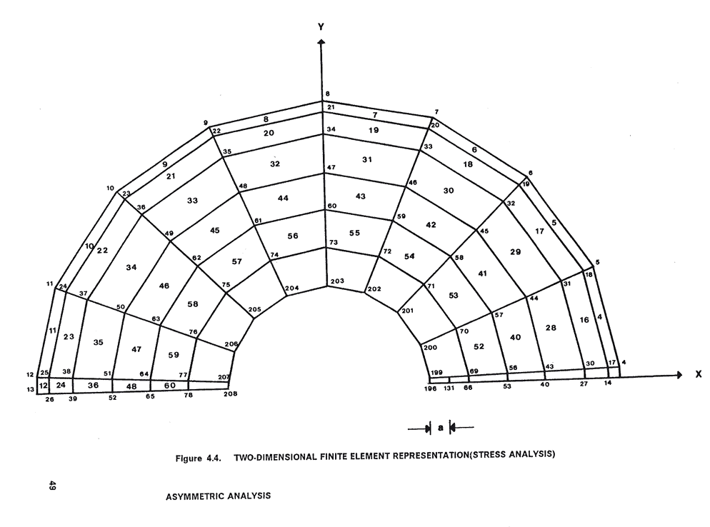
Fig. 2. Two-Dimensional Finite Element Representation

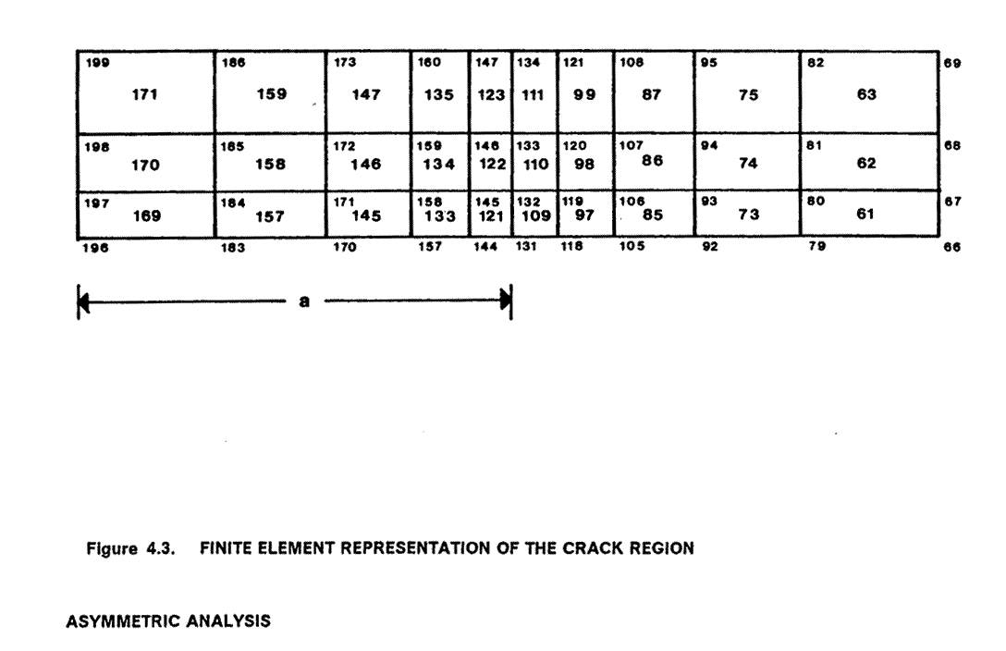
Fig. 3 Finite Element Representation of Crack Region

The radius of the plastic zone at the crack tip is obtained based on Irwin’s plastic zone model (Parker, 1981). Based on the finite element analysis, the tangential stresses at the near crack tip (radius of plastic zone away from crack tip (Rahemi, 1992) can be evaluated. The plot of tangential stress at the near crack tip as a function of time for a year is presented in Fig. 4.

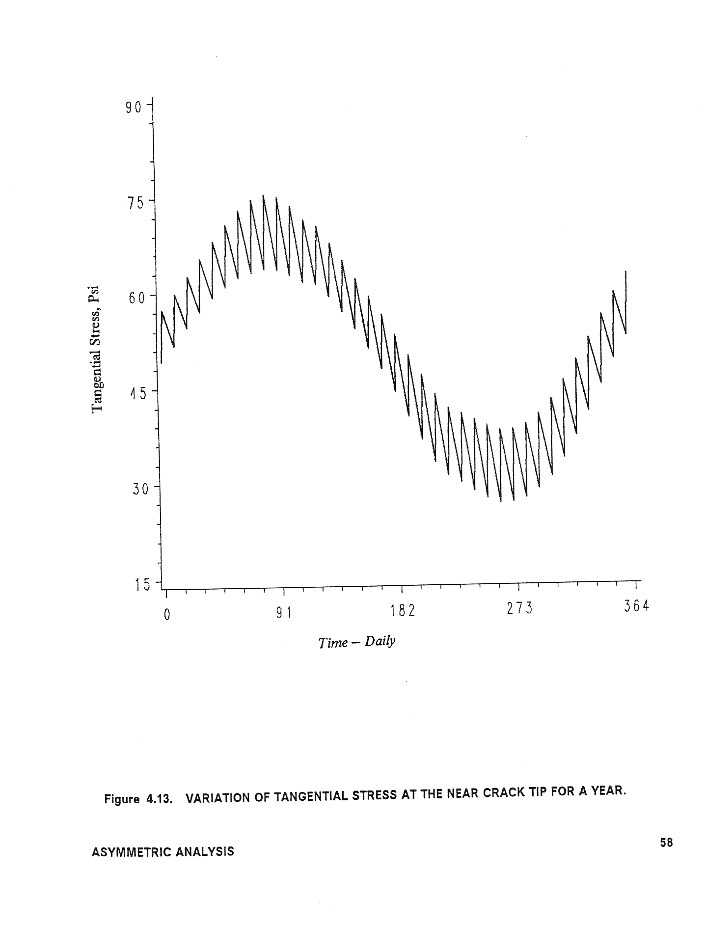
Fig. 4 Cyclic tangential stress at the near crack tip for a year (Daily)

3. Crack Growth Analysis

To predict the life expectancy of the cylindrical structure, a crack propagation analysis based on the Forman crack growth rate relation (Forman, 1967) is applied.

$\frac{\text{da}}{\text{dN}}=\frac{{CΔK}^{n}}{(1−R)K_{\text{IC}}−ΔK}$ (12)

Here da/dN is the crack growth per cycle, C and n are material constants, R is the stress ratio, ΔK is stress intensity range, and K_{IC} is fracture toughness. The numerical integration of above equation cycle by cycle (daily cycle) leads to the crack length after i load applications as

$a_{i}=a_{i−1}+{Δa}_{i}$ (13)

where Δa_{i} is the incremental crack length caused by the i^{th} load cycle given as

${Δa}_{i}=\frac{{CΔK}_{i}^{n}}{(1−R_{i})K_{{\text{IC}}_{i}}−{ΔK}_{i}}$
(14)
$\text{where} R_{i}=\frac{S_{\text{min}}}{S_{\text{max}}} \text{and} {ΔK}_{i}={αΔS}_{i}\sqrt{{πa}_{i−1}}$
The temperature dependent fracture toughness (Heller and Rahemi, 1989) can be assumed as

$K_{\text{IC}}=A+B[1+\text{erf}(\frac{T−T_{S}}{T_{C}})] → −∞≤T≤∞$ (15)

where A and B are constants and T, T_{S} and T_{C} are the ambient, the transition, and the characteristic temperature respectively. The constants A and B may be evaluated from the fracture toughness data, which are related to the maximum stress amplitude and critical crack size (Rahemi, 1992). Typical values chosen for this calculation are as follows
$A=\text{124}\text{.}\text{12}\text{psi}−\sqrt{\text{in}} , B=\text{187}\text{.}\text{94}\text{psi}−\sqrt{\text{in}} , T_{S}=−5^{o}F(−\text{20}\text{.}6^{o}C) \text{and} T_{C}=6^{o}F(3\text{.}3^{o}C)\text{.}$Because temperature is time dependent, the resulting fracture toughness as a function of time (daily cycle) is presented in Figure 5.

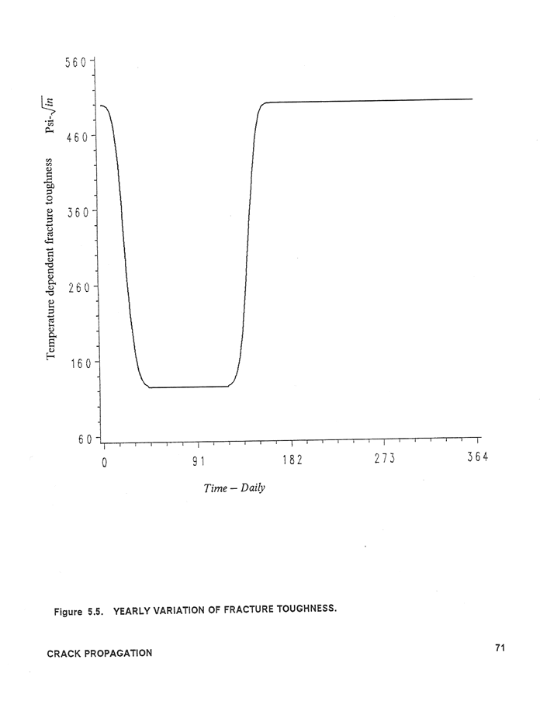
Fig. 5 Yearly variation of fracture toughness

Based on the above numerical evaluation Figure 6 has been plotted for crack propagation vs. time. Crack growth reaches a critical length after 1583 days for the given mathematical parameters.

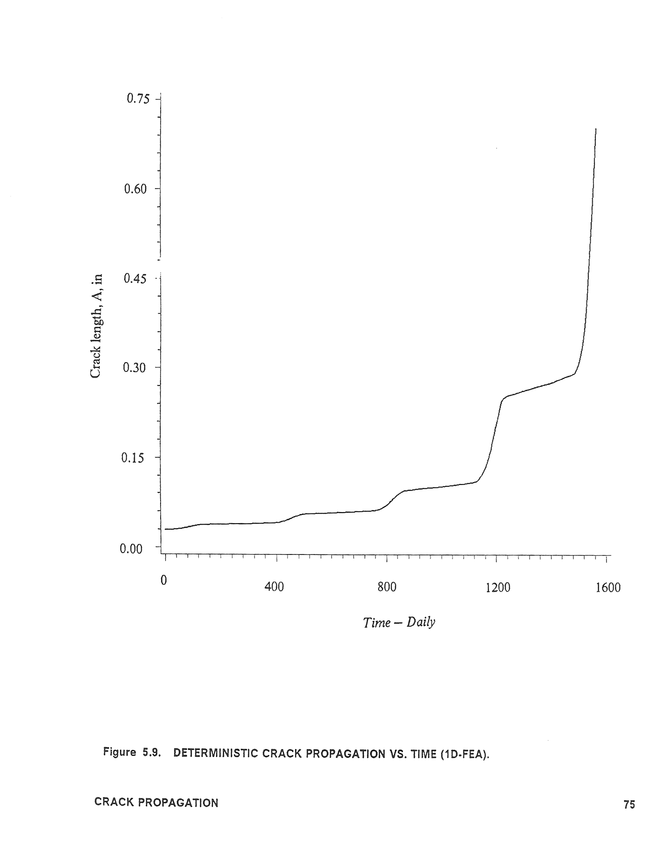
Fig. 6 Deterministic Crack Propagation vs. Time

4. Life Analysis

The life of the cylindrical structure is defined as the number of days that a structure can be in service before reaching its critical crack length. Based on one-dimensional finite element analysis, it has been observed that the cylindrical structure with an initial crack length of 0.03// has a life of 1750 days (Rahemi, 1992). Using two-dimensional finite element analysis, the life of the structure has been reduced to 1583 days, 9 % less than one-dimensional finite element analysis. Two-dimensional FEA for crack propagation is conducted by considering an existing crack in the body. One-dimensional FEA, stresses along the crack line of an uncracked body were used to provide the stress intensity factor for the pressurized crack by

the numerical evaluation of Green’s Integral and consequently the crack propagation. Hence, 2D FEA, based on presence of a crack in the body, provides more accurate life analysis than 1D FEA.

5. Conclusion

The numerical results for temperature and thermal stress distribution through the cylindrical wall are based on an axisymmetric external, time dependent, temperature function which has a variation between –25 to +75 ºF (Alaska’s environment). Based on one-dimensional finite element analysis, it has been observed that the cylindrical structure with an initial crack length of 0.03// has a life of 1750 days (Rahemi, 1992).

However, because of asymmetry in the cross section due to the existence of an initial crack, a two-dimensional finite element analysis is performed to provide more accurate thermal stress distribution through the cylindrical structure as crack propagates through the varying stress field. Stress in the close vicinity of the crack tip will exceed the material’s critical stress. Hence, stress curves of the crack region were used to obtain the size of plastic zone and consequently stresses at the near crack tip.

The crack propagation, based on the Forman crack growth rate, for the maximum and minimum cyclic thermal loading was analyzed. Crack growth and the critical crack size as the crack travels through the varying stress field have been evaluated cycle by cycle for an initial crack size A_{o} = 0.03 in. Based on two-dimensional FEA, cylindrical structure has been found to have a life of 1583 days.
It has been observed that temperature dependent fracture toughness varies between 12 to 50 $\text{psi}−\sqrt{\text{in}}$; the low value corresponds to low temperature and high value corresponds to high temperature. It also has been observed that crack grows more rapidly during the low temperature region.

The presented life analysis is based on a deterministic approach. However, due to the random nature of temperature and thermal stress, a future study will consider a probabilistic approach to predict service life of the cylindrical structure.

6. References

Forman, R.G., Kearney, V.E., and Engle, R.M., “Numerical Analysis of Crack Propagation in Cyclic Load
Structure,” Journal of Basic Engineering, Trans. ASME, Vol. 89, No. 3., 1967, pp. 459-464.

Heller, Robert, A. and Rahemi, Hossein, “The Effect of Thermal Variation in Fracture Toughness,” Proceedings
of ICOSSAR, 5th International Conference on Structural Safety and Reliability, San Francisco, CA.,
August1989, PP. 1595-1602.

Holman, J. P. “ Heat Transfer,” 9th ed., McGraw-Hill, N.Y., 2002.

Kakac, S. and Yener, Y., “Heat Conduction,” 2nd ed., Hemisphere Publishing Corporation, New York, 1985.

Parker, A.P., “The Mechanics of Fracture and Fatigue,” E. & F.N. Spon, London, 1981.

Rahemi, Hossein “Thermal Fracture Service Life Analysis of a Solid Propellant Rocket Motor,” Ph.D.
Dissertation, Virginia Polytechnic Institute and State University, April 1992.

Rahemi, Hossein “Engineering Analysis with Patran-Nastran Finite Element Application” 1st Draft, Vaughn
College Book Store, 2006.

Reddy, J.N. “An Introduction to the Finite Element Method,” 3rd ed., McGraw-Hill, N.Y., 2006.

Sechler, E.E., “Elasticity in Engineering,” Dover, New York, 1968.

Timoshenko, S.P., and Goodier, J.N., “Theory of Elasticity,” 3rd ed., McGraw-Hill, New York, 1970.

