Fifth LACCEI International Latin American and Caribbean Conference for Engineering and Technology (LACCEI’2007)
“Developing Entrepreneurial Engineers for the Sustainable Growth of Latin America and the Caribbean:
Education, Innovation, Technology and Practice”
29 May – 1 June 2007, Tampico, México.
A Study of Positioning Effects on Switching Power Supplies Conducted Emissions

Yves-Thierry Jean-Charles
EMI R&D Lab, Florida Atlantic University, Boca Raton, FL, USA

Vichate Ungvichian
EMI R&D Lab, Florida Atlantic University, Boca Raton, FL, USA, ungvich@fau.edu

Settapong Malisuwan
Chulachomklao Royal Military Academy, Nakhon-Nayok, Thailand

ABSTRACT

Conducted emissions (CE) testing procedure is dictated by well known standards, such as ANSI C63.4-2003 and CISPR 22 to mention a few, which ensure repeatable and consistent measurement procedures. However, uncertainties remain since device setup differences may exist among test sites that adhere to those standards. Those differences sometimes can be enough to alter the conclusions. This paper studies how the placement of the typical switching power supply (SPS) may affect the CE outcomes. A variety of SPSs are evaluated in terms of how their positioning in the test setup affects the level of the conducted emissions recorded for the frequency range of 150 kHz and 30 MHz. The results show that there is a variation up to 10 dB among the different configurations. These disparities that are linked to the positioning of the power supply may lead to questioning the site to site measurement repeatability or setup procedure under the current standards.

Keywords: ANSI C63.4-2003, CISPR 22, Line Impedance Stabilization Network, Conducted Emissions, Compliance

1. INTRODUCTION

Reproducibility of test results is a constant concern for Electromagnetic Compatibility (EMC) evaluations. In ANSI C63.4-2003 and CISPR22-2003 standardized procedures for Electromagnetic Interference (EMI) testing have been developed. Even though these standards significantly reduce disparities among test sites results, the possibility of inconsistency still remains. This paper focuses solely on CE measurement practices in accordance to ANSI C63.4-2003 and CISPR22-2003. CE testing results are very repeatable. The source is stationary during the measurements and the emissions recordings are dictated by measurement software such as HP 85864B, which reduces the human factor on the test outcome. However, measurement setup is still left at the discretion of the test engineer who has to interpret setup procedures that sometimes have not been clearly described by the test standard manuals (ANSI C63.4-2003 and CISPR22, 2003). The question raised is whether the test engineer’s interpretations significantly affect the test results.

This study will not attempt to evaluate the compliance of the devices under test but will investigate on how the positioning of the peripheral devices in conducted emissions measurements may affect the results. Usually, the CE measurements have to be performed for both phase and neutral lines with respect to ground. To speed up the data collecting, only the power disturbance emissions of the phase line of the equipment under test (EUT) in relation to the safety line are recorded and reported. Different types of off-the-shelf SPSs are evaluated in accordance to the standard testing procedures described in ANSI C63.4-2003 and CISPR22-2003. The levels of the emissions on the power line are recorded on an HP 8566B spectrum analyzer connected to a Line Impedance Stabilization Network (LISN), bounded to the horizontal ground plane. The LISN provides a known impedance from 150 kHz to 30 MHz and isolates EUT from emissions from the power line (Clayton, 2003). Since the CE limits of FCC and CISPR 22 standards are the same (CFR, CISPR 22), the CISPR 22 limit for conducted emissions over the frequency band 150 kHz to 30 MHz is used to observe the CE levels of the SPSs. Three different units are evaluated in this study, a laptop SPS, a cordless cellular phone battery charger and a cellular phone SPS wall adaptor. All of these EUTs are 2-wire systems, with only phase and neutral lines. Since the stability of the device under test is necessary in order to ensure consistency among the results, the SPSs are warmed up for at least 15 minutes before collection of data.

2. MEASUREMENT SETUP

The assessment takes into consideration the positioning of the SPSs in reference to the LISN. Photographs 1 and 2 show the LISN placed on the horizontal ground plane with two bond straps at the rear, which is 20 cm away from the vertical metallic plane.

2.1 Cordless Battery Charger

The cordless battery charger pertains to the category of wall-mounted devices. According to ANSI C63.4, these equipments must be treated as table-top devices. Therefore, three configurations are attempted for the assessment:

- a) The charger plugged directly to the LISN for normal use (Photograph 1).
- b) The charger put on the table-top and connected to the LISN via a 9 ft extension cord (14AWGx3G) (Photograph 2).
- c) The charger put on a PVC stand 18 inches above the floor and 0.4 m from the wall (Photograph 3).

The last setup was attempted in order to simulate a height close to typical residential and commercial power receptacles installations of 18-24 inches (NFPA, 2005).

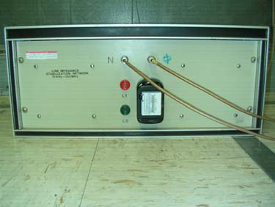
LISN
LISN
SPS

Photograph 1: Cordless Battery charger on LISN

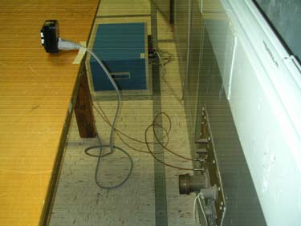
SPS

Photograph 2: Cordless Battery Charger on
Table-Top

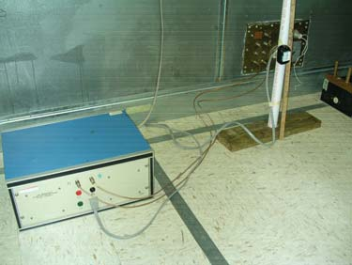
SPS

Photograph 3: Cordless Battery Charger 18” above the Floor

2.2 Cellular Phone SPS

The cellular phone SPS is connected to an off-the-shelf cellular phone with a fully charged battery. Since the SPS evaluated also falls within the category of wall-mounted devices, configurations identical to that previously depicted are attempted.

- a) The SPS is plugged directly to the LISN (Photograph 4).
- b) The SPS is on the table-top and connects to the LISN via a 9-ft extension cord (14AWGx3G) (Photograph 5).
- c) The SPS is on a PVC stand 18 inches above the floor and 0.4 m from the wall (Photograph 6).

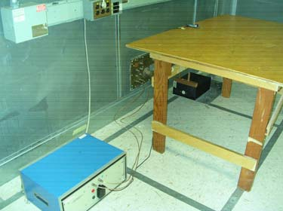
SPS
SPS
Phone

Photograph 4: Cellular Phone SPS on LISN

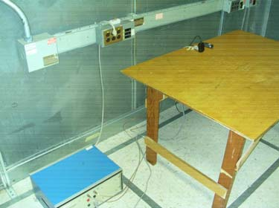
SPS

Photograph 5: Cellular Phone SPS on Table

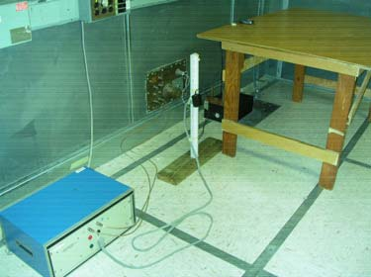
SPS

Photograph 6: Cellular Phone SPS 18” above the floor

2.3 Laptop SPS

The laptop SPS does not belong to the category of wall-mounted devices. Therefore, different configurations are attempted for the preliminary assessment. Since the main interest of this study is the assessment of the amplitude variations depending on the location of the SPS, a laptop computer was not connected to the EUT. The different setups are as follows:

- a) The SPS on the ground floor and 40 cm from the LISN (Photograph 7)
- b) The laptop SPS on the wooden table (Photograph 8)

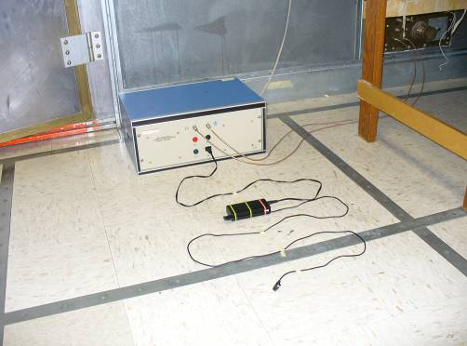
SPS

Photograph 7: Laptop SPS on the Floor

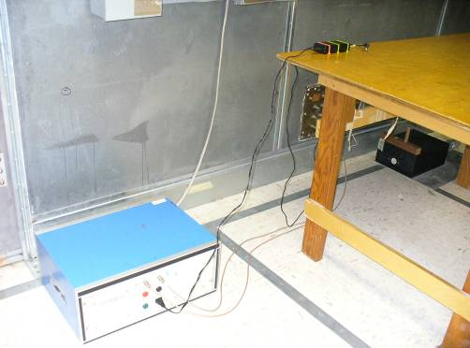
SPS

Photograph 8: Laptop SPS on Table-Top

3. RESULTS

3.1 Cordless Battery Charger

Figures 1, 2 and 3 show the CE results for the 3 configurations of the cordless battery charger. While the pattern of the CE does not change significantly across the frequency range, the magnitude of the emissions varies from one setup to another. The changes are more noticeable in the lower frequency range of 150 kHz to 2 MHz. The emissions are higher for the battery charger plugged directly to the LISN. The emissions over 8 MHz are about the same for the three configurations. However, in the frequency range of 500 kHz to 8 MHz, discrepancies up to 10 dB can be observed. CE are highest in Configuration 2.1 (a), and average to about 40 dBµV. For Configuration 2.1 (b), the emissions average drops by about 10 dB. Configuration 2.1(c) also shows a significant drop of 15 dB from Setup 2.1 (a). The evaluation of the SPS when it is connected directly to the LISN corresponds to the worst case scenario and is the setup that is likely to be adopted by accredited test houses.

Figure 1: Cordless Battery charger on LISN

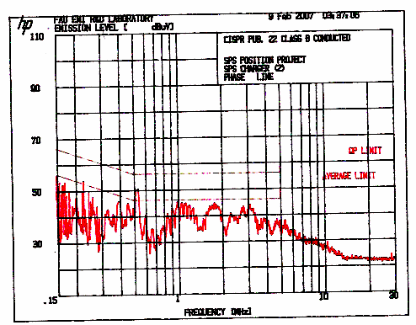
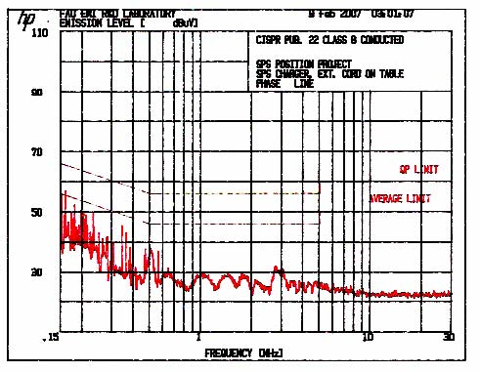
Figure 2: Cordless Battery charger on Table-Top

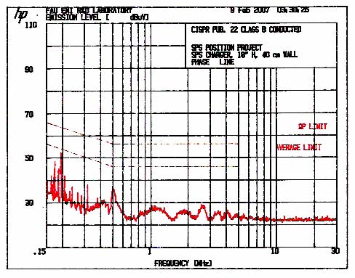
Figure 3: Cordless Battery charger on the Floor

3.2 Cellular Phone SPS

CE from the cellular phone SPS are graphed in Figures 4, 5 and 6, which show that the cellular phone SPS does not behave like the cordless battery charger. The average emissions levels are very similar among the three plots since the correlation of the emissions is less than 5 dB. Therefore, one can conclude that the positioning of the power supply in reference to the LISN does not seem to affect the overall level of the emissions

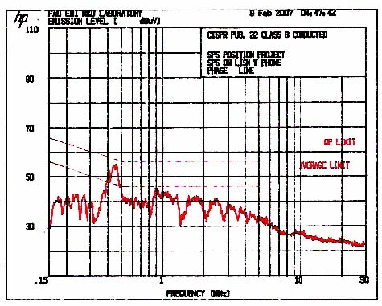

Figure 4: Cellular Phone SPS on LISN

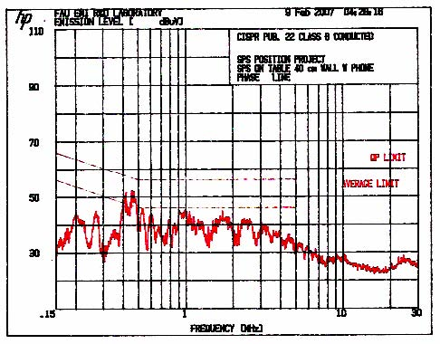

Figure 5: Cellular Phone SPS on Table

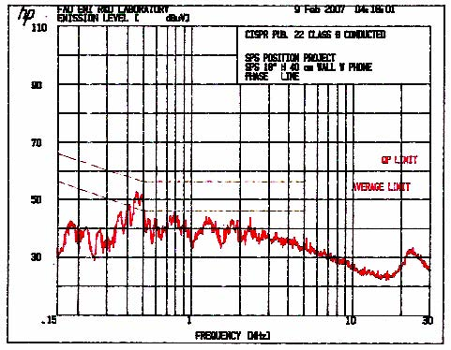

Figure 6: Cellular Phone SPS on Table

3.3 Laptop SPS

The graphical data shows that the no-load laptop SPS CE levels are also significantly affected by positioning. Figures 7 and 8 depict the emissions from when the laptop is moved from the floor to the table top. The disparities can be observed across the whole band of evaluation (150 kHz to 30 MHz). For the range of 150 kHz to 1 MHz, the CE levels differ up to 13 dB. In the remaining band, the difference is less than 7 dB. The graphical data also exhibits that the CE are much higher when EUT is placed on the ground floor. This is due to the fact that the SPS provides stronger capacitive coupling to the floor.

Figure 7: Laptop SPS on the Floor

Figure 8: Laptop SPS on the Table-Top

For the cellular phone and the laptop SPSs, the graphical data shows that the CE levels vary depending upon their placement in relation to the LISN and the horizontal and vertical ground planes. The trend observed is that the emissions are higher when the device is closer to the horizontal and vertical ground planes. EUT couples with the ground surfaces, affecting CE results. The emission levels are lower when the SPSs are placed on the table-top; they however seem to increase when EUT is closer to the ground (plugged directly on the LISN or on the floor). The change in the magnitude of the conducted emissions can be explained as an increase of capacitive coupling between EUT and the ground plane, which is an alternate path for common-mode currents (two-wire system). Those commode-mode currents result themselves from imbalance within the system (Pignari and Orlandi, 2003). The results also suggest that the effects of capacitive coupling are prominent when the device is closer to ground or directly connected to the LISN which leads to higher magnitude of the conducted emissions. The location of LISN EUT receptacle is usually 3-inch above the floor, which is not a typical height (NFPA 2005) for indoor residential power outlets. Therefore, depending on the device’s location, coupling between the ground plane and SPS may be atypical. Discrepancies in the results may lead to a questioning of the test repeatability from site to site. On another hand, the emission levels did not vary much for the cellular phone charger. The device seems to be less susceptible to common mode currents since the results are very similar for the different configurations attempted.

4. CONCLUDING Remarks

The conducted emissions levels in the frequency range of 150 kHz to 30 MHz due to the positioning of SPSs are investigated. The units evaluated for this study are two-wire SPSs consisting of a cordless battery charger, a cellular phone SPS and a laptop SPS. The measurements show that positioning does not significantly affect the CE levels for the cellular phone SPS, since the discrepancies among the results are less than 5 dB. On another hand, the two other SPSs are very sensitive to placement since the levels of the emissions increase when the SPSs are closer to the ground floor. Emissions are at least 7 dB higher for when the devices are placed closer to the LISN and the ground plane than when put on the table-top. This phenomenon is due to imbalance of the SPS design. Capacitive coupling between SPS and ground plane creates a return path for the common-mode currents and increase the level of the emissions. Since only 2-wire systems are used for this study, one may wonder if 3-wire SPS may be more immune to a change in location, vis-à-vis the ground plane. The problem of capacitive coupling due to the placement of the SPSs in CE measurements is an issue that surely needs to be addressed and investigated. While the EUT placement close to the LISN and ground floor leads to the worst case scenario, this setup may not be typical to all test houses, let alone representative of the device’s configuration in the real world. In order to ensure result repeatability among test sites, a specific language (ANSI C63.4-2003 and CISPR 22, 2003) should be sought for SPS type devices. Another suggestion could be the use of an intermediate extension cable between the LISN and the EUT power cord so that the receptacle of the extension cord is installed at a height similar to that of typical wall/floor outlet to emulate typical coupling.

REFERENCES

ANSI C63.4-2003, “Methods of Measurement of Radio-Noise Emissions from Low-Voltage Electrical and Electronic Equipment in the range of 9 kHz to 40 GHz”, www.ansi.org.

Clayton R. Paul “Introduction to Electromagnetic Compatibility”, 2nd edition, John Wiley and Sons, Inc..2003.

Code of Federal Regulations, Title 47 (47CFR), Part 15, Subpart B: “Unintentional Radiators”; www.fcc.org.

International Electrotechnical Commission, CISPR 22 (EN55022), “Information Technology Equipment - Radio Interference Characteristics - Limits and Methods of Measurement, 4th Edition, 2003-2004; www.iec.ch.

NFPA, “National Electrical Code Handbook (NEC)” (2005), Article 210, W Marketing.

Pignari, S. A., Orlandi, A. (2003). “Long-Cable Effects on Conducted Emissions Levels”. IEEE Transactions on Electromagnetic Compatibility, VOL. 45, NO. 1.

AUTHORIZATION AND DISCLAIMER

Authors authorize LACCEI to publish the papers in the conference proceedings. Neither LACCEI nor the editors are responsible either for the content or for the implications of what is expressed in that paper.”

