The Rescue of Computing Devices in Educational Institutes

M.C. Rosi Areli Hernández Cruz
Universidad Tecnologica de la Huasteca Hidalguense, Huejutla de Reyes, Hidalgo México, areliher@yahoo.com.mx
Universidad Valle Del Bravo, Tampico, tamps.

SUMMARY
In education, the technologies of the information have great potential in all aspects, from basic to college education. And it is due to it that educative organisms are interested in renewing in short periods of time their computers. Nevertheless, the constant “technological updates” have become the reason of which the educative centers retire computers they had acquired 4 or 5 years ago, still working, without considering that they can still take advantage of the equipment to improve the technological infrastructure of schools at any level. The study “The Rescue of Computing Devices in Educational Institutes”, displays an alternative that proposes to reframe the new functions of the computers, with the intention of increasing the technological resources for disposition of the students, generating the development of computer science abilities that allow to limit, the straggler position of its scientific and technological strengths increasing its competitiveness. The economic saving that presents the restoration of obsolete equipment, will represent an important impact for those who apply it, without, it in anyway, has to mean a diminution of productivity of the tasks that with them are made, whenever the correspondence between the benefits asked for to the computer and the benefits of the same one has been analyzed properly.
Key words: Obsolete equipment, Restoration, Infrastructure, Hardware.
- Introduction.

Nowadays, the possibility of acquisition of computers at low cost makes possible that these can be obtained with greater facility. This causes that the users replace just a short time in the equipment that they have with equipment with greater benefits.

Now, if it is considered that in the educative centers the massive retirement of computer science systems takes place, when the possibility exists again of equipping the spaces destined for laboratories or computer centers, the problem that is generated is indeed, the storage of personal computers (PCs) considered of “obsolete”, being define with this term, the calculation equipment that no longer has the necessary characteristics for the support of software and hardware of last generation.

This situation has not been unknown to the Technological University of Huasteca Hidalguense (UTHH), institution that in the last years has retired of its classrooms, an important number of computers even though many of them continued working.

- Antecedents of problem.

Computers have been considered for many years computer science tools that allow to process and to administer great amount of data; due to this, they have become one of the key elements for the development of any sector, independently of his application.

In the decade of the 50' s, software received special importance when it became evident that some operations of computers were repetitive, but that could be automated by means of the use of programs, thus being born, the first operating systems, which became partly fundamental for the operability of a computer. We understand that the software is the instruction set or program that a computer uses to operate.

It is important to mention that the existing bond between the hardware (tangible parts) and software (programs and instructions) is simply essential. Nevertheless, he is this last one who defines in many occasions the technological development of the hardware, because it is indeed the one that must have the capacity of execution of the assigned instructions.

This means that, whenever it is required to use last generation software it would probably acquire new hardware, reason by which the computer science equipment will have to be update or necessary to replace by another one with the economic implications that this brings with itself.
3. Exposition of problem.

At the present time the technological advances allow millions of people to sell, to communicate, to learn and to amuse themselves, becoming instruments for a better development of the society. Nevertheless, as other mass media, we do not take advantage of all its capacity.

These advances have hit to the educative system and at the moment they have an important value, because its application allows a greater interactivity and flexibility of the learning. Also, they offer the possibility of obtaining in an immediate form, a great amount of information through Internet or simply the manipulation of the software tools fortifies the process of teaching-learning.

For such intention, the UTHH has made available for their students the computer science infrastructure necessary for their educative activities, and, during this period, throughout 9 years of existence, has been replacing their computers by others with greater benefits.

The previous as a fundamental part to obtain one of its main objectives that is to distribute technological education of superior level for the formation of apt human resources in the application of knowledge and the creative solution of problems, with a sense of innovation and incorporation of the scientific and technological advances.

Nevertheless, when acquiring new PCs has been retiring an important number of computer equipment, which, is stored in a warehouses because it no longer counts with the appropriate characteristics of hardware for the storage and support of last generation software, nevertheless, many of these continued working.

Before this fact some questions arise, like:

a.- Is it really necessary, to invest in very short periods of time great amounts of money in computer science infrastructure to obtain the incorporation of the scientific and technological advances of last generation?

b.- Is there the possibility that the old computer equipment can continue being used?

c.- Is the retirement of computers in operation acceptable, without analyzing before the possibility of extending its life utility assigning them to other functions?

d.-. Which would be the impact of acceptance of the workers and students when reusing equipment of calculation in the UTHH?

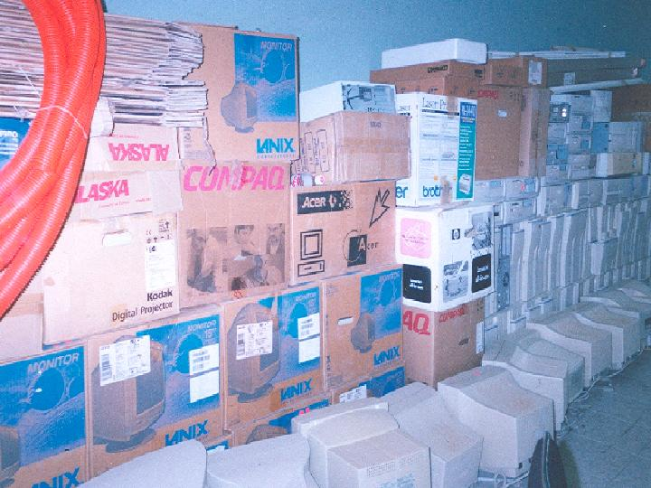
Figure 1: Stored computer equipment .

The problem itself, is that by virtue of the technological infrastructure updates computer equipment that still works is retired (see fig 1), and it could be used to make basic operations in other areas where it is not required that these have sophisticated characteristics, this is he reason why it is essential to apply strategies for the restoration of computers that have been stored.

4. The reusability of personal computers.

Decades ago only a very small part of the population could accede to some of the then little electrical and electronic apparatuses that were made, since its high price made inaccessible for the majority.

Therefore, they were used during long periods of time, repairing them successively, and getting rid of them when it’s repairing was made impossible.

Nevertheless, at the moment, the fast evolution of microelectronics has allowed to create an enormous variety of equipment destined to satisfy very different necessities and desires for a reasonable price for a high percentage of the population. For that reason, their production and consumption has been increasing until reaching unthinkable levels in a short time.

In addition, the diminution of the period of its time of used, has made the term that passes from its acquisition until it is rejection, at the present time, in many equipment, of a little number of years.

4.1 The computer science scrap.

A computer is obsolete not because it is not possible to be worked with it, but because we cannot install new utilities I it (packages of office, accounting, graphical design, among others). In addition, the connections for peripheral changes, are modernized and they stopped being compatible with those of previous apparatuses.

A moment comes in which extending the computer is more expensive than to buy new equipment, because it is difficult to find hardware of it’s generation, without forgetting the memory the machines need to install the last version of a video-game or the speed of navigation in Internet, which require a minimum equipment.

For that reason, when the computer can no longer extend itself, and the companies as the families decide to invest in a new machine, the old apparatus becomes a hindrance.

Some important numbers that indicate the magnitude of the computer science scrap iron problems describe next:

Spain generates between 100,000 and 160,000 tons of domestic electronic sweepings in a year. Whereas every day, in the state of California more than 6,000 computers are obsolete. Dundee J. Navin Chandra, professor of the Carnegie Mellon University affirms that in the U.S.A. “at the present time by each three computers that are bought, two are obsolete” (EROSKI).

The National Recycling Coalition predicts that in the 2007 there will be the enormous amount of 500 million obsolete computers in the U.S.A. But, in the agreement with Silicone Valley Toxics Coalition, more then 50% of the computers that are removed are functional and have been rejected to be replaced by others with the latest technology.

In Mexico there isn’t an exact data on the amount of computers that are rejected annually, nevertheless, It is known that from 2001 to 2006 the use of computers in Mexico has increased in 11,9%, when 23 million 644 thousand 198 computer users increased to 26 million 593 thousand 409. These numbers come from the Institute National Statistic and Information (INEGI).

The subject of the electronic remainders is already a reason for international preoccupation. The UN impels an international convention to regulate its handling and the United States, the European Union and in China have even began to adopt legal and operative measures to reduce the toxic components and to promote a safe recycling on great scale.

In Mexico, a diagnosis of the problem does not exist yet and much less, norms for the exhausted handling.

The National Institute of Ecology (INE), hardly started in May 2005, the Electronic Product study and Contamination in Mexico, that tries to evaluate the possible risks to the environment’s health and that should have been concluded by the end of the 2006.

  - Technological necessity of last generation.

It can be understood then that, in the last years, when greater benefits from computer equipments are required to keep a greater amount of information, to diminish the time response and to work with better quality images, we evidently think, in hardware from the last generation.

And it is completely healthful when its applications are practiced in technical areas, economic, scientific, among others. But when it’s about applications where functional office applications and access to the resources of the Internet are the only thing required, half-full equipment of the 90s can be used.

The computer market is directed by retailers who are trying to sell new hardware and software. To promote the reusability does not give commercial benefits to the market. As Linux does not need a great hardware, it is very useful to use with a small hardware.

5. alternatives.
Based on the previous thing, it is evident that the noticeable situation to acquire new technology, is based on the prevailing necessity to acquire new hardware, although properly is the software that demands its application in hardware of last generation.
Nevertheless, the computer equipment can continue operating with suitable software and offer the same characteristics of speed and processing in office tasks, education-learning and access to Internet. For it, the procedure to follow is: the evaluation and valuation of the tasks to make, as well as, the reassignment to these specific tasks.
It was important to make a study on the software that could be used to reuse the equipment that was discontinued. And finally, it was decided to use GNU/Linux.
GNU/Linux, represents an alternative for the restoration of “obsolete” equipment, without making great economic efforts, because it is not required to make licensing payments, and the applications can easily be acquired either via Internet or be obtained with the distribution that has been decided to use.

In addition, of which GNU/Linux, comprises the range of free software, that’s why it has all the advantages of use, application and distribution without incurring in a crime, nor expensive payments.

6. Advantages for the educative institutions.

The restoration of “obsolete” equipment represents important advantages for the educative sectors, in which the use of technological resources is made necessary more and more.
The benefits that can be obtained with the application of free software as an strategy for the rescue and the optimization of the hardware resources are:

- Saving of costs in the acquisition of new applications of software.
- Support the participation, understanding, innovation, communication, investigation and the self-taught learning.
- Generate experience to work with the diversity of applications.
- Create a culture for the generation of proposals combined to the incorporation in the labor field.
- Robustness of the system and control of virus.
- Efficiency in the administration of the equipment.
- Facility of installation, maintenance and update of software.

Students can have these and many other benefits at a new educative level, in which, with the greater computer science infrastructure availability their abilities are developed.

7. Restoration of equipment in the UTHH.

After investigating diverse alternatives under which discontinued computer equipment of the UTHH could be reused, which were determined that a viable form to do it was forming surroundings client-server using free software, under integrated obsolete PCs.

With the application of appropriate free software, the equipment of single calculation requires a minimum of hardware characteristics for their operation, that is to say, they do not need an important amount of ram memory, neither a processor of last generation, nor require a hard disk.

GNU/Linux was chosen for being the free software that formed suitably, provides the possibility of working graphical surroundings with a minimum of hardware requirements through the application of technology client-server.

Based in the selected alternative of free software, the hardware requirements were determined. These are centered mainly in the computer equipment that will work like server, since this will be the one that will as much provide resources of hardware as of software to the nodes.

Once the characteristics of hardware of nodes were determined the selection of peripherals (keyboard, mouse and monitor) and pieces (card of network, memories, and units, among others more) that could serve was made. This selection was made evaluating the stored equipment of the UTHH (see. Fig.2).

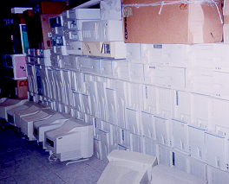
Figure 2: Stored computer equipment.

The selected hardware was examined meticulously to corroborate that it was in perfect state and thus to fulfill the aim I specify.

Once selected and reviewed the required hardware, the pieces were assemble (card of network, video card, memories) making physical connections in the entrances and corresponding ports of each device (see fig. 3).

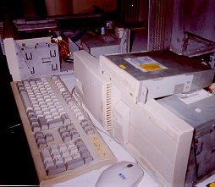

Figure 3: Work conditions evaluation.

After the assembly tests were made once again to verify the pieces that had been assembled. This procedure was extremely important since it worked to recognize the correct operation of the computers that would be used like nodes, besides allow to reject the pieces that did not work correctly.

The selected equipment was finally incorporated to a network, having used physical star topology and Ethernet technology.

8. General aspects of the operation of the network.

In the server a distribution of the operating system GNU/Linux was installed. GNU/Linux was chosen to allow the possibility of operating and of taking advantage of the resources the hardware considered like obsolete.

Once the client computers have had access to the network, services manage the communication with the server soliciting and receiving answers, of the benefits that the server offers (see fig. 4). The nodes only process what it is sent to them from the server, it is important to indicate that they do not have the capacity to make processes by themselves.

The server however, is in charge to transmit the asked information in an efficient form. This way the server takes care of all the computers in the network. In addition, all the applications that settle in the server will be available for the clients, according to the permissions that are established.
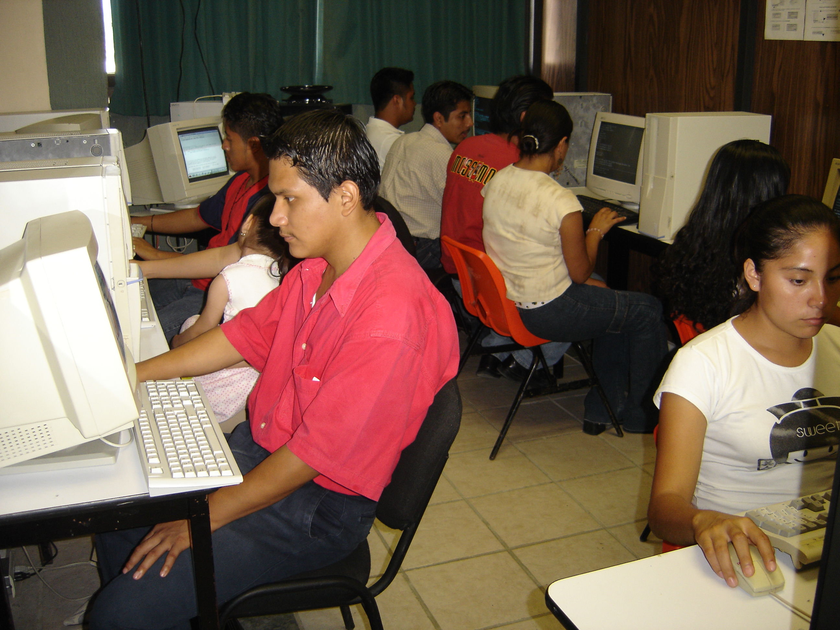

Figura 4: Computer labs with Internet access.

9. Conclusions.

It is important to evaluate the final strategies that are adopted for the relocation of computer equipment that have been retired from writing-desks, with the objective to allow the optimization of the computer science resource through other alternatives that improve their operation. This can be obtained making a deep analysis on the characteristics of the technology that is possessed to be able to orient it to other services.

It is also important, to acquire new technology and/or last generation technology, nevertheless, we must take control of an objective different from the one that is followed at this moment, that is to buy calculation equipment that supports the new software in the market.

We must mention that implanting free software within the Technological University of the Huasteca Hidalguense, represents a new option of tools of operation for the development of activities of the users of this institution, besides to foment the learning of diverse technological alternatives.

With the use of applied free software as a strategy for the rescue and the optimization of the hardware resource the following benefits can be obtained:

- Life utility of the equipment of the computer equipment is made larger.
- Savings in the costs of acquisition of new software applications.
- Support the participation, understanding, innovation, communication, investigation and the self-taught learning.
- Experience on working with a diversity of applications.
- Create a culture for the creation of proposals combined to the incorporation in the labor field.
- Robustness of the system and control of virus.
- Greater amount of computer science resources at disposition of a greater number of users.
- Efficiency in the administration of the equipment.
- An easier installation, maintenance and update of software.
- Curricular value for the students.

The equipment of calculation is constituted by numerous plastic components, printed circuits, glass, resistance and a great list of other components and materials elaborated with metals as the copper, lead, steel, aluminum, silicon, tin and others. For example: a monitor is constituted by elements like phosphorus, cadmium and mercury. When they are rejected, the computers are exposed to the environmental conditions and as consequence they release toxic substances to the air and the underground waters that contaminate the atmosphere.

Its advantage will not manage to prevent that at some point they arrive at the garbage dumps to be definitively consider like computer science scrap, but it will generate the possibility of extending its life utility.

The restoration of technology represented by the computer equipment considered “obsolete”, will allow a great impact that generates changes in the education when making a great amount of equipment available and helping foment the ecological conscience and allow everyone to take advantage of the resources.

With base in this investigation, the reusability of computer equipment through the use of free software in educative institutions is recommended, for this reason a study must be previously made to conduct the necessary battles, like the one in the UTHH.

Finally, the computer tools and the Internet, have produced significant changes in the educative field when being applied to the education-learning process. Obviously the benefits that are obtained will depend to a great extent on the evaluation, administration and allocation of the resources in the application area, this is why this document displays a panorama simply to stimulate the creation of plans and/or programs of action that will allow to evaluate the technology that is going to be replaced, with the objective to obtain their maximum advantage. Nevertheless, it does not try in any way to impose itself in administrative decisions, nor of the users.

References
Heuser, W. (2000) “Linux Ecology-Howto” http://es.tldp.org/COMO-INSFLUG/COMOs/Ecologia-y-Linux-COMO/ , 9/11/2005.
INEGI, (2006), “26 millon of users in Mexico”, http://www.politicadigital.com.mx/nota.php?id_rubrique=15&id_article=172 , 08/10/2006.
Magazine Consumer Eroski No.51 (2002) “New electrical and electronic remainders”, http://revista.consumer.es/discapacitados/es/20020101/medioambiente/33266.php, 28/09/2005.
Montero E. University of Cadiz, (2002), “The reusability of computers” http://www2.uca.es/grup-invest/cit/Opinion_archivos/amd%20PRES.pdf#search='La%20National%20RecyclingCoalition%20predice. 14/10/2005.
Pacheco, L. (2005), Reforma Group, “Threat to Mexico electronic sweepings”, http://www.imacmexico.org/ev_es.php?ID=20583_201&ID2=DO_TOPIC , 18/10/2006.
Rojo, N. (2005) “Electronic sweepings”, http://www.consumer.es/web/es/medio_ambiente/urbano/2005/01/10/114930.php , 30/09/2005.

Authorization and Disclaimer
Authors authorize LACCEI to publish the paper in the conference proceedings. Neither LACCEI nor the editors are responsible either for the content or for the implications of what is expressed in the paper.

