Fifth LACCEI International Latin American and Caribbean Conference for Engineering and Technology (LACCEI’2007)
“Developing Entrepreneurial Engineers for the Sustainable Growth of Latin America and the Caribbean:
Education, Innovation, Technology and Practice”
29 May – 1 June 2007, Tampico, México.

The Human Values Scale in Organizational Recommender Systems from User Models

Javier Guzmán-Obando
University of Girona, Spain, jguzmano@eia.udg.es
Autonomous University of Tamaulipas, México, jguzmano@uat.edu.mx

Gustavo González
University of Girona, Spain, gustavog@eia.udg.es

Ronald U. Ruiz Ordóñez
University of Girona, Spain, ruruizo@eia.udg.es

Silvana Vanesa Aciar
University of Girona, Spain, saciar@eia.udg.es

Josep Lluís de la Rosa i Esteva
University of Girona, Spain, peplluis@eia.udg.es

José A. Castán Rocha
Autonomous University of Tamaulipas, México, jacastan@uat.edu.mx

Abstract
This paper shows the development of a methodology that considers human factors including emotions as represented in the Human Values Scale in user models, particularly in organizational recommender systems. The methodology allows the resolution of specific problems linked to prediction and to the recommendation itself. In this work, we propose to obtain a user's human values scale from user models to improve the models' adaptation to organizational recommender systems. To achieve this objective, the methodology obtains the needed values from user attributes created during the user's previous interactions with the system. We also present preliminary results obtained from a case study applying the methodology, using the objective, subjective and emotional attributes found in the particular domain of banking activities.
Keywords: Recommender Systems, User Models, Human Values Scale
- Introduction
Personalization of services using a user's Human Values Scale (HVS) can improve user satisfaction. According to (Jensen, 2002), the information society will be followed by a society in which individuals will prioritize their decisions in interactions that involve a high degree of emotion, which will be a relevant issue in their values scale. Therefore, we are witnessing a cyclical transformation in society affecting its values scales.
In traditional psychology (Schwartz, 2003), the HVS defines a set of desirable and nonsituational goals; their significance can vary from one person to another and govern their life like a set of individual principles.
Organizational recommender systems represent user preferences for the purpose of suggesting items to purchase or examine. They have become fundamental applications in electronic commerce and information access, providing suggestions that effectively prune large information spaces so that users are directed toward those items that best meet their needs and preferences (Burke, 2002).
However, in the next stage of recommender systems, users will be situational humans who make decisions based not only on their preferences, tastes and interests, but also on their perceptions about them. In recommender systems, emotional sensibility can be defined as the emotional response of the user to the suggestions, advice or predictions of interest made by the system in each particular context, obtained through the objective, subjective and emotional attributes of the User Model (UM) (Gonzalez, et.al., 2005).
Our research is focused on the analysis of HVS using the Schwartz Value Survey (SVS) (Schwartz, 2003), which can take advantage of the UM through its objective, subjective and emotional attributes to define a methodology that responds more exactly to the preferences and interests of the user. This kind of methodology can influence the user's perception and final decision making.
The paper is organized as follows. In Section 2, a brief introduction to work related to the HVS is presented. Section 3 gives a study of the HVS in user modelling to understand the emotional response in recommender systems. In Section 4, we describe the methodology proposed to obtain the HVS of the user from UM. Next, in Section 5, we illustrate the proposed methodology through a recommender system of banking services. Finally, Section 6 offers some conclusions and suggestions for future work.
- Related Work
Research studies (Ravlin and Meglino, 1987) have proved the influence of human values on the perception and decision making of human beings. These studies reveal the value structure of each individual, in particular the values to which a greater or smaller importance is assigned, as they play a determining a role in perception as in decision making. We carried out an analysis of the most used scales on research for measuring human values (Guzman, et.al, 2005). Some do not measure the range of human values relevant in many life domains; others, despite their intention of covering the range of human values comprehensively, leave out critical content (e.g., tradition and power values); in other cases some items are highly sensitive to prevailing economic conditions and measure individuals' values only indirectly. We consider that the most suitable technique to apply in this research is the Schwartz scale of values, as it covers 56 human values included in 10 basic values. The reliability and validity of the Schwartz value survey have been demonstrated in several studies (Gouveia, et.al., 1998) and (Schwartz, 2003).
The Schwartz Value Survey (Schwartz, 1999) consists of 40 items, each one associated with an asymmetric scale from one (opposed to personal values) to six (of supreme importance), indicating the importance of this value as a guiding principle in the user's life.
The survey items are distributed among 10 universal dimensions (see Figure 4.a), which respond to different underlying motivations of the values integrating them. We call these dimensions meta-attributes. They are grouped taking into account compatible typologies and the diametrically opposed incompatible typologies (see Figure 1), which represent a contradiction of objectives that would generate a conflict in the user.
The procedure for scoring agreement to the SVS is as follows:
- apply the SVS;
- to obtain the personal score in a typology, add the points that have been assigned to questions associated with that typology;
- divide the result by the number of questions associated with the typology;
- mark thescore of each typology in the corresponding axis of the Dynamic Structure of Values; and,
- connect the points until a polygon of 10 sides is completed.
This procedure allows the HVS of a user to be developed from existing user models (Guzman, et.al., 2005).

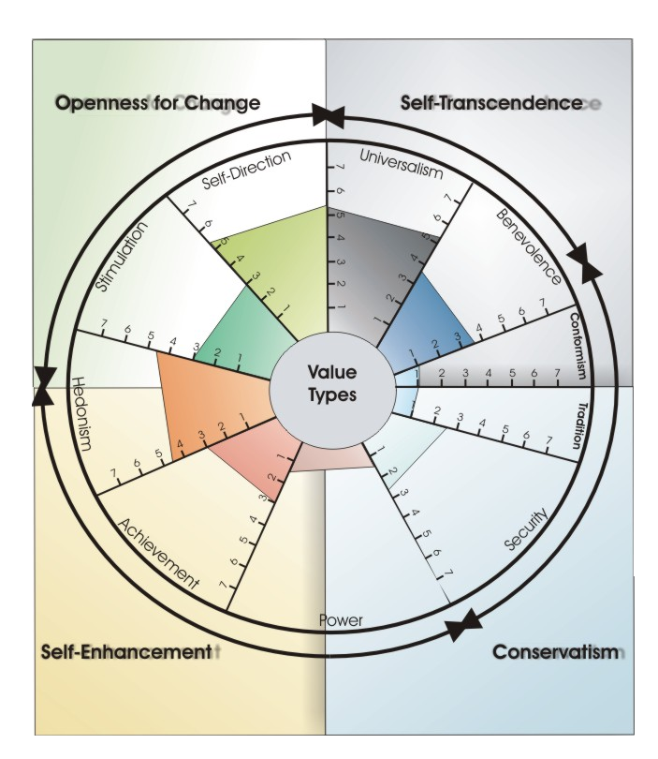

Figure 1: Dynamic Structure of Values according to the Universal Theory of Schwartz
- The Human Values Scale In User Modelling For Recommender Systems
User modelling represents assumptions about the user's knowledge, beliefs, preferences, and other user characteristics (Kobsa, 2001).
One of the most important challenges in user modelling is to build user models that can be used in different domains across several applications. These models are therefore at a metalevel, as opposed to a profile of a specific user. HVS can be introduced in user modelling to respond to this challenge.
The values scale in user modelling can be defined as the set of rules that manage the behaviour of a flexible autonomous entity, which is related with the attributes of the user (Guzman, et.al., 2005).
In our research, the general information about a user is useful for a recommendation process, because one can deduce that the values scale can be applied to autonomous and flexible entities, for instance a multiagent UM (Gonzalez, et.al., 2005), for the following reasons.
- To measure the interests and preferences of a social entity is useful.
- It motivates actions and gives them direction and emotional intensity.
- It functions as a criterion scale to evaluate and justify the actions.
- It is acquired both through the experience of individual learning and through the socialization in the values of a group of socially intelligent agents.
Values act as a central means of rationalizing actions within the human mind. Given a goal, values dictate the way in which the goal will be accomplished (Carter and Ghorbani, 2004).
The values scale is represented by goals (implicit or explicit) that reflect the needs of every flexible and autonomous social entity so the scale can:
- establish social relationships and coordinate them;
- express goals, objectives and interests explicitly; and
- create clusters with similar characteristics and social interests.
The HVS is an integral approach to user modelling and can take advantage of the UM using its attributes to use them in the processes of the recommendation (Guzman, 2005).
- Obtaining The HVS of A User
To calculate the HVS of a user, we must first obtain the user's general characteristics from the UM by applying the SVS. Then, through the proposed method, support will be given to the recommender system to make suggestions as a function of the user HVS.
  - The HVS test
The SVS provides a set of universal values classified into four groups: Openness to Change, Conservation, Self-transcendence, and Self-enhancement. These four groups are further divided into 10 sets of universal values (described above), which have n items to calculate the user HVS. Each item is defined in [0, 1]. (see Figures 2 and 4.a).
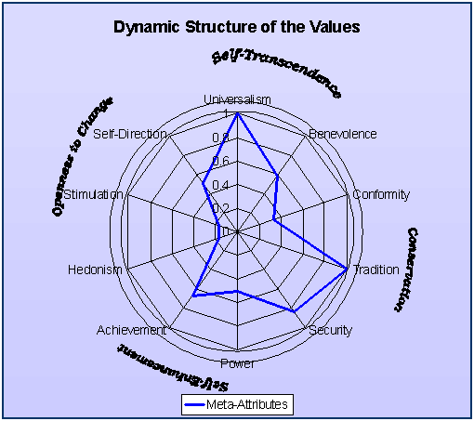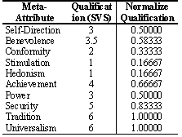

Figure 2: Example of the results from a SVS
  - Information Distribution
The values of the attributes from the recommender system provide relevant information about the user, from which we wish to obtain the HVS.
In our model, the technique represents the values as points in a multidimensional space. Distances between points reflect empirical relations between the values that can be measured by the correlations between the scores that give their importance for the person. A bigger conceptual similarity between two values shows that they are more related empirically, and therefore they will be closer in the multidimensional space. Figure 2 shows the items related to the HVS.
According to Figure 4, the set of parameters that define the HVS are:
$$\text{Evh}=\left\{{\text{Vu}}_{1},\text{.}\text{.}\text{.},{\text{Vu}}_{n}\right\}$$$(1)$
where the Vu are the universal values such as openness to change, conservatism, self-transcendence and self-enhancement.
$$\text{Vu}=\left\{{\text{Vh}}_{1},\text{.}\text{.}\text{.},{\text{Vh}}_{n}\right\}$$$(2)$
The Vh are the human values corresponding to the 10 types described by Schwartz: universalism, benevolence, conformism, tradition, security, achievements, power, hedonism, self-direction and stimulation.
$$\text{Vh}=\left\{a_{1}\text{.}\text{.}\text{.},a_{n}\right\}$$$(3)$
The a values correspond to the attributes or particular items, such as equality, intelligence, social order, richness, or creativity. In this way, we have: $∀a_{i}∈\text{Vh}$ have a $\text{val}(a_{i})∈\left[0,1\right]$; $∀\text{Vh}∈\text{Vu}$ with $\text{val}(v_{i})∈\left[0,1\right]$; and, $∀\text{Vu}∈\text{Evh}$
At the end, each a_{i} in Vh has a value. Once the corresponding values are obtained, the user HVS is generated from the UM with val(u_{i}) in [0,1].
    - Recommendation
The objective of this stage is to take advantage of the user's HVS to provide information to the organizational recommender system to improve the recommendations made to the user. To achieve this objective, the following methodology will be used.
    - Calculation of Numerical Values
In this stage, the calculations are made to obtain the user HVS, following a series of steps.
- Obtain the individual qualification of each Vh.
- Calculate the numerical value of each Vu.
- Perform the global calculation of the user HVS.
Step 1: In this step the value of each Vh is obtained by composing the user HVS. For each Vh there is a set of values (attributes, items) given by:
$∀q∈Q,∃\text{Vh}(q_{i})⊂\text{Vu}|$ ${\text{Val}}_{\text{num}}(q_{i})=\frac{\sum_{j=1}^{j=n_{a}}{{\text{Val}}_{\text{num}}(a_{j})}}{n_{a}}∈\left[0,1\right]$ $(4)$
Where: n_{a} = number of attributes evaluated in Vh.

Step 2: In this step the qualification of each Vu is calculated for the user HVS. For each Vu there is a set of universal values given by:
$∀q∈Q,∃\text{Vu}(q_{i})⊂\text{Evh}$ ${\text{Val}}_{\text{Num}}(q_{i})=\frac{\sum_{i=1}^{i=n_{\text{Vh}}}{{\text{Val}}_{\text{Num}}({\text{Vh}}_{i})}}{n_{\text{Vh}}}∈\left[0,1\right]$ $(5)$
Where: n_{Vh} = number of type values evaluated in Vu.

Step 3: In this last step, calculate the final value that corresponds to the user HVS, as follows:
$\text{Evh}=\frac{\sum_{j=1}^{j=n_{\text{Vu}}}{{\text{Val}}_{\text{Num}}({\text{Vu}}_{j})}}{n_{\text{Vu}}}∈\left[0,1\right]$ $(6)$
Where: n_{Vu} = total number of universal values in the HVS.
    - Linguistic Labels
Traditionally, modifications of fuzzy sets called linguistic labels, equivalent to adverbs, have been used. The interpretation in the fuzzy model of these enunciates involves assigning a value to the belong function with a simple arithmetic calculation.
According to the SVS, the answers to the survey items range from it is not like me to it is very much like me. In this case, we represent the facts defining each set so that each element belongs to the set with a certain degree (possibility).
In a more formal way, a fuzzy set A is characterized by a belong function: μA : U → [0,1] that associates to each element x of U a number μA(x) from the range [0, 1] that represents the degree of belonging of x to the fuzzy set A. U is called the universe of speech. The fuzzy terms for the example studied can be defined by a trapezoidal fuzzy set:
$$μ\tilde{A}(x)=\left\{\begin{matrix}0 & ; & x≤a_{1} & \\ \frac{x−a_{1}}{a_{2}−a_{1}} & ; & a_{1}≤x≤a_{2} & \\ \frac{a_{3}−x}{a_{3}−a_{2}} & ; & a_{2}≤x≤a_{3} & \\ 0 & ; & x≥a_{4} & \end{matrix}\right.$$
In this way, we obtain a graph representing the linguistic variable x by fuzzy logic, as shown in Figure 3.
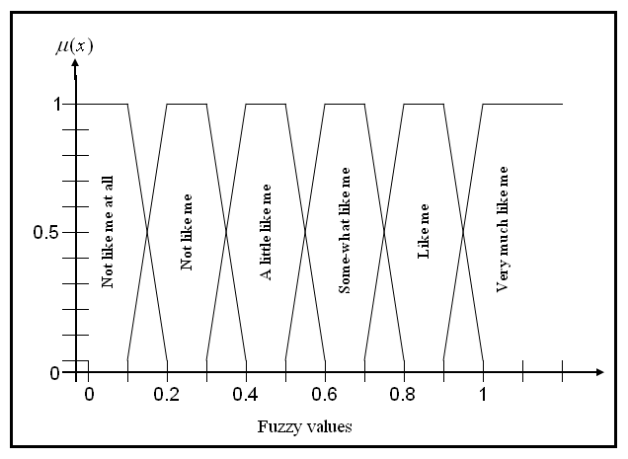

Figure 3: Functions [0,1]
    - Generating Recommendations
Although the effectiveness of existing recommender systems is remarkable, they still have serious limitations as they are unable to perform qualitative inference on the recommendations they offer and are incapable of dealing with the defeasible nature of users' preferences. In this context, defeasible argumentation frameworks (Chesñevar, et.al., 2003) have evolved to become a sound setting to formalize commonsense qualitative reasoning.
In recent years several specialized techniques for improving Web searches have been developed. Most existing approaches are still limited, mainly because of the absence of qualitative criteria for ranking results and insensitivity to user preferences for guiding the search.
At the same time, defeasible argumentation evolved as a successful approach in AI to model commonsense qualitative reasoning with applications in many areas, such as agent theory, knowledge engineering and legal reasoning (Chesñevar and Maguitman, 2004).
We contend that defeasible argumentation, the methodology proposed in (Chesñevar and Maguitman, 2004), can be integrated into existing recommender system technologies, paving the way to solve the problems of the recommender processes. We will analyse our proposal in the next section, illustrating it with a case study.
- Illustration
We illustrate the proposed methodology through a recommender system for banking services.
Nowadays, banks offer their customersproducts and services using recommender systems, taking into account their interests, preferences and attitudes, and the user's interactions with the system (transactions).
UM registers the user's movements so that the recommender system can offer more suitable solutions that will increase the confidence of the customer in the banking organization. This allows the bank to know the customer, interpreting his or her necessities, capacities and attitudes to consumption.
Banking transactions that would help the recommendation process include card contracts, relationship indicators, movements of current account, domiciled invoices, card movements, and income.
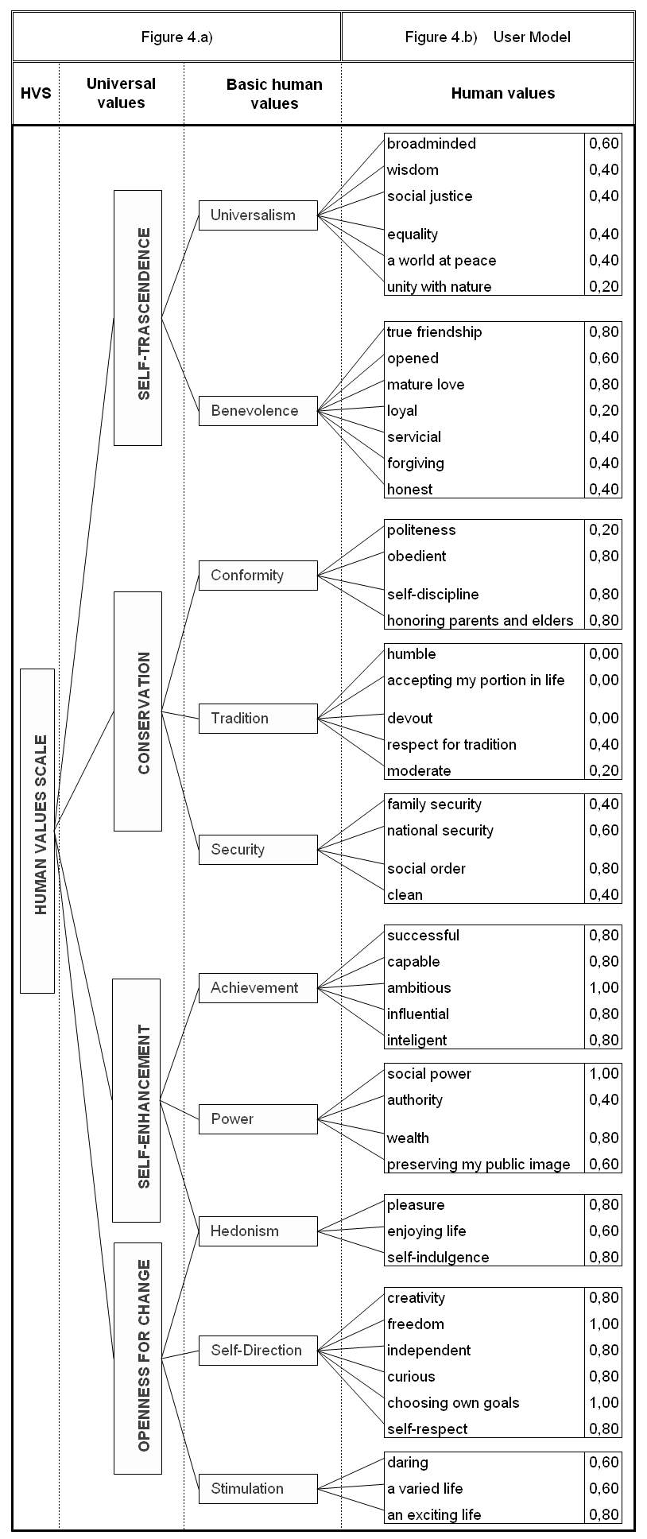

Figure 4: Parameters tree to classify the HVS
  - Description
Assume an intelligent agent A with a knowledge base (K, Δ) that contains information on the conditions under which Services Bank A, according to the HVS of their customers, offer a credit service to purchase a high technology hybrid vehicle.
To offer credit for this t ype of product, the bank conditions are that the customer:
- must have a high degree of openness to change;
- must have a high score in the values group of self-enhancement;
- because of the product/service offered, the level of conservatism must be less that 50%; and,
- the level of self-transcendence must be less than 50%.
In this study, we make the analysis using attributes from the customer Jordi Vilà. We refer to Figure 4.b, in which we represent the values for each of the items extracted from the UM to obtain the corresponding calculations.
  - Applying the methodology
- Following the methodology proposed by (Guzman, 2005), the general characteristics of the user are obtained through the UM that computes the user data for the bank's recommender system.
- According to (3), and as a result of applying the SVS, we obtain the following results.
$$\text{Vh}=\begin{aligned}\left\{\text{val}(\text{broad}\text{min}\text{ded},0\text{.}\text{60}),\text{val}(\text{Wisdom},0\text{.}\text{40}), | \right\}\end{aligned}\left\{\right\}$$
We calculate the users HVS from the UM.
Step 1: Applying equation 4, we obtain the 10 human values of the user as follows.

$${\text{Val}}_{\text{Num}}(\text{Universalism})=\begin{aligned}\frac{\text{val}(\text{broad}\text{min}\text{ded})+\text{val}(\text{wisdom})+\text{val}({\text{social}}_{\text{justice}})+\text{val}(\text{equality})+}{\text{val}(a_{{\text{world}}_{{\text{at}}_{\text{peace}}}})+\text{val}({\text{unity}}_{{\text{with}}_{\text{natura}}})}\end{aligned}6=\frac{2\text{.}\text{40}}{6}=0\text{.}\text{40}$$
In the same way we calculate the other human values:
${\text{Val}}_{\text{Num}}(\text{Benevolence})=0\text{.}\text{51}$;${\text{Val}}_{\text{Num}}(\text{Conformity})=0\text{.}\text{65}$; ${\text{Val}}_{\text{Num}}(\text{Tradition})=0\text{.}\text{12}$; ${\text{Val}}_{\text{Num}}(\text{Security})=0\text{.}\text{55}$; ${\text{Val}}_{\text{Num}}(\text{Achievement})=0\text{.}\text{84}$; ${\text{Val}}_{\text{Num}}(\text{Power})=0\text{.}\text{70}$; ${\text{Val}}_{\text{Num}}(\text{Hedonism})=0\text{.}\text{73}$; ${\text{Val}}_{\text{Num}}({\text{Self}}_{\text{direction}})=0\text{.}\text{87}$;
$${\text{Val}}_{\text{Num}}(\text{Stimulation})=0\text{.}\text{67}$$
Step 2: Using equation 5, we calculate the 4 groups which correspond to the universal values of the HVS

$${\text{Val}}_{\text{Num}}({\text{Self}}_{\text{trascendence}})=\frac{{\text{Val}}_{\text{Num}}(\text{Universalism})+{\text{Val}}_{\text{Num}}(\text{Benevolence})}{2}=\frac{0\text{.}\text{91}}{2}=0\text{.}\text{46}$$
Analogously we can compute the next 3 universal values, obtaining:
${\text{Val}}_{\text{Num}}(\text{Conservation})=0\text{.}\text{44}$; ${\text{Val}}_{\text{Num}}({\text{Self}}_{\text{Enhancement}})=0\text{.}\text{76}$; ${\text{Val}}_{\text{Num}}({\text{Openness}}_{{\text{to}}_{\text{change}}})=0\text{.}\text{76}$
Step 3: In this last step we calculate the user HVS using equation 6.

$$\text{Evh}=\begin{aligned}\frac{{\text{Val}}_{\text{Num}}({\text{Self}}_{\text{trascendence}})+{\text{Val}}_{\text{Num}}(\text{Conservation})+}{{\text{Val}}_{\text{Num}}({\text{Self}}_{\text{enhancement}})+{\text{Val}}_{\text{Num}}({\text{Openness}}_{{\text{to}}_{\text{change}}})}\end{aligned}4=\frac{0\text{.}\text{46}+0\text{.}\text{44}+0\text{.}\text{76}+0\text{.}\text{76}}{4}=\frac{2\text{.}\text{42}}{4}=0\text{.}\text{60}$$
Once obtained the HVS we can carry on with the recommendation process by using an approach with defeasible argumentation.
  - Alternative With Defeasible Argumentation
One solution to the problem is by using defeasible argumentation. Considering that the bank conditions for offering the credit service to Jordi Vilà affect the four main universal values groups directly, these will be considered in the recommender process.
    - First UserCase
If (K, Δ) is the knowledge base defined in 5.1 The group PredName(K, Δ) associated can be divided in the following way:
$\text{Pr}\text{edBase}\left(L\right)=\left\{\text{conservation},{\text{self}}_{\text{trascendence}}\right\}$; and, $\text{Pr}\text{edDeriv}\left(L\right)=\left\{{\text{openness}}_{{\text{to}}_{\text{change}}},{\text{self}}_{\text{enhancement}},{\text{offer}}_{\text{service}}\right\}$
Therefore, the logic defeasible argumentation is as follows:

$$\begin{aligned}Δ=\begin{aligned}\left\{{\text{Openness}}_{{\text{to}}_{\text{change}}}\left(x\right)∧{\text{Self}}_{\text{enhancement}}(x) | \right\}\left\{{\text{offer}}_{\text{service}}(x,y), | \right\}\left\{{\text{Openness}}_{{\text{to}}_{\text{change}}}\left(x\right)≻¬\text{Conservation}(x), | \right\}\end{aligned}\left\{\right\} \\ κ_{G}=\begin{aligned}\left\{\text{Conservation}(x)→¬{\text{Openness}}_{{\text{to}}_{\text{change}}}(x), | \right\}\end{aligned}\left\{\right\}\end{aligned}$$
Considering the universal values group from Jordi Vilà, we have:
The possible values to measure the grade or level of score from the universal values is given by:
$\left(8\right)$$$L_{n}:\text{nvalores}\left\{{0,1}/(n−1),2/(n−1),\text{.}\text{.}\text{.},(n−2)/(n−1),1\right\}$$
Therefore:
$$\begin{aligned}A(x)={\text{very}}_{\text{high}}\left(A_{I}\left(x\right)\right)=A_{i}\left(x\right)=1 \\ A\left(x\right)=\text{high}\left(A_{i}\left(x\right)\right)=A_{i}^{0\text{.}\text{75}}\left(x\right) \\ A\left(x\right)=\text{medium}\left(A_{i}\left(x\right)\right)=A_{i}^{0\text{.}\text{50}}\left(x\right) \\ A\left(x\right)=\text{low}\left(A_{i}\left(x\right)\right)=A_{i}^{0\text{.}\text{25}}\left(x\right) \\ A\left(x\right)={\text{very}}_{\text{low}}\left(A_{i}\left(x\right)\right)=A_{i}^{0}\left(x\right)=0\end{aligned}$$
Then,
$${\text{Openness}}_{{\text{to}}_{\text{change}}}\left({\text{Jordi}}_{\text{Vila}}\right))=0\text{.}\text{76}>0\text{.}\text{75}$$
$${\text{Self}}_{\text{Enhancement}}\left({\text{Jordi}}_{\text{Vila}}\right)=0\text{.}\text{76}>0\text{.}\text{75}$$
$$\text{Conservation}\left({\text{Jordi}}_{\text{Vila}}\right)=0\text{.}\text{44}<0\text{.}\text{50}$$
$${\text{Self}}_{\text{trascendence}}\left({\text{Jordi}}_{\text{Vila}}\right)=0\text{.}\text{46}<0\text{.}\text{50}$$
Note that in all four groups, conditions for the bank to offer the service to the user Jordi Vilà are fulfilled. Therefore the system recommends sending the brochure and all the details regarding the credit service to this distinguished customer.
    - Second User Case
Suppose that for the same problem, we have the HVS from the user Montse Rovira, which data are the following:
${\text{Openness}}_{{\text{to}}_{\text{change}}}\left({\text{Montse}}_{\text{Rovira}}\right))=0\text{.}\text{77}>0\text{.}\text{75}$;${\text{Self}}_{\text{Enhancement}}\left({\text{Montse}}_{\text{Rovira}}\right)=0\text{.}\text{75}=0\text{.}\text{75}$;$\text{Conservation}\left({\text{Montse}}_{\text{Rovira}}\right)=0\text{.}\text{52}>0\text{.}\text{50}$; ${\text{Self}}_{\text{trascendence}}\left({\text{Montse}}_{\text{Rovira}}\right)=0\text{.}\text{48}<0\text{.}\text{50}$
In this case, according to the logic defeasible argumentation, the argument:
$A_{1}=\left\{{\text{Self}}_{\text{trascendence}}(x)→¬{\text{Self}}_{\text{enhancement}}(x)\right\}$
contraargument to: $A_{1}=\left\{{\text{Openness}}_{{\text{to}}_{\text{change}}}\left(x\right)∧{\text{Self}}_{\text{enhancement}}(x)≻{\text{offer}}_{\text{service}}(x,y)\right\}$
therefore the system recommend to the bank not to offer the credit service to the user Montse Rovira.
- Conclusions And Future Work
In this paper, we show a methodology based on defeasible argumentation to organizational recommender systems based on the user's HVS. This HVS is obtained directly from the user model.
Through the proposed methodology, it is possible to calculate the HVS from the user model without disturbing the user with surveys.
The preliminary results obtained from the illustration, in section 5, on banking services show that the HVS of the users is important to improve the recommender processes in the organization.
In future, we will work on the implementation of this methodology to test it using machine-learning techniques to obtain better recommendations in multiple areas. It is intended to extend the use of defeasible argumentation to obtain diverse techniques to improve the user's decision making.
- Acknowledgements
This work was supported through Autonomous University of Tamaulipas; in part, by the Grant TIN2006-15111/Estudio sobre Arquitecturas de Cooperación from the Spanish government and by EU project Nž 34744 ONE: Open Negotiation Environment, FP6-2005-IST-5, ICT-for Networked Businesses.
Referencias
Burke, R. (2002). “Hybrid recommender systems: Survey and experiments”, User Modeling and User-Adapted Interaction, 12(4).
Chesñevar, C. and Maguitman, A. (2004). “ARGUENET: An Argument-Based Recommender System for Solving Web Search Queries”, IEEE Conference on Intelligent Systems, Varna, Bulgaria.
Chesñevar, C.I., Dix, J., Stolzenburg, F. and Simari, G.R. (2003). “Relating Defeasible and Normal Logic Programming through Transformation Properties”, Theoretical Computer Science, 290(1).
González, G., López, B. and de la Rosa, J. L. (2005). “A Multi-agent Smart User Model for Cross-domain Recommender Systems”, Proceedings of Beyond Personalization 2005: The Next Stage of Recommender Systems Research, International Conference on Intelligent User Interfaces IUI'05, San Diego, California, USA.
Gouveia, V.V., Clemente, M. and Vidal, M.A. (1998). “El cuestionario de valores de Schwartz (CVS): propuesta de adaptación en el formato de respuesta”, Revista de Psicología Social, (15)3.
Guzmán, J. (2005).“Research Work Report: Methodology to obtain the user's Human Values Scale from Smart User Models”, Department of Electronics, Computer Science and Automatic Control University of Girona, http://eia.udg.es/~jguzmano/PublicacionesJGO.htm/Research Work-JGO, Spain.
Guzmán, J., González, G., de la Rosa, J. L. and Castán, J.A. (2005) “Modelling the Human Values Scale in Recommender Systems: A First Approach”, Frontiers in Artificial Intelligence and Applications Series Book, Volume: 131, IOS Press, ISBN 1-58603-6, Amsterdam, The Netherlands.
Carter, J. and A. Ghorbani A. (2004). “Value Centric Trust in Multiagent Systems”, Faculty of Computer Science. University of New Brunswick Fredericton, NB, E3B 5A3, Canada.
Jensen, T. (2002). “New Consumers and New Communities in Consumption”.
Kobsa, A. (2001). “Generic User Modeling Systems”, User Modelling and User-Adapted Interaction, Kluwer Academic Publishers, Netherlands.
Ravlin, E.C. and Meglino, B.M. (1987). “Effect of values on perception and decision making: A study of alternative work values Measure”, Journal of Applied Psychology.
Schwartz, S.H. (1999). “A theory of cultural values and some implications for work”, Applied Psychology: An International Review.
Schwartz, S.H. (2003). “A Proposal for Measuring Value Orientations across Nations”, The Hebrew University of Jerusalem, Jerusalem.

Authorization and Disclaimer
Authors authorize LACCEI to publish the paper in the conference proceedings. Neither LACCEI nor the editors are responsible either for the content or for the implications of what is expressed in the paper.

