Fifth LACCEI International Latin American and Caribbean Conference for Engineering and Technology (LACCEI’2007)
“Developing Entrepreneurial Engineers for the Sustainable Growth of Latin America and the Caribbean:
Education, Innovation, Technology and Practice”
29 May – 1 June 2007, Tampico, México.

Development of Real Time Simulation Models of Solid Oxide Fuel Cells for use in Hardware-in-the-Loop Systems

Denver F. Cheddie
Florida International University, Miami, Fl, USA, dcheddie@yahoo.com

Norman D. H. Munroe
Florida International University, Miami, Fl, USA, munroen@fiu.edu

Abstract
A dynamic model of a solid oxide fuel cell (SOFC) is presented. This one-dimensional model is based on the transport and electrochemical phenomena occuring inside the cell. The model is designed for rapid computations, thus enabling its implementation in real time simulation systems, such as hardware-in-the-loop (HIL) envirnoments. It was determined that a 1D model utilizing 21 computational nodes gives the best balance between computational speed and accuracy. This model is able to predict the transient thermal and voltage response of the fuel cell to changes in load current. At a base cell current of 340 A, a steady state cell voltage of 0. 7483 V is predicted. The steady state channel temperature increases are predicted to be 70 K at the anode and 90 K at the cathode. Based on the thermal inertia of the cell, steady state conditions are reached in approximately 10 minutes.
Keywords: Real time, HIL, SOFC, simulation
- Introduction
The concept of a hydrogen economy has generated tremendous interest in recent years. A hydrogen economy is one where hydrogen is the main energy vector. There are various reasons for this interest. Firstly, the emission of green house gases from hydrogen systems is considerably less than fossil fuel combustion, and thus hydrogen energy is less deleterious to the environment. Secondly, the USA is seeking to achieve energy independence from Middle Eastern oil. Thus politics is also a major driving force toward a hydrogen economy.
Because of the renewed interest in hydrogen energy, fuel cell technology has emerged as a major power source of the future. Fuel cells are electrochemical devices which convert the potential energy resident in a fuel and oxidant to electrical energy without direct combustion. If hydrogen and oxygen are used as fuel and oxidant respectively, then the only emissions would be water and heat. If hydrocarbons are used as fuels, then there will be emission of carbon dioxide during the reformation process, but this emission is still less than combustion processes.
Solid oxide fuel cells (SOFC) are particularly attractive for stand alone power generation or co-generation. SOFCs operate at high temperatures (600-1000 ⁰C), therefore produce useful heat as well as electrical power. Because of the high temperature, SOFCs can be used in conjunction with other power systems. Figure 1 shows a schematic of a SOFC – gas turbine hybrid power plant. The SOFC works together with a regular gas turbine to produce additional electrical power and heat. Such systems are very useful for stand alone power generation.
Fuel cell modeling and simulation are important tools in the development of fuel cell technology. Effective and comprehensive modeling can preclude the high costs of prototype development and testing. It can also save time and expedite research and development. The hardware-in-the-loop (HIL) concept is used to investigate the feasibility of various power generating systems involving fuel cells. HIL systems involve a fuel cell model, operating in real time, fully interacting with real components of a power plant. Figure 2 shows a schematic of a HIL setup for the SOFC – gas turbine hybrid shown in Figure 1. Such a system is advantageous because it avoids the need for having an actual SOFC. It can test the feasibility of the hybrid power generating concept with actually having the fuel cell, thus avoiding the cost of development and prototyping.
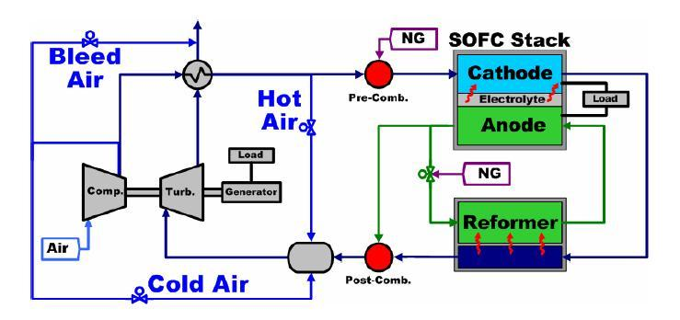

Figure 1: Schematic of a SOFC – Gas Turbine Hybrid Power Plant

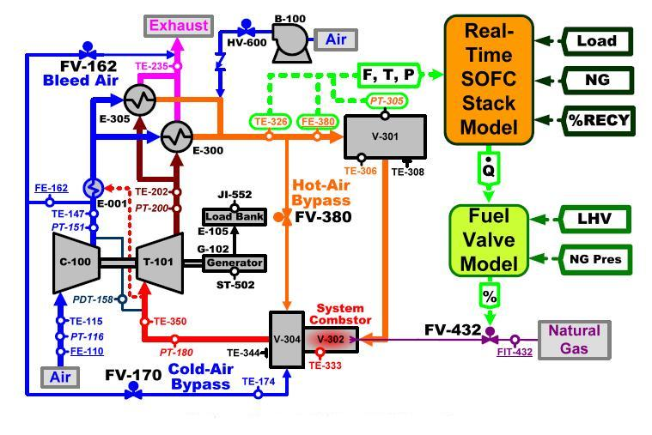

Figure 2: Hardware-in-the-Loop Schematic

However, it is essential that the fuel cell model be accurate and fast. It must accurately simulate the fuel cell behavior to properly interact with the other components. And it must do so quickly enough to operate in real time. Depending on the setting, the compressor valve in the turbine system may open and close every 5 milliseconds. So it is imperative that the fuel cell model perform time dependent computations in less time than 5 ms.
The Applied Research Center (ARC) of Florida International University (FIU) is working together with the US Department of Energy (DOE) National Energy Technology Center (NETL) in Morgantown, WV to improve the fidelity of their SOFC models. The NETL is investigating a SOFC – gas turbine hybrid power plant, by utilizing the HIL concept. Their present fuel cell models operate in zero dimensions (0D) using lumped system domains. Such models apply the governing differential equations over lumped domains, and hence determine transient input/output behavior. Because of their simplicity, they perform rapid computations. Unfortunately, because of their simplicity, those computations are of low fidelity or low accuracy. FIU is seeking to improve the fidelity of their systems by developing 1D SOFC models.
1D models divide the fuel cell domains into numerous control volumes, depending on the number of computational nodes used. As such, they improve the accuracy of computations, especially those involving temperature variations within the cell. Figure 3 shows the mass and energy balance across one nodal control volume. The problem with 1D models is that they require longer computational times than 0D models. The goal of the present work is to develop a 1D dynamic (transient) model of an SOFC, which is capable of performing time dependent computations, is less than 5 ms, thus enabling their utilization in real time HIL systems.

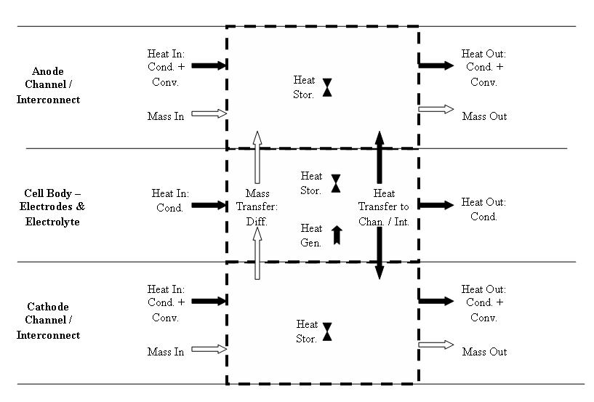

Figure 3: Control Volume Heat and Mass Balance

- MODEL DEVELOPMENT
The present model entails air (oxygen and nitrogen) flowing in the cathode, and reformed hydrogen (hydrogen, carbon dioxide and water vapor) flowing the in the anode. The anode gases enter the cell at 1100 K and atmospheric pressure, while the cathode gases enter at 1073 K and atmospheric pressure. The nitrogen and carbon dioxide are electrochemically inert. Oxygen dissociates into oxygen ions and electrons, while hydrogen gas reacts with those ions to produce water. The flow of electrons results in an electrical current, while the electrode potential difference provides the cell voltage. Equations 1 and 2 show the half cell reactions occurring at the anode and cathode respectively.
$2H_{2}+2O^{2−}→4e^{−}+2H_{2}O$ (1)
$O_{2}+4e^{−}→2O^{2−}$ (2)
The reversible cell potential can be computed from the temperature and partial pressure of the reactant gases.
$E=E_{0}+\frac{RT}{2F}\text{ln}\left(\frac{P_{H_{2}}P_{O_{2}}^{0\text{.}5}}{P_{H_{2}O}P_{\text{atm}}^{0\text{.}5}}\right)$ (3)
$E_{0}=1\text{.}\text{2877}−\left(2\text{.}\text{904}x{\text{10}}^{−4}\right)T$ (4)
The voltage drops or overpotentials can be determined based on the ohmic resistance of the various cell components and the activity of the electrodes (Aguiar et al, 2005).
$η_{\text{act}}^{\text{an}}=\frac{RT}{F}\left[{\text{sinh}}^{−1}\left(\frac{i}{2i_{0}\left\{\frac{P_{H_{2}}}{P_{H_{2}}^{\text{ref}}}\frac{P_{H_{2}O}}{P_{H_{2}O}^{\text{ref}}}\right\}}\right)−\frac{1}{2}\text{ln}\left(\frac{P_{H_{2}}P_{H_{2}}^{\text{ref}}}{P_{H_{2}O}P_{H_{2}O}^{\text{ref}}}\right)\right]$ (5)
$η_{\text{act}}^{\text{ca}}=\frac{RT}{F}\left[{\text{sinh}}^{−1}\left(\frac{i}{2i_{0}}\right)\right]$ (6)
$η_{\text{ohm}}=i\left[\left(6\text{.}\text{78}x{\text{10}}^{−\text{10}}\right)\text{exp}\left(\frac{\text{10}\text{.}3x{\text{10}}^{3}}{T}\right)+\left(0\text{.}\text{23174}\right)\text{exp}\left(−0\text{.}\text{0115}T\right)\right]$ (7)
The actual cell voltage is equal to the reversible cell potential less the overpotentials.
The governing equations of mass, species, momentum and energy transport are shown below.
$\frac{∂\left(ρu\right)}{∂x}=−\frac{∂ρ}{∂t}+\frac{\sum{{\overset{o}{m}}_{i}}}{A_{\text{ch}}L_{\text{cell}}}$ (8)
$\frac{∂P}{∂x}=−\frac{∂\left(ρu\right)}{∂t}+\frac{∂\left({ρu}^{2}\right)}{∂x}+\frac{\sum{{\overset{o}{m}}_{i}}u}{A_{\text{ch}}L_{\text{cell}}}−4⋅\frac{f\text{Re}}{2}⋅\frac{{μN}_{\text{ch}}}{A_{\text{ch}}}u$ (9)
${\left({ρc}_{p}\right)}_{\text{int}}\frac{∂T_{\text{int}}}{∂t}=−\frac{∂\left({ρucT}_{\text{int}}\right)}{∂x}⋅\frac{A_{\text{ch}}}{A_{\text{int}}}+k_{\text{int}}\frac{∂^{2}T_{\text{int}}}{∂x^{2}}+\frac{\sum{{\overset{o}{m}}_{i}c_{i}T_{\text{int}}}+H\left(T_{\text{pen}}−T_{\text{int}}\right)}{A_{\text{int}}L_{\text{cell}}}$ (10)
${\left({ρc}_{p}\right)}_{\text{pen}}\frac{∂T_{\text{pen}}}{∂t}=k_{\text{pen}}\frac{∂^{2}T_{\text{pen}}}{∂x^{2}}+\frac{\sum{{\overset{o}{m}}_{i}c_{i}T_{\text{pen}}}+Q_{\text{gen}}−H\left(T_{\text{pen}}−T_{\text{int}}\right)}{A_{\text{pen}}L_{\text{cell}}}$ (11)
$ρ\frac{∂ω_{i}}{∂t}=−\frac{∂\left({ρuω}_{i}\right)}{∂x}D_{i}\frac{∂^{2}\left({ρω}_{i}\right)}{∂x^{2}}+\frac{{\overset{o}{m}}_{i}}{A_{\text{ch}}L_{\text{cell}}}$ (12)
The governing equations are applied over the control volume shown in Figure 3. The time dependent differential equations are then solved in Matlab/Simulink using a 4th order Runge-Kutta method. All other numerical values, constants and cell dimensions are the same as those in Liese et al (2006).
- Results and discussion
The number of nodes used in the model must be chosen to achieve the best balance between speed and accuracy. Figure 4 shows the steady state cell voltage at a cell current of 340 A for various number of nodes. It is found that for this problem, steady state conditions are achieved within 600 seconds. Figure 5 shows the variation of steady state outlet temperatures as the number of nodes increase. Figure 6 shows the computational time required to perform each computation.
These figures show that as the number of computational nodes increases, the accuracy of the results improve. The temperature increases across the cell from inlet to outlet because the gas streams pick up heat, which is generated in the cell. This temperature increase however is overestimated when a small number of nodes is used. As the number of nodes increases, there is a leveling of off the outlet temperatures. The same thing is true of the cell voltage. Figure 6 shows that the computational time increases as the number of nodes increases, as expected. As the number of nodes increases, the model is required to perform more computations.
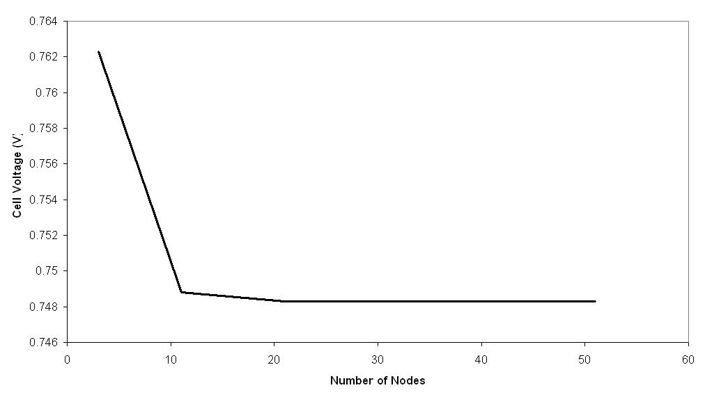

Figure 4: Steady State Cell Voltage vs. Number of Nodes

So the number of nodes must be chosen to achieve the best balance between speed and accuracy. It can be seen that the improvement in accuracy from 3 nodes to 21 nodes is great, whereas the improvement from 21 nodes to 51 nodes is minimal. Essentially the accuracy does not improve much above 21 nodes. However, the computational time continues to increase. 21 nodes require 3.5 ms of computational time for each time iteration, while 51 nodes require 13.8 ms. Since 5 ms is the critical time value, a model using 51 nodes cannot be used for real time systems. The model with 21 nodes is clearly the best choice. Its accuracy is not much different from the 51 node model, but its time requirements are much less. The remainder of the results will be based on the 21 node model.
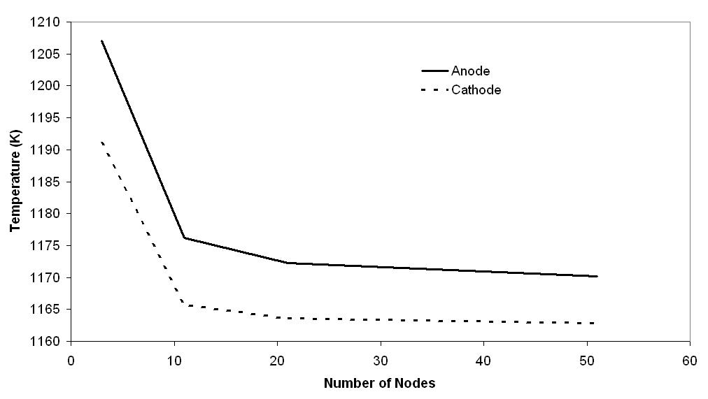

Figure 5: Steady State Outlet Channel Temperatures vs. Number of Nodes

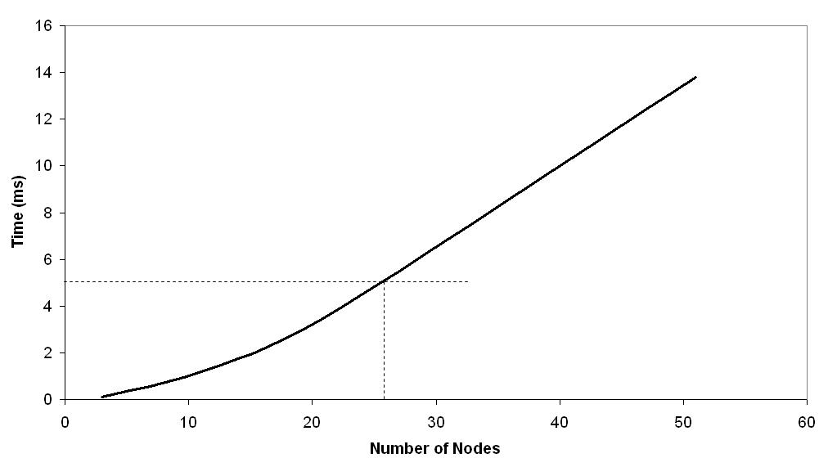

Figure 6: Computational Time vs. Number of Nodes

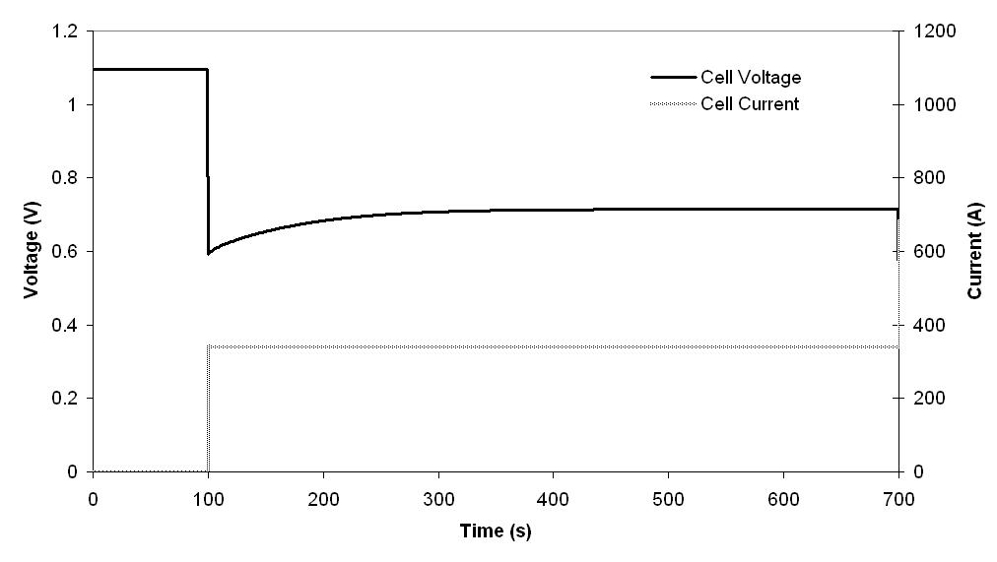

Figure 7: Transient Voltage Response

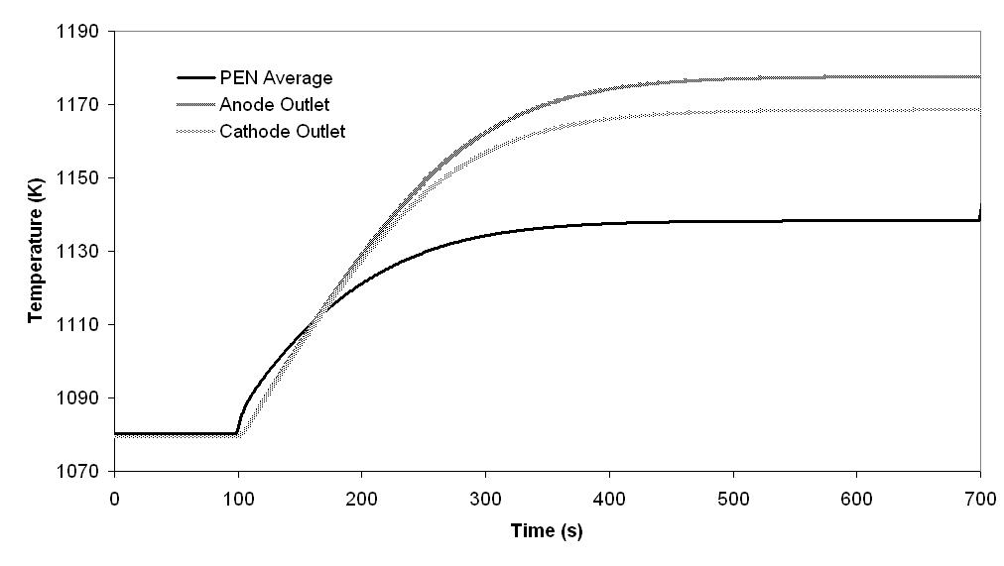

Figure 8: Transient Thermal Response

Figure 7 shows the transient voltage response when the current increases from 0 A to 340 A at time = 100 seconds. In fuel cells, the voltage decreases as the current increases. Figure 7 shows an instantaneous decrease in voltage when the current changes. However, over time the voltage slowly increases and levels off at 0.7483 V.
Figure 8 shows the corresponding plot for anode and cathode outlet temperature and average PEN temperature. It shows that the temperatures gradually increase to their steady state values. At 340 A, there is more heat being generated in the cell than at 0 A, hence the increase in all the temperature values. As the PEN temperature increases, the reversible cell voltage increases, while the ohmic and activation overpotential decrease. Both of these contribute to the increase in cell voltage over time following the instantaneous drop (Figure 7). It is also seen that steady state conditions are only reached after nearly 10 minutes, due to the high thermal inertia of the system.
- Conclusions
A one-dimensional model was developed for a SOFC, which is designed for use in HIL systems. It is found that employing 21 computational nodes allows for high accuracy and fast computational times (3.5 ms). This model can be used for real time simulation of SOFC, while improving the fidelity over existing lumped-parameter models. The present model is able to predict the transient voltage and thermal response to changes in load current. As such it can effectively interact with real components in a HIL system.
- Acknowledgments
The authors would like to express their gratitude for the support from the NSF CREST Supplement Grant (Award No. HRD-0317692) in conducting this work.
- Nomenclature
Arabic Symbols
A Area
cp Specific heat capacity
F Faraday constant
f Friction factor
H Heat transfer co-efficient
k Thermal conductivity
m Mass flow rate
N Number
P Pressure
Q Heat
R Universal gas constant
Re Reynolds number
T Temperature
t Time
u Velocity
x Displacement in the direction of the gas channel
Greek Symbols
μ Dynamic viscosity
ρ Density
ω Mass fraction
Subscripts and Superscripts
0 Reference state
act Activation
an Anode
atm Atmospheric
ca Cathode
ch Channel
gen Generated
i Species
int Interconnect
ohm Ohmic
pen Positive-electrolyte-negative
References
Aguiar, P., Adjiman, C.S., and Brandon, N.P. (2005). “Anode-Supported Intermediate-Temperature Direct Internal Reforming Solid Oxide Fuel Cell II. Model-Based Dynamic Performance and Control”. Journal of Power Sources, Vol. 147, No. 1, pp 136-147.
Liese, E.A., Gemmen, R.S., Smith, T.P., and Haynes, C.L. (2006). “A Dynamic Bulk SOFC Model Used in a Hybrid Turbine Controls Test Facility”. GT2006-90383, Barcelona, Spain.

Authorization and Disclaimer
Authors authorize LACCEI to publish the paper in the conference proceedings. Neither LACCEI nor the editors are responsible either for the content or for the implications of what is expressed in the paper.

