Fifth LACCEI International Latin American and Caribbean Conference for Engineering and Technology (LACCEI’2007)
“Developing Entrepreneurial Engineers for the Sustainable Growth of Latin America and the Caribbean:
Education, Innovation, Technology and Practice”
29 May – 1 June 2007, Tampico, México.

A knowledge base system for the oxidation cyanide process of industrial wastewater treatment.

G. Tapia Trejo
Centro de Investigación en Ciencia Aplicada y Tecnología Avanzada Unidad Altamira del instituto Politécnico Nacional. Km 14.5 Carretera Tampico-Puerto Industrial CP 89600 Altamira Tam. MEXICO. Tel. 00 (52) 833 2 60 0124 Fax. 00 (52) 833 2600124. e-mail: gtapia@ipn.mx

J. Bourgois
Ecole Nationale Supérieure de Mines de Saint Etienne. 158 Cours Fauriel. F-42023 Saint Etienne Cedex 2 (France) FRANCE.

F. Carrillo Romo
Centro de Investigación en Ciencia Aplicada y Tecnología Avanzada Unidad Altamira del Instituto Politécnico Nacional. Km 14.5 Carretera Tampico-Puerto Industrial CP 89600 Altamira Tam. MEXICO.

Abstract.
A dynamic mathematical model was developed to predict the cyanide concentration of effluent in the wastewater treatment. These tools will be utilized for engineers and operators involved in control, supervision and decision making during operation of treatment plants in real time supervision.
The aim of this work is to develop performance decision making help tools, so as to improve the operating conditions of treatment (security, reliability, efficiency). The model has been tested and evaluated with the real data collected in the wastewater plant.
The quantitative process models are based on the classical physical-chemical theory. The operators’ experience and know-how are being formulated and implemented within a real-time knowledge-based system.
Keywords: Modeling; dynamic system; Wastewater treatment; cyanide, sodium hypochlorite, decision support systems, control process, metal finishing, simulation and supervision

Introduction.
In order to retain or increase their market share chemical process industries, which face increasing pressure from environmental and safety regulations as well as growing demands on product quality and availability, have to continuously improve process operation and existing chemical processes. Further, new processes need to be developed. Time and cost constraints force these industries to reduce their experimental effort during process development and to facilitate, even routinize, the application of model-based process technology such as model-based production planning and scheduling, or model-based process optimization and control.
Despite the commercially available modeling tools, the effort spent for all kinds of modeling activities is the most time consuming step in all industrial project where mode-based process engineering techniques are applied. It has been pointed out by practitioners recently (Laganier 1996) that this comparative high effort prevents the application of state of the art model-based technology in many industrial projects.

A knowledge based system.
The most common definition of KBS is human-centered. This highlights the fact that KBS have their roots in the field of artificial intelligence (AI) and that they are attempts to understand and initiate human knowledge in computer systems (Wiig, 1994). The four main components of KBS are usually distinguished as: a knowledge base, an inference engine, a knowledge engineering tool, and a specific user interface (Dhaliwal & Benbasat, 1996). On the other hand, the term KBS includes all the organizational information technology applications that may prove helpful to manage the knowledge assets of an process, such as ESs, rulebased systems, groupware, and database management systems (DBMS) (Laudon & Laudon, 2002).
Some of these applications which are implemented by knowledge-based systems include the following applications : medical treatment, personal finance planning, engineering failure analysis, waste management, production management, thermal engineering, decision support, knowledge management, knowledge representation, power electronics design, framed buildings evaluation, financial analysis, chemical incident management, automatic, tumor segmentation, business game, climate forecasting, agricultural management, steel composition design, strategic management, environmental protection, wastewater treatment, decision making and learning, isokinetics interpretation, chemical process controlling, therapy planning, plant process control, outage locating planning, concurrent system design, case validation, chip design, agriculture planning, power transmission protection, crop production planning, tropospheric chemistry modeling, planar robots, and urban design.
In this work is development a chemical models of the process of decyanidation with H₂O₂ have been implemented in MatlabTM . They are based on the classical theory of chemistry and physics as well as on the analysis of the real data, acquired on-site.
Other approach of this work is the Expert systems (ES). The basic idea behind ES is simply that expertise, which is the vast body of task-specific knowledge, is transferred from a human to a computer. This knowledge is then stored in the computer and users call upon the computer for specific advice as needed. The computer can make inferences and arrive at a specific conclusion. Then like a human consultant, it gives advices and explains, if necessary, the logic behind the advice (Turban & Aronson, 2001). ES provide powerful and flexible means for obtaining solutions to a variety of problems that often cannot be dealt with by other, more traditional and orthodox methods. Thus, their use is proliferating to many sectors of our social and technological life, where their applications are proving to be critical in the process of decision support and problem solving. The real-time knowledge-based system implements the operators’ experience and know-how.
Based on the scope of ES applications, the work of S.-H. Liao (S.-H. Liao, 2005) analyze and classifies ES methodologies using eleven categories:
- rule-based systems,
- knowledge-based systems,
- neural networks,
- fuzzy ESs,
- object-oriented methodology,
- case-based reasoning (CBR),
- system architecture development,
- intelligent agent (IA) systems,
- modeling,
- ontology, and
- database methodology
The integration of methodologies for the progress of ES is an interdisciplinary research topic. Thus, future ES developments need integration with different methodologies, and this integration of methodologies and cross-interdisciplinary research may offer more technologies to investigate ES problems. “The Change” is a source of future ES development. The change due to social and technical reasons may also permit or inhibit ES methodologies and application development (.Shu-Hsien Liao, 2005).

The wastewater treatment process in the metal finishing industry.
The metal finishing industries generate a great amount of waste of high toxicity, this amount represent 95 % of polluting agents generated by the industry in the last years. The polluting agents are mainly: heavy metals (Pb ²⁺ Al³⁺, Cu²⁺, Ni²⁺, Zn²⁺, Cr^{III}, Cr^{VI}, etc.) the cyanides (NaCN, KCN) and organic compounds (phenols, alcohol and cyclic-organic compounds).
Under pressure of the new European and international standards a well as the growing public concern about the environmental issues the metal finishing industry is leading an effort to conduct an analysis for innovation of ideas such as environmental insurance and technology verification.
To control waste disposal costs, metal finishers have to focus on developing and implementing a facility-wide waste reduction (Szafnicki et al., 1998; Flachon, 1998). In other words, metal finishers must consciously seek out ways to decrease the volume of waste they generate.
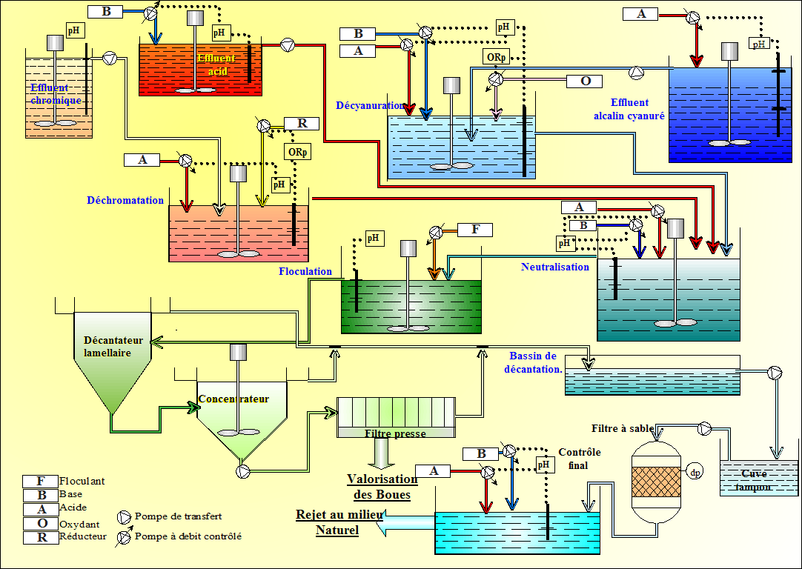
One approach to waste reduction is to recover process materials for reuse (Office of Waste Reduction Services Environmental Services Division State of Michigan, 1995). Also the toxicity compounds used in metal finishing process can be recovered or destroyed using available technologies. For example, cyanides and heavy metals are eliminated during the oxidation (decyanidation) and precipitation stages respectively, Fig. 1.
Fig. 1. Schema of the typical wastewater treatment in the metal finishing industry.
The classical treatment process of wastewaters issued from e.g. the metal finishing industry consists of the following main stages: the cyanide oxidation (decyanidation), the neutralization (pH control), the chromium removal, the flocculation, the precipitation (e.g. of metal hydroxides), the decanting of treated liquids, the filtration, the final control of water and the treatment of the sludge. The paper focuses on the one stages of chemical treatment: the decyanidation. The description of this stage is dealt with in the following sections. The development of the knowledge-based system models is detailed next. Finally the conclusion presents a comparison between of the real and simulated data. The perspectives for the application project are mentioned.

Methodology for the modeling of the wastewater industrial treatment.
One important means to overcome this modeling bottleneck is the development of more advanced computer-based tools supporting the modeling process which can be viewed as a sequence of activities like model generation, validation, documentation, or application. There is significant research activity in various groups aiming at the development of novel computer tools, the reviews of Marquardt (Marquardt, 1996), and Pantelides and Britt (Pantenlides 1994) for one overview, but as long as a detailed under standing of the process of model development in industrial productivity is missing the productivity of modeling engineers and the quality of models will not be improved sufficiently by more advanced modeling tools.
Many models have been proposed for predicting the cyanide concentration in effluent quality of stabilization ponds. Completely mixed reactor with pseudo first-order reaction approach has been frequently used for design and modeling purposes, this is the case of present work. Most of the empirical models were developed for predicting the effluent quality of stabilization ponds based on BOD (Mayo, 1989; Ellis and Rodriguez, 1995, 1995b; Sperling, 1999; Kayombo et al., 2002). Some ecological models were developed to predict the behavior of the stabilization ponds (Ferrara and Harleman, 1980; Moreno Grau et al., 1996; Kayombo et al., 2000; Mashauri and Kayombo, 2001). We worked with le model of decyanidation process with H₂O_{2.} This model is structured in base on conservation principles, reaction stoichiometry and physicochemical laws.
Advanced modeling tools should provide some simple means of supporting the modeling process in the sense of the last step for the section. As a general guideline for tool development, no strict control flow can be imposed on the modeler. The tool must offer the flexibility to the modeler to focus on whatever issue it is interested in at a certain time. The modeler must have access to the functionality it needs at a given step. The information entered into the system during a particular modeling step must be propagated in the system to be used in other modeling steps at a later time regardless the sequence these modeling steps are carried out. As an example, information from a conceptual modeling tool must be transferred to the documentation tool and vice versa. The methodology of definition and development model is presented to follows paragraphs.

Storing and retrieving of data.
All the data collected and the decisions taken during the formulation of the functional specification should be stored for retrieval at later stages of the modeling process. We realized during long time many formation stages in the plant. In these seasons they were to recover data of 1999 (three months) and 2000 and 2001 (Integral data of year).

. Model base for structured model representation.
The model structure is constituted of various blocks of physico-chemical process. Governing equations with underlying assumptions and typical use cases (parameter values, examples, etc.) should be included. Support for continuous updating and improvement of the modeling concepts would be appreciated.

Integration of data driven and first principles based modeling.
There is an incentive to integrate mechanistic and empirical modeling since this enables the modeler to use process knowledge and informative process data efficiently. There is a support for adapting such models in today’s tools. Methods and tools for data handling, time series analysis, data filtering, parameter estimation and model structure discrimination were made

Validation.
Model validation is closely related to empirical, identification based modeling techniques. Methodologies for validation of complex nonlinear (dynamic) models need to be developed and appropriate tool functionality must be provided. It should to include informal knowledge provided by plant operators.
To eliminate the influence of disturbs, to assure the stability and/or to optimize the process is possible if to conceive a mechanism to accomplish the aspects, this knowing quantitative of the process. The capacity to know quantitatively a process is developed during the process modeled.
The models can be of varied types, each one associated to an functional purpose. Each model type solves different problems. In the control of process request conceptual and mathematical models. In general, the mathematical models are built, of preference, based on a conceptual proven model and reliable. In particular, we will appeal to laws of the matter and dynamic conservation bilans.
The purpose of this work is to contribute to optimize the destruction of cyanide in the wastewater of the metal finishing industry because the cyanide is extremely toxic for the man, nevertheless the cyanides is used in the metal finishing industries, such as the sodium and potassium cyanides, have been a key component of plating solution for many years (Agency for Toxic Substances and Disease Registry, 1989), particularly in plating copper, zinc and other metals. Also cyanide is an excellent complexer and has a wide tolerance for the impurities and variations in bath compositions (NEWMOA, 1999). Nerveless the formation of hydrogen cyanide have the greats possibilities the HCN is a colorless gas or liquid with a faint, bitter almond odor. Sodium cyanide and potassium cyanide are both colorless solids that have a slight odor of bitter almonds in damp air. All these substances are highly toxic.

The principal physico-chemicals considerations of decyanidation model with H₂O₂.
The current cyanide waste treatment implies converting free cyanide species into less toxic cyanates or even into nitrogen and carbon dioxide, leaving behind the complex cyanides in sludge, which then must be treated further. One of the main ways of decyanidation is the oxidation with hydrogen peroxide (H₂O₂). In this stage the cyanides are transformed to species less toxic and/or destroyed totally or partially by oxidization.
The Peroxides are widely used throughout industry for the safe and effective treatment of cyanide in process and waste waters. Under alkaline conditions cyanide is efficiently oxidized to the, much less toxic, cyanate by peroxides, for example with hydrogen peroxide. Hydrogen peroxide is a powerful oxidizing agent (oxidation potential 1.77 V). Chemical oxidation of the dissolved organics and inorganics present in industrial effluents and concentrated aqueous streams by H₂O₂ is a technique that has been applied to a broad spectrum of organic and inorganic compounds. Hydrogen peroxide is regarded as an isomer of following two structures
Structure (II) represents hydrogen peroxide as a molecule of water linked to an oxygen atom by a co-ordinate linkage. Being a very weak acid, hydrogen peroxide ionizes in alkaline solution and liberates molecular oxygen in the presence of trace of alkali. Due to this decomposition of hydrogen peroxide in alkaline solution, smaller amount of HOO⁻ are available in reaction mixture (De et al 1999).
Experiments were conducted with different doses of H₂O₂, i.e. 44.1, 88.2 and 132.3mM at pH 10.0 at standard room temperature. It was seen that oxidation by H₂O₂ alone was very slow, 90% degradation of CN⁻ occurred in 24 h by 88.2mM H₂O₂. An increase in the hydrogen peroxide concentration results in the increased availability of the HOO− in solution thereby increasing the rate of oxidation of cyanide compound. De et al. (De et al 1999) have reported similar results for the oxidation of phenolic compounds. Cyanate and ammonia were detected as intermediate products, which suggests that cyanide is first oxidized to cyanate, which further oxidized to ammonium and carbonate ions as follows:
CN⁻ + H₂O₂ → CNO⁻ + H₂O (1)
The cyanate formed during oxidation of cyanide undergoes hydrolysis to carbonate and ammonia [Roques 1990].
CNO⁻+ 2H₂O → CO₂ +NH₃ +OH⁻ (2)
CNO⁻+H₂O+OH⁻ → CO₃⁼ +NH₃ (3)
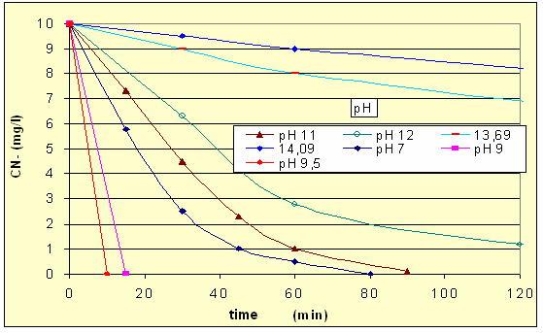
Peroxide treated waste waters can usually be safely discharged following ammonia removal if necessary eg. via ammonia recovery or biological nitrification. Knorre and Griffiths (Knorre and Griffiths, 1984) also used hydrogen peroxide for removal of cyanide and reported that product formation depends upon the amount of hydrogen peroxide used.
The kinetics of reactions (1) and (2) was studied and found to be pseudo-first-order reaction (Sarla, 2004). Oxidation of cyanide to cyanate is kinetically slow when the cyanide ions are associated with alkaline cations such as sodium and potassium, faster for zinc and cadmium complexes and very fast for copper cyanide complexes. Copper formed a complex with cyanide ion, i.e. tetracyanocuprate which had greater affinity for H₂O₂. Cyanate hydrolysis was also favored by copper ions as Cu²⁺ ion concentration was increased, rate of degradation also increased. The latter effect is the reason copper salts are employed for cyanide oxidation.
The effect of pH (fig. 2) was studied by varying the pH of the solution from 7.0 to 14.0. In alkaline pH, cyanide is present as CN⁻ ions, so it reacts easily with H2O2 and Cu²⁺ ions. In acidic pH, cyanide is present mainly as HCN gas which is very difficult to oxidize. Moreover, HCN is highly toxic and volatile. So cyanide treatment should be carried out in alkaline pH. The reaction (2) is favorable at pH lower than 7 at room temperature. Ammonium ion is toxic which can be discharged by nitrification. Hydrogen peroxide dissociates in aqueous solution according to the following equation:
Fig. 1. pH Influence over decyanidation process with H₂O₂
H₂O₂ → HO₂⁻ + H⁺ (4)
In alkaline conditions, the deprotonated HO2− species can be further consumed by the H2O2 molecules and OH− ions :
H₂O₂ + HO₂⁻ → H₂O + O₂ + OH⁻ (5)
Significant enhancement of H2O2 decomposition was observed at pH 11.0 with the presence of Cu²⁺ ions. It was possibly because that Cu2+ ions would consume OH⁻ to form hydroxyl complexes or hydroxide precipitate and accelerate the reactions (5) and (6):
HO₂⁻ + OH⁻ → H₂O + O₂ (6).

Model definition.
In the following lines we will to present the model established to determine H₂O₂ concentration in the decyanidation process, this models is developed with the purpose of optimizing the works in the wastewater stations in the metal finishing industry and to be an tool for decision make in the process control. This model is established under the concept of dynamic model, which is a method of particular optimization good adapted to the problems of dynamic calculus, it is desired to visualize the effect of the external disturbs on the process in a time interval [Culioli 1994]. In the dynamic modeled of one process are associated normally the following variables:
1. The variable of time or step, represented for “t”, taking discreet values in the interval (0,T)
2. The state variable, mathematical memory of the system, denominated “x”, that represents a value at moment “t” of the development of the process.
If we assume a system evolution described by the state equation, this equation can take one from the following two forms. In discret time:
x (t+1) = f(x(t),t) | (1)
The knowledge of x (t) is sufficient to determine x (t+1), x (t+2),…, x (T), this represents, the development of the process even x (t). This is suggested when to the memory of the system is compared with x (t). In continuous time
$$\overset{}{x}=f(x(y),t)$$ | (2)
In this equation if “f” is sufficiently regular acquire the form:
$$\overset{}{x}=\frac{\text{dx}}{\text{dt}}(t)$$ | (3)
Knowing x (t) we can to determine the development of the process after “t”. In other terms x (t) contains all information necessary in “t“. In terms of conservation of mass obtain
$$\frac{\text{dS}}{\text{dt}}=\frac{S\text{.}\text{Accumulation}}{\text{in}\text{.}\text{the}\text{.}\text{time}}=\frac{S\text{.}\text{input}}{\text{in}\text{.}\text{th}\text{.}\text{time}}−\frac{S\text{.}\text{exit}}{\text{in}\text{.}\text{yhe}\text{.}\text{time}}+\frac{S\text{.}\text{production}}{\text{in}\text{.}\text{the}\text{.}\text{time}}−\frac{S\text{.}\text{consumption}}{\text{in}\text{.}\text{the}\text{.}\text{time}}$$ | (4)
Where "S" is the total mass in moles
A static model (or stationaire state) require the equilibrium, the equilibrium characterize for:
$$\frac{\text{dS}}{\text{dt}}=0$$ | (5)
For the contrary, if the differential model is analyzed it is accepted that "S" varies in the system, it is spoken of dynamic model.
$$\frac{\text{dS}}{\text{dt}}=\frac{S\text{.}\text{Accumulation}}{\text{in}\text{.}\text{the}\text{.}\text{time}}+\frac{S\text{.}\text{input}}{\text{in}\text{.}\text{the}\text{.}\text{time}}−\frac{S\text{.}\text{exit}}{\text{in}\text{.}\text{the}\text{.}\text{time}}+\frac{S\text{.}\text{production}}{\text{in}\text{.}\text{the}\text{.}\text{time}}−\frac{S\text{.}\text{consumption}}{\text{in}\text{.}\text{the}\text{.}\text{time}}$$ | (6)
As a dynamic model it is looked for, they will take the follow hypotheses:
The perfect and homogeneous mixes, that is to say the solution will be considered as an unique solution with a chemical uniform composition distributed in all reactor.
Total and exclusive reaction, it is known that the reaction speed in the proces are of some minutes, this fact allows of working the decianidation in continuous without problems, considering the residence time constante.
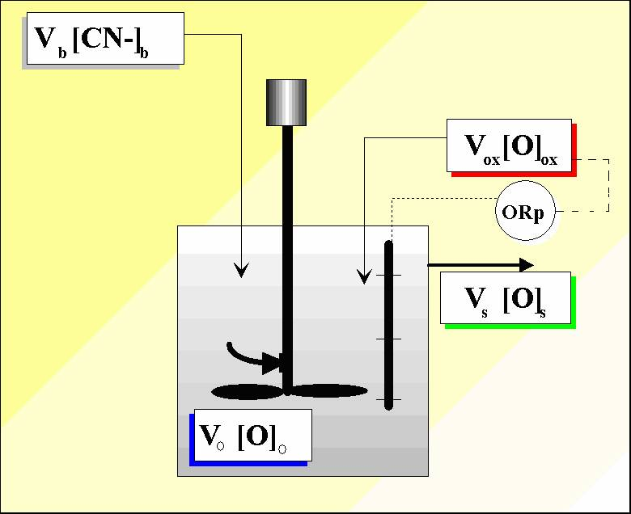
Constant volume(Vo) as it is about processes in series the entrance flows and exit they are identic if we work in a process for slink. In terms of mass:
$\frac{\text{input}}{\text{time}}=c_{j}V_{j}$ = $\frac{\text{exit}}{\text{time}}=c_{e}V_{e}$ | (7)
$$\frac{\text{Acummulation}}{\text{time}}=\frac{\text{dM}}{\text{dt}}=\frac{d(c_{o}V_{o})}{\text{dt}}$$ | (8)
The consummation of H₂O₂ is defined for
$$\frac{\text{consummation}}{\text{time}}=\frac{d(c_{{\text{CN}}^{−}}V_{{\text{CN}}^{−}})}{\text{dt}}$$ | (9)
In term of [H₂O₂] the values of concentration of H₂O₂ in the first time can therefore be calculated by:
$$[H_{2}O_{2}]_{1}=\left(\frac{V_{o}∗[H_{2}O_{2}]_{o}+V_{j}∗[H_{2}O_{2}]_{j}−V_{{\text{CN}}^{−}}∗[\text{CN-}]_{j}−V_{e}[H_{2}O_{2}]_{e}}{V_{o}+V_{j}+V_{{\text{CN}}^{−}}−V_{e}}\right)$$ | (10)
Where: V_{o} and [H₂O₂]_{o} are volume and concentration of hydrogen peroxide respectively in the solution in the reactor (fig 3). The formula is applicable at the first moment of contact and the next values are determined by:
Fig. 2. Schema of Decyanidation System.

$$[H_{2}O_{2}]_{i}=\left(\frac{V_{o(\text{i-1})}∗[H_{2}O_{2}]_{o(\text{i-1})}+V_{\text{ji}}∗[H_{2}O_{2}]_{\text{ji}}−V_{{\text{CN}}_{\text{ri}}^{−}}∗[H_{2}O_{2}]_{{\text{CN}}_{\text{ji}}^{−}}{\text{-V}}_{\text{ei}}[H_{2}O_{2}]_{\text{ei}})}{V_{o(\text{i-1})}+V_{\text{ai}}+V_{\text{ri}}−V_{e}}\right)$$ | (11)
The terms “i” and “i-1” indicate the successive clock ticks and V_{e} and [H₂O₂]_{e} are the volume and concentration of H₂O₂ added in the solution.
This model allows the simulation and prediction of the values of H₂O₂ in the reactor. Nevertheless to be able to made the comparison it is necessary to study and to identify the main variables as the flows of the solutions and the concentrations of the reagents, the time of residence within the reactor, etc.
The reacted concentration is determined by the efficiency of the reaction of cyanide oxidation with peroxide:
$$[H_{2}O_{2}]_{r}=[{\text{CN}}^{−}]\text{*1}\text{.}\text{15*}\frac{\text{PM}(r)}{\text{PM }({\text{CN}}^{−})}$$ | (12)
The factor 1.15 is determined in function of the reagent that can react with the species present in the solution and PM is the molecular weight of the oxidizing reagent (r) and cyanide (CN⁻) respectively.

Industrial application.
The application of this work concerns a metal finishing industry, in which the wastewaters are firs collected by gravitational flow into tw
o separate buffer basins: acid (usually at pH 2 - 3) and alkaline-cyanidated (usually at pH 11 – 12). The alkaline-cyanidated wastewater is first pumped into the decyanidation reactor, where cyanides are oxidated with H₂O₂ at pH ~9 (Flachon, 1998) The adjustment of pH is made by injection of CO₂, that fits the pH at 9.3 – 9.5, which it is the optimal zone for oxidation by H₂O₂ . Variations of +- 0.1 in pH do not imply risks of generation of dangerous species for the environment or the personnel.. The feedings of reagents and solutions have to be synchronized, i.e. as soon as the feeding pump of alkaline solution initiates the CO₂ and H₂O₂ feeding pumps and control systems are activated.

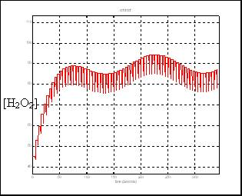
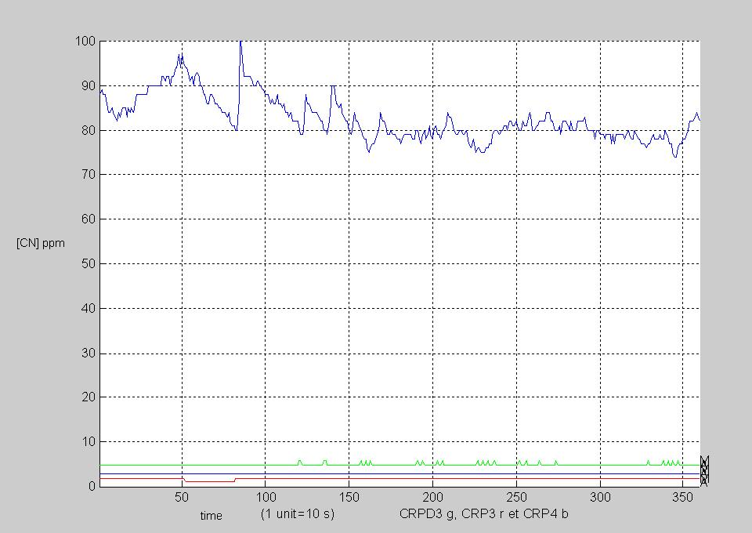
In the fig 4 the evolution of H₂O₂ of the alkaline solutions shows variation of concentration in the solution the entry by the heterogeneity of the concentrations of cyanide of the work solutions and later of the adjustment in pH, the alterations in the data are caused by retard in the answer stoicheiometry for the adjustments in the plant of automatic way, under the slogan to maintain concentration within the parameter established for the control process. Model process data are shown in Fig. 5.
Fig. 3. Real Data H₂O₂ concentration.
Fig. 4 Evolution of H₂O₂ simulation in Matlab.
The differences can be caused by the sensitivity of the equipment reason why the supervision process must be in constant monitoring and maintenance on these to valid of the data on the different processes in operation plant. The validation process and model data is made and simulations are many satisfactory.
The differences between the real and modeled data shows are convincing, but its application is restricted to the disposition of data signal for process, the limitation of the data loaded in the process and the technologies limitations for the monitoring cyanide concentration.

Conclusions
The developed models, the acquired treatment knowledge-base and an integrated tool will enable the development of a knowledge-based real-time system for computer-aided management, control and operation of the treatment plant, Fig. 1.
One of the goals will be to anticipate a solution of faults in the operation and control of the plant.
The economical advantages of the simulation would be that different strategies can be simulated and analyzed a priori, e.g. with respect of the use of different reagents in order to reduce the operating costs.
An integrated presentation of the criteria and the possible strategies would make easier the decision making.
At present, the models are adapted for decyanidation, neutralization and precipitation stages applied to the metal finishing industry. Future developments will determine if they are applicable to other industries and processes, with presence of other chemicals.

References.
Agency for Toxic Substances and Disease Registry. United States Public Health Service (1989) Cyanide Information excerpted from Toxicological Profile for Cyanide. United States Public Health Service. USA.
Dhaliwal, J. S., & Benbasat, I. The use and effects of knowledge based system explanations: theoretical foundations and a framework for empirical evaluation. Information Systems Research, 7, 342–362(1996)..
Ellis, K.V., Rodrigues, P.C., 1995. Developments to the first-order, complete-mix design approach for stabilization ponds. Water Res. 29, 1343–1351.
Ferrara, R.A., Harleman, D.R.F., 1980. Dynamic nutrient cycle model for waste stabilization ponds. J. Environ. Eng. ASCE 106, 37–54.
Flachon I.(1998) Optimisation du fonctionnemet d’une station d’épuration des effluents industriels de traitement de surface. DEA “Sciences et techniques du déchet”, Ecole nationale supérieure des mines de Saint Etienne, France.
Kayombo, S., Mbwette, T.S.A., Mayo, A.W., Katima, J.H.Y., Jorgensen, S.E., 2000. Modelling diurnal variation of dissolved oxygen in waste stabilization ponds. Ecol. Model. 127, 21–31.
Kayombo, S., Mbwette, T.S.A., Mayo, A.W., Katima, J.H.Y., Jørgensen, S.E., 2002. Diurnal cycles of variation of physical–chemical parameters inwaste stabilization ponds. Ecol. Eng. 18, 287–291.
Laganier, F., , 1996, Dynamic process simulation-trends and perspectives in an industrial context. Computers and Chemical Engineering, 20, Suppl. S1595-S1600.
Laudon, K. C., & Laudon, J. P. Essential of management information systems (5th ed). Englewood cliffs, NJ: Prentice Hall. (2002).
M. Sarla, M. Pandit, D.K. Tyagi and J.C. Kapoor. Oxidation of cyanide in aqueous solution by chemical and photochemical process. Journal of Hazardous Materials Volume 116, Issues 1-2 , 10 December 2004, Pages 49-56
Marquardt W. 1996,, Trends in computer-aided modeling. Computers and Chemical Engineering, 20, 591-609.
Mashauri D.A., Kayombo, S., 2001. The application of the two coupled models for water quality management: facultative pond and constructed wetland models. In: Proceedings of the 2nd WARFSA/WaterNet Symposium: Integrated Water Resources Management: Theory, Practice, Cases, Cape Town, pp. 189–200.
Mayo A.W., 1989. Effect of pond depth on bacterial mortality rate. J. Environ. Eng. ASCE 115, 964–977.
Moreno-Grau, S., Garcia-Sanchez, A., Moreno-Clavel, J., Serrano- Aniorte, J., Moreno-Grau, M.D., 1996. A matemátical model for wastewater stabilization ponds with macrophytes and microphytes. Ecol. Model. 91, 77–103.
Office of Waste Reduction Services Environmental Services Division State of Michigan (1995). Fact Sheet: Metal Recovery Technologies for the Metal Finishing industry "A Partnership to Benefit Both Economic Development and the Environment"(nov. 10).
Pantelides C. C. and Brin, H. I. 1994, Multipurpose process modeling environments. In Foundations Computer-Aided Design Conference FOCAPD'94. CACHE, Snowmass, CO, pp. 128-141.
Roques H. (1990) Fondements théoriques du traitement chimique des eaux. Vol. II. Ed. Lavoiser. Paris.
Shu-Hsien Liao. (2005) Expert system methodologies and applications—a decade review from 1995 to 2004. Expert Systems with Applications 28 93–103
Sperling M.V., 1999. Performance evaluation and mathematical modeling of coliform die-off in tropical and subtropical waste stabilization ponds. Water Res. 33, 1435–1448.
M. Sarla, M. Pandita,., D.K. Tyagi, J.C. Kapoor: (2004) Oxidation of cyanide in aqueous solution by chemical and photochemical process. Journal of Hazardous Materials vol. p 49–56
Szafnicki K., Bourgois J., Graillot D., Di Benedetto D., and Poyet J.P.(1998). Real time supervision of industrial wastewater treatment plants applied to surface treatment industries. Water Research Vol. 32, N°.8.
Wiig, K. M. Knowledge management, the central management focus for intelligent-acting organization. Arlington: Schema Press. (1994).
De A. K., Chaudhuri B., Bhattacharjee S., Dutta B.K. (1999) Estimatio of OHº radical reaction rate constant for phenol using UV/H2O2 photo oxidation. J. Hazard Mater 64 (1999) p 91-104
H. Knorre, A. Griffiths. (1984) Cyanide detoxication with hydrogen peroxide using degussa process. Ed D Van Zyl, Proceeding of conference on cyanide and environment, Tucson, Arizona, December 1984.

Authorization and Disclaimer
Authors authorize LACCEI to publish the paper in the conference proceedings. Neither LACCEI nor the editors are responsible either for the content or for the implications of what is expressed in the paper.

