Fifth LACCEI International Latin American and Caribbean Conference for Engineering and Technology (LACCEI’2007)
“Developing Entrepreneurial Engineers for the Sustainable Growth of Latin America and the Caribbean:
Education, Innovation, Technology and Practice”
29 May – 1 June 2007, Tampico, México.

Significant Factors Affecting the Selection of the Approporiate Project Delivery Method

Sameh Monir El-Sayegh, PhD, PMP
American University of Sharjah, Sharjah, United Arab Emirates, selsayegh@aus.edu

Abstract
Project delivery method refers to the owners’ approach in organizing the project team that will manage the entire design and construction process. There are mainly three categories of delivery methods: traditional design-bid-build, design-build and construction management. The choice of the appropriate delivery method is a key decision that has to be made by owners early in the project lifecycle. This decision has a great impact on project success. Through literature review, a comprehensive list of twenty one factors was determined. These factors are grouped into eight categories: time, cost, scope, quality, owner organization, cash flow, project characteristics and risk and relationships factors. A survey was then developed and distributed to construction experts associated with the United Arab Emirates (UAE) construction industry to get their perception as to the importance of these factors. The data was then analyzed and the factors ranked according to their Relative Importance Index (RII). The most significant factors appear to be quality and factors related to the owner organization such as the desire for a single contract and desired level of control. The need for financing was ranked the lowest. This paper reports on the results of this study along with recommendations to the owners’ in dealing with this decision.
Keywords: Project delivery methods, Construction Management, UAE Construction Industry, RII
- Introduction
Owners are faced with an important question at the start of any construction project. This is related to organization of the project team that will manage the design and construction process or the project delivery method. This decision is important as it affects achieving project objectives such as time, cost, quality and safety. Project delivery method deals with the arrangement of contracting parties such as designers, contractors and construction management companies. It answers the questions of what organization gets hired first and how the parties are related contractually to the owner and themselves (Gould, 2005). There is a number of project delivery methods that can be used on construction projects. These can be grouped into three distinct categiries: the traditional design-bid-build, construction management, and design-build. The last two categories are commonly refered to as alternative delivery methods.
The use of alternative delivery method has increased in recent years due to many factors including the increase in complexity and size of projects, increased owner sophistication and requirements, demand for shorter delivery period and others. The traditional delivery method has many drawbacks when it comes to meeting the new owner requirements. The drawbacks include longer delivery time, lack of early estimating and potential for disputes. Using the traditional arrangement often results in adversarial relationships among project participants (Kumaraswamy et al., 2002). Due to the obvious drawbacks of the traditional approach, owners started to use alternative methods such as construction management and design-build. Their use had proved to be successful. Design-build delivery method was shown to be faster than other delivery methods (Kochar and Sanvido, 1998 and Ibbs et al., 2003). Also, design-build was better in controling time and cost growth (Gransberg et al., 2003).
The United Arab Emirates (UAE) construction is booming. There are a lot of new projects that are unveiled every day. Some of these new projects include the tallest building in the world (Burj Dubai), man-made islands (palm island), under water hotel and others. This rapid expansion and the increase in projects’ size and complexity has made owners looking for new methods to deliver their unique projects. However, the decision is not easy as there are many factors that affect the project delivery method decision. These factors are related to time, cost, scope, quality, owner organization, cash flow, project characteristics, risk and relationships. It is important that owners understand these factors as it will assist them in making the right choice for their projects. This paper discusses the different project delivery methods, determines and ranks the significant factors that affect the selection of the approporiate project delivery methods.
- Data Collection
The first step in this research was to determine the factors affecting the choice of the appropriate delivery method in construction projects. This was accomplished through review of related literature especially the works of (Anderson, 2003), (Bai and Hezam, 2003) and (Molenaar and Songer, 2001). A survey was then developed to solicit construction experts perception on the significant factors affecting the choice of delivery method. The respondents were asked to evaluate each factor on a scale of 0 to 4 (extremely critical is 4, critical is 3, normal is 2, slightly critical is 1 and not critical is 0). The Relative Importance Index (RII) was then calculated as an average of the responses. Forty surveys were completed by construction experts working in the UAE construction industry. Data was collected using interviews with the experts to ensure that they understand the factors and to ensure that they will fill the surveys. The respondents profile is shown in Figure 1. The respondents are mainly owners as they are the ones who decide on the delivery methods. The projects included 6 residential, 13 commercial, 6 industrial and 15 infrastructure projects.
Figure 1: Respondents’ Profile
- project delivery methods
There is a number of delivery methods that are used on construction projects. Each has advantages and disadvantages. The delivery methods can be grouped into three distinct categories. These are traditional design-bid-build, construction management and design build. There exists a number of variations in each category.

  - traditional delivery methods
    - design-bid-build
In the traditional design-bid-build arrangement, the owner has two separate contracts: one with the designer and one with the contractors. The design company is hired first to provide design services and develop the contract drawings and specifications. At the end of the design phase, the designer assists the owner in the bidding phase and selecting the contractor. Then, the owner signs a contract with the construction company to deliver the project. The designer assists in supervising the project during the construction phase. This is a familiar delivery method to most owners and requires a defined scope prior to bidding. The main disadvantages are the lack of involvement of construction professional during the design phase, longer delivery time (sequential), less flexible for changes and it often results in adversarial relationships among the parties involved.
    - Multiple design-bid-build
In this arrangement, the owner divides the projects into several contract packages and hires a separate designer and contractor for contract package (Figure 2). This method is similar to the previous one in terms of familiarity but it is faster due to the possibility of phasing and is cheaper due to more competition for individual contracts. However, this method involves a larger number of contracts for the owner to handle and still there is no construction professional involvement during design.

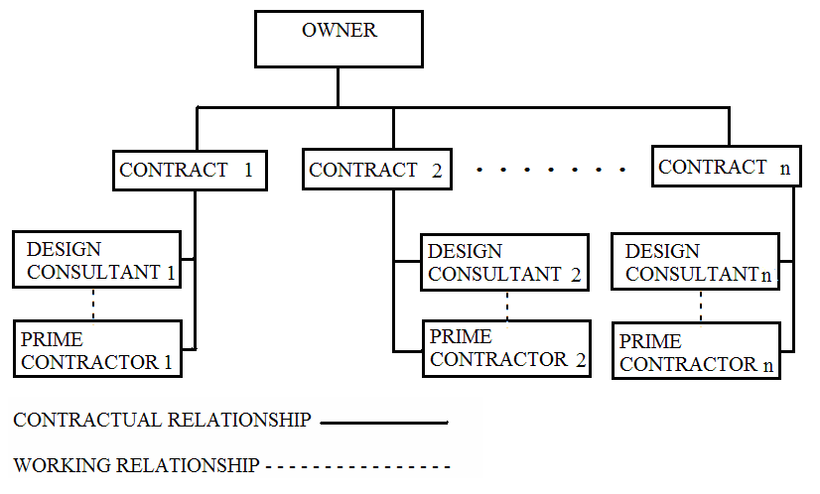

Figure 2: Multiple Design-Bid-Build
    - Multiple prime contractor
This method is a variation of the previous two methods. Here the owner hires one designer for the whole project and then divide the project into several packages with each package awarded to a separate prime contractor. This method offers an advantage over the multiple DBB in that it offers a single point of responsibility for design. This method allows for phased construction which make it faster and cheaper.
  - construction management
    - Construction management
This method is similar to the traditional DBB method except for a major addition that is the construction management company. In this method, the owner hires a construction management company at the start of the project. The construction management company assists the owner in selecting the design company, manages the design process and then assists in hiring the prime contractor and later manage the construction process. This method offers the advantages of professional construction input during the design phase which allows for constructability and value engineering studies. This method allows for more control on project cost, time, quality and safety. The main disadvantage is the lack of overall cost guarantee.
    - agency construction management
This is a variation of the previous method where instead of hiring one prime contractor for the whole project, the owner, with the assistance of the construction management company, hires several subcontractors to deliver the project (Figure 3). This arrangement provides more comprtition which leads to more cost savings. Also, it is a faster delivery method due to the possibility of phasing. The main disadvanategs are the larger number of contracts to handle, communication challenges, and no single responsibility for construction.
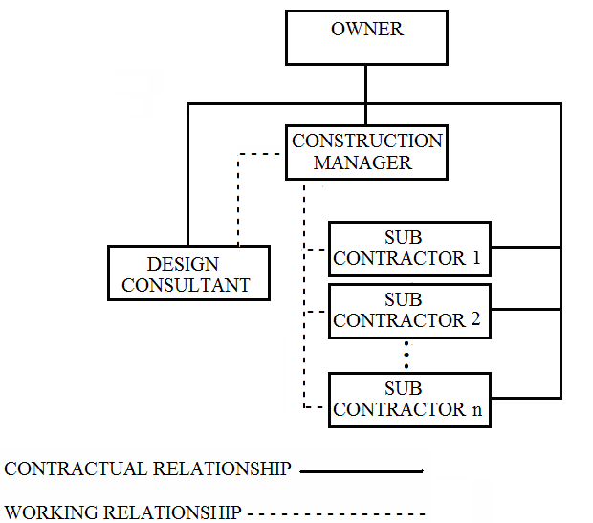

Figure 3: The Agency Construction Management Delivery Method
    - construction management at risk
In the previous two methods, the construction management company has limited risk in case of cost overruns and delays. In this arrangement, the construction management company takes that risk. In this arrangement, the owner hires a construction management at risk company which acts as both a construction management company during the design phase and then acts as a prime contractor during the construction phase. The advantages include single point of responsibility for construction, faster delivery method and ease of changes incorporation.
    - engineering-procurement-construction management
In this arrangement, the owner hires one company to perform design, procurement and construction management services and then hires a prime contractor for the construction work. This is a hybrid method between construction management and design-build. This arrangement allows the owner to have direct contact with the general contractor. This is not available in the design-build option.
    - program management
The program management arrangement is similar to the multiple DBB method except with a major addition that is the program manager. Here the program management company assists the owner in dividing the program into projects (contracts) and manages the design and construction of each of these contracts. This program manager provides standardized technical and management experience to all projects, reduces owner involvement, takes advantage of the economy of scale and may result in reduced time of project delivery.
  - design-build
    - design-build
In this method, the owner hires one company for both the design and the construction of the project. The design-build company may perform the work itself or hire consultants for the design and subcontractors for the construction work. The advantages of this method include single point of responsibility for design and construction, faster delivery and design and construction integration. The main disadvantages are the lack of check and balances by the owner and the lack of direct contract with the construction contractor.
    - multiple design-build
In this arrangement, the owner divides the projects into bid packages and hires a separate design-build contractor for each package. This method allows for more phasing which results in time and cost savings. However, in addition to the problem with design-build, there are more contracts to manage.
    - build-operate-transfer
This is a variation of design-build that invilves financing and operation by the design-build contractor.
    - bridging
This method is a variation of the design-build method. In this arrangement, the owner hires an Architectural / Engineering company to provide the initial program design and then hires a design-build company to deliver the project. During project execution, the A/E firm supervises the project.
In the UAE, owner are accustumed to the traditional delivery method. However, in recent years, they started to utilize other alternative delivery method. Figure 4 shows the distubution among the 40 projects investigated.
Figure 4: Project Delivery Methods in the UAE
- significant factors
Factors affecting the selection of the appropriate delivery method are divided into eight categories. Each respondent was asked to assess the importance of each of these factors. The relative importance index (RII) was then calculated for each of these factors. Figure 5 shows the ranking of these factors in terms of importance. The maximum value for RII is 4.
Figure 5: Ranking of Significant Factors Affecting the Delivery Method Selection
  - Time-related factors
This category includes two factors: Ensuring the shortest completion time for the whole design and construction and ensuring completion on schedule. The first factor (RII is 2.4) is ranked 12th among the twenty one factors. Owners are more worried about ensuring the on-time completion (RII is 2.8) and is ranked 7th. This shows the importance of construction management delivery methods that are not necessarily the fastest method but help maintain the schedule and ensure timely completion.
  - cost-related factors
This category includes ensuring the lowest cost and ensuring completion with budget. Ensuring the lowest cost (RII is 2.6) is ranked 10th while ensuring completion within budget (RII is 2.925) is ranked 5th. This again goes inline with the time-related factors as decision makers are worried about controlling cost growth rather than achieving the cheapest cost.
  - scope-related factors
This include three factors that were ranked low. Capitalizing on a well-defined scope (RII is 1.3) and ranked 19th which is insignificant according to the respondents. The second factor is the potential for changes during construction (RII is 1.875) and ranked 16th. The third factor is the owners’ desire for flexibility to make changes during construction (RII is 1.9) and ranked 15th . Although these factors are important in deciding the apprporiate delivery meth, it seems that the UAE respondents ranked them lower than other factors.
  - quality-related factors
Attaining the highest overall quality is the most important factor (RII is 3.1) and ranked 1st. This shows the desire to deliver quality products. Although quality must be ensured in all delivery methods, some delivery methods such as construction management help in achieving this objective.
  - owner organization-related factors
The selection of the approporiate delivery method depends largely on the owner’s organization. Three of the top ten factors appeared to be related to owner’s organization. The owner’s desire for single project contract (RII is 3.075) is ranked 2nd. This means that owners prefer the delivery method that minimizes the number of contracting parties such as design-build and construction management. Also, the desire for single construction contract (RII is 2.775) is ranked 8th. The owner’s desired level of control (RII is 3.025) is ranked 3rd which means that owners still prefer to stay in control of the construction project. The need for construction professional input during design (RII is 2.3) is ranked 13th. This is surprising as professional construction experience is really needed during the design phase for construcability and value engineering studies. The level of in-house management experience (RII is 1.375) is ranked 18th which indicates that it is not a critical factor in the decision making process compared to the other factors.
  - funding/cash flow-related factors
The desire for early estimates (RII is 2.975) is ranked 4th which indicates that owners prefer the delivery method that provides them with early estimates even before the design is complete. Delaying or minimizing expenditure rate (RII is 1.5) is ranked 17th and the need for financing (RII is 0.8) is ranked 21st. This indicates that owners in the UAE are not worried about financing or cash flow issues.
  - project characteristics-related factors
The project itself sometimes dictates the approporiate delivery method. The importance of the project (RII is 2.85) is ranked 6th, project complixity (RII is 2) is ranked 14th while owner’s familiarity with the project (RII is 1.1) is ranked 20th.
  - risk and relationships-related factors
The amount of risk (RII is 2.75) is ranked 9th. This factor is important in choosing the method that properly allocated the risk among contractual parties. Minimizing adeversarial relationships (RII is 2.425) is ranked 11th. Owners prefer methods that minimizes the disputes and adversarial relationships that are common in the traditional design-bid-build delivery method.
- summary and conclusion
There are several project delivery methods that owners can select from in order to deliver their construction projects and achieve their objectives. There are three main categories and a number of variations. The traditional delivery methods takes longer time to complete and result in adversarial relationships. The construction management methods offers more control over time, cost, safety and quality. Design-build methods minimizes the number of contracts and allows for good design-construction integration. To assist the owner in choosing the appropriate delivery method, a number of factors should be considered. This research indicated that quality is the main factor followed by the owner’s desire for single project contract, desired level of control, desire for early estimates and the desire to control cost growth. It is clear that the traditional delivery methods have shoe comings when it comes to meeting these factors and objectives. This paper presents the characteristics of the common project delivery methods and ranking of the factors affecting the selection process. Owners need to evaluate their objectives carefully and choose the method that maximizes their chances of meeting these objectives.
References
Anderson, Stuart D. “Owner’s Tool for Project Delivery and Contract Strategy Selection User’s Guide 165-2”, 2nd Edition, Construction Industry Institute, USA, 2003.

Bai, Yong and Hezam Adel A. “Integrating Innovative Project Delivery Methods into the Construction Curriculum”. ASC Proceedings of the 39th Annual Conference 2003, Clemson University – Clemson, South Carolina, ASC, 119-128.

Gould, Frederick E., “Managing the Construction Process: Estimating, Scheduling and Project control”. 3rd Ed., Prentice Hall. New Jersey, USA, 2005

Gransberg, Douglas D., Badillo-Kwiatkowski, Gayla M. and Molenaar, Keith R. “Project Delivery Comparison Using Performance Metrics”. AACE International Transactions 2003, CSC 2.1 – 2.5

Ibbs, William, Kwak, Young H., Ng, Tzyu, and Odabas, Murat, “Project Delivery Systems and project change: Quantitative Analysis”. Journal of Construction Engineering and Management 2003, 129 (4), 382-387.

Konchar, Mark and Sanvido, Victor, “Comparison of U.S. Project Delivery Systems”. Journal of Construction Engineering and Management 1998, 124 (6), 435-444.

Kumaraswamy, Mohan M., Morris, David A. “Build-Operate-Transfer Type Procurement in Asian Mega Projects”. Journal of Construction Engineering and Management 2002, 128 (2), 93-102.

Molenaar, Keith R. and Songer, Anthony D. “Web-Based Decision Support Systems: Case Study in Project Delivery”. Journal of Computing in Civil Engineering 2001, 15 (4), 259-267.

Authorization and Disclaimer
Authors authorize LACCEI to publish the paper in the conference proceedings. Neither LACCEI nor the editors are responsible either for the content or for the implications of what is expressed in the paper.

