Design and Development of a Teaching Module in Nanotechnology
Olivia A. Graeve¹, Stacy Gleixner², and Elliot Douglas³
¹University of Nevada, Reno, USA, oagraeve@unr.edu
²San Jose State University, San Jose, USA, gleixner@email.sjsu.edu
³University of Florida, Gainesville, USA, edoug@mse.ufl.edu

Introduction
This abstract discusses the progress of curriculum development under an NSF, CCLI-EMD sponsored work, “Development of Project-Based Introductory to Materials Engineering Modules” (Gleixner et al. 2005, Gleixner et al. 2006). A multi-university team of faculty is developing five lecture modules for use in Introductory to Materials courses. This course is required by most engineering programs in the U.S., with an annual enrollment of 50,000 students. This freshman/ sophomore class is an ideal place to excite students about their engineering majors and expose them to real world engineering experiences. PRIME Modules are being developed that teach the fundamentals of a traditional introduction to materials engineering course in the context of modern technologies. The key objectives of the modules are to show students how the fundamental principles are interrelated to each other and applied to modern applications. The module that is the focus of this abstract is intended to present the student to the concept of solid oxide fuel cells and the application of nanomaterials to this technology.
Background
A fuel cell is an energy conversion device that converts the chemical energy of a fuel directly to electrical energy and heat, giving much higher conversion efficiencies than conventional combustion methods, as shown in Figure 1.

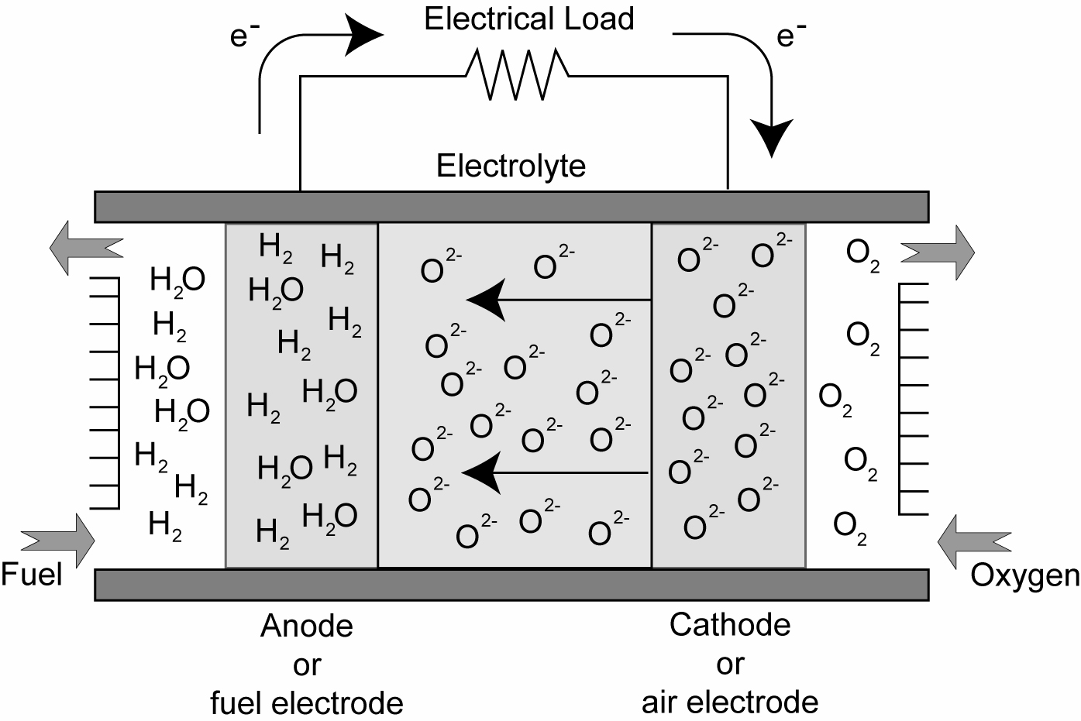
Figure 1: Schematic diagram of a solid oxide fuel cell.

The main difference between the different types of fuel cells is the operating temperature, which affects the materials of which the fuel cell is made of, and the type of fuel that can be used. High temperature fuel cells, also known as solid oxide fuel cells or SOFCs, operate at temperatures between 600°C and 1000°C and consist of all solid materials that are capable of withstanding the higher operating temperatures.
A fuel cell consists of two electrodes (an anode and cathode) that sandwich an electrolyte (a specialized material that allows ions to pass but blocks electrons). A typical SOFC consists of an Y₂O₃-doped ZrO₂, with about 8 mol% yttrium, as the electrolyte. This material is now the standard commercial electrolyte material in SOFCs because of its high chemical and thermal stability and pure ionic conductivity over a wide range of conditions. The purpose of the electrolyte is to separate the fuel and oxidant gases in order to prevent a direct combustion. Without the presence of the electrolyte, the possibility of an external circuit that carries electrons would not be possible. As current flows from the anode to the cathode, the current can then be used for doing external work.
The cathode is made of La_{1-x}Sr_{x}MnO_{3-d}, x ~ 0.15-0.25 and the anode is made of Ni/ZrO₂. The anode is prepared from a ~50:50 wt.% ratio NiO+YSZ mixture, which is reduced in situ to yield Ni metal particles. To generate reasonable voltages, SOFCs are not operated as single units but as arrays of units with a doped lanthanum chromite (e.g., La_{0.8}Ca_{0.2}CrO₃) interconnect joining the anodes and cathodes of adjacent units. This interconnect material is expensive and its elimination is one of the main motivations for going to lower operating temperatures.
Nanotechnology in SOFC’s
Recently, it has been shown that nanostructured electrolytes have an increase of about in order of magnitude in ionic conductivity, as compared to conventional microcrystalline materials. This effect is attributed to the large amount of grain boundaries present in the nanostructured materials. The benefit of such improved performance can be used in three ways: (a) directly as enhanced power output, (b) by lower operating temperature in terms of longer component life and (c) as a buffer for peak electricity demands during operation. In addition, the electrodes also benefit from having a microstructure in the nanometer regime. Figure 2 shows a close-up of the cathode/electrolyte interface. First to notice is the fact that oxygen gas must travel through the cathode as efficiently as possible to get to the electrolyte. This is done quite efficiently if there are many very small pores. It becomes impossible: (1) if pores are not connected, or (2) if pores are so few and far between that the diffusion of oxygen is effectively zero. Both possibilities are shown in Figure 3.

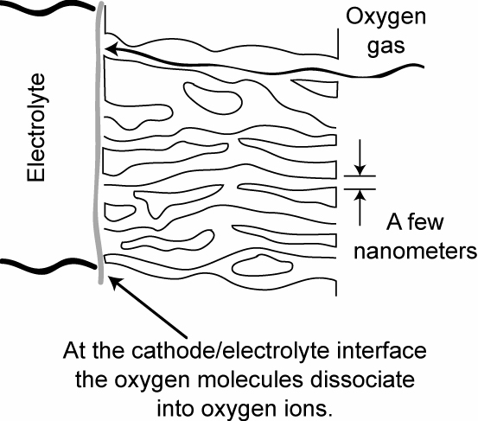
Figure 2: Schematic diagram of the
cathode/electrolyte interface.

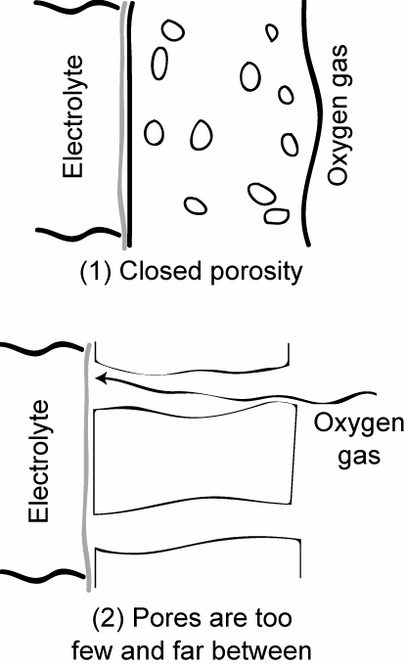
Figure 3: Inefficient configuration for the
cathode in an SOFC.

The electrolyte is very different from the electrodes in that it contains no porosity. Now, the movement of oxygen ions has to be done as efficiently as possible. This is accomplished by manufacturing a fully-dense material with many vacancies, hence, the use of yttria-doped zirconia. The oxygen ions travel through the structure by jumping from vacancy to vacancy. The diffusion process is both from bulk diffusion and grain boundary diffusion. However, grain boundary diffusion is much more rapid, because of the higher amount of disorder at these boundaries. This leads to the conclusion that the higher the amount of grain boundary area, the better diffusion of the oxygen ions. Nanostructured materials have a large amount of grain boundary area and are quite optimal for promoting grain boundary diffusion. Here, again, the manufacturing of fully-dense and nanostructured components is a growing field that requires much more research.
Learning Objectives of Module
While exploring SOFC’s and nanomaterials, students learn the basics of ceramics, defects, and phase diagrams with emphasis on the following objectives:
Week 1
- Describe crystal structures of ceramic materials.
- List the major applications of ceramics and factors involved in designing ceramics for those applications.
- Describe simple synthesis and processing techniques for ceramic materials.
- Describe the arrangement of atoms in a noncrystalline ceramic such as glass.
- Describe coordination number in ceramic materials.

Week 2
- Define point defects.
- Calculate atomic density in a solid.
- Distinguish between substitutional and interstitial impurities.
- Define planar defects.
- Describe defects in ceramic materials.
- List the differences between bulk and nanocrystalline materials.
- Define interstitial and substitutional diffusion.
- Calculate diffusion coefficients for materials.
- Describe and calculate ionic conductivity in ceramic materials.
- Describe the role of defects in the ionic conductivity of ceramic materials.

Week 3
- Calculate mole fraction and weight fraction of a phase using the lever rule.
- Construct a phase diagram from phase composition data.
- Determine the number of components and phases present on a phase diagram.
- Determine the equilibrium phases and composition of the phases as a function of temperature and overall composition from a phase diagram.
- Sketch microstructure as a function of cooling rate for a specific alloy.
- Recognize and describe isomorphous, eutectic, and eutectoid phase diagrams.
- Identify the invariant points in a phase diagram.
References
Gleixner, S.H., Douglas, E., Graeve, O., Lackritz, H., Demsetz, L., and Moll, A. (2005). "Development of Project-Based Introductory to Materials Engineering Modules," Proc. 2005 ASEE Annual Conf. & Expo., Vol. 1526.
Gleixner, S.H., Douglas, E., and Graeve, O. (2006). "Project-Based Introductory to Materials Engineering Modules on Biomaterials, Solid Oxide Fuel Cells, Non-Volatile Memory, and Fiber Reinforced Plastics," Proc. 2006 ASEE Annual Conf. & Expo., Vol. 2464.

