Fifth LACCEI International Latin American and Caribbean Conference for Engineering and Technology (LACCEI’2007)
“Developing Entrepreneurial Engineers for the Sustainable Growth of Latin America and the Caribbean:
Education, Innovation, Technology and Practice”
29 May – 1 June 2007, Tampico, México.

Evaluation of Creosote-Treated and CCA-Treated Wood for Marine Applications

D.V. Reddy, Ph.D., P.E.
Center for Marine Structures and Geotechnique, Florida Atlantic University, Boca Raton, Florida, US, dvreddy@civil.fau.edu

J.C. Bolivar, B.S., E.I.
Center for Marine Structures and Geotechnique, Florida Atlantic University, Boca Raton, Florida, US, jbolivar@fau.edu

I. Gil, B.S.
Center for Marine Structures and Geotechnique, Florida Atlantic University, Boca Raton, Florida, US, igil@fau.edu
Abstract
Chromate copper arsenate (CCA) treated wood has been utilized in a variety of applications, to provide protection from fungus and termites. However, the United States Environmental Protection Agency does not allow the use of CCA-treated wood “…intended for most residential settings”, and “…where treated wood may come into direct or indirect contact with drinking water, except for uses involving incidental contact with docks or bridges”. This is because chromium, arsenic, and copper have been observed as having negative impacts on human health and the environment. Although CCA-treated wood is still permitted in marine construction, there is a high level of concern regarding arsenical contaminants.
For this reason, non-CCA preservatives for marine applications have been studied to determine effective replacements. In this study, bending tests have been performed on 18 marine exposed CCA-treated samples, and 18 marine exposed non-CCA samples (creosote-treated), to determine how the non-CCA-treated marine piles perform compared to CCA-treated ones.
Southern pine sapwood cylindrical specimens of 6” diameter, 42” long, were prepared. Half of them were treated with chromate copper arsenate, and the other half with creosote. These specimens were subjected to seashore exposure by submergence 1 foot below low-tide level for eight months. They were then removed and rated for the extent of marine organism attack on faces and edges, based on ASTM ratings. Specimens cut into 13mm x 89 mm x 457 mm panels, were tested for strength loss in three-point bending with a span of 150mm. The data recorded comprised the material properties (moisture content and specific gravity), beam geometry, maximum failure load, and failure locations. Statistical analysis based on the t-test method, was used to validate the experimental data, obtain clear behavioral parameters for comparison of material and structural integrities of both types of treated wood, and determine the effectiveness of both types of treatment.
Keywords: CCA, wood, creosote, marine, preservatives
- Introduction
Pressure treating wood has been a long-lasting practice in the United States and other countries in order to protect wood structures from damage inflicted by microorganisms. Wood protection agencies have been relying on the use of two broad categories of wood preservatives; oil-borne, such as creosote and pentachlorophenol, and waterborne, such as chromated copper arsenate. The use of these types of treated wood includes marine piles, railroad ties, and utility poles, among others. However, in spite of their usefulness to protect wood structures, these major wood preservatives are being constantly re-evaluated in terms of their toxicity levels.
Chromated copper arsenate (CCA), a waterborne compound, is one of the most commonly used wood preservatives in North America. This form of wood treatment leaves no oily residue on the wood sample and is widely utilized due to its effectiveness in protecting the wood from the marine environment. Chromated copper arsenate (CCA) treated wood has been utilized in a variety of applications in which protection from fungus and insects is desired. However, the United States Environmental Protection Agency does not allow wood treaters to use CCA-treated wood “…intended for most residential settings”, and “…where treated wood may come into direct or indirect contact with drinking water, except for uses involving incidental contact with docks or bridges” (USEPA, 2007). This is because chromium, arsenic, and copper have been documented as having negative impacts on human health and the environment. This, of course, includes the marine environment as well. Although CCA-treated wood is still permitted in the use of marine construction, there is a high level of concern that arsenical contaminants are being released into the environment.
As an alternative, the use of non-CCA preservatives has been studied in the hope that an effective replacement can be found. Some of the non-CCA preservatives currently in use include i) Copper Azole – Type A (CBA - A) – 49% boron as boric acid, and 2% azole as tebuconazole, ii) Ammoniacal Copper Citrate (ACC) – 31.8% copper oxide, and 68.2% chromium trioxide, and iii) Ammoniacal Copper Quat (ACQ) – 67% copper oxide, and 33% quarternary ammonium compund (Lebow, 2004).
Another non-CCA preservative is creosote, used as a wood preservative. It is a brownish oil based liquid containing phenols and creosols obtained from distillation of coal tar (Hoffman et al., 2002). It is a water insoluble fungicide and biocide, and is hence used as a treatment technique on marine pier pilings. In recent years, the use of creosote is being limited due to its environmental concerns; “…some states have considered limiting creosote, and a few New England states recently banned creosote for marine piling applications” (Freeman et al., 2006). Although the toxicity of creosote has been documented, it has been widely used as a viable alternative for CCA-treated wood, as it provides benefits in terms of its cost-effectiveness, and higher penetration ratings, which may induce prolonged protection. At the same time, the structural integrity capabilities of both must be compared, to establish which type of treatment, under identical conditions, will provide greater benefits in terms of durability.
For this reason, extensive testing was conducted on piles containing both types of treatment. 18 CCA-treated, and 18 creosote-treated samples were prepared, and tested in terms of their organism attack resistance, moisture content, specific gravity, and ultimate strength testing through a three-point bending analysis, in order to determine which type of treatment will provide greater structural benefits despite of providing similar environmental concerns.
- Experimental methodology
Twelve wood cylindrical specimens of southern pine sapwood were prepared. Six specimens were treated with Chromated Copper Arsenate and the other six with Creosote. The dimensions of the piles were 6” diameter x 42” height. These specimens were exposed to the ocean environment underneath a marine pier at Florida Atlantic University’s SeaTech campus in Dania, Ft. Lauderdale. The wood specimens were suspended 1 foot below low-tide level to subject them to real ocean conditions for a limit period of eight months. Regular bricks were attached to the bottoms of the specimens to maintain their vertical placement in the water. Figure 1 shows the marine exposure layout for the specimens.
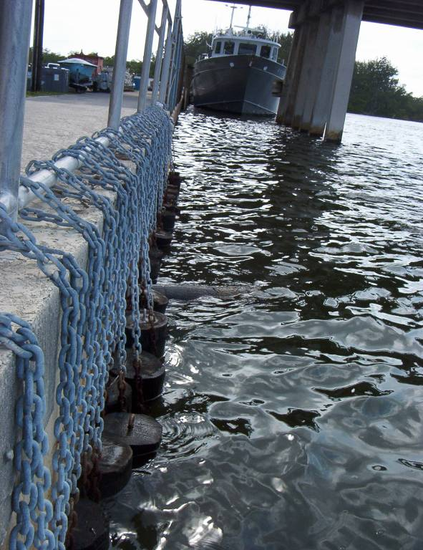

Fig. 1: Wood Piles Under Marine Exposure at Sea Tech Campus
After the limiting exposure period was completed, the specimens were removed from the pier using a hydraulic jack and a pulley system. After the piles were pulled out of the water, the bricks, hooks, and chains were removed and properly disposed, in order to maintain the structural integrity of the specimens and with the purpose of facilitating their testing. Figure 2 shows the hydraulic jack and pulley system used to remove the specimens from the ocean.
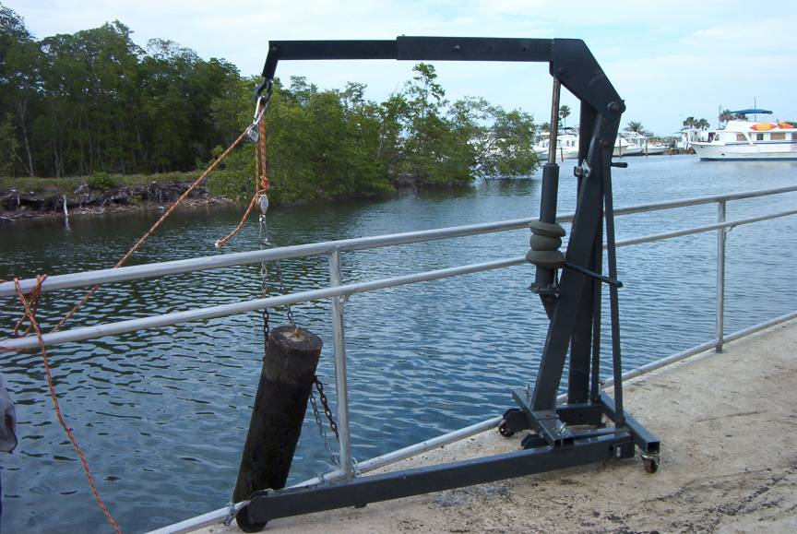

Fig. 2: Specimen Removal from the Ocean
Once the specimens were taken out of the water, the piles were rated for extent of marine organism damage on faces and edges, using ratings from the American Society for Testing and Materials (ASTM, 1990). A panel with no signs of organism attack was assigned a rating of 10, 9 for light attack, 7 for moderate attack, 4 for heavy attack, and 0 for total destruction of the panel. Figure 3 shows the organism attack condition of the specimens, right after removal from the water.
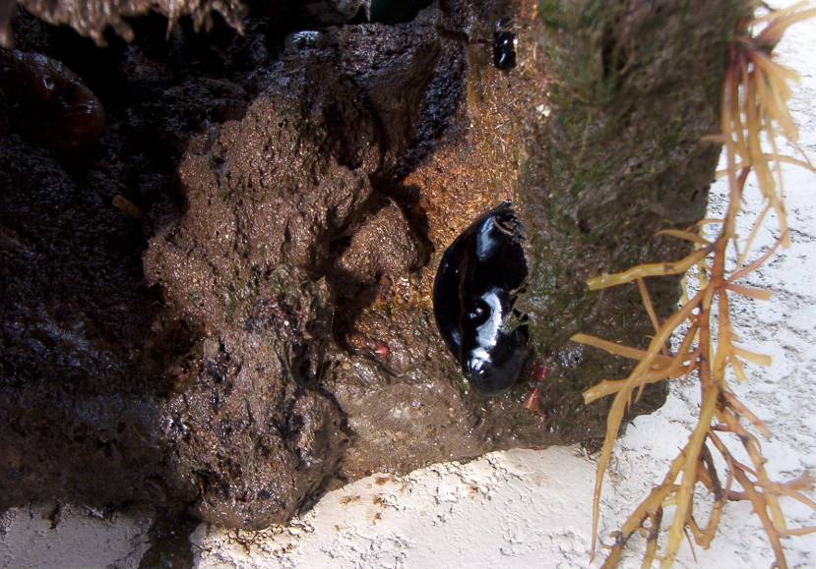

Fig. 3: Organism Presence in Piles
After this process was completed, the specimens were brought back to the Boca Raton campus of Florida Atlantic University, and the piles were cut into panels of 13mm thick x 89 mm wide x 457 mm long, Figure 4 shows the cylindrical specimens, and Figure 5 shows the panel assembly made for bending testing.
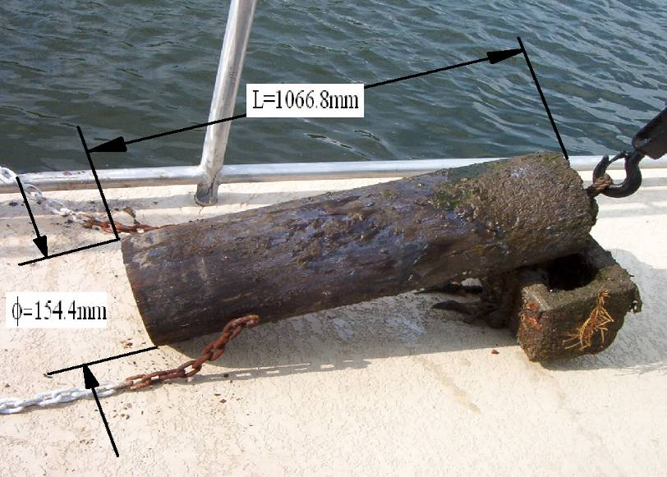

Fig. 4: Original Pile Specimen vs. Strength Testing Panel

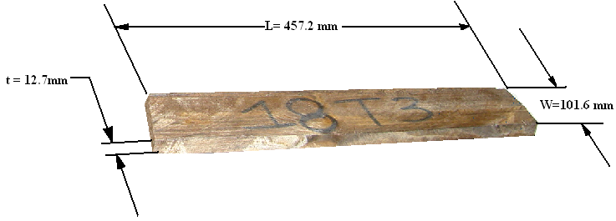

Fig. 5: Wood Panel for Bending Testing
After the specimens were cut, testing for strength loss in three-point bending was performed, with a span of 150mm. The data was recorded taking into account the maximum load and location of failures, as well as the material properties and beam geometry. Figure 6 shows the testing process for ultimate strength.
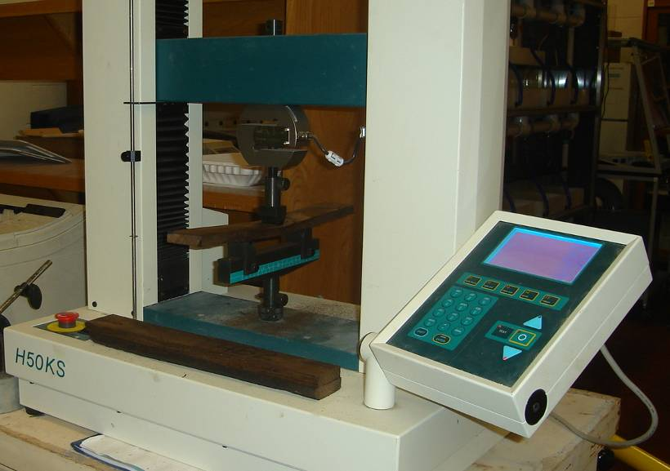

Fig. 6: Ultimate Strength Testing of Specimens
Following the strength testing process, the specimens were then tested for moisture content and specific gravity. For the moisture content testing, sawdust was obtained from each of the specimens, and an empty can was assigned to each one. The mass of each empty moisture can was determined, as well as the mass of each can with a representative sample of wood for each case. The moisture cans with their respective wood samples were oven dried for 24 hours. Then, a measurement of the dry mass of the wood was taken, and compared to the mass of water in the sample in order to find the moisture content for each sample. Figure 7 shows an example of the wood samples used for moisture content.
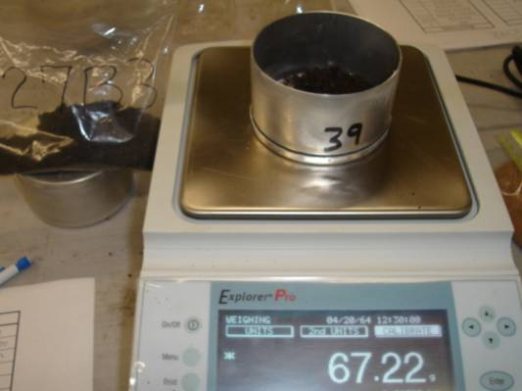

Fig. 7: Wood Sample for Moisture Content Testing
For the specific gravity testing, volumetric flasks were filled up with distilled water up to the 500 ml mark. Later, samples of 100g of sawdust were added to the emptied flasks, and the flasks filled up with distilled water up to two thirds their capacity. The air was then removed from the wood-water mixture by boiling the flasks for about 20 minutes. The temperature was then lowered back to room temperature, and distilled water added to the flasks up to the 500 ml mark. Subsequently, the mass of the flasks with wood and distilled water was measured, and the content of the flasks was poured into evaporating dishes, making sure that no wood was left inside the flasks. The content of the evaporating dishes was oven dried for 24 hours, and the mass of the dry wood determined to calculate the specific gravity. Figure 8 shows the boiling process of wood samples in order to remove the entrapped air as described above.
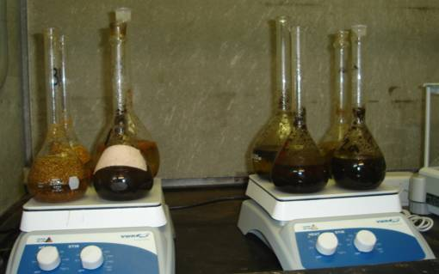

Fig. 8: Boiling of Wood Samples in Volumetric Flasks
- Comparison of physical and mechanical properties between cca-treated and creosote-treated wood
The CCA-treated and creosote-treated wood were compared in terms of several parameters including their organism attack rating, their structural integrity from ultimate stength analysis, and other physical characteristics such as moisture content and specific gravity. Table 1 shows the organism attack rating for all specimens analyzed.

Table 1: Organism Damage Rating on Specimens
Type | Specimen | Rating | Type | Specimen | Rating
Creosote-treated | 2T1 | 9 | CCA-treated | 30T1 | 9
Creosote-treated | 2T2 | 9 | CCA-treated | 30T2 | 9
Creosote-treated | 2T3 | 9 | CCA-treated | 30T3 | 9
Creosote-treated | 4B1 | 9 | CCA-treated | 31T1 | 8
Creosote-treated | 4B2 | 9 | CCA-treated | 31T2 | 8
Creosote-treated | 4B3 | 9 | CCA-treated | 31T3 | 8
Creosote-treated | 7T1 | 4 | CCA-treated | 33B1 | 8
Creosote-treated | 7T2 | 4 | CCA-treated | 33B2 | 8
Creosote-treated | 7T3 | 4 | CCA-treated | 33B3 | 8
Creosote-treated | 11B1 | 4 | CCA-treated | 36B1 | 7
Creosote-treated | 11B2 | 4 | CCA-treated | 36B2 | 7
Creosote-treated | 11B3 | 4 | CCA-treated | 36B3 | 7
Creosote-treated | 18T1 | 6 | CCA-treated | 38T1 | 6
Creosote-treated | 18T2 | 6 | CCA-treated | 38T2 | 6
Creosote-treated | 18T3 | 6 | CCA-treated | 38T3 | 6
Creosote-treated | 27B1 | 6 | CCA-treated | 39B1 | 9
Creosote-treated | 27B2 | 6 | CCA-treated | 39B2 | 9
Creosote-treated | 27B3 | 6 | CCA-treated | 39B3 | 9
Based on the ASTM ratings description given in the experimental methodology section for organism attack, the results of these ratings clearly indicate that the CCA-treated wood was more resistant to intrusion and damage caused by organisms. This results are very evident, given that the exposure conditions were the same in terms of location and exposure time. For both creosote-treated and CCA-treated wood, six specimens presented a rating of nine, indicating light attack. However, for the remainder of the specimens, the CCA-treated wood presented superior performance by maintaining a rating between light and moderate attack, while the creosote specimens presented signs of heavier organism attack.
For the structural integrity of the specimens, a clear comparison of the ultimate strength capabilities for both types of wood was performed through a three-point bending test. Figure 9 shows the configuration of the three-point bending test, and Table 2 shows the results of the experiments.
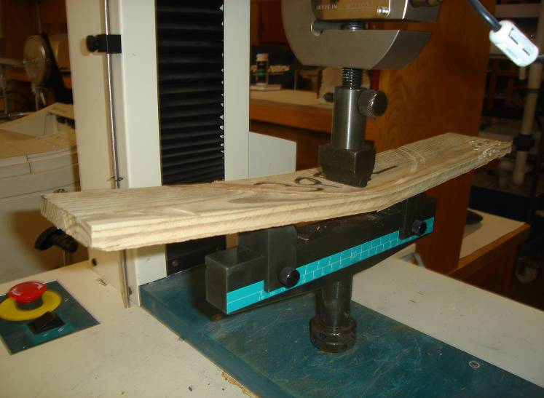

Fig. 9: Three-Point Bending Testing

Table 2: Ultimate Strength Values for CCA-treated and Creosote-treated Wood
Specimen | Creosote-treated (lbf) | Specimen | CCA-treated (lbf)
2T1 | 579.63 | 30T1 | 1045.36
2T2 | 552.28 | 30T2 | 695.78
2T3 | 162.99 | 30T3 | 641.83
4B1 | 698.41 | 31T1 | 1177.62
4B2 | 631.92 | 31T2 | 1505.09
4B3 | 808.94 | 31T3 | 1226.23
7T1 | 621.60 | 33B1 | 689.04
7T2 | 976.42 | 33B2 | 821.30
7T3 | 704.40 | 33B3 | 1127.79
11B1 | 643.21 | 36B1 | 611.11
11B2 | 786.08 | 36B2 | 517.06
11B3 | 496.08 | 36B3 | 1048.73
18T1 | 957.31 | 38T1 | 1518.21
18T2 | 985.41 | 38T2 | 2054.75
18T3 | 387.04 | 38T3 | 1405.80
27B1 | 360.82 | 39B1 | 1042.36
27B2 | 758.36 | 39B2 | 1177.25
27B3 | 743.74 | 39B3 | 1037.87
Mean | 658.59 | Mean | 1074.62
Sdev | 218.43 | Sdev | 389.02
The results of the ultimate strength testing were further analyzed using a t-test statistical analysis. The results of this testing demonstrated that the CCA-treated wood had higher ultimate strength values than the creosote-treated wood. This can be observed from Table 2, by inspecting the mean results of the ultimate strength of both types of wood. The arithmetic mean for the CCA-treated wood is 63% higher than the mean of the creosote-treated wood. In some instances, the creosote treated wood performed very poorly when compared to the rest of the specimens, e.g. samples 2T3, 18T3, and 27B1. However, these results do not coincide with heavier levels of organism attack as shown in Table 1. This may be attributable to the somewhat subjective characteristics of the proposed fungi and microorganisms intrusion ratings, which are determined by mere observation.
The moisture contents of the CCA-treated and creosote-treted wood were compared. Since the creosote-treated wood presents an oily texture, it was expected to have a lower water penetration and moisture content level than the CCA-treated wood. Nevertheless, the data obtained, shown in Tables 3 and 4, contradicts this.

Table 3: Moisture Content Comparison for CCA-Treated and Creosote-Treated Wood
Specimen | Creosote-treated (%) | Specimen | CCA-treated (%)
2T1 | 16.60 | 30T1 | 8.51
2T2 | 16.37 | 30T2 | 8.94
2T3 | 16.94 | 30T3 | 9.69
4B1 | 16.92 | 31T1 | 8.76
4B2 | 16.39 | 31T2 | 7.87
4B3 | 18.26 | 31T3 | 8.86
7T1 | 13.78 | 33B1 | 9.95
7T2 | 14.43 | 33B2 | 7.83
7T3 | 16.28 | 33B3 | 7.89
11B1 | 17.20 | 36B1 | 9.25
11B2 | 17.04 | 36B2 | 8.26
11B3 | 17.25 | 36B3 | 9.52

Table 4: Moisture Content Comparison for CCA-Treated and Creosote-Treated Wood Continued
Specimen | Creosote-treated (%) | Specimen | CCA-treated (%)
18T1 | 19.14 | 38T1 | 12.12
18T2 | 19.07 | 38T2 | 9.04
18T3 | 16.12 | 38T3 | 8.72
27B1 | 17.87 | 39B1 | 7.88
27B2 | 18.08 | 39B2 | 8.20
27B3 | 16.97 | 39B3 | 9.42
Mean | 16.91 | Mean | 8.93
Sdev | 1.40 | Sdev | 1.04
The specific gravities of the creosote-treated and CCA-treated wood were collected and compared. The tabulated values are presented in Table 5.

Table 5: Specific Gravity Comparison for CCA-treated and Creosote-treated Wood
Specimen | Creosote-treated | Specimen | CCA-treated
2T1 | 1.47 | 30T1 | 1.53
2T2 | 1.35 | 30T2 | 1.55
2T3 | 1.46 | 30T3 | 1.43
4B1 | 1.40 | 31T1 | 1.54
4B2 | 1.52 | 31T2 | 1.53
4B3 | 1.43 | 31T3 | 1.60
7T1 | 1.47 | 33B1 | 1.56
7T2 | 1.51 | 33B2 | 1.61
7T3 | 1.44 | 33B3 | 1.52
11B1 | 1.35 | 36B1 | 1.48
11B2 | 1.34 | 36B2 | 1.55
11B3 | 1.27 | 36B3 | 1.49
18T1 | 1.40 | 38T1 | 1.54
18T2 | 1.04 | 38T2 | 1.56
18T3 | 1.41 | 38T3 | 1.32
27B1 | 1.47 | 39B1 | 1.55
27B2 | 1.48 | 39B2 | 1.53
27B3 | 1.39 | 39B3 | 1.49
Mean | 1.40 | Mean | 1.52
Sdev | 0.11 | Sdev | 0.07
The findings indicate that the specific gravities of CCA-treated wood specimens were higher than those of creosote-treated wood. The statistical t-test analysis performed confirmed this.
- Conclusion
The results of the investigations indicate that the CCA-treated wood has higher ultimate strength than the creosote-treated wood by as much as 63% in average. The CCA-treated wood also provided superior resistance to organism attack, as indicated by the results of the ASTM ratings, as well as lower moisture content and higher specific gravity. Although the CCA-treated and creosote-treated wood present negative health and environmental effects, the creosote treatment may arguably be considered less environmentally harmful as it takes a much longer exposure time to develop its detrimental effects.
Acknowledgements
The authors thank Florida Atlantic University for its immense support during the experimental process. In particular, the authors would like to thank the Department of Civil Engineering for their continuous support, and the Department of Ocean Engineering for allowing the use of the Sea-Tech facilities in Dania Beach, Florida. Special gratitude is also expressed to Ms. Vilma Caballero and Mr. Victor Gutierrez for their cooperation and assistance for the completion of the project, without which the project could not have been successful. Gratitude is also expressed to Mr. S. Koshny, Senior Consultant, Golder Associates Inc., formerly from the Florida Department of Environmental Protection, Hazardous Waste Management Division, for the initial support for this project.
References
Lebow, S. (2004). “Alternatives to Chromated Copper Arsenate for Residential Construction”, Proceedings of the Environmental Impacts of Preservative-Treated Wood Conference, Orlando, Florida, USA.
Freeman, M.H., Nicholas, D.D., and Schultz, T.P. (2006). “Nonarsenical Wood Protection: Alternatives for Chromated Copper Arsenate, Creosote and Pentachlorophenol”. Environmental Impacts of Treated Wood, Editors: T.G. Townsend, and H. Solo-Gabriele, CRC Press, Boca Raton, Florida, USA.
Hoffman, T. R., Hendricks, L.T., and Powell, K. (2002). “Selecting Preservative Treated Wood with Special Emphasis on Landscape Timbers”, University of Minnesota, Minnesota, USA.
United States Environmental Protection Agency (2007). Chromated Copper Arsenate (CCA): Consumer Safety Information Sheet: Inorganic Arsenical Pressure-Treated Wood, http://www.epa.gov/oppad001/reregistration/cca/cca_consumer_safety.htm, 01/05/07.
Authorization and Disclaimer
Authors authorize LACCEI to publish the paper in the conference proceedings. Neither LACCEI nor the editors are responsible either for the content or for the implications of what is expressed in the paper.

