Fifth LACCEI International Latin American and Caribbean Conference for Engineering and Technology (LACCEI’2007)
“Developing Entrepreneurial Engineers for the Sustainable Growth of Latin America and the Caribbean:
Education, Innovation, Technology and Practice”
29 May – 1 June 2007, Tampico, México.
The Tropical Environmental Observatory Network (TEON): Collaborative Science and Technology Resource for Inter-hemispheric Sustainable Development

Carlos E. Ruiz

US Army Engineer Research and Development Center, Vicksburg, Mississippi, USA

Carlos.e.ruiz@erdc.usace.army.mil

John M. Nestler

US Army Engineer Research and Development Center, Vicksburg, Mississippi, USA
John.m.nestler@erdc.usace.army.mil

Ismael Pagan-Trinidad

University of Puerto Rico at Mayaguez, Mayaguez, Puerto Rico

Ismael.pagan@gmail.com

Domingo Rodríguez

University of Puerto Rico at Mayaguez, Mayaguez, Puerto Rico
domingo@ece.uprm.edu

ABSTRACT
Countries of the tropical Americas must manage valuable, unique, and fragile natural resources in a way that increases the standard of living for today, but without jeopardizing these natural resources for use by future generations. The University of Puerto Rico, with support from the U.S. Army Engineer Research and Development Center, proposes to establish the Tropical Environmental Observatory Network (TEON) as a focal point for developing environmental quality management tools for use in the tropics. The TEON is a suite of geographically distributed sites linked together by standardized sets of sampling equipment, sensors, sensor integration methods, monitoring protocols, database standards, database storage facilities, data viewers, and communications hardware. The TEON will allow scientists and engineers working in different countries or for different agencies and universities to collaboratively develop standardized tools to support natural resource management and sustainable development. These tools will be specifically developed for the unique and challenging conditions encountered in the tropical Americas. We will present findings from the first test site at Jobos Bay National Reserve, Puerto Rico. Under the LACCEI umbrella, the TEON will begin implementation at other sites, so that the benefits of standardized hardware, software, and procedures can be realized.
Keywords:
Environmental Observatory, Sustainable Development, Tropical Ecology, Tropical Processes,

- INTRODUCTION
  - PROBLEM STATEMENT
The countries of the tropical Americas possess some of the most valuable, unique, and fragile of the world’s natural resources that together exemplify the challenge of sustainable development. These resources must be managed in a way that increases the standard of living for today, but without depleting them for use by future generations. Latin America must equitably and sustainably develop ports and harbors, mineral resources, forest resources, water resources, and land resources. Presently, the region is struggling with issues as diverse as unregulated basin development, cultural eutrophication, unregulated aquaculture, unregulated coastal development and tourism, deforestation, and lack of potable water. In addition, these countries are subjected to catastrophic natural disasters such as earthquakes, mudslides, and floods whose effects must be forecasted and managed. Many countries in the region lack the technology base and the human resources to meet the dual challenge of sustainable development and catastrophe management because of their small size or economic status.

Many of the region’s countries share generally similar tropical climates, tropical weather patterns, land forms, hydrology, language, and culture. We conclude that they also must share common technology deficits and human resources needs. In a perfect world, these similar needs would lead to the creation of a central technology and educational resource that would meet the science, engineering, and human capital needs of the region. Such a central resource could minimize duplication of effort to economically develop new technologies and to effectively educate the region’s next generation of scientists and engineers in a collaborative, scientific setting. Unfortunately, such a resource does not presently exist.

Working through LACCEI, the University of Puerto Rico, with support from the U.S. Army Engineer Research and Development Center (ERDC), proposes to meet the technology and educational needs of the region by creating the Tropical Environmental Observatory Network (TEON) to serve as a focal point both to develop environmental quality management tools for use in the tropics and to help educate the region’s next generation of scientists and engineers.
- WHAT IS THE TEON?
The University of Puerto Rico at Mayaguez (UPRM) proposes to establish the TEON as part of both its education and outreach responsibilities and to supplement the activities of the Tropical Environmental Research Center (TERC) (Nestler, 2006). The TEON will be generally modeled after the National Science Foundation initiated National Environmental Observatory Network program (NEON), but will remain institutionally separate from it. That is, the nonprofit corporation that runs the NEON program will not have any voice in the operation of the TEON, although the TEON will parallel the NEON both in its governance structure and in its networking architecture and informatics baseline design. This separation is necessary because the NEON includes primarily sites in the USA while TEON will potentially include sites in many different countries.

The TEON will be comprised of a suite of geographically distributed sites linked together by standardized sets of sampling equipment, sensors, sensor integration methods, monitoring protocols, database standards, data viewers, database storage facilities, and communications hardware. Like the NEON, the TEON will encompass computing power, storage capacity, networking capability from sensor to scientist/user, and specialized software and hardware environments.

The TEON and TERC are designed to supplement each other (Figure 1) with the TEON focusing on the creation and use of IT tools by a user group and the TERC focusing on conducting studies by a collaborative, multi-disciplinary group of scientists and engineers. In essence, the members of TEON are the user group of the TERC. The owners of the TEON sites will typically be agencies (or universities conducting research at agency sites) in different countries who have banded together to address common issues. By banding together within the TEON, these agencies can aid in the development of standardized tools and approaches, develop human capital, maintain a consistent dialogue with the science and engineering community represented by the TERC, increase technical capacity, achieve economies of scale, and benefit from efficiencies of operation.

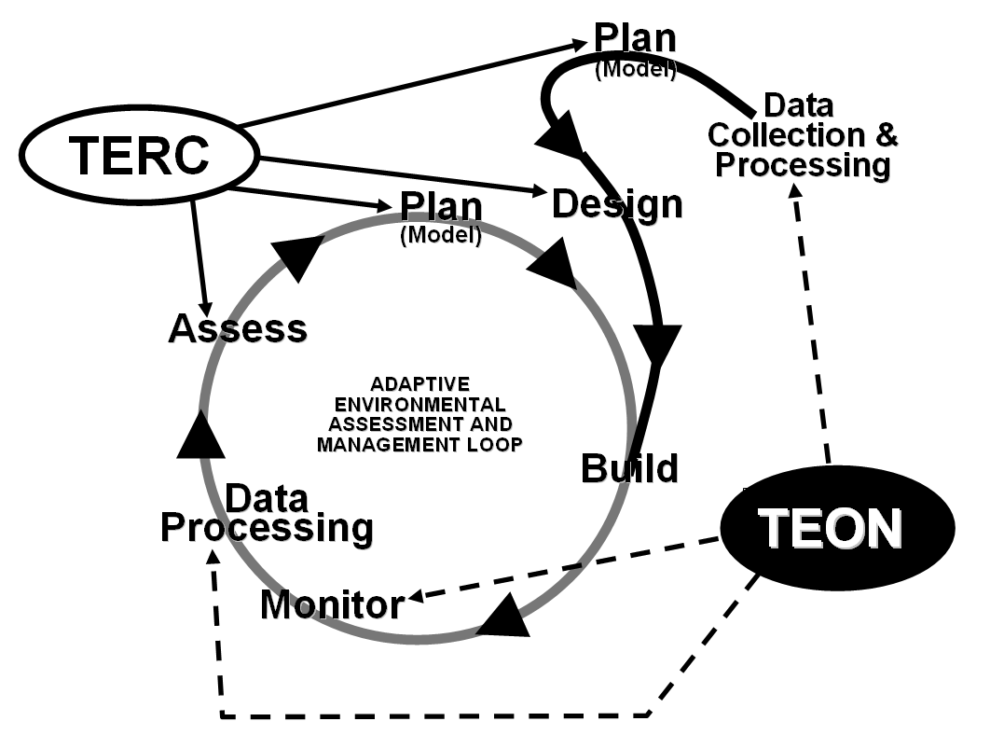

Figure 1: Relationship between the TERC and TEON for standard (black) and adaptive water resources management (gray).

Unlike NEON, the TEON cyberinfrastructure will not include staff to operate and maintain equipment, develop and support software, create standards and best practices, nor provide other key services like security and user help-desk. The staff to perform the latter suite of activities will reside within the associated TERC which, in turn, will be staffed by personnel from the UPRM, visiting scientists and engineers hosted by the UPRM, and staff of the ERDC.
  - TERC FUNCTIONS
The TERC would have two primary functions. First, it would mobilize the joint expertise of the partners to provide research, development, and technology on water resources and catastrophe management tools and technology for the Caribbean Basin and Central and South America. The countries in the region are challenged because they lack monitoring systems, forecasting tools, and assessment technologies to manage their water resources including extreme events such as droughts or storms. Second, the UPRM wishes to use the TERC to take advantage of its potential to be a doorway between the Latin countries and the USA by being a collector and distributor of Latin graduate students who are interested in studying water resources issues in the USA. UPRM can provide language skills for MS students sufficient to allow them to transfer to other major US universities for completion of the terminal degree including the Universities of Iowa and Illinois, Jackson State University, and Rice University.
  - TEON GOALS
The TEON will have the following goals for tropical zone research in the Americas:
- Provide an umbrella for consistent local and regional research & education to address complex environmental challenges.
- Support regional scale research via geographically distributed sites & infrastructure networked together via state-of-the-art IT communications.
- Provide laboratory and field instrumentation guidance, site-based experimental infrastructure templates, and analytical and modeling standards.
- Transform tropical environmental engineering research by enabling studies on major environmental challenges at regional scales.
- Optimize conduct of real-time ecological studies at all levels of biological organization and temporal and geographical scales.
- To serve in other fields as requested by the partners
- Facilitate collaboration among
- Disciplines (e.g., engineers, natural and social scientists, economists)
- Agencies within a country
- Universities
- Countries
- Provide sites for addressing present and evolving science challenges, e.g.:
- Ecosystem interfaces
- Shallow water processes
- Define reference condition ecosystem restoration
- Climate change
- Coastal geomorphology
- Ecological response
- Management of threatened, endangered, commercial, sport species
- Serve as a test bed for environmental quality (EQ) monitoring, assessment, & management tools
- TEON’S POTENTIAL CONTRIBUTION TO REGIONAL CAPACITY BUILDING
TEON will service the technology needs and educational requirements of the tropical Americas by providing a site for scientific and educational collaboration.
  - INTERHEMESPHERIC SCIENTIFIC COLLABORATION
The TEON will allow scientists and engineers working in different countries or for different agencies and universities to collaboratively develop standardized tools to support natural resource management (including extreme conditions such as floods, landslides, and droughts) and sustainable development. These capabilities are particularly important for adaptive management of complex ecosystems where “learning” about natural system response must be integrated into resource management. These tools will be specifically developed and tested for the unique and challenging conditions encountered in the tropical Americas. Moreover, the collaborative nature of the TEON ensures efficient and cost effective development and testing of these tools by avoiding duplication and ensuring interoperability across countries and agencies. Under the LACCEI umbrella, we urge the region to begin implementation planning for the TEON so that the benefits of standardized hardware, software, and procedures can be realized.
    - WALSAIP DEVELOPS INFORMATICS TOOLS FOR TEON
In 2005 the US National Science Foundation awarded funding to the UPRM for the Wide Area Large Scale Automated Information Processing (WALSAIP) proposal. WALSAIP’s goal is to develop modular, reconfigurable, and scalable working prototypes in the form systems, tools, and applications to aid and support a network infrastructure for the automated processing of signal-based information acquired from array sensors in heterogeneous, wide area, large scale, distributed systems. A second goal is the utilization of working prototypes in specific scientific and engineering applications dealing with identification, monitoring, assessment, and management of regional water resources in tropical areas, with particular emphasis given to the Caribbean region (WALSAIP, 2005). Multi-year research under WALSAIP will develop the necessary informatics infrastructure to underpin the TEON. Therefore, partners participating in the TEON will have access to the basic information technology without having to make their own separate investments. This technology will be a value-added feature of participation in TEON. WALSAIP information technology can be broadly separated into two categories, data tools and web services.
Data tools will include:
- standard data formats to standardize regional data sets so they can be efficiently utilized to develop knowledge sets;
- data viewers that work on standard data formats to graphically and statistically analyze data from TEON sites;
- sensor and sensor systems that can be used to remotely collect data to measure a variety of variables that can be used for training, status and trends determination, and model development; and
- wireless networks over which data can be transferred to either a central repository, an archive system, or directly to the user.
The tools described above can be used to create and maintain comprehensive environmental data sets for large systems such as basins, estuaries, and bays. These data sets can be used to create a monitoring network, learn about tropical system processes, be used as the foundation for the development of assessment and forecasting tools, and serve as the record of ecosystem response needed for adaptive management.
    - TECHNOLOGY TRANSFER
Achieving the full potential of TEON requires a web-based system by which scientists, managers, and engineers can communicate, archive data, and serve as a repository of tools. Using technology developed under the WALSAIP, we intend to build a full suite of web based services that includes web portals (virtual shared workspace), web browsers (to efficiently navigate through the web portal), and libraries of programs, models, and catastrophe management tools. Partners in TEON will have full access to any tools developed through the TEON. Additionally, we anticipate that some of the partners within TEON (e.g., the University of Iowa) will also be part of NEON or other major environmental observatory based programs (e.g., Water Directive Framework of the European Union) whose products can be incorporated into TEON. Training in the use of these web-based tools will be coordinated through or provided by the TERC.
  - INTERHEMESPHERIC EDUCATIONAL COLLABORATION
Scientific and engineering education is the critical element for improving regional technical capacity. The TEON will promote regional development by educating next generation of regional scientists and engineers on real problems, at large scales, and using the newest tools and technologies. Educational outreach will be met via general facilities and educational opportunities and separate specialized facilities focused on students or faculty.
    - GENERAL OUTREACH
Selected TEON sites will be learning centers that feature interpretive facilities where students of all ages and interested members of the public can see and experience first hand how science and engineering are used to build improved tools for environmental quality and catastrophe management. Exposure to these sites by students in primary and secondary schools will help interest them in careers in science or engineering. Educational outreach to the public will help Latin American societies better understand the challenges of sustainable development, the need for better tools, the need for EQ monitoring networks, and how education, science, and engineering can serve this need.
    - FACULTY OUTREACH
Collaboration through TEON will reduce or eliminate the barriers that typically prevent free communication across countries, agencies, and universities. As part of strengthening communication and collaboration among TEON partners, we plan to offer opportunities for faculty exchanges, visiting professorships, postdoctoral fellowships, and other professional networking opportunities faculty. The TEON sites will be extended because of TEON’s association with other environmental observatory based programs in the world; these opportunities for professional networking can extend beyond the region served by LACCEI.
    - STUDENT OUTREACH
The future of the region served by LACCEI hinges on the recruitment and training of the next generation of scientists and engineers. The most important goal of TEON is to provide opportunities and encouragement for student participation in scientific discovery and tool development. We plan to create an educational setting where students can select and execute topics for special projects, theses, and dissertations. Through the TEON, students can gain experience working on the large scale, real world problems they will face upon graduation. In addition to the professional preparation provided by TEON, students can be mentored by some of the region’s premier scientists and engineers through their degree work or through internships and student exchanges.
  - TEON CONTRIBUTES TO REGIONAL SUSTAINABLE DEVELOPMENT
Sustainable development requires that the needs of future generations be considered as the needs of today’s generation are met. Sustainable development, often done in an adaptive management framework, requires tools for status and trends assessment and environmental forecasting that work in a tropical environment and target the critical environmental management issues in the region served by LACCEI. TEON will contribute to sustainable development in several ways.
    - SENSORS AND SENSOR SYSTEMS
Sensors and sensor systems are a critical part of sustainable development because they provide information that can be used for status and trends analysis and create the data sets that can be used to develop, calibrate, and validate forecasting tools. Innovative sensor designs can integrate information obtained from several variables; be designed to work in remote areas, or be hardened to work under extreme conditions, or designed for use commensurate with local technology level in undeveloped areas.
    - SCALING UP TO LARGE AREAS
The building blocks of TEON are individual sites each of which shares common data formats and can be easily accessed by web tools. Within the TEON framework, sites can be scaled from individual sites to continental scales depending upon how the data are consolidated. This scalability of the data allows issues to be addressed from local (watershed), to basin wide and finally to continental scales depending upon the needs of the TEON partners.
    - TEST BED FOR ENVIRONMENTAL MANAGEMENT TECHNIQUES
Many large scale environmental challenges require an adaptive management approach in which best management practices are implemented along with monitoring ecological response variables. By analyzing the response variables, managers are able to discern the effectiveness of a particular management action and adjust it as needed. TEON sites designated for long term monitoring can provide excellent opportunities for the “learning” phase of adaptive management in which the relationship between management action and ecosystem response is discerned. Moreover, this “learning” can be institutionalized in the standardized tool sets that the TEON will make available to its partners.
- PROOF OF THE TEON CONCEPT - JOBOS BAY
The Jobos Bay National Estuarine Research Reserve (JBNERR) includes 2,883 acres in the second largest estuarine area in Puerto Rico (Figure 2). The Reserve encompasses 15 tear shape mangrove islets known as Cayos Caribe and the Mar Negro area in western Jobos Bay. The reserve is located on the southern coast of Puerto Rico (see Figure 2 insert), between the municipalities of Guayama and Salinas and is home for the endangered brown pelican, peregrine falcon, hawksbill sea turtle, and West Indian manatee. The Reserve, designated in 1981, is principally managed by the Department of Natural and Environmental Resources.
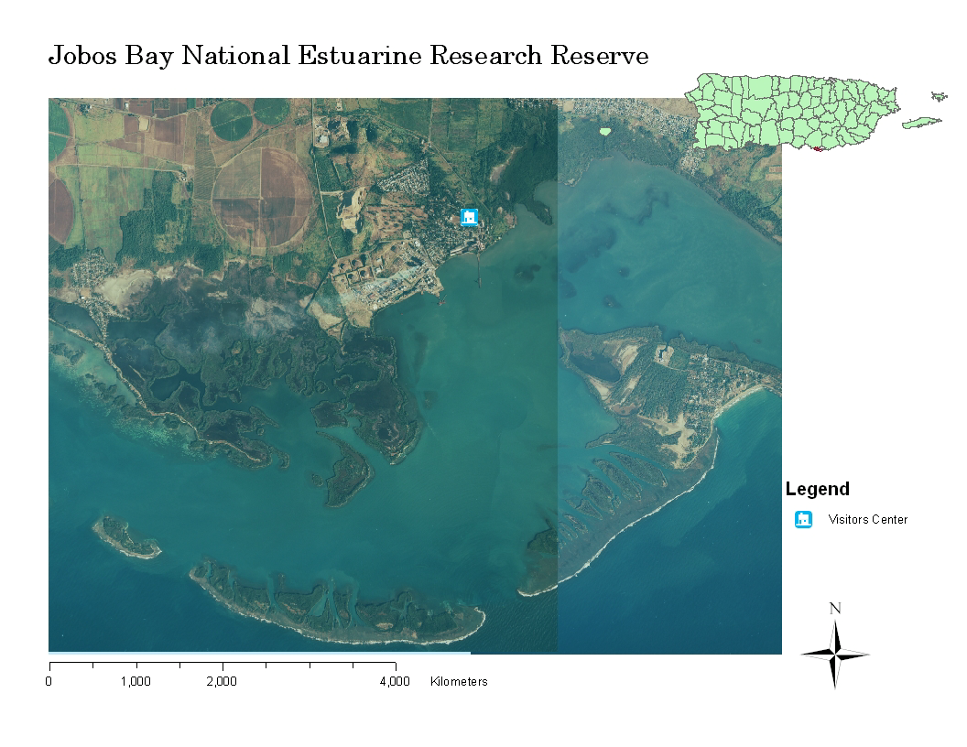

Figure 2: Jobos Bay Reserve
The Jobos Bay Reserve is made up of subtropical dry forest, coral reefs, fringing and basin mangrove forest, seagrass beds, mangrove channels, salt and mud flats, lagoons and freshwater wetlands. JBNERR is the only site in the National Estuarine Research Reserve System that contains a representative example of an offshore Caribbean coral reef. The reserve’s corals display the typical zonation of Caribbean reefs. Finger corals, gorgonians, zoanthids and seagrass beds characterize the scoured channels between the Cayos Caribe islands. Like many reef communities found in southern Puerto Rico, communities located off Cayos Caribe exhibit relatively low diversity and abundance and tend to be dominated by massive scleractinian corals, gorgonian octocorals and algae. These habitats form a very complex, diverse and productive coastal association that provides unique opportunities for environmental research and education (Jobos Bay, 2006a).
Reserve facilities in Aguirre consist of a visitor center and administrative building that includes a laboratory, conference and exhibit area, and library. A dormitory is available to house visiting researchers and educational groups. Interpretive trails are located on Cayos Caribe, Jagueyes Forest and Mar Negro Lagoons.
National Estuarine Research Reserves are federally designated "to enhance public awareness and understanding of estuarine areas, and provide suitable opportunities for public education and interpretation." The reserve system is one of only three programs within NOAA in which education is federally mandated. The reserve system provides a range of educational programming to key audiences in reserve watersheds (community groups).
The Coastal Training Program provides up-to-date scientific information and skill-building opportunities to individuals who are responsible for making decisions that affect coastal resources. Coastal Training Programs offered by reserves focus on issues such as coastal habitat conservation and restoration, biodiversity, water quality and sustainable resource management. Programs target a range of audiences, including land-use planners, elected officials, regulators, land developers, community groups, environmental non-profits, and coastal businesses. These training programs provide a range of opportunities for professionals to network across disciplines and develop new collaborative relationships to solve complex environmental problems (Jobos Bay, 2006b).
The selection of JBNERR as the first test site for the TEON was based on the proximity of the site to the UPRM, the monitoring needs of the reserve, the foundation of a NOOA site, and that education is a federal mandate for the facility. In addition, the site is suited for what the TEON wants to provide: sites where research facilities are available, current research and monitoring programs are ongoing, and a mandate exists for further investigations. The initial application at JBNERR is a distributed sensor network (WALSAIP 2006). The test bed is the establishment of a wireless monitoring station that uplinks monitoring data, typical of Figure 4, to the UPRM servers. The site fits into WALSAIP’s environmental surveillance monitoring, which focuses on water-related ecological and environmental applications, and addressing issues such as scalability, modularity, signal representation, data coherence, data integration, distributed query processing, scheduling, usability, and computer and network performance.
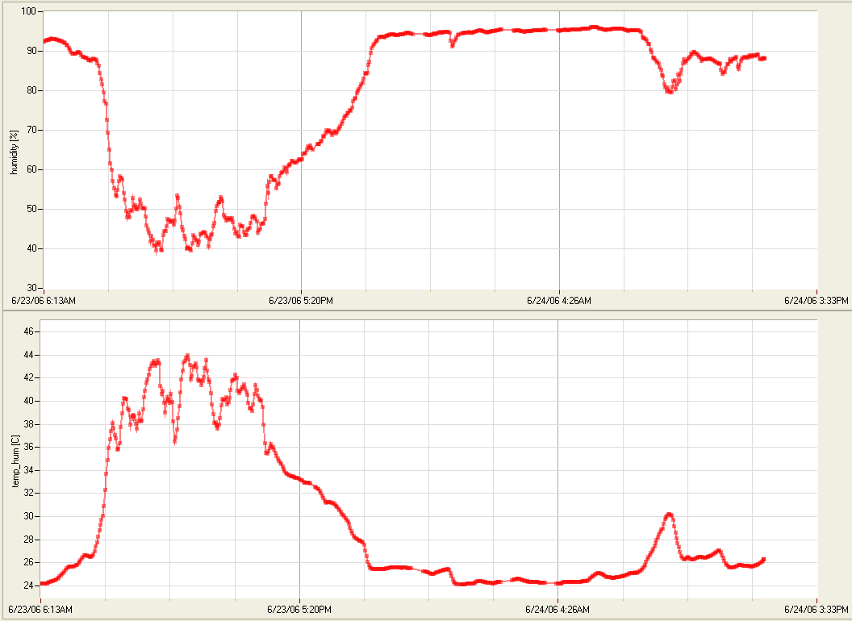
Figure 3: Jobos Bay Reserve Monitoring Data.

  - EDUCATION OUTREACH EXAMPLES
The selection of JBNERR as the first TEON site was based on its potential for an educational outreach site. JBNERR is a site where students from different disciplines and countries can learn and perform research in processes unique to Jobos Bay. In JBNERR students are able to study endangered species, coral reefs, and a unique estuarine whose largest source of fresh water is groundwater. The site’s facility includes a dormitory, thus facilitating the accommodation of students from remote sites. Students are able to participate in current research initiatives (Jobos Bay 2006c) or submit proposals for future research (Jobos Bay, 2006b).
  - FUTURE TEON SITES?
Future TEON sites have to follow the example of Jobos Bay. They need to have a history and commitment to monitoring, education, and research. One such site is the Mayagüez Bay Watershed. This coastal watershed is located on the western side of the Island of Puerto Rico. The Mayagüez Watershed Initiative has been primarily focused on the development of a conservation and management plan for the Río Grande de Añasco watershed. The Río Grande de Añasco is one of the three main tributaries of Mayagüez Bay. The drainage area of the Río Grande de Añasco watershed extends over eight Municipalities (Mayagüez, Añasco, San Sebastián, Las Marías, Lares, Maricao, Adjunta and Yauco) and contains thirteen additional rivers (Guilarte, Limaní, Guayo, Prieto, Toro, Blanco, Cañas, Lajas, Guabo, Bucarabones, Mayaguecilla, Arenas and Casei) and four lakes (Lake Guayo, Lake Yahuecas, Lake Prieto and Lake Toro). These rivers converge into Río Grande de Añasco which drains into the Mayagüez Bay. Numerous studies in the watershed have identified the need to develop a strategic plan to reduce sediment and nutrient loads, as well as other pollution sources (Mayagüez Bay, 2006).
Other potential sites are in Belize: One is the Gladden Inlet - Laughingbird Caye – Little Water Caye marine reserve and the second is Placencia Lagoon. The islands are a marine reserve which supports spawning aggregations of snapper and grouper fish, and whale sharks. Placencia Lagoon is a shallow estuary between the Placencia peninsula and the mainland. The lagoon is fringed with red mangroves, supports several species of sea grass, tarpon, snook, American crocodiles, and manatees.
Around fifty studies of long term research and monitoring of the Belize reef and coastal zone have been performed by Smithsonian over the years. Several nutrient and sediment transport studies have been performed in the last three years. All the attention from local sources and USA researchers (Michigan, Illinois, and Georgia) makes the study areas in Belize prime candidates for selection as a TEON site.
- GOVERNANCE
TEON governance will be modeled after the U.S. National Science Foundation NEON program. The principal objective for the governance, oversight, and coordination of TEON networking and informatics include:
- Establish a clear organization command and control structure that is capable of providing critical TEON support with respect to communication, data and information processing and exchange, and security.
- Create a forum whereby partners involved in TEON can define their science needs requirements.
- Through the TERC create working groups and expert teams to oversee the development of TEON cyberinfrastructure and ensure that community-based standards and best management practices are adopted.
- Coordinate development of TEON cyberinfrastructure with LACCEI, other observatory groups, other partnering scientific enterprises to maximize data sharing and interoperability.

TEON governance, oversight, and coordination will be provided by a Limited Liability Corporation, TEON, Inc., that will be generally modeled after NEON governance. TEON will be managed by a Chief Executive Officer (CEO) who reports to a Board of Directors comprised of a maximum of twelve board members distributed into a permanent (six) and temporary (maximum six) groups. The CEO will be nominated by the President of the UPRM and must be approved by a majority of board members. The CEO will serve a term of two years renewable once. The six permanent board members will be distributed as follows: two from UPRM, two from ERDC, and two from LACCEI institutions. Permanent Board members will be selected as follows: UPRM President (2), ERDC Director (2), and executive council of LACCEI (2). Permanent board members will serve terms of two years renewable once. The CEO will assign one permanent board member each to the following roles: Chief Information Officer, Cyber Security Officer, Sensor Development and Application Coordinator, Applied Modeling and Assessment Coordinator, Modeling Needs Coordinator, and Social and Water Resources Issues Coordinator. The CEO will execute the will of the permanent board members as determined during monthly board meetings and will not vote in Board deliberations except to break a tie. Temporary board members will be nominated by a majority of permanent board members and serve nonrenewable two year terms. Temporary board members generally will reflect the composition of TEON sites. Figure 4 shows the relationships among the partners and potential partners of the TEON.
- DISCUSSION
The underlying rationale for the TEON and its value for environmental quality management in the tropics are symbolically described in Figure 1. A substantial economy of scale can be achieved by developing standardized suites of procedures and tools for monitoring, assessment, and forecasting focused on unique tropical conditions. This economy occurs because the duplication of developing similar tools and procedures for each new study is avoided. Therefore, study costs are reduced, staff can be more efficiently trained, trans-boundary disputes over EQ issues are reduced, and resource management is improved.

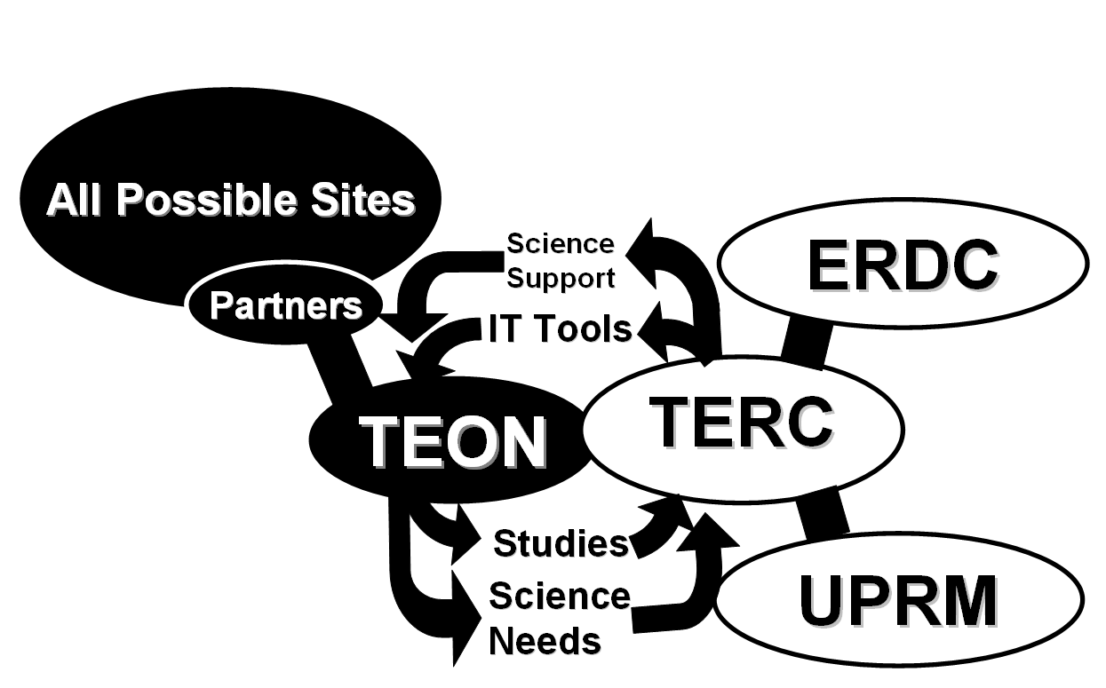
Figure 4: Relationship between TEON, TERC, UPRM, ERDC, and potential partners with decision making authority (black blocks) and technology flow (arrows).

References
Jobos Bay (2006a). Jobos Bay National Estuarine Research Reserve (JBNERR), http://nerrs.noaa.gov/JobosBay/welcome.html (February 10, 2007).
Jobos Bay (2006b). “Jobos Bay National Estuarine Research Reserve Evaluation (2006),” Office of Ocean and Coastal Resource Management National Ocean Service National Oceanic and Atmospheric Administration. http://coastalmanagement.noaa.gov/mystate/docs/JobosBayNERR2006.pdf (February 10, 2007).
Jobos Bay (2006c). JBNERR Research Opportunities, http://ctp.uprm.edu/jobos/ and http://ctp.uprm.edu/jobos/investigacion/becas.html (February 10, 2007).
Mayagüez Bay (2006). Mayagüez Watershed Initiative. http://www.epa.gov/region02/water/lakes/mayaguez.htm
Nestler, J.M., Ruiz, C.E., Fleming, B., and Pagan-Trinidad, I. (2006). “Tropical Environmental Research Center,” Second WALSAIP and Wetlands Workshop, University of Puerto Rico at Mayaguez, Mayaguez, Puerto Rico; February 6, 2006.
WALSAIP (2005). “The Wide Area Large Scale Automated Information Processing (WALSAIP) Project, WALASAIP Newsletter, Vol. 1, No. 1, August 31, 2005.
WALSAIP (2006). WALSAIP Testbeds, http://www.walsaip.uprm.edu/index.php (February 10, 2007).
Wilcox (2004). MEMORANDUM FOR: CEERD-EP-W, Attn: Drs. John Nestler and Carlos E. Ruiz, March 31, 2004.

Authorization and Disclaimer
Authors authorize LACCEI to publish the paper in the conference proceedings. Neither LACCEI nor the editors are responsible either for the content or for the implications of what is expressed in the paper.

