Fifth LACCEI International Latin American and Caribbean Conference for Engineering and Technology (LACCEI’2007)
“Developing Entrepreneurial Engineers for the Sustainable Growth of Latin America and the Caribbean:
Education, Innovation, Technology and Practice”
29 May – 1 June 2007, Tampico, México.

Capping Design Approaches for Contaminated Sediments

and Dredging Residuals:

Engineered Reduction in Bioavailability

Carlos E. Ruiz

Research Civil Engineer, US Army Engineer R&D Center, Vicksburg, MS, USA, Carlos.E.Ruiz@erdc.usace.army.mil

Paul R. Schroeder

Research Civil Engineer, US Army Engineer R&D Center, Vicksburg, MS, USA Paul.R.Schroeder@erdc.usace.army.mil

Abstract
Traditionally, caps for in situ contaminated sediments have been designed for complete, long-term isolation by using very thick layers of capping materials. Great savings and flexibility could be obtained by designing for reduction in bioavailability instead of isolation, or a combination of both. Caps could be designed for reduction in bioavailability using clean sands and gravels or adsorptive or reactive media. Thin sand caps can reduce flux to the water column by providing a short-term physical separation between the water column and contaminated sediment until mixing moves contaminants to the water-cap interface. Thin caps are suitable for residuals isolation following environmental dredging. Low organic carbon sand caps reduce short-term bioavailability to the food chain by burial and reduction in sediment productivity by decreasing sediment carbon in the surficial sediment layer. Thin sand caps are best suited for water bodies with high burial rates or high water column productivity that will replenish the sediment with clean organic carbon. Adsorptive or reactive caps can reduce flux to the water column by decreasing contaminant bioavailability in the sediment due to reduction of contaminant concentration in the pore water. A multi-layered cap would address contaminants with different properties or classes.

Keywords: Dredging, Residuals, Capping, Sediments, Contaminants
- Introduction
Traditionally, caps for in situ contaminated sediments and dredged material in confined aquatic disposal cells have been designed for long-term isolation by using very thick layers of capping materials. To achieve isolation, cap thickness is provided to accommodate bioturbation, consolidation, erosion, placement variability, advection and diffusion for long-term control. Limitations due to volume of capping materials required and costs have sometimes restricted the areal extent of cap coverage. In some circumstances, the thickness presents unacceptable impacts on navigable depth, limiting the range of projects and areas that can be remediated by isolation capping. Great savings and flexibility could be obtained by designing for reduction in bioavailability instead of isolation.
Caps could be designed for reduction in bioavailability using clean sands and gravels or adsorptive or reactive media. Thin sand caps can reduce flux to the water column by providing a short-term physical separation between the water column and contaminated sediment until mixing moves contaminants to the water-cap interface. Mixing is provided by erosion, resuspension, deposition and bioturbation. Low TOC sand caps reduce short-term bioavailability to the food chain by burial and reduction of sediment dwelling organisms and reduction in sediment productivity by decreasing sediment carbon in the surficial sediment layer. These effects are particularly pronounced for shallow bioturbators. Thin sand caps are best suited for water bodies with high burial rates or high water column productivity that will replenish the sediment with clean organic carbon.
Adsorptive or reactive caps can reduce flux to the water column by decreasing contaminant bioavailability in the sediment due to reduction of contaminant concentration in the pore water. These caps also reduce bioavailability to the food chain by decreasing bioaccumulation in the sediment dwelling organisms due to reduction in sediment contaminant concentration. Adsorptive media for organic contaminants could consist of natural sediments/soils that are high in organic carbon, amended soils/sands with activated carbon, coke, other low-cost carbon, or other sorbents. Adsorptive media for heavy metals could consist of zeolites, clays, and metal oxides. Reactive media include zero-valent iron, phosphates, and similar reactants.
  - RECOVERY MODEL
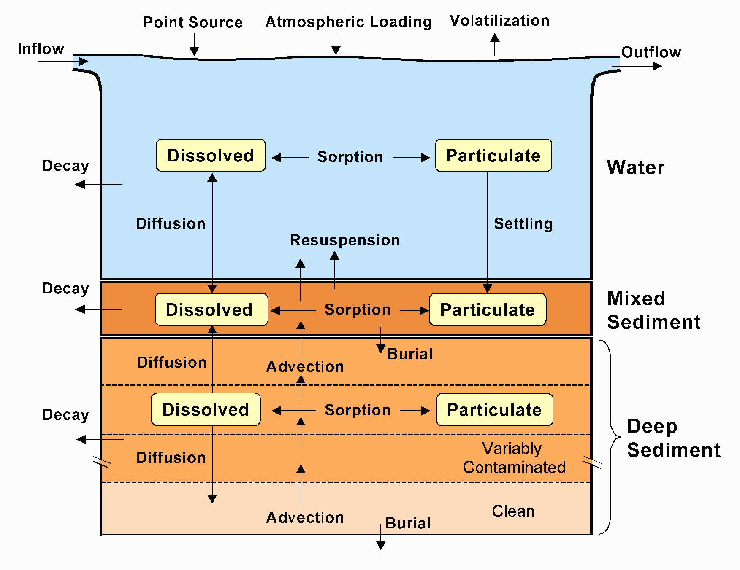
The computer model, RECOVERY (Ruiz et al. 2007, Ruiz and Gerald, 2001, Boyer et al 1994), is used to assess the long-term impact of contaminated bottom sediments on surface waters. The model couples contaminant interaction between the water column and the bottom sediment, as well as between the contaminated and clean bottom sediments. The contaminant is assumed to follow linear, reversible, equilibrium sorption and, if decay occurs, first-order decay kinetics. The physical representation of a system consists of a well-mixed water column underlain by a vertically-stratified sediment column. The sediment is uniform horizontally but segmented vertically into a well-mixed surface (active) layer and deep sediment. The deep sediment is segmented vertically into variably contaminated and clean sediment regions. Processes incorporated in the model are sorption, decay, volatilization, burial, resuspension, settling, bioturbation, and pore-water diffusion. The solution couples contaminant mass balance in the water column and in the mixed sediment layer along with diffusion in the deep sediment layers. The model was verified against laboratory and field data (Ruiz et al. 2001), as well as against an analytical solution for the water and mixed sediment layers. These comparisons indicate that the model can be used as an assessment tool for evaluating remediation alternatives for contaminated bottom sediments. A schematic of the system and the processes modeled in RECOVERY is shown in Figure 1.
Figure 1: Schematic of the Sediment-Water System as Modeled in RECOVERY
  - CAP CONFIGURATIONS FOR CONTAMINATED SEDIMENTS

The assessment of new and traditional capping designs was based on cap performance to contain contaminants. The assessment consisted of a parametric evaluation of the capping designs using the RECOVERY model. Two cap conditions were considered: a thin (15-cm) cap representing the short-term isolation and surficial sediment dilution condition, and a thick (100-cm) cap representing the long-term isolation condition. The various options are presented in Figure 2 (each layer is 5 centimeters). All the evaluations were performed with a mixed layer of 5 or 10 centimeters (the gray area labeled bioturbation in Figure 2). Minimization of the cap thickness while limiting contaminant exposures to acceptable levels is desired to provide significant cost savings. Two capping media (sand and an adsorptive media) and two isolation thicknesses (5 cm and 80 cm) were examined. Model parameters and contaminant partitioning characteristics between the pore water and capping media are listed in Table 1.

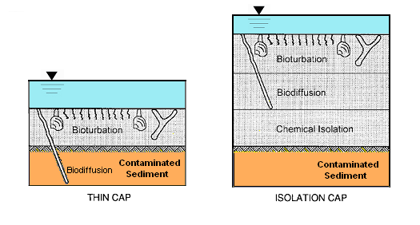
Figure 2: Cap Configurations

  - ENVIRONMENTAL DREDGING RESIDUALS
Residuals (shown in Figure 3) in the broadest sense refer to the contaminated sediment left behind in or adjacent to the dredging footprint following a dredging operation. Because there are numerous potential sources of surface or near-surface residual sediment contaminants, residuals can be broadly grouped into two categories: 1) undredged inventory; and 2) generated dredge residuals.

Undredged inventory includes all contaminated sediments above the target cleanup level that may be present beneath the dredged prism cutline, which are uncovered as a result of the dredging operation. Dredge-generated residual includes all residual sediments resulting from the dredging operation. Sources of generated dredge residuals include sediments dislodged but left behind by the dredgehead that fall to the bottom without being widely dispersed, material that sloughs into the dredge cut from adjacent undredged areas, sediments resuspended by the dredge head that quickly resettle, and sediments resuspended by dredging or other activities in upcurrent areas that resettle to the bottom (although dredging is normally conducted in the downstream direction in order to avoid this).

All dredges leave some residual sediment, and it has become clear with field experience that residual sediment can be a major factor driving cost and effectiveness of an environmental dredging project. Residual sediment

Table 1: Baseline Values Used in the Parametric Evaluation

Parameter | Value
Mixed layer thickness (cm) | 5 and 10
Cap thickness (cm) | 15 and 100
Porosity of cap | 0.5
Specific gravity of cap | 2.67
Kd for cap | 1 and 1000
Initial contaminant concentration in cap (mg/kg) | 0.2
Sediment thickness (m) | 1
Porosity of sediment | 0.67
Specific gravity of sediment | 2.54
Kd for sediment | 10
Initial contaminant concentration in sediment (mg/kg) | 100
Settling velocity (m/yr) | 26
Burial velocity (m/yr) | 0.00003
Molecular diffusivity (cm2/sec) | 5x10-6
Biodiffusion coefficient (cm2/sec) | 2x10-5
Biodiffusion depth (cm) | 5 and 10

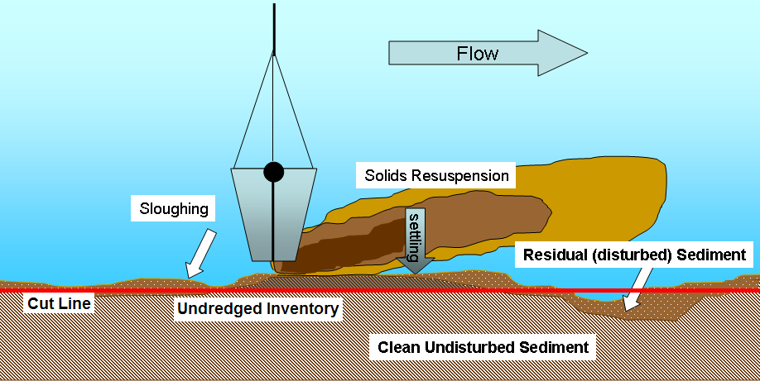
Figure 3: Schematic of Residuals
thicknesses for environmental dredging projects have ranged from a few inches up to a foot, while measured residual contaminant concentrations have widely varied, ranging from less than 1% to near 100% of the pre-dredge concentrations (surficial concentrations were actually higher after dredging for a few projects) (Herrenkohl et al 2003). Unlike typical contaminated sediment layers, residuals from environmental dredging are generally thin layers (1 to 10 cm layers with low solids content) with a limited mass of contaminants and may be present for only a few months or years.
Residual concentrations have been predicted for some projects based on an average concentration of the pre-dredging sediment profile (Herrenkohl et al 2003, and Reible at al 2003), and such predictions compared favorably with post-dredging sampling at the New Bedford Harbor site (Herrenkohl et al 2003). Unfortunately, there is little quality data on the magnitude and nature of residual and no commonly accepted methods to predict or monitor the thickness or concentration of residual for a given dredge type operating at a given site (Palermo and Averett 2003).
Patmont and Palermo (2007) compiled data on residuals from twelve environmental dredging projects. He found that the residuals contained 5 to 9% of contaminant mass removed for the eight projects containing PCBs. The other four sites having more mobile contaminants had residuals ranging from 2 to 4% of the contaminant mass removed. The mass of solids in the residuals corresponds to about 10% of the solids (Hayes and Patmont 2004).

Table 2: Values Used in the Residuals Parametric Evaluation
Parameters | Values
Cap Thickness | 0, 5, 10, 20 cm
Capping Media | Sand  Topsoil  Carbon Sand Mixture  Sand over Carbon Sand Mixture
Contaminant | Acenaphthylene
Kow | 5010
- Results and Discussion
  - Contaminated Sediments

The results of the RECOVERY model runs for capping contaminated sediment are shown in Figures 4, 5 and 6 for the five cap configurations, a 100-cm thick isolation cap, a 15-cm thin isolation cap with 5 cm mixed layer and 5 cm biodiffusion, a 15-cm thin cap with 10 cm mixed layer and 10 cm biodiffusion, and two 15-cm adsorptive caps (thin and isolation). Figure 4 presents the contaminant flux from the sediment to the water column as a function of time for the five cap configurations. Figure 5 presents the contaminant concentration in the surficial mixed layer as a function of time for the five cap configurations. Figure 6 presents the contaminant concentration in the pore water of the surficial mixed layer as a function of time for the five cap configurations.

Traditionally, caps have been designed to reduce the surficial concentration of contaminants to decrease the exposure to receptors. Figure 4 shows the thick isolation cap reduces the surficial sediment concentration the most, followed by the thin isolation cap, and then the thin caps. The long-term concentrations of the sorptive caps are lower than all of the sand caps. From the standpoint of bioavailability as shown potentially by the pore water concentrations in Figure 5, the sorptive caps perform the best. The thick isolation cap performs better than the other sand caps and the thin cap performs only slightly worse than the thin isolation cap. With high deposition rates, the difference between all three sand caps becomes small. The flux results shown in Figure 6 show the same performance as indicated by the pore water results.

Figure 4: Surficial Sediment Concentration Predictions

Figure 5: Surficial Pore Water Concentration Predictions

Figure 6: Contaminant Flux Predictions
  - Residuals
The surficial pore water concentration predictions for capping residuals are shown in Figure 7 as a function of the cap thickness and capping media. Surficial pore water concentration is a strong indicator of bioavailability. Thin caps (5cm) reduce contaminant exposure (bioavailability) as a function of carbon content in the capping media; increasing carbon content reduces bioavailability. Minimal isolation caps (10 cm) reduces exposure 1 order of magnitude more than a thin cap for mobile contaminants (acenaphthylene), independent of carbon content. Full isolation caps (20 cm) reduce exposure 2 orders of magnitude more than minimum isolation caps for mobile materials. The reductions produced by the isolation caps would be greater for immobile contaminants (such as PCBs) and would be a strong function of carbon content.
- Conclusions

Thin caps significantly reduce bioavailability and perform best in areas of higher deposition. When compared to the bioavailability of the sediment prior to capping contaminated sediments, even the thin cap reduces contaminant flux and pore water concentration by a factor of 50 initially and by at least a factor of 20 in the long term as well as reducing the surficial sediment concentration by a factor of 500. The sorptive caps reduce the bioavailability of contaminated sediments by a factor of about 100 more than all of the sand caps over the long term. Thin, sorptive caps can be employed successfully in areas of high, deep bioturbation and low burial rates. In the long term, thick sand isolation caps perform only slightly better than other sand caps. In all cases caps must be physically stable to achieve the desired long-term performance. Capping material properties are important for thin and minimal isolation caps and for mobile contaminants. Greater cap thickness and/or retardation capacity should be provided for mobile contaminants.

Figure 7: Surficial Pore Water Concentration Predictions for Capped Residuals
- Acknowledgements

The model described and the results presented herein, unless otherwise noted, were obtained from research conducted under the Dredging Operations Environmental Research Program of the United Stated Army Corps of Engineers by the U.S. Army Engineer Research and Development. Permission to publish this information was granted by the Chief of Engineers.
References

Boyer, J. M., Chapra, S. C., Ruiz, C.E. and Dortch, M. S. 1994. RECOVERY, A Mathematical Model to Predict the Temporal Response of Surface Water to Contaminated Sediments. Technical Report W 94 4, U.S. Army Engineer Waterways Experiment Station, Vicksburg, MS.
Hayes, D. F., and Patmont, C. 2004. Estimating & Evaluating Post-Dredging Residuals: Approaches, Tools, and Methods, Addressing Uncertainty and Managing Risk at Contaminated Sediment Sites, USACE/USEPA/SMWG Joint Sediment Conference, Vicksburg, MS, October 26-28, 2004. http://el.erdc.usace.army.mil/workshops/04oct-ccs/M-Hayes-Patmont.pdf
Herrenkohl, M. J., Lally, J., Johnston, B., Hartman, G., Snow, E., Fowler, T., Hogarty, B., Keeley, K., and Wakeman, J. (2003). “Engineering case study – Ward Cove sediment remediation project, Ketchikan, Alaska,” Journal of Dredging Engineering, 5(2), 15-33.
Palermo, M.R., and Averett, D.E. 2003. “Environmental dredging - A state of the art review.” Proceedings of the 2nd International Symposium on Contaminated Sediments: Characterization, Evaluation, Mitigation/Restoration, Monitoring, and Performance, Quebec, Canada, May 26–28.
Patmont, C. and Palermo, M.R. 2007. Case Studies of Environmental Dredging Residuals and Management Implications. Proceedings of the Fourth International Conference on Remediation of Contaminated Sediments, Savannah, Georgia; January 22-25, 2007.
Reible, D.D., D. Hayes, C. Lue-Hing, J. Patterson, N. Bhowmik, M. Johnson, and J.Teal , “Comparison of the Long-Term Risks of Removal and In-Situ Management of Contaminated Sediments in the Fox River”, Journal of Soil and Sediment Contamination, 12(3) 325-344 (2003).
Ruiz, C. E., Aziz, N. M., and Schroeder, P. R. 2001. “RECOVERY: A Contaminated Sediment-Water Interaction Model,” Environmental Modeling & Assessment. 6: 151-158.
Ruiz, C. E. and Gerald, T. K. 2001. “RECOVERY version 2.0: A mathematical model to predict the temporal response of surface water to contaminated sediments,” ERDC/EL TR 01-3, U.S. Army Engineer Research and Development Center, Vicksburg, MS.
Ruiz, C. E., Schroeder, P. R., Dortch, M. S., and Gerald, T. K. 2007. RECOVERY Version 4.3: An Improved Contaminated Sediment-Water Interaction Model. Proceedings of the Fourth International Conference on Remediation of Contaminated Sediments, Savannah, Georgia; January 22-25, 2007.

Authorization and Disclaimer
Authors authorize LACCEI to publish the paper in the conference proceedings. Neither LACCEI nor the editors are responsible either for the content or for the implications of what is expressed in the paper.

