Fifth LACCEI International Latin American and Caribbean Conference for Engineering and Technology (LACCEI’2007)
“Developing Entrepreneurial Engineers for the Sustainable Growth of Latin America and the Caribbean:
Education, Innovation, Technology and Practice”
29 May – 1 June 2007, Tampico, México.
Applying Lean methodologies and tools in an egg producing company

Joaquín Fuentes-Pila, Carlos Rodríguez Monroy
Food Quality Engineering Research Group. Departamento de Ingeniería de Organización, Administración de Empresas y Estadística, E.T.S.I.I., Universidad Politécnica de Madrid, Madrid, España, crmonroy@ingor.etsii.upm.es

Ramón Antelo, Juan Torrubiano, Larisa Roldán
Galgano Group. Consulting Company

Abstract
Since Womack et al. (1990) published “The Machine that Changed the World”, showing the results of an international assembly plant benchmarking study carried out by the MIT International Motor Vehicle Program, the Lean Production paradigm, initially based on the Toyota Production System, has been applied successfully by an increasing number of leading companies within the automotive industry. Currently, Lean methodologies and tools have already shown their potential, both in manufacturing and service sectors, to improve dramatically productivity, speed, responsiveness, delivered value, and profits. Lean Manufacturing has also been applied by large companies in the agri-food sector, but there is little information on these applications available in the scientific literature. Similarly to applications of other Total Quality Management improvement methodologies such as Six Sigma, highly specialized consulting companies are playing a major role in supporting and facilitating their introduction in large companies. However, it is not clear whether these methodologies can be applied to SMEs following the same patterns. This paper illustrates the application of the Lean Production methodology in an egg producing medium enterprise. In this initiative, a team from the Technical University of Madrid and consultants from Galgano Group, a consulting company with an extensive experience in Lean Production, have collaborated under the financial support of the Spanish Centre for the Development of Industrial Technology (CDTI). Preliminary results as well as strengths and weaknesses of the Lean methodology applied in this specific context are discussed.

Keywords: Lean Manufacturing, Value Stream Mapping, Supply Chain Management; Consumption Egg Production

1. Introduction
Galgano Group has developed its own methodology for the implementation of a Lean Production System in different types of organizations. This methodology is based on the Toyota Business System (Galgano, 2002) and incorporates the most recent developments disseminated by the Lean Enterprise Institute, a non-profit organization founded by James P. Womack and Daniel T. Jones. But accumulated experience and know how are key factors for understanding the leading role that Galgano Group is playing in helping private companies and public service organizations to create Lean organizations (Galgano, 2006). Figure 1 shows the main principles and tools that are applied by Galgano Group for implementing a Lean Production System.
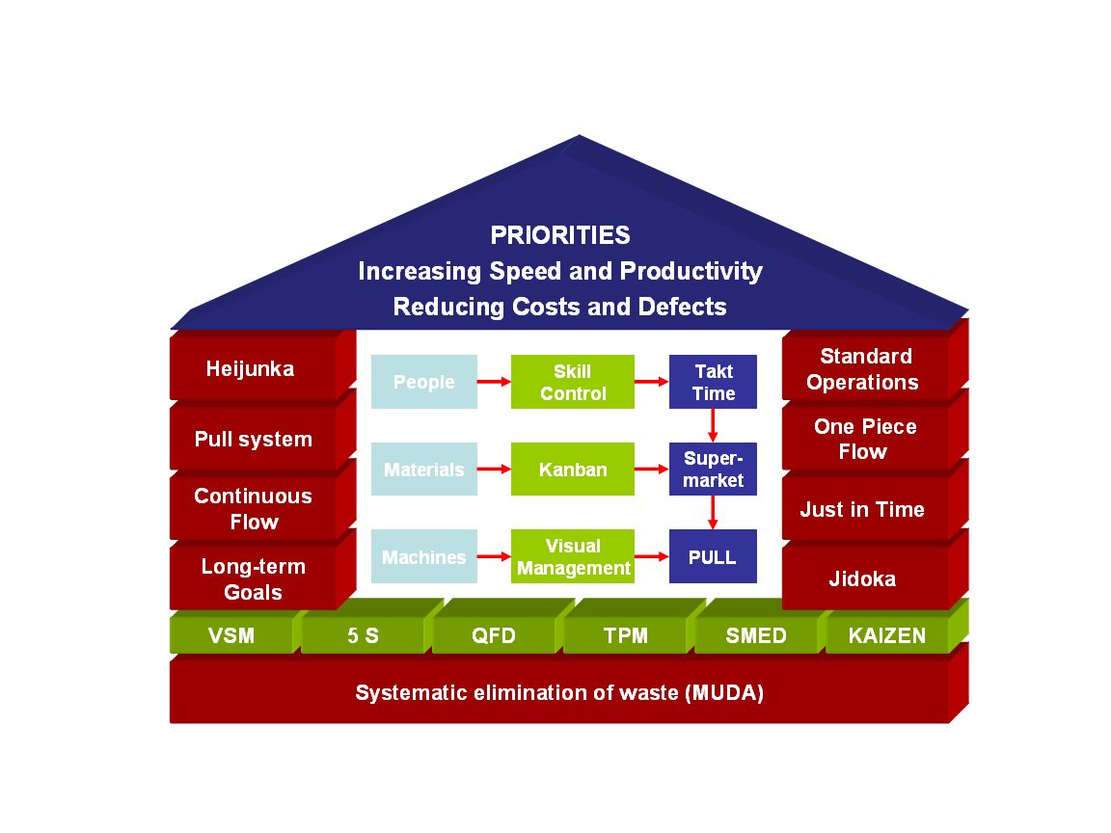
Figure 1: Main Principles and Tools applied by Galgano Group for implementing a Lean Production System

A connected issue is the role of Lean Manufacturing in the design of Lean Supply Chains for standard food products. Shell eggs are a good example of a standard food product. Advocates of Supply Chain Management maintain that competition is shifting from firm versus firm to supply chain versus supply chain. Supply Chain Management integrates suppliers, manufacturers, distributors, and customers by using information technology to meet final consumer needs and expectations efficiently and effectively. Researchers in this field are investigating how to design and build more effective supply chains. Recently, a theoretical framework for supply chain design has been proposed. This framework establishes a connection between the type of product being produced (standard, innovative, or hybrid) and the type of supply chain (lean, agile, or hybrid) that could be more effective and competitive. The feasibility of applying this framework to the Spanish egg supply chains is examined. Adopting a case study perspective, this paper explores the possibilities of connecting Lean initiatives at company level with improvements in the coordination of food supply chains.

In the Spanish agri-food sector, this consulting company has applied successfully its methodology for implementing Lean initiatives in companies such as Damm (a beer and beverage Spanish company), Freixenet (a cava and wine producing Spanish company), Cadbury Schweppes (beverage and confectionery multinational group), PANRICO (a Spanish group producing cakes and pastries as well as bakery and bakery products), or LACASA (a chocolate and candy producing Spanish company). All these firms are large manufacturing companies where products and processes are highly standardized. Another common characteristic of these companies is their ability to operate within global food supply chains.

The egg producing firm where this research project is being carried out only operates in the Spanish national market. Consumption eggs could be considered a standard product but the high inherent variability in some commercial quality parameters makes them a particular case of standard product. This inherent variability is mainly due to biological factors such as the age of laying hens, breed and strain, and egg-laying cycle (before or after molting). Nevertheless, egg production systems are highly intensive and many processes are partly or totally automated. Consumption eggs can be considered a product in the maturity phase of the product life cycle. Some companies have developed consumption eggs with a greater content in functional components such as Omega-3 fatty acids or Conjugated Linoleic Acid (CLA). These incremental innovation initiatives could be limited by the new Regulation of the European Union on the use of nutrition and health claims for foods.

The level of vertical integration is usually high in the Spanish egg industry. That is the case of the company analyzed in this study. This company buys one day old chick flocks and raise them until they are moved to a layer house. At 18-22 weeks of age, laying hens start to lay eggs. All the layers housed in a layer house have the same age. Feed is produced by the company in its own feed mill. Feed also have an influence on commercial quality parameters.

By using a belt system, eggs are collected and move directly from the layer house to the egg classification and packaging facility. In this facility, eggs are checked by visual inspection to remove broken eggs, eggs with cracks, dirty eggs, and eggs with different types of spots. Removed eggs are processed by using an egg pasteurization system and commercialized as different types of egg products. Non-removed eggs are classified in different size grades by using an automatic classification machine. Three different machines are used for packing eggs within different types of packages. Packaged shell eggs are distributed by company trucks to the retailers. The enterprise has three warehouses in different locations to support shell egg distribution activities.

Large retailers are major customers of this firm. A large proportion of the total production of consumption eggs is sold under retailer brands. Commercial quality requirements of some customers are very demanding. Food safety is a crucial issue to maintain large distribution retailers as customers. Quick response to customer orders is another key issue.

In the initial phase of the project, the Galgano Group applied its own methodology for implementing Lean initiatives. The first step of this methodology consists in applying Value Stream Mapping techniques to provide company managers with a diagnosis. Shell egg classification, packaging, storage, and distribution were the value chain activities selected in this initial phase. Value Stream Mapping can be defined as a study that provides a description of the entire material and information flow of products or services from a supplier to a customer. The flows are broken down and value and non-added value processes are identified. Different time measures are taken to estimate machine and operator efficiency and to evaluate whether cycle times can meet “takt time”. Takt time can be calculated as the available production time divided by customer demand.

Value Stream Mapping starts by developing a Value Stream Map (VSM) for the current processes. The current VSM provides a diagnosis of the current situation and allows identifying waste. Based on this diagnosis, a future VSM is proposed. The future VSM incorporates improvement proposals in order to solve problems such as:
• How customer demand (takt time) is related to production capacity
• How and where to create continuous flow
• How to transfer customer requirements to the production process
• How and where to level out the workload
• How to carry out the different processes

2. IDENTIFYING STRENGTHS AND WEAKNESSES OF THE METHODOLOGY APPLIED FOR IMPLEMENTING A LEAN PRODUCTION SYSTEM

Both the current VSM and the future VSM were developed. This study showed that productivity can be improved considerably. Some improvement proposals have been implemented by company managers. The number of product specifications has been reduced. New belt systems have been introduced to transport classified eggs from the classification equipment to the different packaging machines. Speed regulators in the belt systems are used to facilitate continuous flow. A 30 % increase in productivity has been reached after implementing these improvements. This productivity increase has permitted that the company can classify and pack the production of a new layer house that has recently been built. If these changes had not been introduced, the company would have needed to acquire a new classification machine with a greater capacity. This investment would have increased fixed costs significantly, rising the financial vulnerability of the company in a market where profit margin per unit can be very low.

Some limitations of the methodology applied to develop the VSMs have been detected. Variability in commercial quality of eggs is playing a major role in assigning eggs coming from a layer house to a particular customer. Customers have different commercial quality requirements. For each of the relevant commercial quality variables, the probability distribution depends on the age of laying hens, their breed and strain, and the egg-laying cycle (before or after molting the flock). There are important changes in the probability distribution of the weight of the eggs as the age of laying hens increases. For this reason, there are substantial variations in the proportions of extra large (greater than 73 grams), large (between 63 and 73 grams), medium (between 53 and 63 grams) and small eggs (lower than 53 grams) collected from a layer house. Figure 2 illustrates these changes by using the information provided by the classification machine for the weekly number of different categories of eggs collected at a certain layer house, age of layers going from 27 weeks old to 40 weeks old. Exponentially weighted moving average (EWMA) control charts for individual data has been used. These control charts suggest that the processes are not in a state of statistical control (Montgomery, 2001). The trends observed in the charts are known by consumption egg producers. For each week in the productive life of a particular breed and strain, poultry breeders provides information on expected number of eggs laid, proportions of weight categories, mortality, Haugh units or thickness of the shell. This information can be used as a benchmark obtained under optimal conditions, but its usefulness for providing forecasts under commercial conditions is limited.
This inherent variability was not taken into account in the development of the VSMs. Refinements in the methodologies applied are being studied in order to take explicitly into account variability and risk. The company keeps historical data on different quality control and production records. This information can be used to develop regression models in order to forecast expected values for a certain week taking into account previous week production data. By using regression techniques, the forecasts are tailored to the specific conditions of the commercial production setting. From the confidence intervals associated with a particular forecast, it is possible to estimate probability distributions for commercial quality parameters. The final objective is to incorporate these forecasts into a decision support system for developing the daily production plan taking into account customer demands and expected proportions of each egg in a particular layer house.

Figure 2: EWMA charts for individual data on weekly number of different categories of eggs collected at a certain layer house

Likewise, a risk modelling approach for machine efficiencies, uptimes, operator cycle times, machine cycle times and lead time will be adopted. All these refinements are intended to improve the ability of Value Stream Mapping techniques to evaluate both the current situation and the future improvements in environments where variability and risk are high. Recently, Abdulmaleka and Rajgopal (2006) have pointed out that the future VSM cannot be easily evaluated in some situations. These authors have also proposed applying simulation to evaluate the future VSM. Simulation techniques can handle uncertainty and create dynamic views of intermediate inventory levels, machine efficiencies, and the different time measures for a future VSM. This approach provides a quantification of the expected benefits that could be obtained by implementing the proposed improvements (Abdulmaleka and Rajgopal, 2006). This information enables company managers to compare the expected performance of the future Lean system (future VSM) with the existing system (current VSM). This comparison can be a good basis for supporting the decisions to be adopted by company managers.

Another limitation is the difficulty to use a pull system for avoiding overproduction. The production systems designed for high producing egg layer hens is based on mass production principles. For each layer house, probability distributions of production and quality parameters are gradually changing as the age of laying hens increases. These changes are mainly governed by biological factors that are not under the control of production managers. Because consumption eggs are a perishable product, they have to be collected, classified, packed, and distributed regularly, minimizing lead times. For this reason, improvement proposals were focused in creating continuous flow.

A pull system would require radical changes in the primary production system. These changes were considered incompatible with the determinants imposed to egg intensive production by primary poultry breeders, a highly concentrated industry at a worldwide level. Since the end of the1980s, ten multinational companies control the world market for the major commercial strains of egg layers (Agriculture and Agri-Food Canada, 2005).

In the classical Porter’s Five Forces Model, the bargaining power of suppliers and the bargaining power of customers reflect the firm's “vertical” linkages with external actors (Rugman and Verbeke, 2000). In this case, primary poultry breeders are major suppliers in this food supply chain. Given the extremely high concentration in this industry, the bargaining power of these suppliers is very high. Primary poultry breeders are interested on promoting a mass production system for the primary production of table eggs that pushes high product volumes downstream the supply chain. On the other side of the consumption egg supply chain, large food retailers are the main customers of the SME studied. They also have a relatively high bargaining power. But they are adopting Just in Time strategies to minimize the cost of maintaining large inventories while improving coordination with suppliers to avoid stockouts. These strategies are promoting that food suppliers introduce pull production systems. But table egg suppliers face difficulties to introduce pull production systems because the primary production system has been designed as a highly pushing mass production system.

A need for improving communication between consultants and the managers of the SME has also been detected. Recently a qualitative tool has been proposed for helping managers to select the Lean methodologies and tools that should be applied first in a specific situation (Herron and Braiden, 2006). This methodology will be customized and applied to this particular case in order to explore its potential for developing sustainable quantifiable productivity improvements.

3. ANALYSING THE OPPORTUNITIES TO CREATE LEAN SUPPLY CHAINS IN THE CONSUMPTION EGG SECTOR

Vonderembse et al. (2006) have recently proposed a framework to design supply chains. They distinguish between three types of possible supply chains: lean, agile, and hybrid supply chains.

According to these authors, a Lean Supply Chain is based on the application of Lean methodologies and tools in order to eliminate waste or non-value steps along the chain. These continuous improvement efforts are focused on achieving internal manufacturing efficiencies and setup time reduction, which make possible the economic production of small quantities. Substantial cost reductions, profitability improvements and manufacturing flexibility can be obtained by applying this strategy along the supply chain. In the framework proposed, the Lean Supply Chain paradigm is recommended for standard products. These are products that have stable demand as well as design characteristics and production requirements that change slowly over time. The stability in demand facilitates the forecasting of future demand.

In the Agile Supply Chain paradigm, agility relates to the interface between a company and the market. Agile Supply Chains are driven by products and services that incorporate the voice of the customer. Competitive advantages are based on responding to rapidly changing, continually fragmenting global markets. Agile manufacturing techniques, an extension of lean manufacturing, are applied in this context. Vonderembse et al. (2006) recommended applying the Agile Supply Chain paradigm for innovative products in the phases of introduction and growth of the product life cycle.

Finally, a Hybrid Supply Chain paradigm is proposed for “assemble to order’’ products where demand can be accurately forecasted. Lean or Agile Supply Chains are utilized for component production depending on whether the component can be characterized as a standard or as an innovative product. Table 1 summarizes the framework proposed by Vonderembse et al. (2006) to design supply chains.

In this study case, consumption eggs could be considered a standard product in the maturity phase of product life cycle. Therefore, according to Vonderembse et al. (2006), the recommended strategy would be to create Lean Supply Chains. Large retailers could benefit by establishing a long-term relationship with consumption egg suppliers implementing Lean Production initiatives. Higher quality and just-in-time delivery could be some of the benefits reached by the retailers following this strategy. But inherent variation in egg quality introduces some hurdles for the successful application of the Lean Supply Chain paradigm. Statistical Process Control and Lean tools such as Jidoka can be applied to deal with this problem (Dhafr et al., 2006). One of the problems detected is the limited ability of the operators at the visual inspection checking point for removing all broken eggs, eggs with cracks, dirty eggs, and eggs with different types of spots. Statistical Process Control techniques could be used to establish when the belts transporting the eggs that arrive to the visual inspection checking point has to halt or slow down. Introduction of equipments for automated detection of cracks or spots could be an option to be considered. Another related issue is the interaction between consumption egg production and pasteurized egg product production. When the number of eggs removed increases, pasteurized egg product production also increases.

Table 1: The framework proposed by Vonderembse et al. (2006) for designing supply chains.
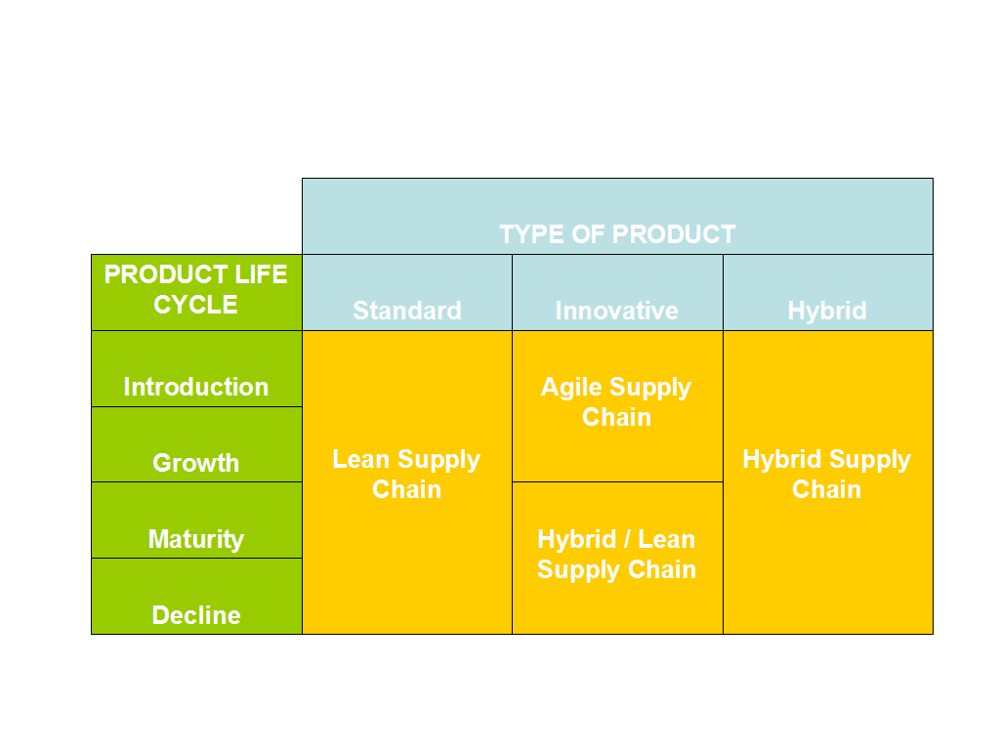
As it was commented above, the difficulty to use a pull system is another limitation for applying the Lean Supply Chain paradigm with all its potential advantages. It is not easy to change the egg intensive production system that prevents the application of a pull system. This production system is linked in some degree to another key player in egg supply chains, the companies that own the parental lines selected to produce the one day old chicks.

Following the work of Fearne and Dedman (2000), the role that supply chain partnership for retailer quality labels is playing and could play in a near future should be analyzed. Quality labels considering the implementation of food safety requirements more demanding that the one established for food safety official regulations could be an option. Lion Quality mark is a well known example of this strategy. But differentiation on food safety is not easy to communicate to final consumers without causing counterproductive effect on demand. Another strategy is differentiation on commercial quality or innovation oriented to enhance the health-promoting or disease-preventing properties of consumption eggs. For these strategies, high levels of food safety are a prerequisite. Product certification schemes linked to supply chain partnerships could contribute to support these differentiation strategies. In this context, Lean Production initiatives would be crucial for reducing lead times in order to market fresher eggs than competitors. Likewise, Lean Supply Chains could market these higher quality or functional eggs at prices more competitive that other egg supply chains not adopting this paradigm.

4. Conclusions

This paper concludes that it is feasible to apply the Lean Production paradigm in the consumption egg production industry despite the limitations detected. The methodological enhancements proposed could contribute to overcome some of the abovementioned limitations in the classification, packaging, storage and distribution phases of the value chain. But it is much more difficult to introduce Lean principles in the primary production of eggs, heavily based on mass production principles.

References

Abdulmaleka, F. A., Rajgopalb, J. (2006). Analyzing the benefits of lean manufacturing and value stream mapping via simulation: A process sector case study. Int. J. Production Economics, article in press.

Agriculture and Agri-Food Canada (2005). Poultry Marketplace: Primary Poultry Breeders. Online document: http://www.agr.gc.ca/poultry/brcs-elsc_e.htm#egg

Dhafr, N., Ahmad, M., Burgess, B., Canagassababady, S. (2006). Improvement of quality performance in manufacturing organizations by minimization of production defects. Robotics and Computer-Integrated Manufacturing, 22: 536–542.

Fearne, A,, and Dedman, S. (2000). Supply Chain Partnerships for Private-Label Products: Insights From the United Kingdom. Journal of Food Distribution Research, 31: 14-23

Galgano, A. (2002) Le Tre Rivoluzioni. Caccia Agli Sprechi: Raddoppiare la Produttività con la Lean Production. Guerini e Associati, Milano.
Galgano, A. (2006) Fare Qualita. Il Sistema Toyota per Industria, Servizi PA, Sanità. Guerini e Associati, Milano.
Herron, C., and Braiden, P. M. (2006) A methodology for developing sustainable quantifiable productivity improvement in manufacturing companies. Int. J. Production Economics, 104: 143–153.

Rugman, A. M., and Verbeke, A. (2000). Six cases of corporate strategic responses to environmental regulation. European Management Journal, 18: 377-385.

Vonderembse, M. A., Uppal, M., Huang, S. H., Dismukes, J. P. (2006). Designing supply chains: Towards theory development. Int. J. Production Economics, 100: 223–238.

Womack, J.P., Jones, D.T., Roos, D. (1990). The Machine that Changed the World. Rawson Associates, New York.
Authorization and Disclaimer
Authors authorize LACCEI to publish the papers in the conference proceedings. Neither LACCEI nor the editors are responsible either for the content or for the implications of what is expressed in the paper.

