Fifth LACCEI International Latin American and Caribbean Conference for Engineering and Technology (LACCEI’2007)
“Developing Entrepreneurial Engineers for the Sustainable Growth of Latin America and the Caribbean:
Education, Innovation, Technology and Practice”
29 May – 1 June 2007, Tampico, México.

Inspection of Chatter Damage in End Milling Operations by Using Wavelet Transformations

Kimberly Bickraj
Florida International University, Miami, Fl, U.S.A, kbick001@fiu.edu

Bulent Kaya
Gebze Institute of Technology, Gebze, Turkey, bkaya@gyte.edu.tr

Ahmet Yapici
Florida International University, Miami, Fl, U.S.A, yapicia@fiu.edu

Ming Li
Florida International University, Miami, Fl, U.S.A, mli002@fiu.edu

Ibrahim N. Tansel
Florida International University, Miami, Fl, U.S.A, tanseli@fiu.edu

Babur Ozcelik
Gebze Institute of Technology, Gebze, Turkey, ozcelik@gyte.edu.tr
Abstract
A joint research program has been established between Florida International University (FIU) and Gebze Institute of Technology (GIT) on metal cutting. GIT has collected data during the milling operation of a plate and captured its chatter development. FIU has analyzed the data by using the wavelet transformation method. The time and time-frequency domain analysis results of various approaches of the wavelet transformation method were compared in the paper. The excellent time domain resolution of the wavelet transformation was very convenient to pinpoint the areas of the workpiece surface which may have chatter damage. However, limited frequency domain resolution of the wavelet transformation made detection of chatter and identification of the problems more difficult.

Keywords: metal cutting, end milling, wavelet transformation, chatter

1. Introduction
Chatter vibrations and tool wear are two important problems in the metal cutting operations. If chatter is not detected in the early stages, excessive vibrations ruin the surface of the workpiece and may even create dangerous accidents. In terms of tool deterioration, worn tools create large forces which perpetuate rough surfaces and in this manner machined parts are wasted. For such reasons many manufacturers select their operating conditions very conservatively and change the cutting tools often to avoid problems. However, this approach increases manufacturing cost and reduces productivity. Additionally for Computer Numerically Controlled (CNC) machines, operators must still be present in order to observe and ensure that the machining processes take place smoothly thus adding to the inefficiency of the entire system. Hence, the objective of this research is to evaluate the feasibility of the use of the wavelet transformation for detection of chatter from the cutting forces.

In the past various monitoring procedures, signal analyses and diagnosis techniques have been researched and presented as possible solutions for tool chatter. (Gradisek et al., 2003) used entropy and coarse grained information rate (CIR) to detect chatter by analyzing the grinding force and acoustic emission. (Karpuschewski et al., 2000) used a combination of the acoustic emission signal and back-propagation (bp) type neural networks to detect chatter. (Tansel et al., 2005) developed a Genetic Tool Monitor (GTM) by using an analytical model for micro-end-milling operations combined with genetic algorithms, while a blend of bp type neural networks and genetic algorithms by (Tansel et al., 2006) are utilized for the selection of optimal cutting conditions for CNC milling. Fuzzy logic pattern recognition and fuzzy logic control have also been successfully used for the suppression of chatter in milling by (Kubica and Ismail, 1996). Wavelets and ART2 type neural networks were utilized for the classification of metal cutting in (Wang et al., 2006). A new method for tool chatter monitoring was proposed by (Lange and Abu-Zahra, 2002) which involved using wavelet analysis of ultrasound waves. (Chin and Yoon, 2003) investigated the detection of chatter in endmilling operations by applying the wavelet transform to the cutting force and comparing it to the FFT. Also (Choi and Shin, 2003) used a wavelet-based maximum likelihood (ML) estimation algorithm to detect chatter in turning and milling.

2. theoretical background
Wavelets are generated by using a family of functions derived from the following single function (Daubechies, 1988):
$h^{(\text{a,b})}(x)=|a|^{\text{-1/2}}h(\frac{\text{x-b}}{a})\text{ ,}$ (1)
In the above equation, h^{(a,b)} is the family of wavelets. The a and b are the dilation and translation parameters respectively. The original signal can be obtained by using the following expression:
$\text{f=C}\int{\frac{\text{da}}{a^{2}}}h^{(\text{a,b})}h^{(\text{a,b})}$ (2)
where f is the original function. The <h^{(a,b)}, f> is called the inner product of the wavelet.
The basic function (scaling function), Φ(x), is calculated with the following equation:
$Φ(x)=\underset{n}{\sum{}}c(n)Φ(\text{2x-n})\text{ ,}$ (3)
where c(n) is the wavelet coefficient and n is the index. The following expression is used to calculate the primary wavelet, Ψ(x):
$Ψ(x)=\underset{n}{\sum{}}(\text{-1})^{n}c(\text{n+1})Φ(\text{2x-n})\text{ ,}$ (4)

where c(n+1) is the coefficient. The following expression can be used to obtain the original function:

$\begin{aligned}f(x)=\underset{\text{n=-}∞}{\overset{∞}{\sum{}}}c(n)Φ_{n}(t)+\underset{\text{i=0}}{\overset{∞}{\sum{}}}\underset{\text{j=-}∞}{\overset{∞}{\sum{}}}d(\text{i,j})Ψ_{\text{i,j}}(t)\text{where}c(n)=\int{f}(t)φ_{n}(t)\text{dt}d(\text{i,j})=\int{f}(t)Ψ_{\text{i,j}}(t)\text{dt }\text{.}\end{aligned}$ (5)

where c(n) and d(i,j) are the coefficients of the wavelet transform and f(t) is the original signal. (Daubechies, 1988) developed a wavelet system based on an orthonormal base.

3. experimental setup
Experiments were performed at Gebze Institute of Technology (GIT). An aluminum plate 5 mm thick and 138.2 mm long was cut with a five axis Deckel Maho DMU 60 P high speed CNC milling machine. The spindle speed was 1,592 rpm while the feed rate of the table was 647m/min. The horizontal depth of cut into the material (in the x direction) is 1mm while the vertical depth of cut into the workpiece started at 0.5 mm and increased to 7 mm. The cutting forces in 3-dimensions and the torque were measured through the use of a Kistler 9123C1111 type rotational dynamometer and a 5223 multi-channel signal conditioner. All of the data was collected via a National Instrument PCMCI 6036E DAQ Board with a BNC 2110 connector. The sampling rate was 5K/sec.

The experimental setup and the geometry of the workpiece are presented in Figure 1. The feed direction is in line with the Y axis while Z direction is chosen to be in the Z-axis. It was observed that when the tool reached the middle of the workpiece length, it began to vibrate severely and generated loud noises in the process. When the vertical depth of cut reached 5-6 mm, the unsteady cutting conditions diminished.

Forces and torque
Data acquisition system
Y
Z
X
Rotary dynamometer
Figure 1: Experimental Setup

4. results and discussion
In order to analyze the cutting force signal in one of the horizontal directions the D2-type Daubechies orthogonal wavelets were used. The wavelet transformation was obtained at five levels by using MATLAB 7.1. The approximation and the detail coefficients are presented in Figure 2 below. The introduction of chatter is clearly visible when the d1, d₂ and d₃ detail coefficients are inspected. When the tool made its way through roughly half the length of the workpiece the amplitude of the approximation values suddenly increased. Performance of the wavelet packet analysis in Figure 3 further reinforces this clear presence of chatter. Similarly, the development of chatter was easily detectable from the increase of vertical white stripes at certain scales when the continuous wavelet transformation was applied in Figure 4.

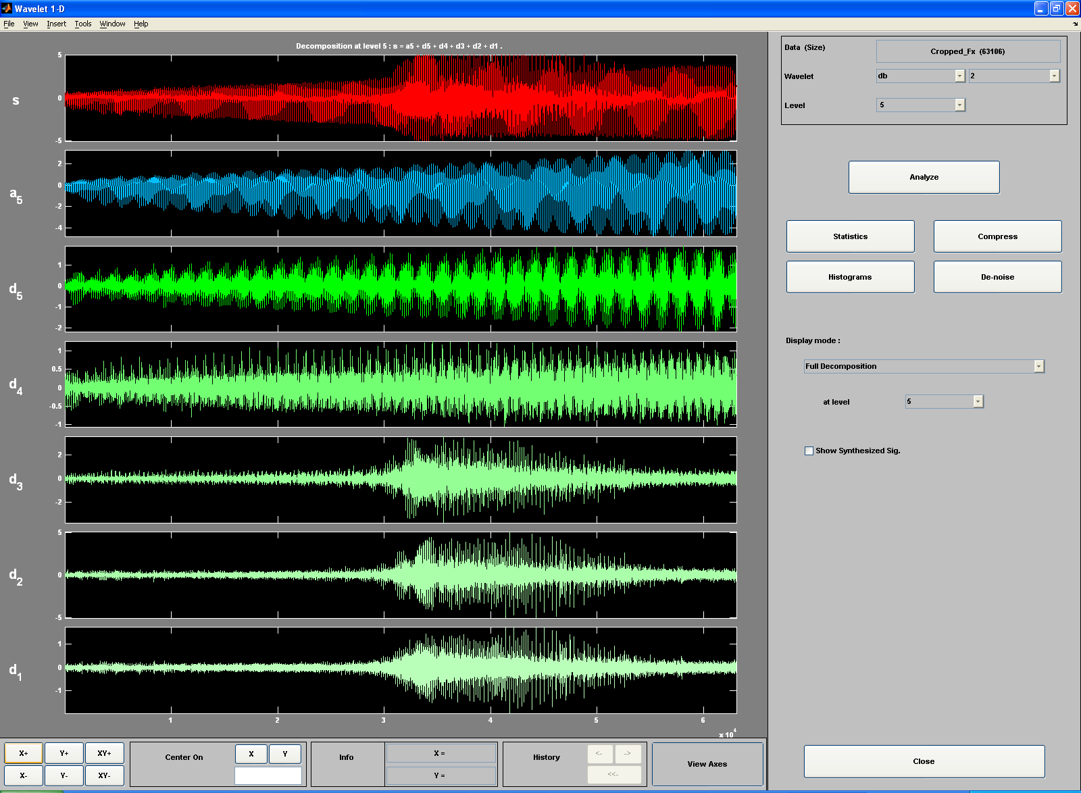

Figure 2: Wavelet Transformation of the X component of the Cutting Force

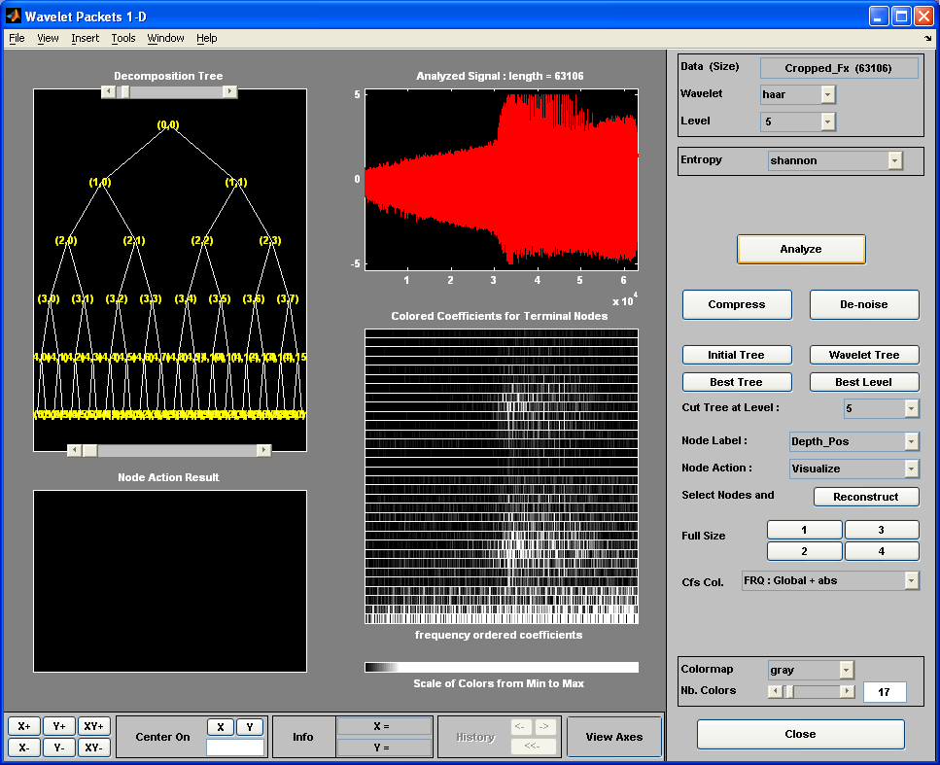
Figure 3: Wavelet Packet Analysis
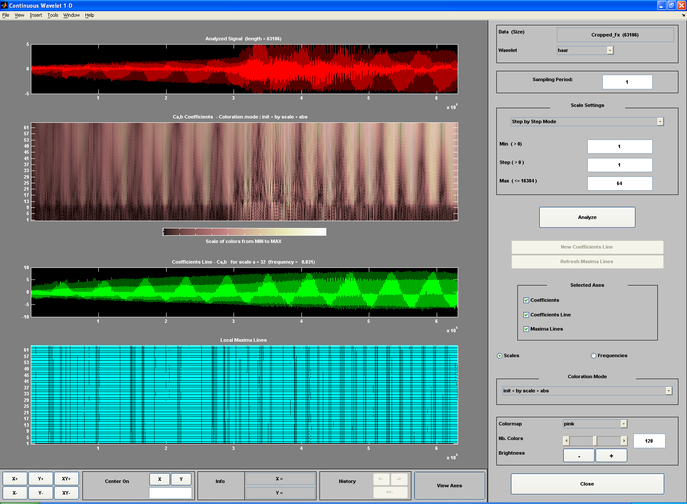
Figure 4: Continuous Wavelet Transformation
5. conclusion
The feasibility of the wavelet transformations were evaluated for detection of chatter in end milling operations. Increase of the amplitude of three detail values indicated development of chatter when the Daubechies 2 orthogonal wavelet was used. Development of activities at certain bands indicated chatter when the packet analysis and continuous wavelet transformations were used. In all the studied cases, the time resolution of the wavelet transformation was excellent. Unfortunately, it also demonstrated the difficulty of the identification of the dominant vibration frequencies of the cutting forces for determination of the sources of the problems in the machining operations.
References
Gradisek, Andreas Baus, Edvard Govekar, Fritz Klocke, Igor Grabec (3003), “Automatic chatter detection in grinding,” International Journal of Machine Tools and Manufacture, Vol. 43, pp. 2193-2211.
B. Karpuschewski, M. Wehmeier, I. Inasaki, “Grinding monitoring system based on power and acoustic emission sensors,” Annals of the CIRP , Vol.49, No. 2, pp 235–240.
I. N. Tansel, W. Y. Bao, N. S. Reena, C.V. Kropas-Hughes (2005), “Genetic tool monitor (GTM) for micro-end-milling operations,” International Journal of Machine Tools and Manufacture, Vol.45, pp 223–299.
I.N. Tansel, B. Ozcelik, W.Y. Bao, P. Chen, D. Rincon, S.Y. Yang, A. Yenilmez (2006), "Selection of Optimal Cutting Conditions by Using GONNS," International Journal of Machine Tools and Manufacture, Vol. 46, No. 1, pp 26-35.
E.G. Kubica, F. Ismail (1996), “Active suppression of chatter in peripheral milling part II: application of fuzzy control,” Int. J. Adv. Manufact. Technol., Vol. 12, No. 4, pp 236–245.
X. Wang, P. Chen, I .N. Tansel, A. Yenilmez (2006), “Transformations in machining, Part 1. Enhancement of wavelet transformation neural networks (WT-NN) combination with a preprocessor,” Int. J. Mach. Tools & Manufact., Vol.46, pp 36 – 42.
J.H. Lange, N.H. Abu-Zahra (2002), “Tool Chatter Monitoring in Turning Operations Using Wavelet Analysis of Ultrasound Waves” International journal of advanced manufacturing technology, Vol. 20, No.4, pp. 248-254.
D. H. Chin, M. C. Yoon (2005),“Detection of Chatter in Endmilling Operation Using Wavelet Transform” CIRP Journal of Manufacturing Systems, Vol. 34 No 3.
Taejun Choi, Yung C. Shin (2003), “On-Line Chatter Detection Using Wavelet-Based Parameter Estimation” ASME.
I.Daubechies (1988), "Orthonormal Bases of Compactly Supported Wavelets, "Communications on Pure and Applied Mathematics, Vol. XLI, pp 909-996.

Authorization and Disclaimer
Authors authorize LACCEI to publish the paper in the conference proceedings. Neither LACCEI nor the editors are responsible either for the content or for the implications of what is expressed in the paper.

