Control of a Stewart Platform used in Biomechanical Systems

Fernando Serrano,
Florida Internacional University, Miami, Florida, USA, fserr002@fiu.edu

Amaury A. Caballero
Florida Internacional University, Miami, Florida, USA, caballer@fiu.edu

Kang K. Yen
Florida Internacional University, Miami, Florida, USA, yenk@fiu.edu

Tomas Brezina
Brno University of Technology, Brno, Czech Republic, brezina@fme.vutbr.cz

ABSTRACT

The paper is focused on the analysis of the Stewart platform to be used in the development of a device for the determination of mechanical properties of materials used for substituting spinal segments of human bodies. At the present time, the Stewart platform is widely used and its popularity is due mainly to the following facts, in comparison with serial mechanisms: higher stiffness, better dynamic properties of the mechanism, higher accuracy of the mechanism, precise and easy positioning. Simulations are conducted for the determination of an acceptable control system based on fuzzy logic. A controller description is included.
Keywords: Stewart Platform, Biomechanics, Fuzzy Controllers

1. INTRODUCTION
An important characteristic presented in the solution of biomechanical problems for clinical practice is their complexity, which requires mutual mixture of computational and experimental modeling. Whereas in the computational part, in most cases, commercial software can be used with success, the experimental part requires at least the development, design and manufacturing of fixators, and frequently, of the whole experimental device, including the control system on which specific demands are often put. The concept of parallel kinematics, which is called Stewart platform corresponds to the device of such design. In case that the lower plate is firmly connected to the base, the upper plate is able to move with six degrees of freedom. At the present time, the Stewart platform is widely used and its popularity is due mainly to the following facts, in comparison with serial mechanisms:
higher stiffness, better dynamic properties of the mechanism, higher accuracy of the
mechanism, precise and easy positioning, and wide range of movements.

The objective of the paper is to analyze the Stewart platform and to conduct simulations to evaluate the obtained results with a fuzzy logic controller. In order to conduct the analysis, a fuzzy logic controller has been implemented. For the implementation, the following steps have been followed:
- analysis of the cinematic model of the platform
- analysis of the dynamic model
- definition of the controller’s structure
- design of the membership functions
- design of the rules for the fuzzy controller
- system simulation

The following restrictions were observed for the model implementation:
- Each input is related only to its respective output
- The inductive reasoning method will be used for optimizing the membership functions
2. CINEMATIC MODEL
The use of the Stewart Platform is universal. In biomechanics it has been used in experimental backbone modelling and in experimental modelling of biomechanical problems of large human joints
In Figure 1, it is shown the 6 degrees of movement generated by six extensible legs and the static lower plate (considered individually) with the upper plate which generate all the translations and rotations on the axis. In order to derive the cinematic model of the Stewart platform, it is used a simple model consisting of a base and a platform which are the center of the platform and the other six coordinate systems are located in the base of each extensible leg. The cinematic model for this case has been presented in (Brezina, T.; Efe, O.).

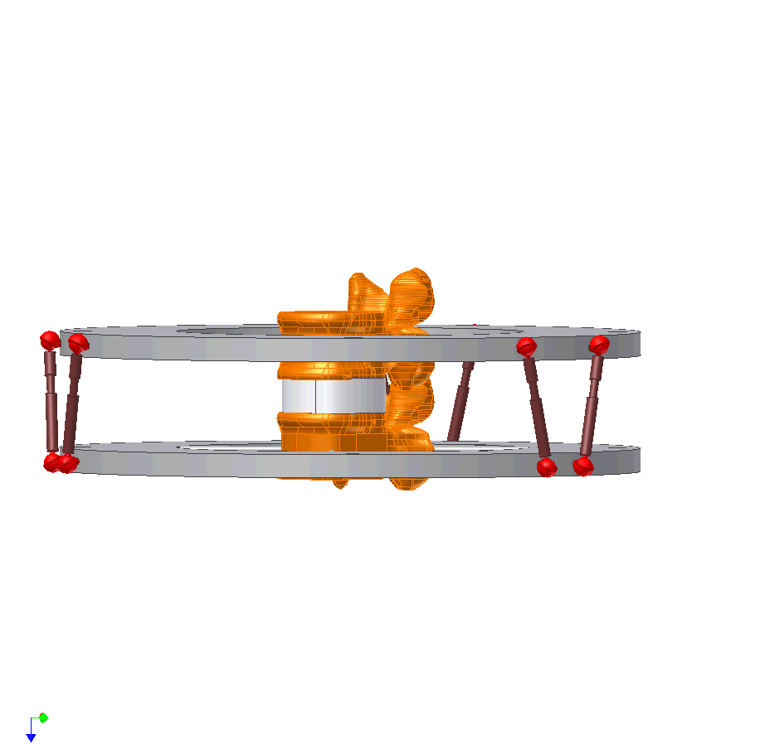

Figure 1: Scheme of Device for Testing Spinal Elements.
3. DYNAMIC MODEL (STATE SPACE MODEL)
To generate each movement it is necessary to use an actuator or motor connected to the upper plate of the platform, having fixed the lower platform. This dynamic model was developed first using the Newton-Euler Dynamical Equations and then converted into a MIMO state space model (Shaowen Fu and Yu Yao). This model is implemented in MATLAB-SIMULINK. The analysis has been based on the Newton-Euler Dynamic Equations, using the vector equations of equilibrium of torques and forces instead of matrix operation.

The following set of equations for the Stewart platform is obtained:
$$m\frac{d^{2}z}{{\text{dt}}^{2}}=F_{\text{zz}}−p(t)−k\frac{\text{dz}}{\text{dt}}$$
$$m\frac{d^{2}y}{{\text{dt}}^{2}}=F_{\text{zy}}−p(t)−k\frac{\text{dy}}{\text{dt}}$$
$m\frac{d^{2}x}{{\text{dt}}^{2}}=F_{\text{zx}}−p(t)−k\frac{\text{dx}}{\text{dt}}$
$$m\frac{d^{2}ψ}{{\text{dt}}^{2}}=M_{\text{zz}}−p(t)−(I_{y}−I_{x})\frac{dφ}{\text{dt}}\frac{dθ}{\text{dt}}$$
$$m\frac{d^{2}φ}{{\text{dt}}^{2}}=M_{\text{zy}}−p(t)−(I_{x}−I_{z})\frac{dθ}{\text{dt}}\frac{dψ}{\text{dt}}$$
$$m\frac{d^{2}θ}{{\text{dt}}^{2}}=M_{\text{zx}}−p(t)−(I_{z}−I_{y})\frac{dφ}{\text{dt}}\frac{dψ}{\text{dt}}$$

where F_{zx}, F_{zy} ,F_{zz}, M_{zx}, M_{zy}, Mzz are the forces and torques around each axis; m is the mass of the upper plate; I_{z}, I_{y}, I_{x} are the respective inertia values and
$θ$,$φ$, $ψ$ are the respective angles to x, y, and z axis.

State space equations were developed for the simulation:

The model has been linearized using the Jacobian matrix, due to the nonlinear characteristics of the dynamic equations.

$\overset{˙}{X}=\left(\begin{matrix}A_{0} & I_{6} \\ A_{0} & J_{6}\end{matrix}\right)X+\left(\begin{matrix}V_{0} \\ F_{3} \\ M_{3}\end{matrix}\right)U(t)$ (2)
$Y=I_{\text{12}}X$, (3)

Where
A₀ = 6 x 6 zero matrix
I₆ = 6 X 6 identity matrix
J₆ = 6 X 6 inertia matrix that is shown next,

$$J=\left[\begin{matrix}\text{-k/m} & 0 & 0 & 0 & 0 & 0 \\ 0 & −\text{k/m} & 0 & 0 & 0 & 0 \\ 0 & 0 & −\text{k/m} & 0 & 0 & 0 \\ 0 & 0 & 0 & 0 & S_{1} & −S_{1y} \\ 0 & 0 & −S_{2} & 0 & 0 & −S_{2} \\ 0 & 0 & −S_{3} & 0 & −S_{1} & 0\end{matrix}\right]$$

Where
V₀ = 3×1 zero vector
F₃ = 3×1 input forces vector
M₃ = 3×1 input torque vector
$$S_{1}=I_{z}−I_{y}$$
$$S_{2}=I_{x}−I_{z}$$
$$S_{3}=I_{y}−I_{x}$$
For the simulation a sinusoidal input U(t) has been used. The following control requirement have been established:

Basic movements
- x,y,z position in ±5 mm range (accuracy 0,1 mm)
- rotation in x,y,z axes in range ±10° (accuracy 0,5°)
- loading Fx,y,z = 2000 N (accuracy 1 N), Mx,y,z ±10 Nm (accuracy 0,5 Nm)
4. DESIGN OF THE FUZZY CONTROLLER
The selected controller structure is shown in the block diagram in Figure 2 [Bing Chen and Xiaoping Liu]. The design of the membership functions has been accomplished using data generated from the dynamic model referred before. From previous practical studies, it has been found that the random forces lie in the range of -2000 N and 2000 N and the torque in the range of -15 N.m and 15 N.m approximately, the obtained values were compared for the translations and rotations on each axis, using the forces and torques applied at the input of the system.

Legs Trajectories
Device
(Stewart Platform)
Fuzzy Controller
Rotational and positional sensors
+
-

Figure 2: Controller Block Diagram.

The range of each membership function was selected as per the results given by the software, using the inductive reasoning method. (Ross, T.J.; Cordon O.). The 12 selected inputs for the fuzzy system are:

- Translation errors : 3 variables in the X, Y, and Z respectively (ex,ey,ez)
- Rotation errors (3 variables), velocities (3variables) and angular velocity errors (3 variables)

The 6 outputs of the fuzzy system are:

- Forces (3 variables Fx,Fy,Fz)
- Torques (3 variables Tx, Ty, Tz)

For the design of the membership functions 2 steps were applied to determine the range of the membership functions:

- Clustering
- Inductive reasoning Algorithm

A clustering algorithm is needed as a pre processing step before finding the range of each membership function, because it gives an idea on how the data is sort, then the inductive reasoning method is applied in order to find the overlapping of each membership function. K-mean algorithm method has been used for sorting the data and forming the clusters. The method is based on the partitioning of a given set of data points into a number of distinct groups, called clusters. The partition is made looking for the maximum similarity of points into clusters, using some global measure. The k-means algorithm attempts to find the cluster centers (c₁,...,c_{k}) in which the norm D of each data point (x_{i}) is minimized to its nearest cluster center (c_{k}) (Ching-Hung Wang et al).

$$D=\sum_{i=1}^{n}{{\left[\underset{k=(1\text{.}\text{.}\text{.}k)}{\text{min}d(x_{i},c_{k})}\right]}^{2}}$$

The algorithm consists of the following steps:

- Initialize K center locations (c₁,...,c_{k}).
- Assign each x_{i} to its nearest cluster center.
- Update each cluster center c_{k} as the mean of all x_{i} have been assigned as closest to it as possible.
- Calculate D
- If the value of D converged, then return (c₁,...,c_{k}).; else go to step 2.

It’s important to notice that different clustering algorithms may be used: Hard C means, Fuzzy Hard C means etc. This is just a preprocessing step that will be used later in the partitioning process of the membership functions.

As an example, the clusters formation of the variable ex (error in the translation variable x), which is one of the input variables of the fuzzy controller, can be presented. Figure 3, shows this example, using the k mean algorithm for the position error in the x coordinate axis. This plot was made from 80 samples out of 3200 taken from the dynamical model for a good visualization of the clusters. These clusters were used to design the three membership functions for the input variable ex. As per the data location, there can be represented three classes: negative, zero, and positive.

Figure 3. Clusters for the Variable “ex”

In order to find the boundaries of each membership function and the center of each cluster, the method of inductive reasoning is applied. The inductive reasoning method is used for the segmentation of attributes for each fuzzy set and the discriminant power of each attribute is used in a iterative method called dichotomizer, the partition and discriminant power of an attribute are determined by a measurement called entropy.
The following equations are used in the inductive reasoning method ( Castro J. L. and J. M. Zurita)

$p_{k}(x)=\frac{n_{k}(x)+1}{n(x)+1}$; $q_{k}(x)=\frac{n_{k}(x)+1}{n(x)+1}$; $q(x)=1−p(x)$; $p(x)=\frac{n(x)}{n}$

$S_{p}=−\sum_{i=1}^{k}{p_{i}(x)\text{ln}p_{i}(x)}$

$$S_{q}=−\sum_{i=1}^{k}{q_{i}(x)\text{ln}q_{i}(x)}$$

p_{k}= Proportion of samples of k class to the right of the partition
q_{k} = Proportion of samples of k class to the left of the partition
p= Proportion of samples to the right of the partition
q= Proportion of samples to the left of the partition.
n_{k} = Number of samples of k.
N= Number of sample in the whole partition..
S_{p}= Entropy to the right of the partition.
S_{q}= Entropy to the left of the partition.

A complete mapping of the universe of discourse and the point where the minimum entropy is obtained will be considered as the first partition r_{1.} Repeating this process to the left and right of this point r _{k} partitions are obtained, in which the number of membership functions is:

$n_{μ}=r_{k}$

$n_{μ}$= number of membership functions.

The obtained membership functions resulting from the partition of the variable “error in X (ex)” are shown in Figure 4.

Figure 4. Resulting Membership Function for the “ex” variable

6. RESULTS OBTAINED WITH THE SIMULATION

The controllers’ simulations were developed in SIMULINK. As can be seen from Figures 5 and 6, the errors of the time response for the fuzzy controller reach the stability in 0.15 sec approximately. A PID controller has been designed in order to compare its response with that of the fuzzy controller. The control signal (input for the dynamic system) are the six legs forces generated by the actuators, and the output signals are the angular and linear positions.

The gains for the PID controller ($K_{d}$,$K_{i}$ and$K_{p}$) were selected by trial and error.
K_{d} = 7000; K_{p} = 20000; K_{i} = 4000

- The stability with the PID controller is obtained in 0.5 sec. approximately. For both it is desirable to lower this time.
- In a real application, the fuzzy logic controller uses less hardware than a PID controller, because it’s not necessary to use amplification to generate the feedback’s gain in order to reduce the steady state error.
- Fuzzy control systems are a good option in this type of application, due to the nonlinear characteristics of the Stewart platform even if it is necessary to consider other kind of nonlinear characteristics such as coriolis, gravity effects and centrifugal forces.
- The time response of the PID controller can be improved, but if the gains ($K_{d}$,$K_{i}$ and$K_{p}$) are increased, the system could be unstable or saturated.
- Sometimes the PID controller is not enough to get a acceptable time response of the system, due to intrinsic vibrations. Usually it becomes necessary to use a compensator such as a $H_{∞}$ controller in order to reduce vibration effects [Se-Han Lee, et al., 2003].

Table 1 shows the settling time for each controller. From this table it can be seen that, under the design conditions, the fuzzy controller settling time is lower than the PID settling time.

Table 1. Controllers Settling time.

 |  | Fuzzy Controller | PID Controller
X | Settling Time (s) | 0.2073 | 0.500
Y | Settling Time (s) | 0.2070 | 0.500
Z | Settling Time (s) | 0.2072 | 0.500

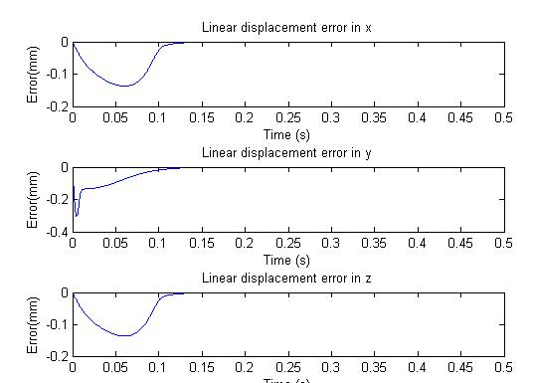

Figure 5: Results Obtained for the Fuzzy Contoller.

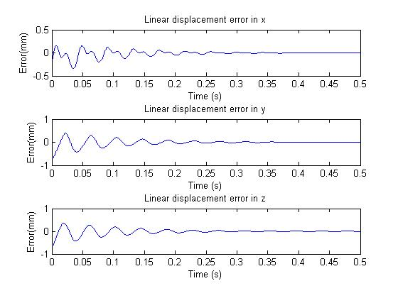
Figure 6. Results Obtained with the PID Controller.

7. CONCLUSIONS
An analysis of the Stewart platform has been developed. These platforms present advantages in comparison to other mechanical structures used in the development of biomechanical devices due to their flexibility, easy and precise positioning, and wide range of movement.

A fuzzy and a PID controller are presented as good alternatives for the control system due to the nonlinear behavior of the controlled device.

The obtained results show the advantages of the fuzzy logic controller, because the PID controller yield a bigger settling time in comparison with the fuzzy logic controller even with high gain constants also, it is easier to implement the fuzzy controller.

REFERENCES

Brezina, T. (2005). “Device for Experimental Modeling of Properties of Biomechanical Systems”. Simulation Modeling of Mechatronic Systems, Brno University of Technology, Faculty of Mechanical Engineering, , pp.93-109.
Efe, O., O. Kaynak. (2000). “A comparative study of soft-computing methodologies in identification of robotic manipulators”. Robotics and Autonomous Systems, Vol. 30, Issue 3, pp.221-230
Shaowen Fu, Yu Yao. (2006). Non-linear robust control with partial inverse dynamic compensation for a Stewart platform manipulator. Int. J. Modelling, Identification and Control, Vol. 1, No. 1.
Ross, T.J. (2004). “Fuzzy logic with engineering Applications”.J. Wiley and sons Ltd.
Cordón O., F. Gomide, F. Herrera, F. Hoffmann, L. Magdalena. (2004). “Ten years of genetic fuzzy systems: current framework and new trends”. Fuzzy Sets and Systems, Vol. 141, Issue 1, , pp.5-31.
Ching-Hung Wang, et al. (1999) “A fuzzy inductive learning strategy for modular rules” Fuzzy Sets and Systems, Volume 103, Issue 1, 1 April 1999, Pages 91-105.
Castro J. L. and J. M. Zurita. “An inductive learning algorithm in fuzzy systems”, Fuzzy Sets and Systems, Volume 89, Issue 2, 16 July 1997, Pages 193-203

Authorization and Disclaimer
Authors authorize LACCEI to publish the paper in the conference proceedings. Neither LACCEI nor the editors are responsible either for the content or for the implications of what is expressed in the paper.

