Fifth LACCEI International Latin American and Caribbean Conference for Engineering and Technology (LACCEI’2007)
“Developing Entrepreneurial Engineers for the Sustainable Growth of Latin America and the Caribbean:
Education, Innovation, Technology and Practice”
29 May – 1 June 2007, Tampico, México.

Using Interactive Web Conferencing for International Collaboration with Institutions in Latin America and the Caribbean

Ivan E. Esparragoza
The Pennsylvania State University, Media, PA, USA, iee1@psu.edu

Matthew Bodek
The Pennsylvania State University, Media, PA, USA, mjb14@psu.edu
Abstract
Distance collaboration has benefited from the development of online collaborative tools and techniques over the past years. The use of computers capabilities, web communication systems, and multimedia software can now be efficiently used to deliver material synchronous and asynchronous on a variety of platforms and applications over the internet. Because of this technological revolution, numerous professors are using these tools to establish collaborative multi-campus and multi-national projects for education and research. A simple search on a database can easily show hundreds on publications about experiences using these collaborative tools for distance interaction. The implementation of distance collaborative projects requires a comfortable level of knowledge of the technological tools available for an effective and successful interaction. Features and limitations of the collaborative tools need to be known to minimize the anticipated difficulties and maximize the valuable attributes. This paper presents guidelines for the use of interactive web conferencing software in establishing and carrying out distance collaboration between Penn State and institutions in Latin America and the Caribbean. The paper reports experiences occurring in this hemisphere since the collaboration among institutions in the Americas has been identified as one of the key practices to provide international experiences to the students that would contribute to the formation of world-class engineers for the Americas. The opportunities and pitfalls discussed in the paper are based on the authors’ experience on this topic.

Keywords: Web conferencing, distance collaboration, global design projects
- Introduction
The rapid growing of technology for communication has created new opportunities for delivery of courses, and for developing collaborative projects and research beyond the classroom. Existing web conferencing software is bringing collaborative tools and functionality to education and research that only a few years ago were only available to the business market. Now, faculty and students in or outside the classroom can be connected to the world to deliver/receive educational instruction or to develop collaboration with partners geographically disperse.
However, the selection of the proper collaborative tools is not an easy task not only because the variety of products available but also due to the different variables to be considered. According to Belyk (2002), and reported later by Baggaley (2003), the most significant criteria to be taken into consideration when selecting a collaborative tool are:
- Cost: institutional and for the user
  - Hardware (system requirements)
  - Software (licenses)
  - Bandwidth (cable, DSL, T1)
  - Paraphernalia (web-cam, microphone, headphone)
- Complexity
  - Usability (easy to use, stability, user friendly)
  - Technical support
  - Synchronous and asynchronous applications
- Control
  - Secured access
  - Privacy (protection, user control, banners, pop-up ads)
- Clarity
  - Resolution
  - Size
  - Layout
- Common technical framework
  - Platform
  - Integration
  - File-sharing
- Features
  - Administrative tools
  - Instructors tools

The implementation of distance collaborative projects requires an appropriate selection and a comfortable level of knowledge of the technological tools available for an effective and successful interaction. Features and limitations of the collaborative tools need to be known to minimize the anticipated difficulties and maximize the valuable attributes. This paper presents guidelines for the use of interactive web conferencing software in establishing and carrying out distance collaboration between Penn State and institutions in Latin America and the Caribbean. The paper reports experiences occurring in this hemisphere since the collaboration among institutions in the Americas has been identified as one of the key practices to provide international experiences to the students that would contribute to the formation of world-class engineers for the Americas. The opportunities and pitfalls discussed in the paper are based on the authors’ experience on this topic.
- Structuring the Collaboration
  - Background
Penn State Delaware County is part of the Penn State University system. This is a commuter campus which offers the first two years of engineering after which students transfer to University Park to complete their degrees. As most of the commuter campuses in the US, the student population is formed mainly by local residents who are non-traditional students. These students hold part-time or full-time jobs while they are attending school. Besides that, most of them have no knowledge of another language or experience working in a diverse team. Additionally, it has been detected that most of the freshman engineering students coming to this campus have no previous experience in design projects, teamwork, and the solution of open-ended problems. There was a clear necessity of providing opportunities for the incoming students so they can develop and/or enhance global competencies.
The Latin American and Caribbean Consortium of Engineering Institutions (LACCEI) is a not-for-profit organization headquartered at Florida International University in Miami, Florida whose mission is to be the leading organization of Latin American and Caribbean Engineering Institutions that will bring innovations in engineering education and research, and emerge as a major force in this hemisphere to foster partnerships among academia, industry, government and private organizations for the benefit of the society and the nations, particularly in the Americas.
One of the most important initiatives of LACCEI is to promote collaboration among the faculty and students members of the consortium. In 2004 Penn State became member of LACCEI, and this campus, as member of the consortium, and recognizing the importance of offering international experiences to engineering students established collaborative partnerships with institutions in Latin America for the development of global design projects. These projects were incorporated in the freshman Introduction to Engineering Design course which is structured as a project-based course. These projects have been used not only to develop important skills such as project management, teamwork, global design, creativity, innovation, and problem-solving abilities but also to foster cultural awareness, understand diversity, and master the use of technology for communication. All these are important global competencies required to educate world-class engineers.
In the Spring 2005, the collaboration through global design projects began with four campuses from three different institutions: Penn State University (USA), Universidad Autónoma de Occidente (Colombia) and Universidade Federal Juiz de Fora (Brazil). The collaboration has growth as can be seen in the collaboration network shown in Figs. 1 to 4, and more than 200 students from nine different universities in six countries (U.S., Brazil, Colombia, Peru, Honduras, and Dominican Republic) have participated in this initiative.
The multinational design projects were adopted since it has been shown that they are one of the most effective ways to incorporate international experience in the curriculum (see Devon et.al., 1998, Pollar et.al., 2002, Ion et.al., 2004). This type of projects allows the students to work in diverse teams geographically disperse while they are solving a real engineering problem. They are short multi-team projects running as part of a course that usually last for seven weeks. The project is assigned to the students in the different countries simultaneously. Teams of students are formed among the institutions participating so each team has a corresponding partner in a foreign institution. Participating students discuss the design methodology and the project at a local level first and then they are asked to discuss the problem and share information with their international partners to enrich the final solution of the problem using web conferencing tools and e-mail.
  - Managing the Project
There are many activities that have to be planned and coordinated in the development of this type of international collaboration. During the planning process all the tasks must be scheduled and the necessary resources determined. During the project execution, it is important to coordinate and facilitate the interaction between the teams and establish contingency plans in the case of inevitable events mainly when technology problems arise.
Some of the most significant issues that have to be taken into account in the project planning include: conciliate academic calendar since not all the institutions have the same calendar for the semester; coordinate time zones since the collaboration is among institutions in different time zones, and follow different daylight saving time patron; select the course and students at each institution since not all of the institutions have a courses devoted just to engineering design; and establish language requirements although English has been used as the standard language for the collaboration.
However, the most challenging task in developing the international collaboration is the collaborative tools for communication. This initiative is not supported by funds at any institution. Therefore, the cost of the collaborative tools has to be minimized and the use of current resources available at each institution should be maximized. This is why, initially, this collaboration started using web conferencing tools that can be downloaded and used over the internet for free. In this particular case MSN Messenger and Skype were adopted for the audio-video conferences over the internet. The course management system used by Penn State and available for those getting a “friends of Penn State account” has been used for asynchronous interaction, even though it has not been employed to its maximum capacity.
The use of these tools gave the students a new perspective and a new meaning for the interaction online. They have found the value of web conferencing for collaboration with partners abroad, which is the new tendency in the corporate world where employees interact with co-workers and collaborators located in offices and departments around the world.
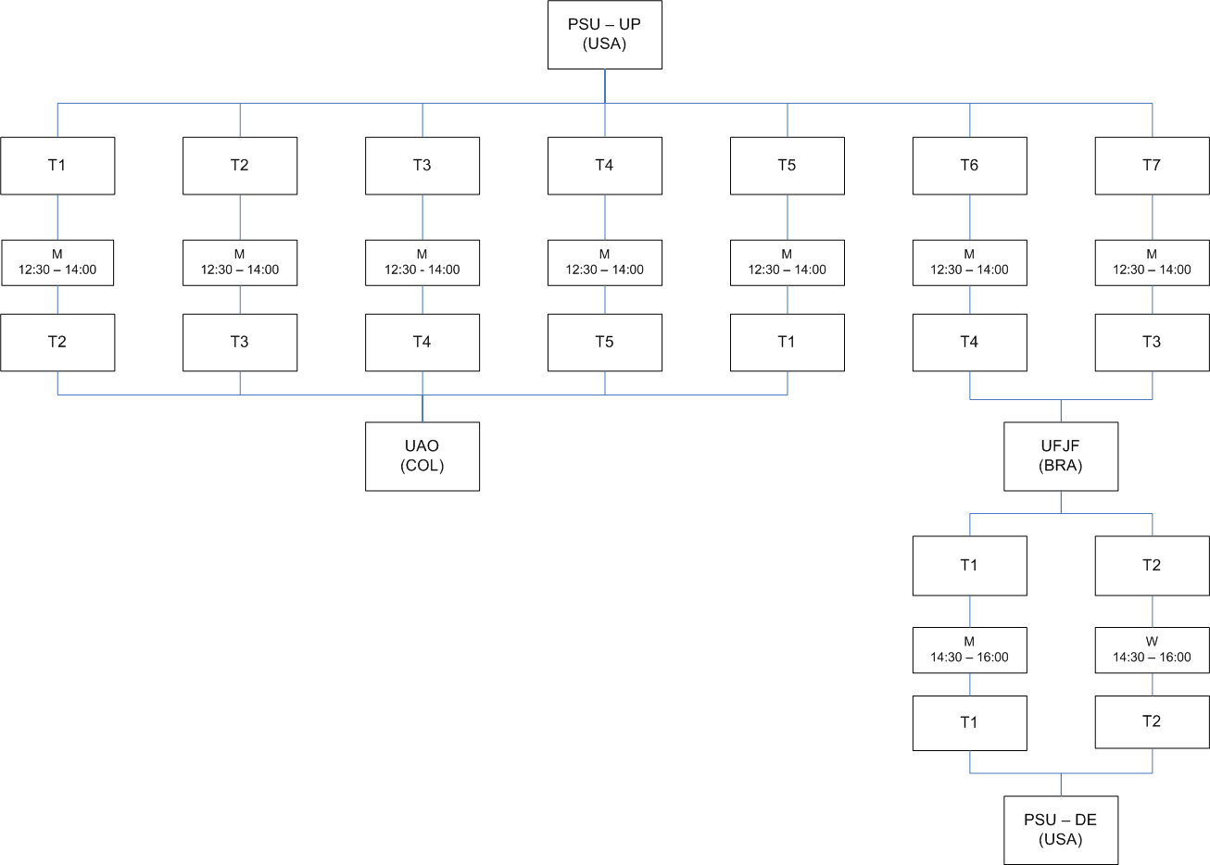
Figure 1: International collaboration network during Spring 2005.
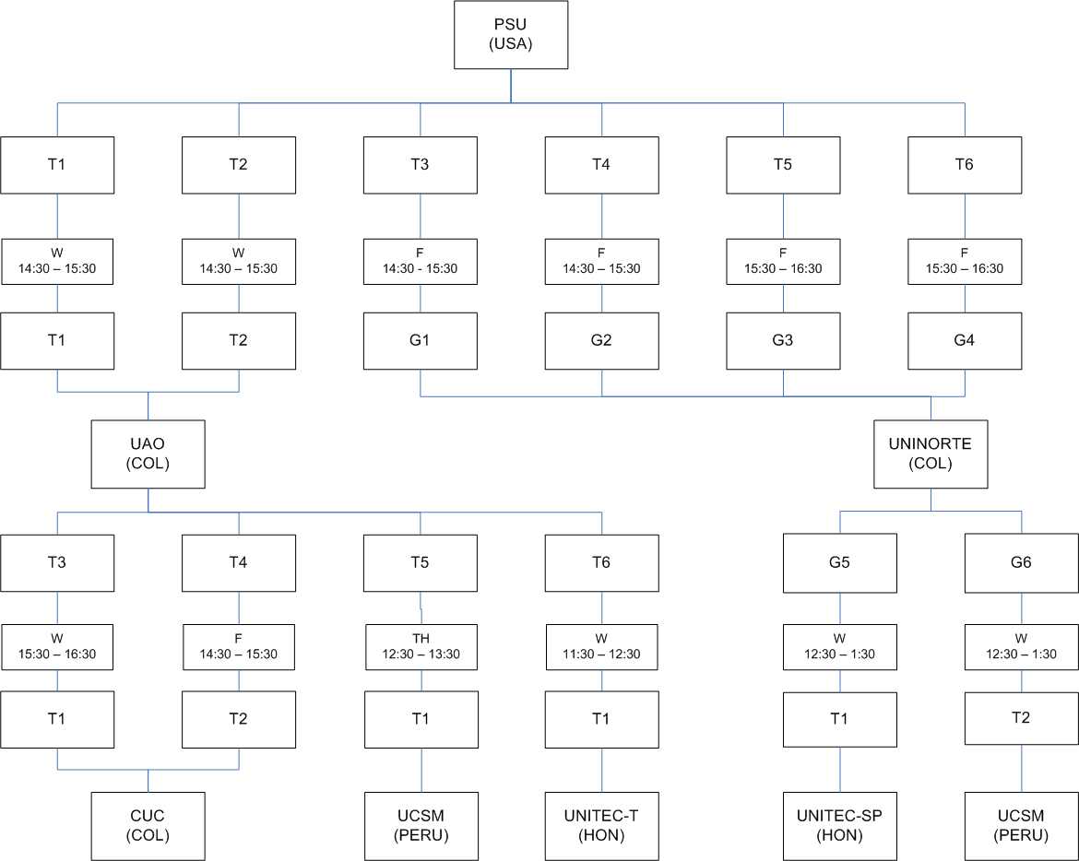

Figure 2: International collaboration network during Fall 2005.

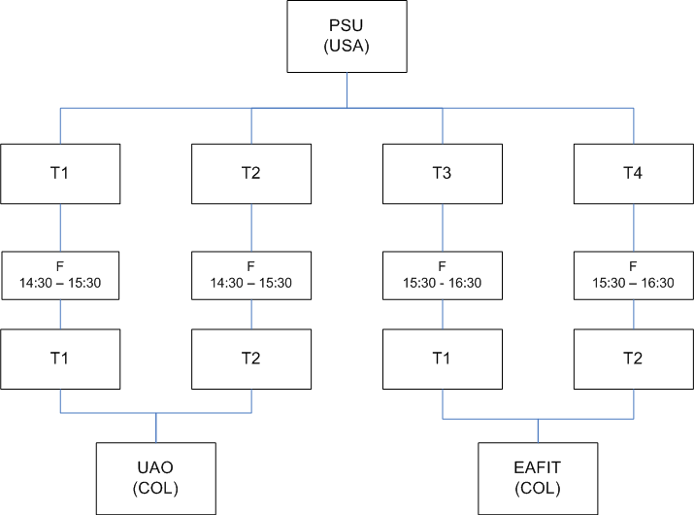
Figure 3: International collaboration network during Spring 2006.

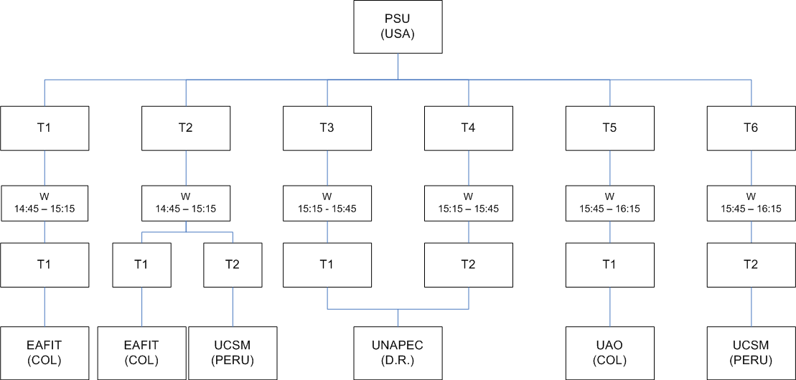
Figure 4: International collaboration network during Fall 2006.
Despite the benefits of cost, easy accessibility and usability, the free online paraphernalia has many restrictions for the global design projects collaboration. This is why during Fall 2006 the web conferencing tool from Adobe, named Breeze, was adopted. This is not a free package but it is supported by Penn State University that uses this program to foster distance education and collaboration. This package has the advantage of offering the same capabilities of the free tools such as voice, video and chat pod, and also a “Share pod” where the participants can share a whiteboard, a Powerpoint presentation, or the computer screen which is very important in collaborative design projects. The main features of the tools used in the collaborations as well as the advantages and disadvantages found in the use of them are discussed in the next two sections.
- Technology Tools
Breeze, a server-based software, uses the Flash plug-in that is installed in most web browsers today. Currently, this product is called Acrobat Connect Professional and is available from Adobe, Inc. Participation required an Internet connected computer with the Flash plug-in installed in the web browser. An additional, small plug-in is required to be downloaded and installed if the individual would be sharing content to other group members.

This server-based solution provided many benefits compared to the stand-alone products. The online collaboration space, known as a meeting room, could be created in advance and access to these rooms could also be controlled with Penn State assigned user ids and passwords. The instructor had the ability to ‘drop into’ these meeting rooms from any Internet connect computer to observe the group’s interactions. A final benefit of this server-based solution was the ability for the instructor to record each collaborative session for review at a later time, or have the student groups review and critique their sessions.

Each individual in a meeting room is assigned one of three roles. Access and control of various tools is dependent on which role an individual is assigned. The role of host provides the most access and control. A host creates the virtual meeting room and grants access by adding a user’s account information into the system. A host does not need to be present during a meeting. If present, the host has the ability to record the meeting, add last minute ‘guests’, share content from their computer, control which tools are available, and promote or elevate individuals to other roles during the meeting.

A presenter role is more limited. The main function of the presenter role is to share or present content during a meeting. There can be more than one presenter in a meeting. The final role in a meeting is that of a participant. Participants are the most limited role and can only view or have information presented to them.

The collaborative tools available in Acrobat Connect Professional are called pods (see Figure 5). These tools or pods can be arranged on the computer screen in different configurations, several of the same tools or pods made available, or these tools or pods can be removed from the screen completely. The host, working with the presenters, makes these decisions prior to the beginning of the meeting.

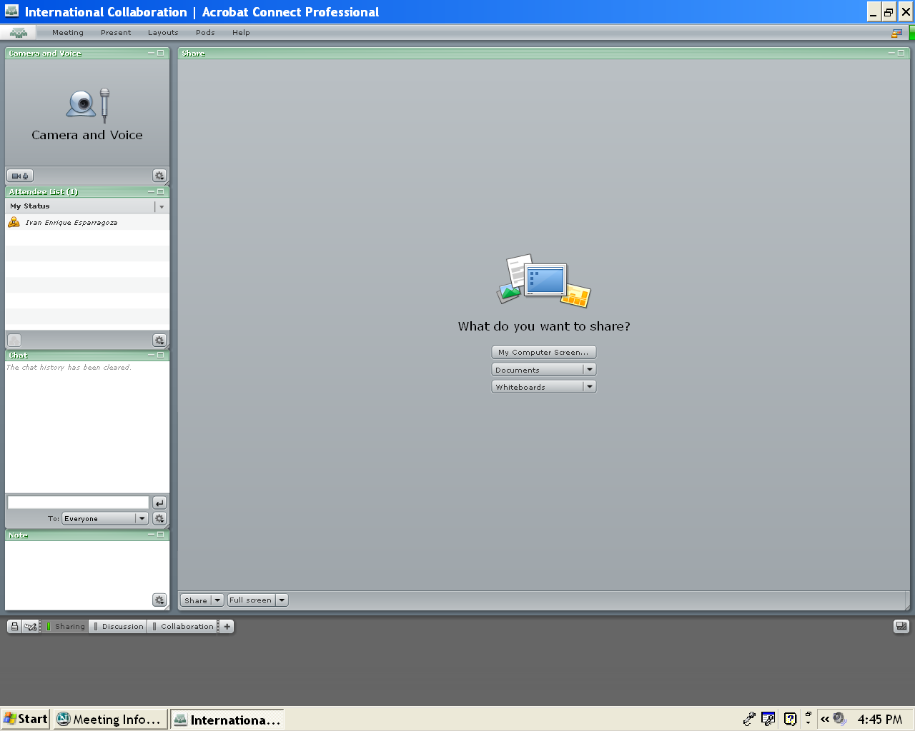
Camera and Voice Pod
Attendee list pod
Chat pod
Note pod
Share pod
Sharing options

Figure 5: Acrobat Connect Professional screen
The camera and voice pod (tool) is by default not available to participants. If a microphone or simple webcam is connected to the computer system, the camera and voice pod allows the host and/or presenters to speak (and be seen) to others in the meeting room. Once a meeting has begun, a host can provide access to the camera and voice pod to participants without elevating a participant to a presenter. This is handy to allow for questions or comments but not allow a participant to take control of a meeting.

Other than the camera and voice pod, the tool used most frequently during a meeting is the share pod. The share pod or tool allows the host/presenter to share content from their computer during a meeting. PowerPoint or Flash files can easily be shared. The share pod also contains annotation tools so that presenters can markup individual PowerPoint slides during a presentation. These annotation tools are also available in the whiteboard component of the share pod. The whiteboard can be used to quickly sketch an idea prompted from the online collaboration.

The third component of the share pod allows individuals to share their computer screen during a meeting. Although not used in this project, this feature holds great promise in working collaboratively through the writing of a proposal or paper, troubleshooting programming assignments, or at other times when computer applications need to be shared.

The recording feature of Acrobat Connect Professional, although not critical during the actual collaboration process, can be used to document meeting minutes or viewed by members of the team that may have missed the meeting.

Two other pods (tools) used during this project were the chat pod and the status pod. These pods allow for text-based feedback to the host or presenter. They can also be used if technical issues, such as audio of video problems, occur during a meeting. Text-based questions can be typed by participants and then answered by the presenter using a microphone in the camera and voice pod. The emoticon component of the status pod can be used for quick responses to yes or no questions, keeping the meeting moving while also bringing the group to consensus on topics.

The remaining tools or pods were not used during this project but provide additional flexibility in a collaborative environment. As its name suggests, the file share pod allows hosts and/or presenters to have a location in the meeting room to upload and for participants to download the documents being discussed during the meeting. The notes pod can record specific questions or decisions that occur during a discussion. These notes are visible to all individuals in the meeting for the duration of the meeting.

The poll pod allows anonymous voting on questions that either occur during the meeting or are preplanned by the host and/or presenter. The emoticons in the status pod allow participants a simple yes or no response. The poll pod permits more detailed questioning of participants to occur during the meeting. Questions presented in the poll pod are best created before the meeting begins and then made available in the meeting when appropriate. It is very difficult for a presenter to try and create these questions and responses while participating (or even leading) a meeting.

And as with the camera and voice pod described earlier, a host can grant enhanced access to specific pods to any or all participants. The pods available in Acrobat Connect Professional provide a host or presenter with several resources to create a productive and enjoyable online collaborative meeting.

To simplify the students online collaborative experience, in this project we focused on three of the pods or tools available in Abode Connect Professional. The camera and voice pod was used so that students and their collaborator could see and speak to each other. The share pod was used to share simple PowerPoint presentations of the design project. And the chat pod allowed participants to initiate a text-based chat so that the discussions could continue if connectivity problems prevented the camera and voice pod from functioning. By requiring the students to develop the PowerPoint presentation before the online meeting allowed the instructor to help the student’s focus on topic discussion points and limit the effect of a poorly designed PowerPoint moving the online discussion off target.
- Opportunities and Pitfalls

Difficulties are anticipated in using online tools for joint international projects and most of them are of technical nature. On one hand, there are challenges in setting and using the web conferencing meetings, but on the other hand these collaborative instruments offer many opportunities for myriad applications including education, research, and business. These contemporary gadgets are here to stay and are now widely used by educational institutions, the industry, and the government to carry our multiple tasks inherent to each group.

Some of the most notorious difficulties that were identified while using Acrobat Connect Professional (Breeze) for the multinational projects are summarized here:
- Accessibility: Many users in Latin America had difficulties accessing the meeting rooms in Breeze. This technical problem is mainly caused by the firewall and proxy servers setting established in the educational institutions in Latin America. A very close collaboration between the instructors and the IT department is required to guarantee the proper functionality of the software.
- Familiarity: Students had a reasonable knowledge of the free software available for online communication such as MSN Messenger, or Skype but very little knowledge of Acrobat Connect Professional. Much time was spent by the student discovering all the features of the software before they could start the actual meeting. Probably more training is required for the students before the beginning of the interactions.
- Technical Support: There was a lack of technical support especially in the Latin American side.
- Cost: This might be a burden for many institutions in Latin America since Acrobat Connect Professional is a licensed software. However, this web conferencing software was supported by Penn State for distance education and collaboration.

However, the proper use of this tool provides great benefits and opportunities for distance collaboration. Some of the most notorious benefits and opportunities are summarized below:
- Integration: As compared to individual products such as MSN Messenger and Skype, the tools brought together in this product provide a similar interface and they do not require student to learn several different programs. On log on account provides access and not one separate account for each product used that could get forgotten or allowed to expire. Technical support is simplified since only one product needs to be supported.
- Recording: By recording each online meeting, individuals involved, faculty and students are able to watch their online discussions, review the components that worked or did not work, and make necessary changes for the next online meeting.
- Security and Privacy: Only participants with Penn State accounts and the meeting web address can access the room. Those participants form outside Penn State can obtain a friend of Penn State account by registering at https://fps.psu.edu.
- Control: Since many of these online meetings occurred while the instructor is teaching, all individuals are assigned the role of presenter so that they would have access to the necessary pods to conduct the meeting. The instructor might record each meeting and might log into a meeting to observe the discussions and participate if necessary.
- Technical Support: As compared to the free software for online interaction, Breeze is fully supported since is a licensed product. Penn State offer full technical support and has a web page for troubleshooting, and offers also online support.
- Reliability: It is a reliable product fully supported technically as explained before.
- Professional environment: Breeze provides a very professional environment for the interaction providing a realistic and mature work setting.
- Final Remarks and Recommendations
As pointed out earlier in this paper, many of the individual collaborative tools are available at little or no cost. Unfortunately, these tools have only one function. In order to replicate the students’ experience, MSN Messenger, Skype, and Google Document tools would be required. Three separate accounts along with three separate interfaces are required. Also with these tools, the instructor has no ability to design the online collaborative experience by structuring these tools to minimize disruptions and potential failures. By using Adobe Acrobat Connect Professional, the instructor was able to remove unnecessary pods to enhance the learning experience of the students involved.

It is evident that the product described here is an effective means to establish and carry out international collaboration. Its effectiveness depends on the technical support given at each location, especially in Latin America were the firewalls and the proxy servers might prevent the users to access the meeting rooms, and the proper training given to the users.

Products like Adobe Acrobat Connect Professional are bringing a set of collaborative tools and functionality to education that just a few years ago were only available to the business market. One goal of the global design projects is that the students have a positive learning experience using online collaborative tools so that, once they are in the professional world, they can make intelligent decisions as to which tools would be needed to best collaborate in an online environment.
References

Baggaley, J. (2003). “The Evaluation and Selection of Collaborative Tools in Distance Education”, Proceedings of the IASTED International Conference. Computers and Advanced Technology in Education, 473-476, Rhodes, Greece, June 30 – July 2, 2003.
Belyk, D., and Feist, D. (2002) “Software evaluation criteria and terminology”, International Review of Research in Open & Distance Learning, 3(1), 2002.
Online: http://www.irrodl.org/index.php/irrodl/article/view/70/141
Devon, R., Sathianathan, D., Saintive, D., Nowe, M., and Lessene, J. (1998). “Alliance by Design: International Student Design Teams”, Proceedings of the 1998 ASEE Annual Conference & Exposition, Session 2544, Seattle, WA, June 28-July 1, 1998.
Ion, W.J., Woldenhouse, A., Juster, N., Grierson, H., and Stone, A. (2004). “Educating the Global Designer”, in Perspectives from Europe and Asia on Engineering Design and Manufacture, Jiang, Y.X.T., and Juster, N., Eds., Kluwer, 2004, pp.225.336.
Pollar, J.D., Devon, R., McKay, A., and Bilen, S.G. (2002). “Teaching Design Through International Collaborations", Proceedings Int. Conference on Engineering Education, Manchester, England, August 18-21, 2002.

Authorization and Disclaimer
Authors authorize LACCEI to publish the paper in the conference proceedings. Neither LACCEI nor the editors are responsible either for the content or for the implications of what is expressed in the paper.

