Fifth LACCEI International Latin American and Caribbean Conference for Engineering and Technology (LACCEI’2007)
“Developing Entrepreneurial Engineers for the Sustainable Growth of Latin America and the Caribbean:
Education, Innovation, Technology and Practice”
29 May – 1 June 2007, Tampico, México.

Beyond the “Multiple Choice Culture”:

Realizing Hybrid Exams with Tablet-PCs

Sabina Jeschke
Berlin University of Technology, Berlin, Germany, sabina.jeschke@math.tu-berlin.de

Peter Göhner
University of Stuttgart, Stuttgart, Germany, goehner@rus.uni-stuttgart.de

Nicole Natho
Berlin University of Technology, Berlin, Germany, natho@math.tu-berlin.de

Olivier Pfeiffer
Berlin University of Technology, Berlin, Germany, pfeiffer@math.tu-berlin.de

Abstract
The large number of different types of examinations along with the notable broadness of scientific fields to be covered present a strong challenge for all academic institutions. So far, many eLearning environments offering electronic examination tools face a severe problem in their acceptance through the academic community since their evaluation methods are usually restricted to simple mechanisms such as multiple choice, short-answer, gap-filling exercises etc. Yet, at higher levels of education, examinations usually contain problems which require deep analytical understanding. Here, the answers have to be given by a freely phrased text, by a detailed diagram with annotations or by a (mathematical) proof with explanatory intermediate steps.
Tablet PCs hold a large potential to overcome these problems: Their ability to deal with handwritten texts, sketches, diagrams, and pictures, enables a new type of “hybrid examinations”, combining the advantages of the new media with long-established and well proven examination procedures. Within this project, electronic examination environments are extended, enabling them to network and support both, “simple” problems with automated validation and grading mechanisms as well as “complex” problems with individual correction through a human expert if necessary.
Keywords: online examinations, hybrid examinations, Tablet PCs
- Problem Statement
Since international communication skills and intercultural competences are growing in importance in a globalized world, the goal is to enhance the comparability of the different courses and classes in the various countries in order to increase the mobility and flexibility of the students throughout Europe. As a result of the harmonization of the academic degree system, the European higher education system will change substantially over the next years.
Based on the Bologna Declaration of the ministers of education from 29 European countries in 1999 (see Bologna 1999, and EU Rectors 2000), the harmonization process requires a “fine-”modular course system where every single module is to be completed by an examination. Thus, the number of examinations at European universities is going to increase dramatically in the near future. Additionally, due to changes in German national law, German universities are now allowed to select their students. They can now make their choice not only on the basis of the high school diploma (“Abitur”), but on the basis of more specific criteria of suitability, in particular through entrance and aptitude tests, which again lead to an increase of examination processes.
To cope with this increasing number of examinations, new concepts for the academic examination organization have to be designed (see Jeschke et al., 2005 and Tschirner et al., 2006). Clearly, electronic examination systems play an important role in this scenario (see Goolnik, 2006 and Krauß and Körndle, 2005). However, most of these systems (commercial systems as well as open source projects, e.g. Hot Potato, tests in moodle) are mainly based on multiple choice, matching, ordering, gap filling etc. up to now. These “simple” methods of validation may be used for pre-learning scenarios, quizzes etc., but at European universities they are neither accepted nor acceptable for final examinations on an academic level. Sophisticated systems using more advanced analysis approaches are restricted to very special fields, e.g. computer algebra system to verify the correctness of mathematical formulae and symbolic manipulations. On an academic level, most teachers demand electronic examination systems which include the possibility for extensive textual answers, hand sketches, diagrams etc. allowing the formulation of complex explanations.
Unfortunately, no system will be available within the near future that would include handwriting recognition and intelligent automatic text analysis. Therefore, from the point of view of university teachers an ideal electronic examination system combines simple, but stable test scenarios with automatic evaluation and more advanced components like computer algebra systems with tools to attach handwritten text, sketches, diagrams etc. Additionally, the examination documents should be available on a central server in order to improve the “logistics'' of the examination procedures, and to support cooperative content development, distributed grading of the results, availability of the results for the students and documentation of the complete examination process for the central examination office.
- General Project Description, Impact & Expected Outcomes
Examinations are carried out in a “hybrid model”, that is, students are inserting the answers partly by keyboard, partly via handwriting. The project consists of the following components:
- Simple tests that can be automatically evaluated (up to algebraic manipulations that can be validated by computer algebra systems) are graded by the computer. If necessary, this automated validation can be overruled by the teacher, particularly in case of ambiguities or semi-correct solution approaches. Complex, handwritten documents will only be evaluated by human teachers. In case of freely phrased text, handwriting recognition programs are well-suited to preprocess the answers.
- To support an efficient document handling, all examination documents are stored on a central examination server. Most important, different teachers may be simultaneously involved in the evaluation process.
- After determining the complete examination results, students are informed by email. Through the central examination server, the whole examination document (including evaluation annotations etc.) is available in read-only format to allow students to inspect their results. After a suitable period of time for complaints, the final results will be automatically transferred to the students' records.
- The administration of the examination workflow is handled by the software component MosesKonto (open source software, developed at Berlin University of Technology, see Grottke et al. 2006, and Fig. 1 for a screenshot). Within Moses, teachers can access the students' data; the results from any testing software can be uploaded and stored in a standard format; students can register for examinations and have access to their grades. Using the MosesKonto, the examination procedure is integrated into the central identity management model of the university. Authentication via LDAP allows integration of Hybrid Examinations into a central ID-management for user authentication (see Fig. 2 for a diagram of the intended TeXaminus architecture). Web services shall be used to integrate Hybrid Examinations into our existing learning management system (moodle).
- A security concept safeguarding the integrity of all examination documents and facilitating the reconstruction of each examination step during the whole examination process, will be developed.
- The project will be realized by integrating the quiz components of the learning management system moodle, the examination software Hot Potato (both open source projects) and the well known testing system Maple T.A. together with software components for handwriting recognition, annotation of documents etc.
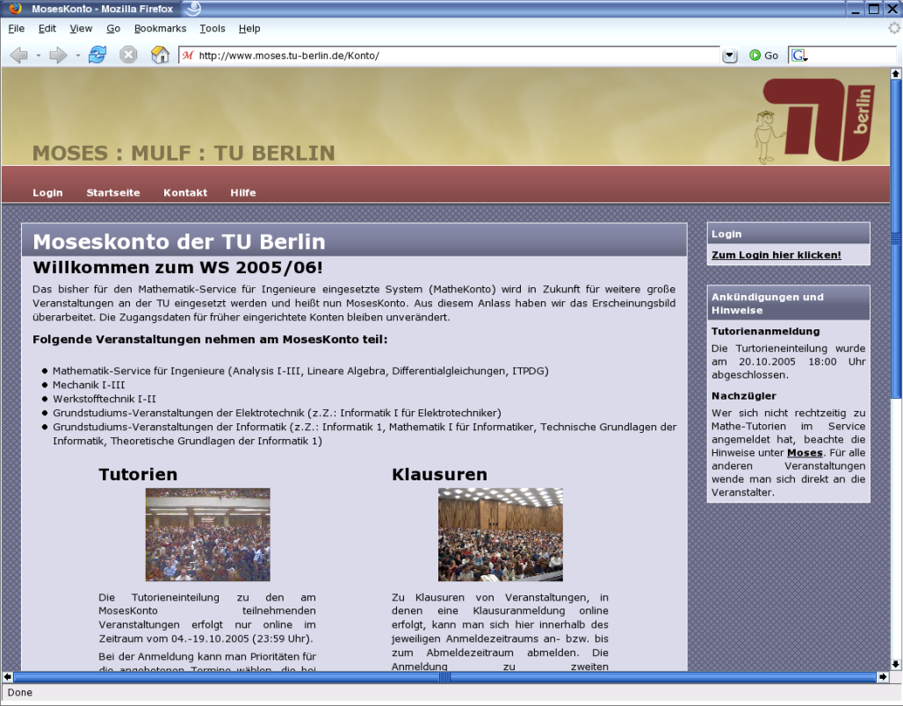

Figure 1: Moseskonto Web-Interface
TeXaminus aims at providing all results of the project to non-profit organizations extensively following an “OpenSource, OpenContent, OpenAccess” strategy: All software components and the evolving examination content will be made available under an open source license.
- Educational Research Questions
The TeXaminus project focuses several educational research questions: First the needs and abilities of prospective students shall be measured before they start a course of studies that possibly does not match her/his skills and needs; secondly the degree of automation in exercise and examination analysis has to be raised in order to cope with the rising student numbers. Finally electronic examinations are needed in order to test skills and abilities which cannot (or only with a great expenditure of time) be checked with pen and paper.

Figure 2: The Architecture of the TeXaminus Project
3.1 Measuring the potential:

Today universities all-over Europe face the challenge of supporting their prospective students in selecting a course of study that fits their needs and abilities. Traditionally the future students had to take those tests, which were written examinations, at a fixed place and date.
Due to the heterogeneous previous knowledge of freshmen measuring their present skills only would not be wise. Rather, determining the occupational aptitude of a candidate for a certain course of study appears reasonable. Therefore, an important education research question is how to identify “potential” instead of “knowledge” by means of hybrid electronic examination environments.
Online-Self-Assessment-Tests take the burden of traveling around the country to take different tests from the candidates, making it easy for them to check their knowledge and skills from any place at any time. So-called aptitude tests are the adequate tool to check, sound knowledge, abilities, skills and personal characteristics (see Albert and Schrepp, 1999). Therefore psychological tests are utilized in the form of questions, advice situations, personal conversations and the generalized in-tray. The problem is the time expenditure for the evaluation and execution of these tests. Hybrid examinations can take remedial action here. Aspects of the personal conversation and the generalized in-tray could be carried out virtually at the computer.
Particularly for technical and scientific courses of studies other questions can be improved by visualization of experiments, editable graphic representations, which can be processed directly, and the possibility to measure motor skills. Since it is conducted at the computer anyway, it is natural that the evaluation should happen automated for the most part. Thus statistical analyses of the results from different points of view (student, teacher, assignment, and question) are easily possible. The part which cannot be automatically evaluated is prepared and can be already semantically enriched for the human proofreader. Thus Hybrid Examinations make online testing and assessment cost effective and simple to carry out. The automatically evaluated results are available instantly after the student has completed the assignment and the results can be displayed graphically and numerically.
Moreover by the online execution of the tests nearly any handicaps can be considered in order to make the examinations accessible for handicapped as well as non-handicapped students and guarantee comparable conditions in the examination (see Dahlmann et al. 2005).
Finally a feedback mechanism can be implemented to monitor whether the results in the tests correlate with the student’s later achievements to adjust the questions in the preliminary tests.

3.2 Re-Formulation for automatic validation:

Due to the large number of examinations, all types of automated validation mechanisms are of great importance to reduce costs and to allow extensive training of the individual learner. The questions arise how problems can be re-formulated in order to use automatic validation mechanisms without reducing the quality of the original problem, and which technologies is best suited to the different examination goals. For any course requiring mathematics complex, free-form entry of equations and intelligent evaluation (see Jantke and Knauf, 2005) of answers are of crucial importance. Embedded in a web-based system for designing assignments, tests and examinations - automatically assessing student performance and answers – the variety of questions is no longer limited to multiple choice, fill-in-the-blank, matching, clickable image, and numeric with margins of error. Moreover symbolic and numeric exercises, free-response questions, which can be tested for mathematical properties such as equivalence, open-ended questions with infinitely many possible answers and questions containing 2-D and 3-D plots based on randomized values can be implemented.
Entangled with virtual laboratories and/or remote experiments (see Jeschke and Richter, 2006) practice problems can be quickly generated in order to give students hands-on-experience. Beyond the enrichment and the simplification of the realization of examinations students’ collaborative skills can be activated by requiring them to discuss the methods the applied to solve their assignment, not just share the final answer (see Cikic et al., 2006, Hampel and Keil-Slawik 2001, and Haake et al. 2004).

3.3 Added value of online examination technologies:

The integration of new technologies into the academic examination process does not only provoke new challenges but also provides new options: An important issue is to investigate the potential of hybrid computer-supported examinations for the improvement of examination procedures beyond the questions of resources and other organizational aspects, but in particular in respect to different examination goals. For example, asking a student to calculate the minimum of the curl of a certain vector field in a traditional examination leads to a long calculation showing that the student is aware of the underlying algorithm. But asking to select the area of minimum curl of the vector field in an interactive applet (by trekking the mouse event) allows verifying if the student is aware of the geometrical meaning of the concept of “vector field curl”.
Another example is: within a written exam it is more or less impossible to test the ability of a student to construct and perform physical, chemical or technological experiments. However, extending online examination tools with virtual laboratories and remote experiments (for details see chapter 4) allows examining the students' knowledge and his or her “hands-on” capabilities.
- Excursus: Virtual Laboratories and Remote Experiments in Online Examination Scenarios
Experiments play a central role in natural and engineering sciences. The integration of new media into teaching and research has led to two principle kinds: virtual laboratories and remote experiments. Integrated into a cooperative knowledge space, they enhance access to experimental setups for all students independent of limitations in time, budget or access to classical laboratories.
Virtual laboratories (Karweit, 1997 and Jeschke and Richter, 2006) use the metaphor of a “real”, scientific laboratory, thus providing a framework that emulates a scientific workplace for hands-on training in a virtual environment. Similar to a real-world laboratory, devices and measurement tools are provided that allow experiments within a specific field. Virtual laboratories for different fields of mathematics and physics form an important contribution to the realization of new learning and research scenarios and are therefore currently under intense development. For theory-oriented areas such as mathematics, theoretical physics and chemistry, they help to bridge the gap between the abstract theory and the real phenomena. Applications of virtual laboratories range from practical support for traditional lectures (e.g. demonstration), over homework assignments and practical training for students up to aiding researchers in experimentation and visualization (see Fig. 4 for a sample GUI).

Figure 3. Screenshot of a remote experiment used during exam, showing critical angle phenomena. | Figure 4: Java Front-End for the Virtual Laboratory VideoEasel for a magnetization experiment.
Complementary to virtual laboratories, remote experiments are real-world experiments, remotely controlled from anywhere outside the laboratory, at almost any given time (see Fig. 3 for a remote experiment, already used in examinations of engineering students). Remote experiments consist of two vital parts, namely the experiment itself, which is supposed to be conducted remotely, and the remote control mechanism. Remote experiments are capable of enhancing the access to “real” experimental techniques which are often extremely complex or cannot be transported and are therefore restricted to a rather small community of students and researchers.
In both scenarios, the experimenter manipulates a set of parameters controlling the experiment and interacting with it, e.g. by a motor, the magnetic field, or - in case of a virtual laboratory - also by manipulating the boundary conditions. Additionally, a set of measurement tools is provided to collect data from the running experiment, e.g. the temperature, the magnetization, a rotation frequency, the mechanical force, etc. Thus, the different approaches possess a number of similarities, but also enrich each other through their differences: remote experiments allow the investigation of real objects including hands-on measurement experience, which obviously does not hold true for virtual laboratories. On the other hand, virtual laboratories are capable of mapping the complete process of constructing an experiment, whereas this kind of flexibility is clearly reduced in remote experiments.
Integrated into online examination tools, virtual laboratories and remote experiments dispose of an important potential to design new examination procedures in order to examine different learning goals.
- Impact and Expected Results
Impact and expected results can be summarized as follows: Within the Texaminus project, a “hybrid exam” system will be developed, where standard elements of electronic examinations like multiple choice, matching, ordering, gap filling etc. allowing automated validation are complemented by extensive (handwritten) textual answers, hand sketches, diagrams, formulae etc. that are to be corrected by human teachers. The Texaminus project will contribute to increasing the deployment of Tablet PCs as an important basis for a modern academic education.

References
Albert, D., and Schrepp, M. (1999) “Structure and design of an intelligent tutorial system based on skill assignments”. In D. Albert and J. Lukas, editors, Knowledge Spaces- Theories, Empirical Research, and Applications, pages 179–196. Lawrence Erlbaum Assoc., New Jersey, 1999.
Bologna (1999). European Ministers of Education. “The Bologna Declaration of 19 June 1999”. http://www.bologna-berlin2003.de/pdf/bologna_declaration.pdf .
Cikic, S., Sinha, U., and Jeschke, S. (2006). “Concepts for Cooperative Knowledge Spaces in Mathematics and Natural Sciences”. Conference Proceedings of the International Conference on Cyberworlds, (CW ’06). IEEE Computer Society, Washington, DC, USA, pp. 99-106.
Dahlmann, N., Jeschke, S., Seiler, R., and Vieritz, H. (2005). “Accessibility in Virtual Knowledge Spaces for Mathematics and Natural Sciences”. Conference Proceedings of AXMEDIS 2005 International Conference. IEEE Computer Press
EU Rectors (2000), “The Bologna Declaration on the European space for Education: an explanation”. 4. Confederation of EU Rectors Conferences and the Association of European Universities (CRE). http://europa.eu.int/comm/education/policies/educ/bologna/bologna.pdf.
Goolnik, G. (2006) „Effective Change Management Strategies for Embedded Online Learning within Higher Education and Enabling the Effective Continuing Professional Development of its Academic Staff”, http://tojde.anadolu.edu.tr/ , last visited: 28.02.2007.
Grottke, S., Jeschke, S., Lach, G., Luce, R., Pfeiffer, O., Sablatnig, J. and, Zorn, E. (2006). “MosesKonto: Student Management and optimized exercise class assignment at TU Berlin”: Proceedings of the E-Learn 2006. Association for the Advancement of Computing in Education (AACE), Editors: Reeves, Thomas C. and Yamashita, and Shirley F., Association for the Advancement of Computing in Education (AACE), pp. 2839-2840.
Haake, J. M., Schümmer, T., Haake, A., Bourimi M., and Landgraf. B. (2004) “Supporting flexible collaborative distance learning in the CURE platform”. Proceedings of the 37th Annual Hawaii International Conference on System Sciences, Los Alamitos, CA, USA, 2004. IEEE Computer Society.
Hampel, T., and Keil-Slawik, R. (2001). “sTeam: Structuring information in a team – distributed knowledge management in cooperative learning environments”. J. Educ. Resour. Comput., 1(2es):3, 2001.
Jantke, K. P., and Knauf, R. (2005) “Didactic Design through Storyboarding: Standard Concepts for Standard Tools”. First Intl. Workshop on Dissemination of E-Learning Systems and Applications (DELTA 2005). Proc. of ACM Press, 2005.
Jeschke, S., Pfeiffer, O., Seiler, R., and C. Thomsen (2005). “"e"-Volution: eltr-Technologies and their Impact on Traditional Universities”. Conference Proceedings of the Educa Online, (ICWE GmbH, Berlin, 2005) pp. 172-176
Jeschke, S., and Richter, Th. (2006). “Individualization and Flexibility through Computer Algebra Systems in Virtual Laboratories”. Proceedings of the Eighth IEEE International Symposium on Multimedia (ISM2006). IEEE Computer Society Conference Publishing Services, Los Alamitos, CA, pp. 965-970.
Karweit, M. (1997). “A virtual laboratory for beginning scientists/ engineers”. Proceedings of ED-MEDIA 97, Calgary, 1997.
Krauße, R., and Körndle, H. (2005) “TEE: The Electronic Exercise”. In Jantke, K. P., Fähnrich, K-P., and Wittig, W. S., editor, Marktplatz Internet: Von e-Learning bis e-Payment, Lecture Notes in Informatics, pages 281– 286. Gesellschaft für Informatik, 2005.
MacKay, D.J.(2003) Information Theory, Inference, and Learning Algorithms. Cambridge University Press, Cambridge, 2003.
Méndez-Vilas, A., Gonzá lez-Pereira, B., Mesa González, J., and J. Mesa González, editors. (2005) “Recent Research Developments in Learning Technologies”, Badajoz, 2005. FORMATEX.
Scott, B. (2001): “Conversational Theory: A constructivist, Dialogical Approach to Educational Technology”. Cybernetics & Human Knowning, 5(4), 2001.
Silver, D. (1997): “Multimedia, Multilinearity and Multivocality in the hypermedia classroom”, http://users.ox.ac.uk/~ctitext2/publish/comtxt/ct14/silver.html , 1997.
Tschirner, N., Müller, M., Pfeiffer, O., and C. Thomsen (2006). “Design and Realization of Multimedia-Examinations for Large Numbers of Participants in University Education”, International Journal of Emerging Technologies in Learning, Vol 1, No 2 (2006)

Authorization and Disclaimer
Authors authorize LACCEI to publish the paper in the conference proceedings. Neither LACCEI nor the editors are responsible either for the content or for the implications of what is expressed in the paper.

http://www.moses.tu-berlin.de
http://www.isis.tu-berlin.de
http://www.moodle.org
http://hotpot.uvic.ca/
http://www.maplesoft.com/products/mapleta/
http://www.math.tu-berlin.de/~thor/videoeasel

