A Concept for Self-contained Electronics Preparation Curriculum in Latin America

Robert A. Summers, PhD.
Weber State University, Ogden, Utah USA
rsummers@weber.edu

Abstract

The delivery of curriculum associated with electronics engineering technology has resisted distance learning formats because it is largely hands-on, requiring lab equipment and component access. The paper will describe a Fundamental Electronics course developed at Weber State University. The course is a one semester, fully self-contained, hands-on entry level course. The Computer and Electronics Engineering Technology department at WSU has experienced renewed enthusiasm and student success learning the basics of electronics using the course. The paper will also show how a translated and modified version of the same electronics course was effectively delivered in a fairly remote region of Costa Rica. It will then propose a completely packaged electronics preparatory curriculum in Spanish that could be adapted to existing secondary schools, trade schools, or as a stand-alone prep course for prospective university students in engineering.

Keywords: electronics, engineering, technology, hands-on, self-contained

1. Background in Self-contained Curriculum

In 2003, the Computer and Electronics Engineering Technology Department at Weber State University (Ogden, Utah) saw declining enrollment and a student apathy towards the rigors of the electronics program. The department traced part of the problem to the entry-level foundation electronics course, which lacked a laboratory component and was rated as “boring” in student evaluations.

The department chair invited the author, a professor in the department, to revise the course. Unable at the time to find a text that was both engaging and comprehensible, he and a colleague authored Fundamental Electronics, using a CD format they could publish themselves at minimal expense. They designed the text to meet the specific requirements for preparing students to enter the CEET program at Weber State University. It is a 2 semester hour course, meeting once a week for two hours. One hour is lecture, and the following hour is laboratory work. There are 15 concept modules to cover the 15 weeks of the semester.

The authors also had in mind the course’s potential as a distance learning package, which would complement the University’s aggressive on-line program. They designed labs to use relatively inexpensive materials, easily packaged for mailing. In order for the students to have access to a trainer for use in their experiments, the package contains the elements for a basic trainer the students assemble and test as Module 2 of the text. They learn soldering techniques, circuit board elements and component characteristics in the process.

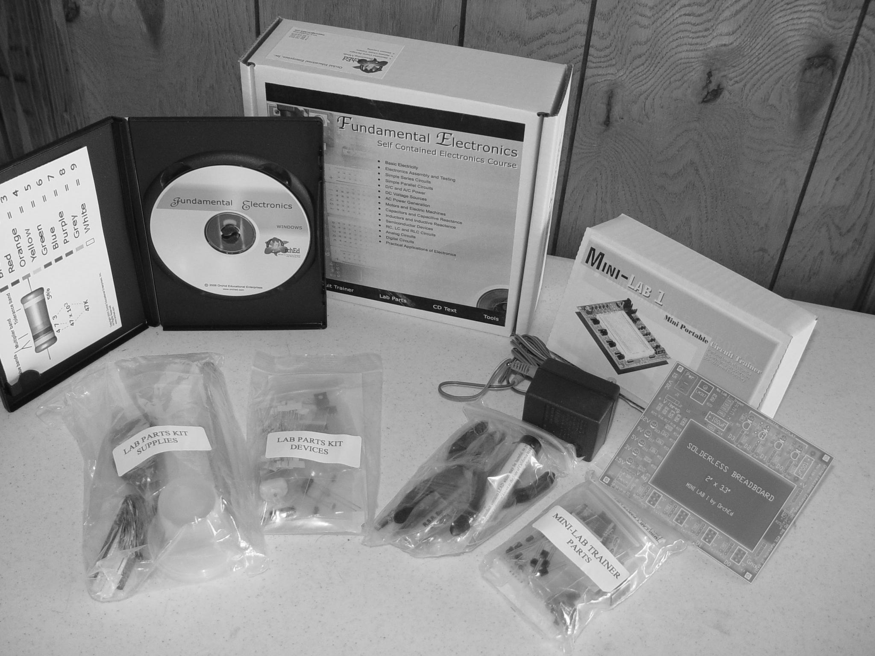

Figure 1: Fundamentals package as sold to university students

In order for students to complete the entire course, in addition to the text, lab parts and mini-lab package, they need access to a computer with Windows™ applications, hot glue gun, soldering iron, a digital voltmeter, oscilloscope and LC bridge. This is basic equipment available in most U.S. high schools, technical schools and colleges. However, truly remote students may not have this access. A Fundamentals package is available which contains a DVM, soldering iron and hot glue gun. The author has a student senior project group working on the design of an inexpensive module that will allow a computer to serve as a simple scope and bridge for the purposes of the course. To publish, assemble and distribute the package, the author has a licensed business called Orchid Educational Enterprises, Inc. The business entity allows for the course package to be sold through the campus book store as a normal course text.

2. The Companion Project

In 1996, the author traveled by car through Mexico and along the Pan American Highway as far as Costa Rica. He ended the trip in the Talamanca region on the Caribbean coast just north of Panama. The word “paradise” is often used to describe many of the regions of Mexico and Central America, and particularly this coast. However, many of the people inhabiting these regions fail to find paradise there. From this trip, the idea of bringing down some of the North American educational opportunities that contribute to a higher standard of living was born. In the ensuing ten years, the author has gathered information and purchased property to establish a headquarters in Costa Rica, where he might begin a technical education project to coincide with retirement from the University.

The author and a small group with similar goals formed the Latin American Technical Education Foundation (LATEF), a charitable foundation to help provide talent and resources dedicated to furthering the cause of providing technical education opportunities in Latin America. While the organization’s charter is broad, so far it has been confined to supporting efforts within the group.

As part of the research stage of the project, the author and a colleague tested the feasibility of using a translated version of Fundamentals to offer a two week mini-course to a group of high school students in the fairly remote town of Bri Bri. The twelve student volunteers would meet at the high school after their normal school day and would build the small trainer, then run some of the experiments on it to illustrate the most basic electronic concepts. In this high school, there are no related courses outside agricultural science to offer background knowledge in electronics.

A generous LATEF donor purchased 12 Fundamental packages containing meters, soldering irons and glue guns. One laptop with a projector and screen would allow the entire class to follow the text and illustrations during the lecture. Everything required for the class easily fit into two checked suitcases.

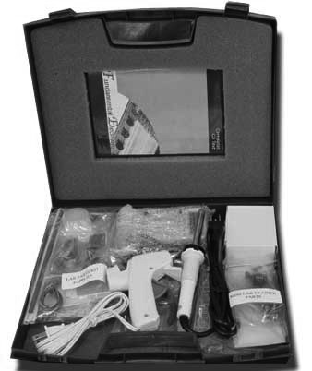

Figure 2: Fundamentals as packaged for Bri Bri course

When the professors arrived for the first class, they were surprised to find only teachers. Some of them were math and science teachers, but the majority taught in unrelated fields. The teachers unapologetically explained they were more entitled to this educational opportunity than their students. They turned out to be enthusiastic learners, and they pointed out that there is a pool of teachers anxious to take advantage of opportunities in technical education so that they can teach it in their region.

In a feedback session at the end of the course, all the participants echoed their enjoyment for the course, but there was a universal question. What do we do with this information? As an isolated course, regardless of its appeal, there has to be a goal and a follow-on step or the information remains isolated and out of context. It was a worthwhile experiment, which contributed much information to forming a broader concept to deliver meaningful education in electronics to Latin Americans.

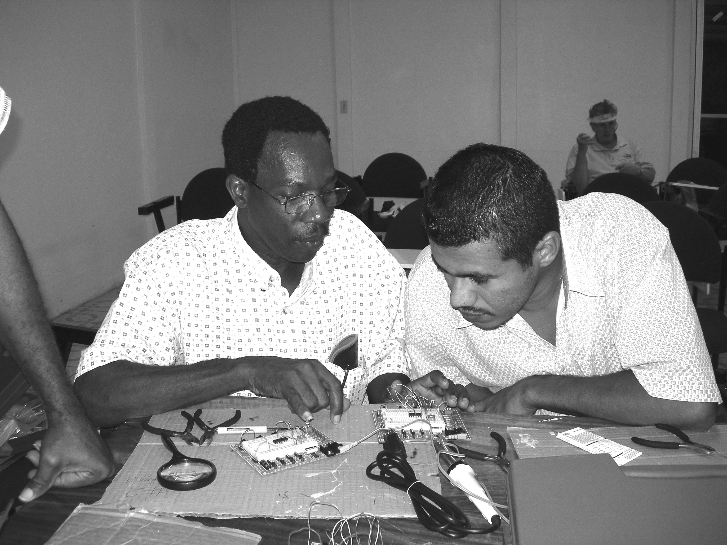

Figure 3: Bri Bri teachers engaged in Mini-lab experiment

3. A Concept to Bring Together the Curriculum with a Meaningful Project

The English version of Fundamental Electronics is completed and tested in a university context, where both students and instructors give it high ratings for both interest and comprehensibility. A modified course in Spanish has been tested in a remote setting lacking in facilities beyond a table and power outlets. The question becomes how may this product be used to provide meaningful technological information to students in Latin America?

The experiment in Bri Bri, Costa Rica indicated a high interest in anything electronic but nowhere to actually apply the new information. In order for the course to be meaningful, there must be a goal, whether it be a job opportunity or progress toward further education. That has led the author to examine an appropriate target for this and other courses he is developing along the same format. A student from Guatemala has provided some interesting insight into these questions.

He comes from an agricultural area, much like Bri Bri, where public school concentrates on literacy rather than technology. He was an apt student, and through mostly luck, he acquired a sponsor to help him go to the United States, where he is now studying in Weber State’s CEET program. He claims there are hundreds in his region with as much aptitude as he has, but who never get the opportunity he has. One has to ask if there isn’t an opportunity for those students to pursue technology education at universities within their own country, if only they have access to preparation for the entrance exams. These exams are the primary inhibitor for Bri Bri students, who pass the exams in alarmingly low percentages.

In Bri Bri, the existing high school education fails to prepare students for advanced education. Without examining secondary schools in other regions and countries, it is irresponsible to suggest that is universally the case in rural Latin America. However, even in the United States, remote schools would benefit from self-contained courses specifically designed as preparatory courses for a specific career path. The concept proposed in this paper is to target capable high school seniors and prepare them for advanced education in technology at institutions already established in their countries.

Few schools would welcome charitable groups coming onto their turf to teach their students. Private schools serve out specialized curriculum, but the cost is prohibitive to even talented students without resources. The concept becomes to organize a set of courses based on portable electronic delivery methods, either CD, DVD or internet where available, and include with the package for each course the tools and components required for hands-on lab applications. The courses would be offered as teacher training, with the idea that qualified teachers in their own schools would teach the courses as electives, either within or outside the normal school day. A reasonable measure of the success of each program would be the number of student participants who qualify for advanced education in technology upon graduation from their secondary school.

As stated, Fundamental Electronics has been developed, university tested and partially translated to Spanish, but even modified for high school, as a stand-alone course, it would be minimally effective in helping students pass entrance exams for technology programs. The author is currently working on a digital electronics course based on a similar format. Other ideas for further development include engineering physics concepts, engineering math concepts, and technical English. Participating students would have to maintain performance standards in their other courses as well to pass all sections of their exams.

Every new program concept eventually heads to the bottom line: who will pay for it? The concept presented here relies heavily on the charitable foundation. The net cost to take Fundamental Electronics to twelve high school teachers in Bri Bri was $1,100, provided by a donor, for the text, lab parts and mini-lab packages. All time and travel expended by the two professors offering the course was donated by them. The audio/visual equipment required for text presentation was loaned by Weber State University. Course participants kept all their materials.

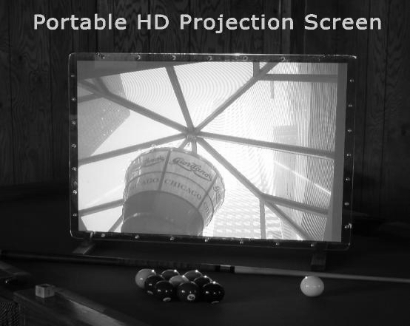

Figure 4: Projector interfaces with a laptop to project images on the high definition tabletop screen.

Once the coursework for this program is fully developed, it lends itself to a trial one location at a time. The ideal location is in relatively close proximity to a cooperating university, one that will assist with curriculum development to prepare students for that university. Ideally, donors will be found who are willing to purchase course materials, and perhaps even sponsor individual students to the point of providing scholarship money should they be accepted to the cooperating university. Participating teachers must be found and fairly compensated for their extra time and training. A funding source for that component must be procured. A local accountability and audit system must be in place to insure that materials are secure and that teachers are providing the curriculum according to their contracts. Success in one location will presumably lead to increased funding sources and participation in additional locations.

4. A Pilot Proposal

The author proposes to test the curriculum in a Latin American country as early as 2008. The Fundamental Electronics modification and translation will be completed and will adapt to a one-class-a week format. The proposal is to continue developing and translating a digital electronics course along the same format, physics concepts, math concepts and technical English, each offered one hour a week for a 36 week period.

The pilot program requires a cooperating university to ensure the curriculum covers a preparatory base for students aspiring to enter engineering programs. The program will also invite a participating secondary school, willing to offer the curriculum as an elective hour during the normal school day, or provide facilities for the courses after school. The cooperating school will screen participating faculty and students as well.

Participating teachers will attend inservice training in the courses they will teach. They will demonstrate mastery of the course material, and will be under contract to deliver the curriculum during the specified time frame. Students will also have periodic assessments that indicate both their mastery of the material and the effectiveness of the curriculum and delivery. During the pilot process, both faculty and students will be asked to evaluate and offer suggestions for improvement. Participating students will be in their final year of secondary school, and at the conclusion of the program, they will be required to enter the examination process for entrance into the cooperating university. Ideally, data will be available to compare exam results from the pilot group with general exam results from students applying to engineering programs at that university.

Participation in this proposed pilot program will be largely controlled by available funding. LATEF is empowered to raise money to pay for this type of activity. Based on the Fundamentals package alone, cost for materials for each student will run $500 for the school year. Participating teachers should receive a stipend for attending inservice training based on their normal hourly salary. Assuming 36 hours of inservice for each course, the stipends would amount to $360 per course, or $1800 for all five courses based on an average salary of $10/hr. Once selected as teachers for the pilot, they will receive a salary for the 36 weeks of the course offerings. Assuming five teachers, each teaching one course for an hour a week, with an hour of preparation, at an average salary of $10/hr, total teacher salaries for the pilot amount to $3600. Teacher compensation and course materials will total approximately $6,000 for the pilot if the $10/hr average salary estimate is correct. If LATEF or another sponsoring foundation were to set and meet a fundraising goal of $12,000, a total of 5 teachers and 12 students would be able to participate in the pilot program. Student access to laptop computers would be desirable, but not essential. Instructors would have laptop computers as part of the lesson projection system.

5. Conclusion

Continued economic development in Latin America is closely tied to the education level of its citizens. Today’s global economy requires a high level of technological expertise among its participants, and we all have an obligation to share both knowledge and resources to provide an even playing field, where all have an opportunity to improve our game. The concept presented in this paper is a serious effort dedicated to this goal. The author welcomes and solicits input, particularly from Latin American educators, as their background and experience will add new perspectives to his ideas.

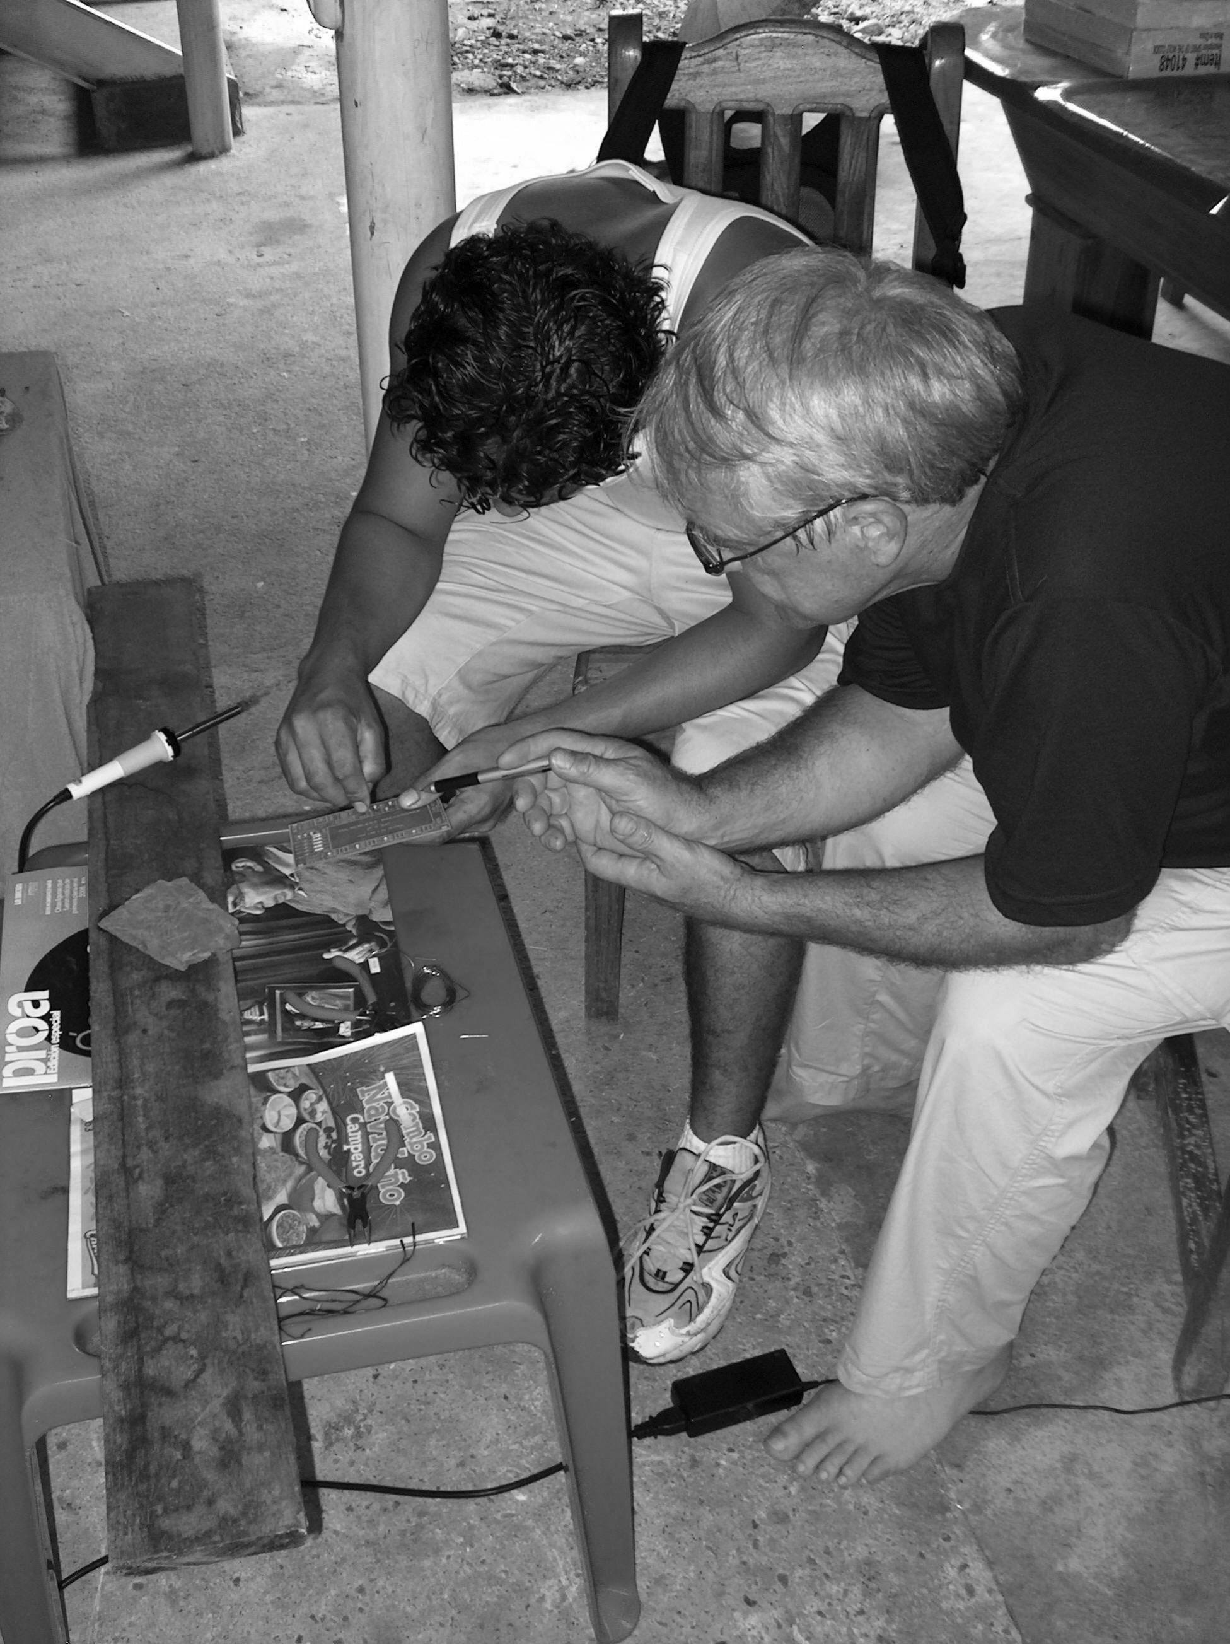

Figure 5: Electronics can be taught anywhere.

Authorization and Disclaimer:

The author, Robert A. Summers, does authorize LACCEI to publish this paper in the conference proceedings. Neither LACCEI nor the editors are responsible either for the content or for the implications of what is expressed in the paper.

