Fifth LACCEI International Latin American and Caribbean Conference for Engineering and Technology (LACCEI’2007)
“Developing Entrepreneurial Engineers for the Sustainable Growth of Latin America and the Caribbean:
Education, Innovation, Technology and Practice”
29 May – 1 June 2007, Tampico, México.

Study On The Landslide Hazard In The Pashley Street, Laventille, Port Of Spain

Vasudevu Kanithi
Department of Civil and Environmental Engineering, University of the West Indies, Trinidad and Tobago. E-mail: vkanithi@eng.uwi.tt
Abstract
The present study deals with the landslide hazard in the Pashley Street, Laventille region a few km east of Port of Spain, Trinidad. The study is a part of the ongoing project ‘Engineering Restoration of Upper Pashley Street Community Infrastructure’ undertaken by the Department of Civil and Environmental Engineering, University of the West Indies, St Augustine Campus. The study is significant since the extent of damage caused by the earth movements is considerable and also the number of people affected is large. Nearly a hundred houses were damaged; some completely and the others partially. Several families had to abandon and relocate their residences elsewhere. Infrastructure like roads and drains got affected. In this study, geomorphologic and geological controls have been analyzed.
Keywords: Landslide hazard, soil, swelling clay, phyllite
- Introduction
In connection with the ongoing ‘Engineering Restoration of Upper Pashley Street Community Infrastructure’ project, studies were carried out. The Pashley Street, Laventille is a suburb of Port-of-Spain, Trinidad. The region stretches from the lowlands along the Eastern Main Road into the hills above Port-of-Spain. It encompasses a total area of about 0.5 square km and has a population of approximately 3500 people. It is an undulated area with seventy-five percent of the total land area being occupied by small ridges or mounds. The slopes vary from less than 100 to sometime more than 450 locally. Settlements exist through out the area over the slopes. This area is accessed via the Old St. Joseph road. The study area is shown in the figures 1 and 2.
The climate is tropical. The average temperature is 250C and the annual variation ranges from 21 to 350C. The rainfall averages 1520 mm a year.
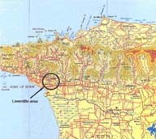
Figure 1: Approximate location of the site under investigation
- Damage due to landslides
In recent years, the area has been experiencing landslides causing damage to the houses and the infrastructure such as roads and drains. The damage is shown in the photos 1 to 6.

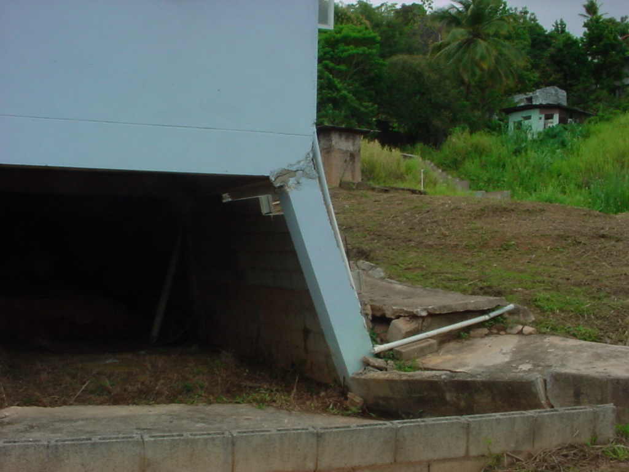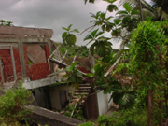
Photo 1: The house got damaged because of land slip towards right side. | Photo 2: Part of the house towards the observer was damaged

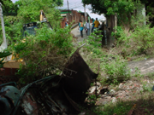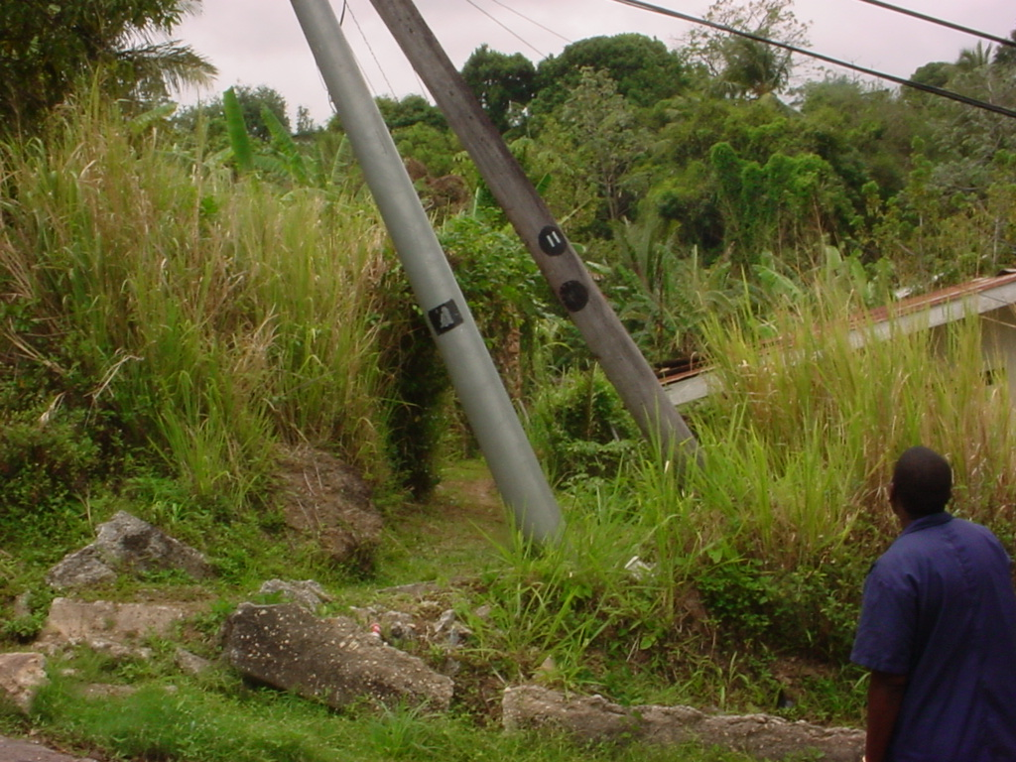
Photo 3: The compound wall was broken and moved towards left. | Photo 4: Debris of the retaining wall and the bent electrical poles.

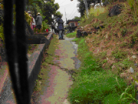
Photo 5: The shift of road towards right can be seen.. | Photo 6: This road has been damaged. Soil moved on to the road.

- geology andgeomorphology of the area
Investigations were carried out to understand the nature of landslides. One of the aspects of the investigations is the study of geomorphology and geology of rocks and soils. Geologically and geomorphologically, Trinidad and Tobago is made into five divisions known as a) the Northern Range, b) the Northern Basin, c) the Central Range, d) the Southern Basin and e) the Southern Range (Suter, 1960, and Persad, K.M.1979). The Northern range occupies that part of the island which lies north of the line drawn from the Port of Spain on the west to Matura pint on the east. It is a hilly rugged country almost inaccessible in some parts with dense forests. The relief of the area is 105m (between 5 and 110m contours). The geological map of the study area is shown in the fig. 3.
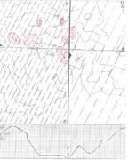
Figure 3: Geological map of the study area, Pashley Street, Laventille. The N-S trending fault FF is shown. A vertical cross-section along AB is shown at the bottom. The landslides are shown in red colour. They are taking place along the slopes between the 25 and 95 contours.
The Pashley area is the southernmost edge of the Northern Range. Almost all the rocks of the Northern Range consist of the low grade metamorphic series of the Caribbean group (Brown and Bally, 1966). The geology of the area as a whole is complex. However, three distinct litho units are observed in the area. They are clay (photos 7), phyllite (photos 8&9) and quartzites (photo.10). Quartzites occur only as thin bands in limited areas. These litho units alternate. Phyllite has thin foliation and is highly disturbed. It is a medium grade regional metamorphic rock of light brown colour. It is none other than a lithologic (metamorphic) transition of clay.
The series of narrow ridges and valleys occupying the study area reflects the geology of the area. The mounds are occupied by phyllites, which are a bit hard and the valleys comprise soft clays. The general strike of these formations is northeast (N40⁰E). The area is bisected by a NS trending fault (fig. 3) occupied by a long valley with a perennial spring. While the eastern section of the fault comprise phyllites (photo 9&10), the western part is occupied by soft clays, phyllites and thin bands of quartzite. Rocks on the east gently dip towards west and are not much disturbed (photo 10), whereas those on the western side dip (> 45⁰) towards west and very much disturbed.

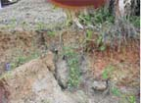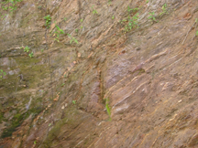
Photo 7: Clay. Over this clay the houses were built. | Photo 8: Phyllite. A normal fault can be seen.

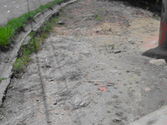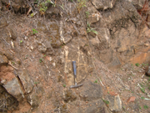
Photo 9: Nearly horizontal strata. | Photo 10: Hard quartzite.
- drainage
The drainage mostly is guided by the contours and the contours in turn are carved by geology. There are natural springs in the area as observed in the topographic map. They were also noticed during field trips. But these spring courses were modified by construction activity. Besides, paved drainage was developed, often interfering with the natural drainage.
- soils
It is pertinent to note that only those structures that are situated on the soils were damaged the ground below being destabilized. In general soils owe their nature largely to parent material. There are both residual and transported soils in the study area. Residual soils occurring in these dissected areas are mostly original clays. They are covered by transported soils on their top. The transported soils are mostly derived from the adjoining mounds and their slopes which consist of young sedimentary parent materials of clay, shale, etc or their (slightly) metamorphosed equivalent, phyllite. Transported soils occupy slopes of the mounds. Most soils contain a mixture of clay, organic matter, sand and silt. Percentages of sand, silt and clay in soil vary from place to place. Soils of this area contain more than 60% of clay. An average clay percentages of 17 randomly chosen samples from different depths (0” to 15”) was found to be 63.11% (table 1).

Table 1: Percentage of clay in the bore samples at different depths
BH | Sample No. | Depth in feet | Gross wt. | Clay wt. | Clay % | Remarks
B4 | 2&3 | 0.0-4.0 | 457.5 | 272.5 | 50.89 | Quartzite pebbles and pieces of tiles present.
B4 | 4&5 | 4.5-7.5 | 265.2 | 121.6 | 45.85 | Brown phyllite pebbles +coarse sand + silt.
B4 | 6 | 6.8-9.5 | 216 | 98 | 45.37 | Quartzite pebbles present
B4 | 8 | 10.5-12.0 | 368.3 | 204.4 | 55.49 | Quartzite and phyllite pebbles and grains present
B5 | 1&2 | 0.0-2.5 | 413.8 | 316.6 | 76.51 | Soft phyllite, silt fraction is more
B5 | 4 | 4.8-6.0 | 298.25 | 220.5 | 73.91 | Soft phyllite pebbles + silt (>60%)
B5 | 6 | 6-7.8.0 | 205.4 | 135 | 65.73 | Soft phyllite fragments + silt (>60%)
B5 | 7 | 9.0-10.8 | 190.75 | 134.5 | 70.51 | Small quartzite pebbles + phyllite coarse sand + silt (>60%)
B5 | 8 | 10.8-12.3 | 195.15 | 120 | 63.38 | Small quartzite pebbles + phyllite sand + silt (>60%)
B5 | 9&10 | 12.0-15.0 | 180.9 | 125.6 | 69.43 | Quartzite coarse sand + silt (>60%)
B7 | 4 | 4.5-6.0 | 319 | 176.5 | 55.32 | Coarse quartzite sand + silt (>70%)
B7 | 5 | 6.0-7.5 | 339.4 | 202.1 | 59.54 | Cindery volcanic pebbles, phyllite + silt (>50%)
B7 | 7 | 9.0-10.8 | 294 | 152.8 | 51.97 | Cindery volcanic pebbles + phyllite + silt (>50%)
B7 | 9&10 | 12.0-15.0 | 427 | 173.3 | 40.58 | Quartzite small pebbles + Coarse sand + silt (>50%)
B10 | 1 | 0.0-1-5 | 333.1 | 216 | 64.84 | Bigger pebbles of igneous rock (dolerite) and limestone breccia + coarse sand + silt
B10 | 9&10 | 12.0-15.0 | 265.2 | 212.6 | 70.44 | Hard phyllite pebbles present
B11 | 6 | 6.8-9.5 | 211.65 | 110.7 | 51.13 | Small pebbles of quartzite + phyllite + silt
Average of all the 17 samples |  |  |  |  | 63.11

Clays of the study area are of original argillaceous sediments of the basin unaffected or least affected by metamorphism and the derived products of phyllites occupying the mounds as indicated by the bore hole data. Clay is a naturally occurring, inorganic component of most soils. Chemically, clays are aluminosilicates [Al₄Si₄O₁₀(OH)₈] and carry negative charges. The most common clay minerals can be classified into five groups: smectite (montmorillonite, beidellite, nontronite, and others); illite (illite and glauconite); kaolinite (kaolinite, halloysite, and others); chlorite (chlorite and others); and sepolite (sepolite and palygorskite).
Clay is made up of tiny particles less than 0.002 mm or >8φ (Krumbein 1941) in diameter. By comparison, silt particles range from 0.002 to 0.05 mm in size and sand particles from 0.05 to 2.0 mm. For this reason, clays are considered to be fine textured; silts, medium textured; and sands, coarse textured. Sand is composed of large, neutral particles of silicon dioxide (SiO₂).
Clay acts as a binding agent between soil particles. It gives soil elasticity and provides cohesion of soil particles. The result is a network of capillary pores that hold moisture against the force of gravity.
- discussion and conclusions
As mentioned earlier, all the landslides in the study area are confined to areas where thick layer of clays occur. Laventille has expansive soils and the effect of moisture changes results in shrinkage (photo 12) and swelling of the soils. The landslides and the consequent damages are the result of continual heavy rains for several days. And the landslide is not at a sudden incident happening in a single moment. It is a gradual movement during several rainy seasons; at least five years as indicated by the age of the coconut trees (photos 13&14). The bend in the trees indicates gradual landslide during the 4 to 6 years. The residents of the colony also were of expressed the same opinion.
Clays by nature are porous but not permeable. On this account they get saturated and the constituent clay minerals swell. Initially when water is added to clays, it is adsorbed around the clay particles and so the capillary films are enlarged. This impedes the gravitational flow of water. Further addition of water causes swelling of minerals like montmorillonite of smectite group which are capable of absorbing appreciable amounts of water between the individual silicate layers of the structural lattice (Nwaiwu and Nahu, 2006). Kalpana and Dinesh observed significant changes in the silicate (Si-O) stretching region (1150 to 950 cm¹) with changes in swelling and orientation.
According to Olive et al (1989), swelling clay is “clay that is capable of absorbing large quantities of water, thus increasing greatly in volume”. The swelling potential of clay is dependent on the amount and kind of clay minerals present, their exchangeable ions, the electrolyte content of the aqueous solution, particle-size distribution, void size and distribution, water content, superimposed load, and other factors. Also they added that where the swelling clays are at or near the surface and within the zone of weathering, they constitute a potential source of damage to foundations and structures; particularly susceptible are lightweight types of construction such as concrete slabs for highways, canal linings, spillways, and basement floors and foundations of buildings, as well as walls supported by these foundations.

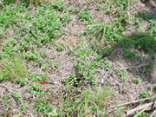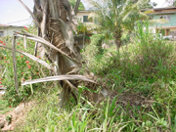
Photo 12: The ground developed cracks in dry season. Surface cracks are indicators of soil that is prone to swelling and shrinking. The width of the cracks is as much as 6” | Photo13: The bent coconut tree. It bends toward the land slip (to the left).

Tourtelot (1974) attributes the origin of the accumulation of nearly all the highly montimorillonitic, thick and widespread shale unites that are of recognized engineering significance to deposition of volcanic ash in ocean basins.
According to Jerome V. De Graff et al (1989), the presence of clay either inherited from parent sedimentary bedrock or derived from weathering of metamorphic and volcanic bedrock contributes to the tendency of soil masses to fail. As a result of water, especially during continuous rains for days, clays get over saturated, soaked, swollen and become viscous. Sometimes vibrations (by vehicular traffic on the nearby roads or pathways) in ground trigger and accelerate movement in the viscous clays. Instances of soils swelling and flowing like slurry in several parts of this country were reported (Vasudevu 2006). During rainy season, when the clay is saturated, it slides down under its own weight along the slope. It has got nothing to with the water table or drainage.
Legget (1988) observes that slides in sensitive clays can develop from small beginnings to massive flows as excessive pore water is released to form slurry which is viscous enough to carry large blocks of still solid soil. Ground loading and vibrations associated with moving vehicles or local construction activity are often thought to contribute to the failure. He also adds that such phenomena were observed and reported by many earth scientists.
All the landslides here are confined to areas where thick layer of clays occur. It is obvious that Laventille has expansive soils and the effect of moisture changes results in shrinkage and swelling of the soils within the region. It is observed that landslides here are not matter that has taken place in a single event. It is gradually happening. It is taking four to five years here to destabilize the ground to affect the structures. Geomorphology with undulations, geology with the type of rocks and soils, and the climatic environment with uninterrupted heavy rains for several days are the factors that are responsible for the prevalence of landslides in this country.
References
Brown, C.B. and G.S. Bally, (1966), “Land Capability Survey of Trinidad and Tobago, 0.4, Central Trinidad”
Jerome V. DeGraff et al (1989), “Landslides: their extent and significance in the Caribbean”. Brabb and Harrod (eds.), © 1989 Balcema, Rotterdam, ISBN 90 6191 8766.
Kalpana and Dinesh, “The effect of clay – water interactions on swelling in Montmorillonite clays”. An article from internet.
Krumbein, W. C. (1941), “Measurement and geological significance of shape and roundness of sedimentary particles”. Journal of Sedimentary Research; August; v. 11; no. 2; p. 64-72
Nwaiwu, C. M. O. and I. Nuhu (2006), “Evaluation and Prediction of the Swelling Characteristics of Nigerian Black Clays”. Geotechnical and geological Engineering, vol. 24, No.1 ISSN: 1573-1529 (Online)
Olive, W.W et al (1989) “Swelling Clays Map of the Conterminous U. S”. U.S. Geological Survey Publication.
Persad, K.M. (1979). “Outline of the Geology of the Trinidad Area”. Fourth Latin American Geological Congress Trinidad and Tobago, pp 738-758.
Robert F. Legget (1988), “Geology and Engineering” (page 511), 3rd edition, New York: McGraw-Hill
Suter, H.H (1960), General and Economic Geology of Trinidad, B. W. I, H.M. Stationary Office, London (second edition)
Vasudevu and Kanhai (2006), “Landslides in Trinidad – A Geotechnical Study” Proceedings Volume, LACCEI 2006.

Authorization and Disclaimer
Authors authorize LACCEI to publish the paper in the conference proceedings. Neither LACCEI nor the editors are responsible either for the content or for the implications of what is expressed in the paper.

