Service Learning Multidisciplinary Projects
to Develop Diverse Global Engineers
Zenaida Otero Gephardt, Yusuf A. Mehta, Dianne Dorland, Mariano Savelski,
Beena Sukumaran, John C. Chen and John L. Schmalzel
College of Engineering, Rowan University, Glassboro, NJ 08028, gephardtzo@rowan.edu

ABSTRACT

The integration of service learning into projects and coursework offers an opportunity to expose students to the socioeconomic aspects of technology. Students are directly exposed to technology as an important component of social and economic stability throughout the world. The development of global engineers is an important aspect of modern engineering education and multidisciplinary, multicultural team based projects are an excellent means to strengthen this aspect of student development. The Rowan University Engineering Clinics are courses designed to include state-of-the-art technology and pedagogy in the engineering curriculum. These courses are the hallmark of the Rowan Engineering education and provide an excellent vehicle for the integration of service learning into the curriculum. Service learning can enhance technical education while exposing students to the economic and social outcomes and consequences of technology. Multicultural and multidisciplinary projects in Latin America to enhance students’ technical foundation and provide a pedagogically sound opportunity for service learning will be detailed. Projects in Chile and El Salvador will be highlighted. The focus will be on the similarities in pedagogy, student learning and benefits to the host communities. Service learning as a vehicle to attract and retain underrepresented students in engineering will also be discussed.

Introduction and Background

Service learning has gained more prominence in education as a vehicle to expose students to societal, ethical and moral issues (O’Grady, 2000, Madden, 2000, Butin, 2000, Canada and Speck, 2001). Engineering educators have participated actively in these efforts throughout the curriculum. Service learning has provided an important teaching tool in first year courses (Oakes and Thompson, 2004, Thompson et al., 2005) and senior and graduate courses (Bullard et al, 2004, Talbert et al., 2003, Draper, 2004). These researchers found that students want to connect their professional education with solutions to societal problems and that service learning is an important vehicle for students to develop a clear understanding of internationalization. Internationalization continues to gain prominence in the present discussions on engineering education for the 21st century and beyond. Academics and industrial leaders realize a global economy requires global engineers. The internationalization of engineering education has become more important as trade barriers have been removed and the societal and technological impact of a global economy has become more evident. There is no general consensus on the definition of a global engineer. However, an international component in the curriculum designed to connect technology with engineers’ responsibility to enhance the quality of life worldwide is critical in the development of engineers that will be able to contribute to the global community.

Connecting international technical education with service learning enhances the understanding of societal and economic conditions in the developing world. It allows students to develop an in-depth understanding of the costs and benefits of sustainable development and globalization to communities. Sustainable development is an especially important aspect of international engineering education because it is a critical element in improving the quality of life of people worldwide. This is especially the case in the developing world (Juárez-Nájera et al., 2006, Conceigao et al., 2001). Service learning in engineering education can also serve to attract students typically underrepresented in engineering. This is especially the case for women (Casey, 2005). Researchers have reported (Mihelcic et al., 2006) that the integration of global perspectives in sustainable development projects served to attract women and underrepresented minorities into engineering. They reported that 40% of the project participants were women and 8% were underrepresented minorities. This is a significantly higher participation than the percentage of these populations of engineering students in the College.

There are few technical activities and problems that are not global in nature. Globalization continues to influence economies and communities strongly, and to shape the content and delivery systems of engineering education (Oberst and Jones, 2003). A high quality engineering education must include a global component (Simpson, 2000, Papazoglou, 2006). Most international activities in engineering curricula include travel abroad opportunities and many include the participation of industry (Eijamal et al., 2005, Fortenberry, 1996), collaborative reform efforts (Brodeur and Crawley, 2002), integrated approaches within a college or department (Holland and Vazquez de Velasco, 1998), and courses designed to expose students to international perspectives (Ciocci, 2005). The development of global standards is one of the major challenges in the efforts to internationalize engineering education. A multinational approach by faculty to develop courses and upgrade curricula throughout the world is an important component of standards development (Rio and Molina, 2003) as is assessment of these efforts (Kentish and Shallcross, 2006). In order to meet the challenges of a global economy, engineering curricula throughout the world will require changes that enhance the competitiveness of students in the world market (Lyons, 2000, Spinelli, 2001).

Service learning curricula to develop global engineers have benefited students and the profession in numerous ways. They have certainly resulted in more well-rounded engineers who can meet the worldwide technical and societal challenges. However, there also have been other benefits. There are a multitude of ways in which universities can develop graduates with strong analytical and critical thinking skills, a solid ethical foundation and an understanding of the role of engineers in developing a strong and peaceful global community with economies that enhance the lives of people worldwide. The strengths of Rowan Engineering stem from the multidisciplinary project-based team learning approach in the Engineering Clinics (Sukumaran et al, 2006). This approach, combined with a strong service learning component, has provided significant international opportunities for students and faculty. The Rowan College of Engineering was founded as a result of a $100 million gift from industrialists Henry and Betty Rowan in June of 1992 to the then Glassboro State College. At the time, this was the largest single gift made to a public institution of higher education. The engineering curriculum was developed with built-in flexibility to allow for the inclusion of important technical and societal topics. The most important vehicle for this flexibility is the Engineering Clinics. The Clinics are required project-based courses that students take every semester. Table 1 lists the general technical topics covered in the eight-semester Engineering Clinic sequence.

Table 1. Overview of general technical topics in the eight-semester Engineering Clinic sequence

Year | Engineering Clinic Theme (Fall) | Engineering Clinic Theme (Spring)
First Year | Engineering Measurements | Competitive Assessment Laboratory
Sophomore | Multidisciplinary Design Modules | 16-Week Multidisciplinary Design Project
Junior | Product Development | Process Development
Senior | Multidisciplinary Capstone Design/Research Project | Multidisciplinary Capstone Design/Research Project

First year and Sophomore Clinics include topics in ethics and communication and use simple engineering projects to strengthen students’ understanding of mathematics and science principles. Junior and Senior Clinics consist of projects, often sponsored by industry or government, which represent the culmination of the Rowan Clinic experience. Students apply engineering principles learned in the classroom to solve industrially and socially relevant problems. They also can learn new engineering technologies within the Clinic context. The Engineering Clinics are a major vehicle by which the College has internationalized its curriculum and integrated service learning. Students can work on collaborative projects based in other countries. Many of these projects have a strong service learning component. As a result, students enhance their technical skills, learn to apply engineering principles to the appropriate technology in the host country, and learn about world cultures and languages. Most importantly, they work side by side with members of the community in the host country and develop an appreciation for the benefits and challenges of globalization. They witness first hand how technology can benefit humanity. Students who participate in these experiences are ready to tackle the significant technical, societal and cultural challenges that are very likely to be part of their future professional experience. Two Engineering Clinics are highlighted in this work; 1) An Engineers-Without-Borders project was combined with an Engineering Clinic course to provide students with an international service learning experience that made a positive difference to the host community in El Salvador and 2) An Engineering Clinic project to optimize abalone aquaculture in collaboration with independent abalone farmers in Chile and La Universidad Católica del Norte Sede Coquimbo.

Engineering Clinic and Engineers-Without-Borders Project in El Amatón, El Salvador

The project was originated through the Rowan Student Chapter of Engineers-Without-Borders. The Rowan EWB Student Chapter submitted the standard proposal and was awarded the project. It entailed the design and future installation of a water tower and a water delivery system for the host community of El Amatón in Santa Ana, El Salvador. The community is near the border between El Salvador and Guatemala. The project was developed into an Engineering Clinic experience, and as a result the student team included two EWB students and three Engineering Clinic Students. The students and two faculty advisors worked in El Amatón during the last week of August and first week of September 2006. Presently, El Amatón has no running water. Residents must carry water to their homes everyday. This work is mostly the responsibility of women and girls. During the wet season, rain provides enough water on most days and residents can fill containers (canteros) with water. There is a centrally located water faucet (chorro) that is used by the community. Residents use this water for drinking, cooking, cleaning, bathing and for their animals. Many residents also use this water to wash clothes. However, a significant number of residents use the river for this purpose. During the dry season, residents must find water. This involves a 2 or more mile walk to a river. In general, residents walk to and along the river until they find water. Obtaining a day’s supply of water for a family can take a significant portion of the day. As a result, young women and girls often are unable to attend school since providing water for the family is their responsibility. The water used in El Amatón is contaminated to the extent that a significant number of the residents are ill at any given time. Peace Corps efforts have resulted in a majority of residents boiling water prior to use. This has served to decrease the frequency of illness due to water contamination in the Community. Residents of El Amatón use latrines and most homes are so equipped.

The Rowan project included three parts; a land survey, a community survey, and a preliminary water quality assessment. Prior to leaving for El Amatón, students acquired or reviewed land surveying techniques, developed a preliminary community survey and gathered the necessary reagents and equipment for a preliminary water quality determination. The three phases of the project will be described below. However, the focus of this paper is to detail the procedures by which the Rowan team integrated the community and the service-learning component into the project. As a result, these aspects will be discussed in more detail.

Land Survey: Surveying the community was a critical component of this project. All 104 homes in the community were surveyed so as to provide maximum flexibility in the design and installation of the water delivery system. These data allowed for the design of water delivery systems to each individual home as well as water delivery to specific locations in the community. The land survey was completed.

Community Survey: A survey instrument to assess water use per day by the community was developed at Rowan University. This survey included questions regarding quantity and type of water consumption as well as the residents’ ability and willingness to contribute to the project and to maintenance costs for the water delivery system. The average and peak-time water use were quantified as well as the monthly cost that families in the community could afford. The overwhelming majority of residents were willing to help with the installation of the system. However, there was little expertise in construction or with the use of standard tools in the community.

Water quality: The water available to the residents was analyzed for fecal matter, hardness, pH and nitrate and sulfate content. Water from the local chorro used during the wet season and from the river was analyzed. These data were made available to the community and are part of a more comprehensive technical analysis of the water quality and availability in El Amatón. Most disturbing was the high concentration of fecal matter in the river water. This contamination is likely to be a major source of illness in the community.

El Amatón Community Integration and Project Management

The Rowan team arrived in San Salvador and was transported to El Amatón by community volunteers and a representative from the Peace Corps. The Community made a church building, equipped with mattresses and two latrines, available to the team. The Rowan team considered living in the Community an important component of integrating the Community into the project. The Rowan team had meals with different families every day. Families were paid a fair price for providing three meals to the team. The team requested to eat standard local food which consisted mostly of corn and beans. However, families in general served the best possible food including chicken which is not normally eaten in the community. The culture in El Amatón includes a warm hospitality that made interactions with the Community relatively easy. Several of the team members and the Peace Corps volunteer spoke Spanish. In addition, the Peace Corps volunteer was highly integrated in the Community. A Rowan team member was also familiar with general aspects of Hispanic culture. Other than using bottled water, the team lived and ate in the same manner as the Community. In this way, students were provided with a first-hand view of the culture and lifestyle of the Community. The team brought school supplies and toys which were donated to the Community school.

The Community welcomed the team at a community meeting on the afternoon of the team’s arrival. This gave the team an opportunity for introductions. Figure 1 shows the Rowan team during the first Community meeting. The team answered questions and asked for volunteers to assist with the surveys and the water quality analyses. The team listened to the concerns of the community and integrated these concerns throughout the project. A successful project of this type must have the support of the community. During the first meeting, community members volunteered to assist with the project. The team was invited to join in the Community gatherings.

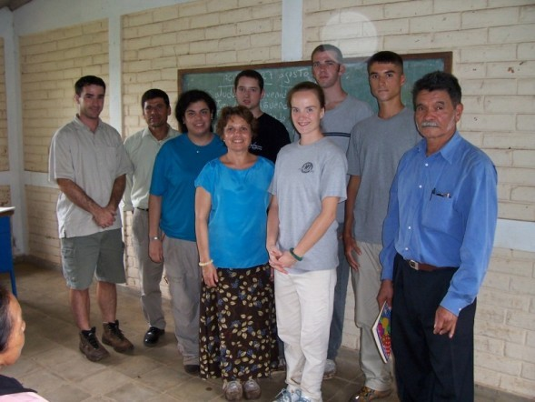
Figure 1: The Rowan Team with a Member of the
El Amatón Community Executive Board

On the second day, the team walked to the river with a Community representative. This gave the team a general idea of the distance that Community members must walk in order to obtain water if it is not available in the public chorro. The team participated in the evening Community gathering, set up the surveying equipment and developed the route for the community surveys. The team met with the Community Executive Governing Board to discuss the plans for the project and answer questions. There were two land survey teams and two community survey teams. The land survey teams were followed by the local children and needed to interact with the home owners as they made their measurements. All land survey measurements were completed by the seventh day. Heavy rains caused some problems, and since it was the wet season, unpaved roads were mostly mud and difficult to travel. The community surveys required a visit to each occupied home. At least one member of the community accompanied each surveying team. The survey included questions about the amount and type of water use by each family. It also included questions regarding the family’s ability to pay for water. These surveys allowed students an in-depth look into the Community and its culture. Community members were candid and gracious during the interviews and were willing to share a significant amount of information. Approximately 90 occupied homes were visited. Interviews began in the morning. The team stopped for lunch and continued until approximately 4:30 PM. This made it possible for the team to complete the interviews with minimal interruption to the families’ work schedule.

Water quality measurements were made on the fourth day. These were completed by the community survey teams. Hardness, pH, and nitrate, sulfate and fecal matter content analyses were performed on the water from the local chorro and from two locations in the river. The team measured water quality from locations frequented by the community. The Peace Corps volunteer and members of the Community guided the Rowan team to the river locations. Hardness, pH and nitrate and sulfate concentration data were analyzed on site by the team. Fecal matter analyses required several days. The Peace Corps volunteer completed the tests and sent the team digital photographs of the water.
These analyses indicated that the water from the river contained an unacceptable amount of fecal matter and other contaminants.

During the surveys, the Rowan team met with the Community to report on the project progress. At this meeting, the team was able to answer questions and had the opportunity to thank the Community for their hospitality and collaboration. The Rowan team also met with the representatives of the excavating company responsible for digging the well. This gave the students important insight as to how business is conducted in the area and also provided technical information as to requirements to pump the water from the well to the water tower. The Rowan team met with the Community a third time to report the results to date and to discuss the next stage of the project. It was concluded that the Rowan team would present three options to the Community for multiple chorros throughout the Community. It was concluded that water delivery to each individual home would need to be a future project. The options would include solar and wind power as possible energy sources for the project. These options would be presented to the Community along with an economic analysis so that the Community could select the option most suitable for its residents. The design of three viable options for a water delivery system to multiple chorros located at strategic places throughout the community
is underway.

Engineering Clinic Project to Optimize Abalone Aquaculture in Chile

Aquaculture is an important component of the Chilean economy. Chile is the world’s second largest exporter of farmed salmon next to Norway. Abalone are a high-value product considered a delicacy throughout the world especially Japan. Abalone are single shell mollusks found in tidal zones at depths of up to 1200 ft below sea level. They live in rocky craggy areas and crevices. There are approximately 90 species of abalone and they can take up to five years to reach harvest size. The first abalone farms were introduced in Chile in 1977. The purpose of this work was to work directly with abalone farmers to analyze engineering aspects of abalone aquaculture that can be used for process optimization. Process components such as tank geometry and water velocity were studied. However, the main focus was engineering process control strategies. The growth and profitability of the aquaculture industry will depend to a great extent on the optimization of systems through automated and statistical process control. These techniques are available and are being employed with excellent results (Ernst et al., 2000). Automated and statistical process control strategies have been used for a wide range of industries. This technology can and has been applied to a wide range of aquaculture systems and its implementation has lead to significant operational enhancements.

The Engineering Clinic was a one year project. During the first semester, students studied aquaculture engineering as it pertained to abalone aquaculture. They studied Spanish and Chilean culture. In addition, they prepared the project scope and learned to program in LabVIEWTM, a monitoring and control software package. The team developed a LabVIEW™ based monitoring and control system for use in abalone aquaculture facilities in Caldera, Chile. The initial programming was completed at Rowan University. The team of two students and one faculty advisor traveled to Coquimbo, Chile to the Universidad Católica del Norte Sede Coquimbo in January 2005. The team brought the software and hardware necessary to monitor and control the water flow and tank water recirculation rate in abalone aquaculture processes. The Rowan team joined the team from La Universidad Católica and traveled to Calderas, Chile where the aquaculture farms are located. The facilities in these farms were designed and constructed under the supervision of La Universidad Católica del Norte. Presently, two types of abalone are farmed in Caldera, Chile; red abalone (Haliotis rufescens) and green abalone (Haliotis discus hannai). The process variables that affect abalone aquaculture include water temperature, salinity, dissolved oxygen and ammonia concentrations (NH₄OH-N), and pH. A strategy to monitor and control these parameters can be used to develop a set of baseline operating conditions and to develop a control system that will maintain them for specified criteria.

Calderas Project Overview and Management

The team arrived in Coquimbo on January 3, 2005. They were met by representatives from La Universidad Católica del Norte Sede Coquimbo and transported to living quarters on campus. Figure 2 shows the Abalone Aquaculture Optimization Team.

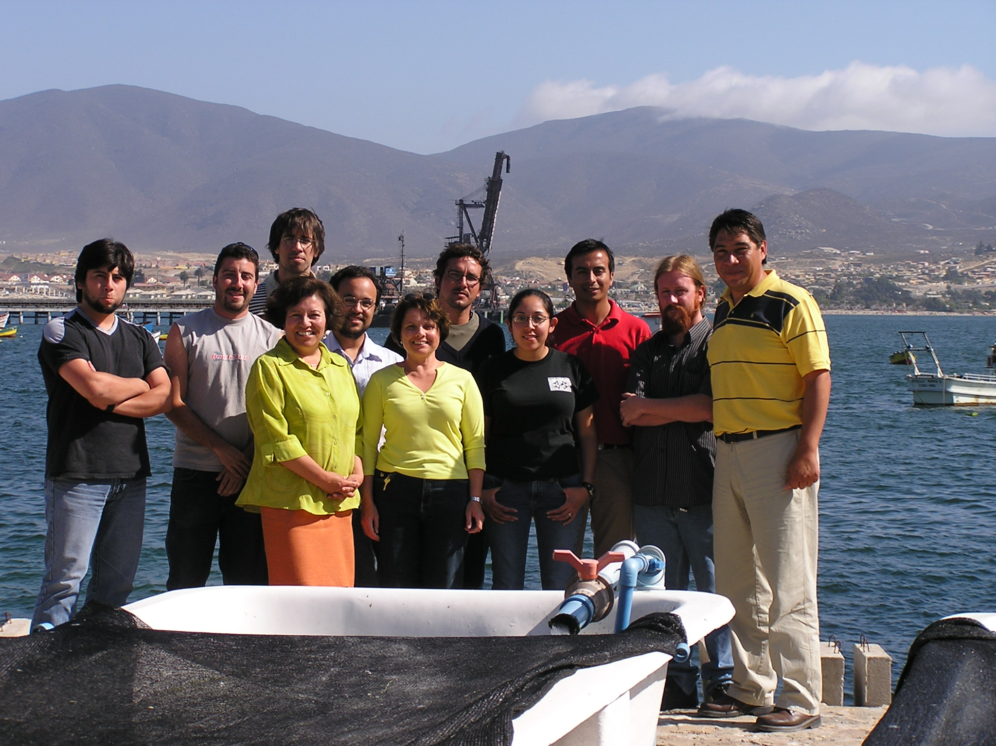
Figure 2: The Abalone Aquaculture Optimization Team
at the Universidad Católica del Norte Sede Coquimbo

Students and their faculty advisor lived on campus. This was an important component of integrating the Rowan students into the Chilean team. The entire team reviewed and finalized the project scope and checked the equipment and software. Rowan students trained the rest of the team to use an electromagnetic flow meter to measure water velocities in tanks and to work the LabVIEWTM software and hardware. The Rowan students learned how to incorporate some of the control components developed at La Universidad Católica del Norte into their control strategies. In addition, students participated in a short course developed in Chile for abalone aquaculture management. The Rowan faculty advisor taught part of the short course including a hands-on demonstration of air-lift technology application to abalone aquaculture. The team then traveled to Calderas to visit two abalone farms in the area. The team made velocity measurements designed to optimize tank geometry and abalone placement in the tanks. The software was made operational so that it could be installed when appropriate equipment arrived at the sites. Figure 3 depicts a LabVIEWTM monitoring and control system for abalone aquaculture process parameters. A LabViewTM parameter monitoring system is composed of a measuring device (thermocouple, pH meter) connected to a field point interface (National Instruments). The interface is directly connected to a PC as shown in the Figure. The measuring device has an analog output which is converted to a digital signal by the interface.
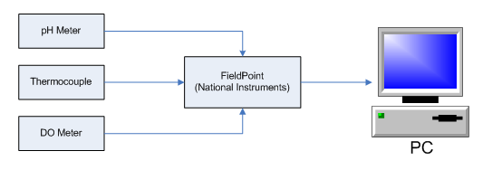
Figure 3: LabVIEWTM Monitoring and Control System for Abalone Aquaculture

Signal management systems such as the field point interface module can handle multiple sensors and meters simultaneously. Their only limitation is the signal range specifications for each port (mA or mV). LabVIEW™ includes calibration curves for most standard sensors to convert signals to measurements. It is also possible to program calibration curves for specific sensors in LabVIEWTM. Figure 4 shows the LabVIEW dissolved oxygen and temperature in a simulated abalone tank as a function of water recirculation rate.

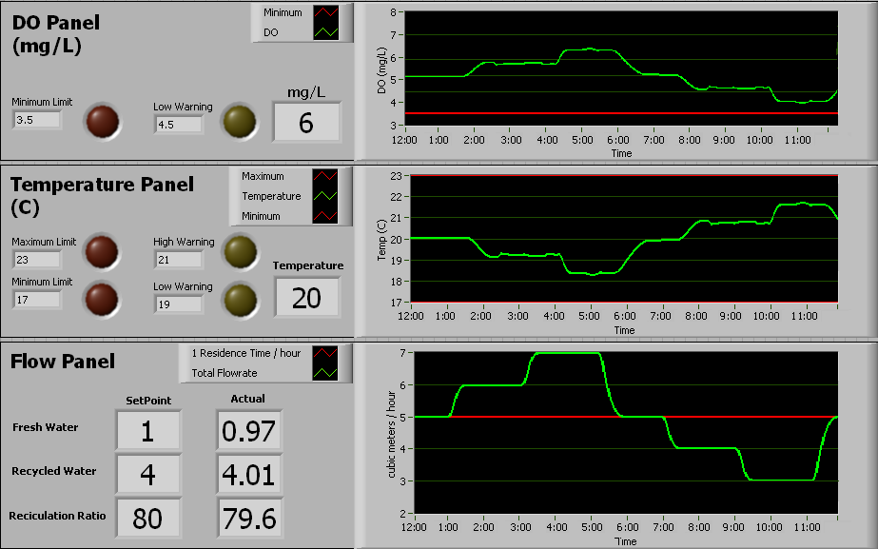

Figure 4: Tank Dissolved Oxygen and Temperature as a function of water recirculation rate

The schematic for the control system and the LabVIEWTM program are shown in Figure 5.
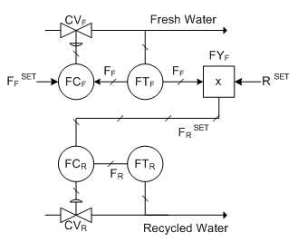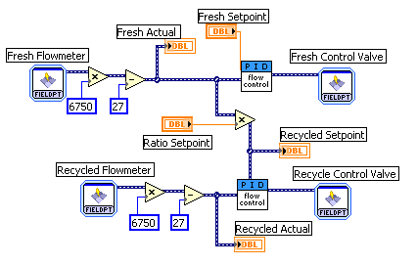
Figure 5: Ratio Control Scheme (a) and Corresponding LabVIEW™ Block Diagram

The team lived together and traveled together. As a result the Rowan students had first-hand exposure to the culture and language. In addition, they learned technical material from their Chilean colleagues. Students also participated in social functions with the rest of the team. This included sightseeing and general student gatherings. Rowan students reported that the experience served to help them understand another culture and how business is conducted outside of the United States. They reported that they had preconceived notions prior to their arrival and that they were impressed with the degree of technical sophistication exhibited by their Chilean colleagues. The Rowan team spent the month of January in Chile and returned with an appreciation for Chilean culture, business principles and general solidarity with their Chilean colleagues. Students’ sightseeing trips in northern Chile gave them additional appreciation of the natural beauty and cultural complexity of the country.

Conclusions

An Engineers-Without-Borders project was successfully integrated into an Engineering Clinic experience and allowed five students to participate in an international service learning educational experience that had significant benefit to the host Community of El Amatón in Santa Ana, El Salvador. Students and their faculty advisors traveled to El Amatón and were able to complete land and community surveys and preliminary water quality analyses. The data are being used to develop three options for water delivery systems to faucets (chorros) in strategic locations throughout the community. These options will include solar and wind power energy sources. The Community will select the option that is most suitable and sustainable. The data indicated that there was fecal matter contamination in the water available to the community and the team stressed the importance of boiling water as a means of sterilization.

The two most important aspects of this work involved the integration of the community into the project and the impact of the project on student development. The Rowan team met with the community upon arrival and was able to answer questions and listen to concerns form community members. Two additional meetings provided opportunities to report on the project progress, accept recommendations from the community and answer questions. Finally, every aspect of the project included at least one community representative. This resulted in significant interaction between the Community and the Rowan team. In this way, the Community had an understanding of the project benefits as well as its limitations, and therefore, sustainability of any system is more likely.

A second Engineering Clinic project gave students the opportunity to participate in a team with Chilean colleagues and travel to abalone aquaculture farms in northern Chile.
Students worked directly with independent business people and were exposed to Chilean business practices. Students and their faculty advisor lived on the campus of the Universidad Católica del Norte Sede Coquimbo and participated in meals and social gatherings with their Chilean colleagues. Rowan students were impressed by the level of technical sophistication of the Chilean team and by all that they learned from their colleagues. Students traveled throughout northern Chile and participated in a short course taught at the University for abalone aquaculture farms personnel.

Students were provided with an important international experience in both projects. It allowed them to see first-hand how technology can be used to improve the lives of people worldwide. They were exposed to a different culture and language, and learned many aspects of technology adaptation to a specific environment and culture. The two projects highlighted here are part of Rowan’s growing commitment to the globalization of engineering education and the integration of service learning throughout the curriculum. Rowan students have participated in hurricane Katrina relief efforts, water purification in Cherokee Indian reservations projects, and a community water delivery project in Thailand. These efforts as well as the projects highlighted here have given students an increased appreciation for how technology can improve the human condition and the benefits and limits of globalization. Students report that they return from these projects with a renewed commitment and energy to be leaders in the application of technology to improve the lives of all of the world’s people.

Bibliography

Brodeur, Doris R., Edward F. Crawley, Ingemar Ingemarsson, Johan Malmqvist and Soren Ostlund. (2002). “International Collaboration in the Reform of Engineering Education”. Proceeding of the 2002 ASEE Annual Conference and Exposition, Montreal, Que., Canada, pp. 1951-1957.
Bullard, Lisa G., Patti H. Clayton, Steven W. Peretti. (2004). Conference Proceedings of the 2004 ASEE Annual Conference and Exposition, pp. 1251-1253.
Butin, Dan W., ed.(2005). “Service Learning in Higher Education: Critical Issues and Directions”. Palgrave Macmillan, NY, NY.
Canada, Mark and Bruce W. Speck, eds. (2001). Implementing Service Learning Programs, Joseey-Bass, San Francisco, CA.
Casey, Terri. (2005). “Women, Engineering and Service Learning”. SWE Magazine, Vol. 51, No. 1, pp. 24-30.
Ciocci, Richard C.(2005). “Delivering an International Experience to Students in an Intercultural Engineering Course”. Innovations in Engineering Education 2005- Conference Proceedings, ASME International Mechanical Engineering Congress and Exposition, Orlando, FL. pp. 271-275.
Conceigao, Pedro, David V. Gibson, Manuel W. Heitor, and Giorgio Sirilli. (2001). “Beyond the Digital Economy: A Perspective on Innovation for the Learning Society”. Technological Forecasting and Social Change, Vol. 67, pp. 115-142.
Draper, Allison J. (2004). “Integrating Project-Based Service-Learning into an Advanced Chemistry Course”. Journal of Chemical Education, Vol. 81, No. 2, pp. 221-224.
Eijamal, M.B., S.W. Pang and S.J. Edington. (2005). “Gaining International Competence: A Multi-faceted Approach to International Engineering Education”. Conference Proceedings of the 2005 ASEE Annual Conference and Exposition, Portland, OR., pp. 6745-6753.
Ernst, D., J. Bolte and S.S. Nah. (2000). “Aquafarm: Simulation and Decision Support for Aquaculture Facility Design and Management Planning”. Aquaculture Engineering, Vol. 23, No. 1-3, pp. 121-179.
Fortenberry, Normal L. (1996). “Under the Jeweler’s Loupe: Global Engineering Education”. Computer Applications in Engineering Education, Vol. 4, No. 2, pp.169-172.
Holland, Nancy and Guillermo Vasquez de Velasco. (1998). “Internationalization of Undergraduate Programs: A Model Program Using Reciprocal Distance Education, Traditional Study Abroad Programs and International Internships”. Journal of Engineering and Applied Science, Vol. 2, pp. 595-599.
Juárez-Nájera, Margarita, Hans Dieleman and Sylvie Turpin-Marion. (2006). “Sustainability in Mexican Higher Education: Towards a New Academic and Professional Culture”. Journal of Cleaner Production, Vol.14, p.1028-1038.
Kentish, Sandra E. and David C. Shallcross. (2006). “An international Comparison of Final-Year Design Project Curricula”. Journal of Chemical Engineering Education, Vol. 40, No. 4, pp. 275-280.
Lyons, William C. (2000,). “U.S. and International Engineering Education”. Journal of Professional Issues in Engineering Education and Practice, Vol. 126, No. 4, pp152-155.
Madden, Steven J. ed. (2000). Service Learning Across the Curriculum: Case Applications in Higher Education, University Press of America, Lanham, MD.
Mihelcic, James R., Linda D. Phillips and David W. Watkins, Jr. (2006). “Integrating a Global Perspective into Education and Research: Engineering International Sustainable Development”. Environmental Engineering Science, Vol. 23, No. 3, pp. 426-438.
Oakes, William and Michael Thompson. (2004). “Integration of Service Learning into a Freshman Engineering Course”. Conference Proceedings of the 2004 ASEE Annual Conference and Exposition, pp. 7991-8017.
Oberst, Bethany and Russel C. Jones.(2003).”Megatrends in Engineering Education”. Conference Proceedings of the 2003 ASEE Annual Conference and Exposition, Nashville, TN, pp. 4477-4488.
O’Grady, Carolyn, ed. (2000) “Integrating Service Learning and Multicultural Education in Colleges and Universities”. L. Erlbaum Associates, Mahwah, NJ.
Papazoglou, Thales M. (2006). “An International Dialogue on Electrical Engineering Education”. Turkish Journal of Electrical Engineering and Computer Science, Vol. 14, No. 1, pp. 99-100.
Rio, Walden S. and Dany C. Molina. (2003). “International Linkage in Engineering Education”. Conference Proceedings of the 2003 ASEE Annual Conference and Exposition, Nashville, TN, pp. 4013-4018.
Simpson, Ian. (2000). “International Engineering Education: A French Example”. Engineering Science and Education Journal, Vol. 9, No. 3, pp. 99-104.
Spinelli, Giancarlo. (2001). “Internationalism and Implications for Engineering Education: Changes in European Educational Systems”. IEEE Antennas and Propagation Magazine, Vol. 43, No. 6, pp.117-118.
Sukumaran, Beena, Kauser Jahan, Dianne Dorland, Jess Everett, Jennifer Kadlowec, Zenaida Gephardt and Steven Chin. (2006). “Engineering Clinics: An Integration of Research into the Undergraduate Curriculum”. Council on Undergraduate Research Quarterly, Vol. 26, No. 3, pp.115-121.
Talbert Matthew, Stephanie Farnkhopf, Sharon Jones, and Robert Houghtalen. (2003). “Combining Service Learning with Graduate Education”. Journal of Professional Issues in Engineering Education and Practice,
Vol. 124, No. 4, pp. 211-215.
Thompson, Michael, William Oakes and George Bodner. (2005). “ A Qualitative Investigation of a First-Year Engineering Service Learning Program”. Conference Proceedings of the 2005 ASEE Annual Conference and Exposition, pp. 11915-11930.

