Fifth LACCEI International Latin American and Caribbean Conference for Engineering and Technology (LACCEI’2007)
“Developing Entrepreneurial Engineers for the Sustainable Growth of Latin America and the Caribbean:
Education, Innovation, Technology and Practice”
29 May – 1 June 2007, Tampico, México.

International Capstone Senior Design Projects

J. C. Ordonezª , J.V.C. Vargas^{b}, A. Morega^{c} , C.A. Luongoª, C. Shihª
ª Department of Mechanical Engineering, FAMU-FSU College of Engineering, Tallahassee, Florida 32310, USA
^{b} Department of Mechanical Engineering, Federal University of Parana, Brazil
^{c} Department of Electrical Engineering, Polytechnic University of Bucharest, Romania

Abstract
This paper describes our efforts to bring international collaborations to Capstone Senior Design projects. This effort is motivated by the need to expose students to a global working environment, where in addition to the complexity of team dynamics, they have to face challenges associated with the distance, language, schedules and curriculum differences. We started two years ago, with two international teams composed of students from the Department of Mechanical Engineering at the FAMU-FSU College of Engineering (USA) and (i) the Department of Mechanical Engineering at the Federal University of Parana (Brazil) and (ii) the Department of Electrical Engineering at the Politehnica University of Bucharest (Romania). Now that the second round of teams has completed the experience we were able to evaluate some corrections that were introduced after the first year (Ordonez et al., 2006) to address the lack of effective communication. In the paper, we report in our strategies and lessons learned regarding the team selection process, the selection of effective communication channels, the funding, and positive and negative elements associated with the experience.
Keywords: Senior Design, International collaboration

Introduction
We have completed the second cycle having international collaboration as part of the senior design project. Each cycle lasts one academic year.
The Mechanical Engineering curriculum at the FAMU-FSU College of Engineering features a capstone one-year senior design course in which students work in teams tackling engineering problems provided and sponsored by industrial partners (Luongo and Shih, 2006). Similarly, both the Federal University of Parana (Brazil) and the Politehnica University of Bucharest (Romania) have their capstone one-year senior design courses.
Driven by economic globalization and off-shoring of engineering jobs (Oberst and Jones, 2004), (Hirleman, et al., 2004) new challenges appear for engineering education. Economic globalization is a historical process resulting of human innovation and technological progress in large part driven by engineers. Engineering educators and students must learn to adapt to a global work environment were there is less and less resistance to the flow of economic goods, knowledge and information between countries and cultures.
This paper describes our experience introducing an international component into the capstone senior design course. The main objective of this experience is to expose students to a global working environment, where in addition to the complexity of team dynamics, they have to face challenges associated with the distance, language, schedules and curriculum differences. We started, two year ago, with two international teams between the Department of Mechanical Engineering at the FAMU-FSU College of Engineering (USA) and (i) the Department of Mechanical Engineering at the Federal University of Parana UFPR (Brazil) and (ii) the Department of Electrical Engineering at the Polytechnic University of Bucharest PUB (Romania) and are now completing the second cycle of projects with teams from the same schools.
1. PROJECT SELECTION AND SPONSORSHIP
Since the entire pedagogical premise of the capstone experience revolves around engineering design projects, and great effort goes into mimicking as much as possible the conditions encountered by engineers in industry, it is important to expose students to a global working environment.
In both years, the project with UFPR was selected jointly by FAMU-FSU and UFPR and received sponsorship from Shell and the Center for Advanced Power Systems at FSU. The project with PUB was selected and sponsored by CERN (the European Organization for Nuclear Physics Research in Geneva, Switzerland). The level of funding for both projects was similar to other teams with no international counterpart ($3000 approximately). In the case of the UFPR team there was an additional $2000 dollars budget allocation to sponsor a one week visit to FAMU-FSU by a team member in the two collaborations.
2. TEAM ASSIGNMENTS AND ACADEMIC CALENDARS
Once projects are identified and selected for the academic year (August to April in the USA), the next challenge is to make the team assignments. A large part of the success and failure of the senior capstone experience rests on the ability to assemble high-performance teams (Luongo and Shih, 2006). Since one of the main motivations behind the capstone experience is to expose students to team-based design and procedures, the make-up of each team is very important. At FAMU-FSU we have used slightly different techniques to assign teams and over the years we have learned what works or not. It is fair to say that if students were allowed, they would make their own teams based on friendship and level of comfort. There would also be a tendency for teams to cluster by GPA (with some teams nucleating all class overachievers, while other teams would be composed of students with low GPAs). We clearly observed this during 1999, the first year of the course, in which we offered some latitude for the student to choose projects.
Beginning with the second year of the capstone course we have limited the ability of the student to choose projects and instead the instructor assigns the teams and forces students to work in groups without the comfort level of picking teammates. The process is somewhat complicated because certain constraints need to be observed:
- Allow members of students chapters (e.g., SAE, ASME) to work on specific projects sponsored by such organizations
- Allow students on the BS-MS (co-terminal) track to work on projects sponsored by certain industrial partners that also serve as hosts for summer internships
- Consider the student’s career interest or objectives as much as possible (e.g., students going into a bioengineering program in graduate school, students supported by certain fellowships from specific industry sectors, etc.)
- Ensure teams are composed by students from both universities represented at our college: FAMU and FSU
Aside from these constraints, the method used to assign teams is rather straightforward. Each student in the class is assigned to one of four groups according to GPA (top quartile, second quartile, etc.). Each team is given four ‘slots’, one from each GPA quartile group, and a random drawing is used to pick a student’s name and then allow him/her to pick a project with an open ‘slot’ for the GPA group the student is in. The end result is that all teams have the same ‘average GPA’, and to the extent that name drawing is random, most of the students (but not necessarily all of them) will be satisfied with their projects and teammates. Even though prior GPA is not at all a good indicator of performance in the capstone course (in fact most of the top performers in senior design come from the second quartile group, and not the top), the method ensures a uniform distribution of GPA among all teams and indeed project execution and performance tends to be quite uniform for the entire class.
At FAMU-FSU the capstone senior design team selection starts in August, and the projects run until April of the following year.
The Department of Mechanical Engineering at the Federal University of Parana (Brazil), UFPR, has a similar course system to FAMU-FSU, i.e., divided in semesters, with two Senior Design courses in the two last semesters. However, since Brazil is in the southern hemisphere, the summer starts in December and ends in March. Therefore, the summer vacation occurs during the FAMU-FSU spring semester. The academic year at UFPR ends in the middle of December, whereas the end of the school year at FAMU-FSU is in the middle of April. Such differences bring natural difficulties to be overcome, regarding the synchronization of the work of the two design teams. In the first experience, the adopted criterion was that the host Department (FAMU-FSU) would conducted the project with the assistance of the other team (UFPR), therefore the Brazilian team had to follow the FAMU-FSU semesters, i.e., to work together with the FAMU-FSU team, finish and present the project at the end of the FAMU-FSU school year in April.
For the first experience, all senior ME students at UFPR were eligible to apply and the opportunity was offered at the Department Internet site and in the classroom. The Brazilian team selection criteria were: i) an individual interview conducted in English to evaluate language skills; ii) only students with a GPA above 65 % of the maximum GPA were considered, and iii) a committee consisting of three professors, the ME Department Coordinator, the Senior Design Project coordinator, and the faculty supervisor, made the final decision to select the three students for the first team.
For the first collaboration, a decision was made to allow the students to conduct freely their activities. The idea behind that decision was to analyze by the end of the first experience, without any bias, the performance of our selected students from UFPR and how they interacted with the FAMU-FSU team.
In the second experience, the selection criteria were the same at UFPR. The difference was that the opportunity was advertised for two months instead of two weeks. In this way, English skills were properly evaluated together with self-leading abilities. The result was that team communication reached an excelent level. Another important improvement was in the division of separable and independent tasks for each team, so that the end products merged only by the last stage of the project (2 last weeks) where the two teams joined at FAMU-FSU for producing the final product and preparing the final report and presentation.
The Romanian team at Politehnica University of Bucharest (PUB) was made of undergraduate senior students (last year of studies) and graduate students in Electrical Engineering. This structure provides continuity between generations, while helping the integration with the US team. Currently at PUB, the senior design project is part of the tenth semester of the curriculum (March-June), and it is single and full-time activity for the student.
The Romanian team’s tasks in this multi-disciplinary project are the control and data acquisition and reduction, and we selected students with their majors in the areas of electrical engineering. Communicating in English was not a problem, since the majority of engineering students in Romania speak English.
The Romanian team was responsible to develop data acquisition and processing methods and software needed for the shaft calibration and balancing. This includes: background research, with focus on sensor (accelerometer, tachometer) data acquisition, software design, testing procedure and data analysis. The group provided also the motor control. The US team was responsible for the mechanical design and implementation of the experiment, as well as the actual running of the experiment at Florida State University. The Internet was used to transfer data in real time between the test bed and the Romanian team. All data collection and processing was automated, implemented in a LabView program. The DAQ systems at the US team site generated output data to specific data files that were then compresed and sent for analysis to the Romanian team’s processing server (PUB) via HTTP. As data was received on the server, it was archived and backed up to a RAID volume, and passed to the processing application, a Matlab program. The processing application exported its results to a HTML document, so the progress of the experiment could be viewed almost in real-time by both teams.

3. PROJECT DESCRIPTIONS
In the first year the Brazil-USA team developed a Tri-generation System for Distributed Power, Refrigeration and Hot Water Supply.
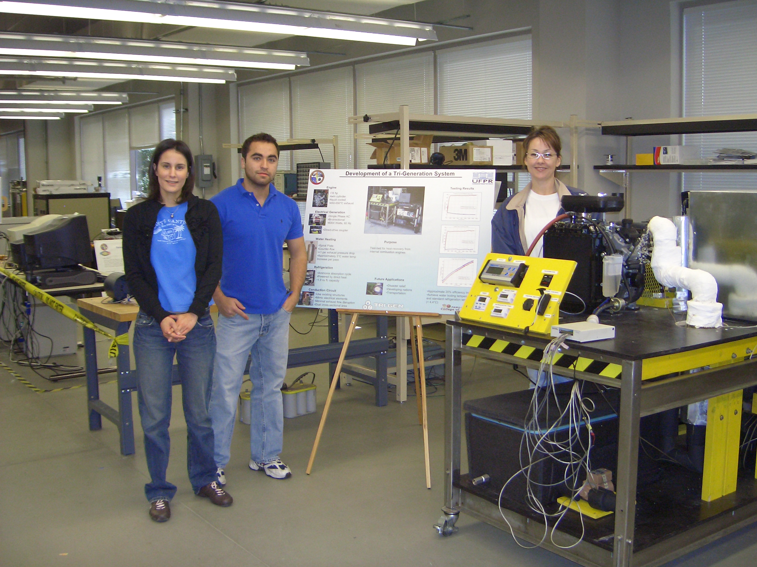
Figure 1. Experimental Setup And Team During Caps-Open House (Brazil-Usa)

This project was selected in collaboration between UFPR, the Center for Advanced Power Systems and the Sustainable Energy Science and Engineering Center at Florida State University. The aim of this project was to design and build a prototype of a tri-generation system that will serve as an experimental unit to investigate the potential of tri-generation systems for energy conservation and production. The tri-generation system uses the waste heat from an internal combustion engine to produce hot water and a cold space. Electricity is also produced through an electrical generator coupled to the IC engine shaft. While this system serves as an experimental unit it has the potential for use in other applications. For example, the system could aid returning hurricane victims by providing electricity, hot water, and refrigeration to homes without power through one cost effective, convenient system. It could also be used in recreational vehicles to decrease dependency on external power sources and increase the efficiency of the vehicle. The work consisted of the design and assembly of a prototype in the laboratory, its characterization and instrumentation. In a final stage, using the experimental measurements, the team performed a thermal analysis of the system, aiming the optimization of the operating and project parameters for maximum thermodynamic performance of the produced technological innovation. The prototype was built at the facilities of the Center for Advanced Power Systems at Florida State University. All students were required to undergo basic laboratory safety training and examination to gain access to the facilities.
During the second year, a new team was assigned to the trigeneration project with a multitask assignment: modify the system, previously running on gasoline, to be able to accept multiple fuels (e.g,. ..), introduce a water distiller unit, include bypass valves in order to allow system reconfiguration and control, and the generation of an additional cold space using the refrigeration effect associated with compressed gas expansion when a compressed gas is used as fuel.
The Romania-USA team project was proposed by The European Center for Nuclear Physics (CERN) in Geneva, Switzerland, an organization that is currently building a large particle acceleration facility. The accelerator will operate on an array of superconductive magnets, running at near absolute-zero temperatures. The magnetic field for each superconductor must be kept in prescribed limits to ensure proper accelerator operation. To do this, field measurements are taken to compare magnets to each other using a device called Twin Rotating Unit (TRU). Since higher rotation frequencies are desired, shaft balance becomes a concern as unacceptable imbalances may cause erroneous field measurements and component failure due to fatigue loading.

Figure 2. First year team members during preparation.

The senior design project requires the design and construction of a test-bed that measures and helps correct shaft eccentricity. It has to be stand-alone, and capable of handling shafts of various lengths, and the balancing method employed must not include magnetic components, and must be able to function at superconductor operating temperatures. A data acquisition system is needed to collect the measurement data. The system has to be sensitive enough to measure in the microvolt range, and must gather necessary data, including sensor output voltages, shaft rotation rates, etc. A test procedure must also be developed in order to verify that the device can perform at necessary quality levels.
4. COMMUNICATION CHANNELS
The communication channels that were used, in their order of importance are: videoconference, teleconference via phone line, e-mail, web conference, chat, voice over IP, and web pages.
In the first year, we had different experiences with the two teams: in one case, active communication was observed, mostly motivated by the inherent dependence of the ongoing activities at each site. On the other case, the communication was poor. There were technical difficulties during the first videoconference and the team members backed to simpler but less engaging methods of communication (email and web pages).
At the end of the second semester two students from Brazil visited the US team for the final presentation and senior design open house event. This face-to-face encounter and the opportunity to visit the host department can be used to motivate the students.
The issue of communication was addressed closely in the second year, partially through the project definition. For example, the teams at each location designed and built components that were assembled together by the end of the period. This strategy made the success of the project more dependable on the continuous interaction between the teams, which actually happened in the second year with a better student selection, as discussed earlier in the text.
During the second year, in order of importance, the communication channels between Brazil-USA team have been: videoconference (weekly), using instant messenger, and e-mail.
5.CONCLUSIONS AND LESSONS LEARNED
Aimed at bridging different cultural and educational environments throughout the world (USA, Europe, and Latin America) while providing for higher professional standards, the proposed joint senior design projects brought together teams from the FAMU-FSU Department of Mechanical Engineering, the Federal University of Parana and the Polytechnic University of Bucharest. Some lessons learned from our experience are:
- Students recommend not inheriting a previous senior design project since this limits their options on creativity and design;
- During the second year there was a more clear tasks division between the local and the abroad teams. This proved to be beneficial to get the level of involvement balanced on both sides;
- The teams had the opportunity to face the difficulties of developing an international collaboration, in terms of developing a common timeline with tasks, deadlines and a final goal to be achieved;
- The announcement time at UFPR was not long enough (2 weeks) in the first year, therefore the number of candidates was not large enough (only six). A longer announcement time of two moths in the second year, provided a better student selection, with excellent results in communication improvement and project outcome;
- The second year experience showed that there is no need for assigning a graduate student to co-supervise the team, provided that a good student selection is conducted;
- There was graduate student involvement in the Romanian team only. In that particular case, the additional supervision facilitated the communication. We however believe that if necessary it is possible to keep the teams with undergraduate students only.
- The strategy in selecting the Romanian team carries the difficulty of grading the undergraduates, as they conduct the work for extra credit and outside a design class framework. However, this work adds value to their research experience, and this counts on a longer term in their academic evaluation.
- We find it important that team spirit should be developed at an earlier stage of undergraduate education, such that the selection for the senior project is just a matter of meeting the project’s specific objectives.
- Securing good projects not only involves identifying industrial partners, but more specifically, individuals that are willing and able to work with the students throughout the academic year. The projects must be somewhat meaningful to the industrial partner if any, yet not be mission-critical, and funding must be available to construct prototypes or other hardware as required by the project.
- We feel that the team selection for the international collaboration should benefit from some freedom to allow students that are highly motivated about the idea of interacting with teams abroad to be part of this experience.
- We propose tighter project formulation with special emphasis on interface formulation. The project should be formulated in a way that the technical issues should require the simultaneous involvement of both teams, such that without proper communication the project cannot be completed satisfactorily.
- Multidisciplinary projects can be used to enhance team interaction: for example the Romania-USA project had strong mechanical, electrical and information technology components. This created dependence between the USA team (composed mainly of mechanical engineering majors) and the Romanian team (with electrical and information technology majors).
- As pointed by (Lin et al., 2005) international capstone design projects can serve as “check points” or calibration tools for different undergraduate curricula. The international exposure benefits not only the capstone senior design but the programs involved.
Additional information about the experience:
Teams composition: UPB : three students (2005-2006), 3 students (2006-2007); UFPR three students (2005-2006), two students (2006-2007), USA five students (2005-2006), three students (2006-2007).
Cross-cultural exposure: Due to the EU context, the Romanian students are generally introduced to cross-cultural concepts; the same is true for Brazil. In the specific cases reported here, there was a previous exposure of the teams to cross-academic educational activities.
High vs. low context cultures: The advisors are by a "high context culture" related (i.e., previous common work), whereas the students are connected by a "low context culture". To this, the projects add the general "high context European - American cultures", which is rather similar in what concerns technical education, etc. [Beer, 1997]
Monochronic vs polychronic time: EU, Brazil and US are "western" cultures. Western cultures vary in their focus on monochromic or polychromic time. Americans (Germans too) are strongly monochromic, and this was the style for both projects: there was a timetable with well defined targets and deliverables, and the groups were prepared and focused on the specific topics when meeting and discussing (via chat, skype or phone). (Straker, 2007).
In-person visit experience: The meeting occurred at the end of the project and only in the Brazil-USA collaboration. Students served well as hosts and the meeting impacted the final project presentation. The PUB projects did not benefit of in-person visits. The teams were able though to fulfill in due time the tasks, and produce quality deliverables.
Overall, we consider the idea of a cooperative, international project very exciting, challenging, professionally rewarding, and not the least a friendship relation builder.
Acknowledgments
The authors acknowledge the dedication of all students involved in this experience and the support from Shell, the Center for Advanced Power Systems (CAPS), the European Center for Nuclear Research (CERN) and the Brazilian National Council of Scientific and Technological Development (CNPq).

Authorization and Disclaimer
“Authors authorize LACCEI to publish the papers in the conference proceedings. Neither LACCEI nor the editors are responsible either for the content or for the implications of what is expressed in the paper.”

References
Beer J. 1997 Communicating Across Cultures, http://www.culture-at-work.com/highlow.html (accessed on April 14, 2007).

Hirleman, E.D., Atkinson, D., Groll, E.A., Matthews, J., Xu, L., Allert, B., Hong, W., Albers, A., Wittig, S.L.K, Lin, Z.Q., Xi, L.F., “ GEARE: A Comprenhensive Program for Globalizing Engineering Education”, Proceeding of the 2004 American Society for Engineering Education Annual Conference & Exposition, Salt Lake City, UT, 2004.

Lin, Y., Harby, D., Jang D., Ye, Z., “Problems and Solutions in Internationalizing Capstone Design”, Proceedings of the 2005 American Society for Engineering Education Annual Conference & Exposition, Portland, Oregon, June 12-15, 2005.

Luongo, C.A., Shih, C., “Senior Design Projects in Mechanical Engineering -- A Case Study of Capstone Experience with Strong Industrial Participation”, 2006 ASEE Annual Conference, Chicago-Illinois, June 16-21, 2006.

Oberst, B.S, Jones, R.C., “Canaries in the Mineshaft: Engineers in the Global Workplace”, Proceeding of the 2004 American Society for Engineering Education Annual Conference & Exposition, Salt Lake City, UT, 2004.

Ordonez, J.C., Vargas, J.V.C., Morega, A.M., Luongo, C.A., Shih, C., “An International Component to Capstone Senior Design Projects,” 36th ASEE/IEEE Frontiers in Education Conference, October 28-31, San Diego, CA, 2006.

Straker, D. (2007), Hall's Cultural Factors, http://changingminds.org/explanations /culture/ Hall_Culture.htm (Accessed on April 14, 2007).

