Fifth LACCEI International Latin American and Caribbean Conference for Engineering and Technology (LACCEI’2007)
“Developing Entrepreneurial Engineers for the Sustainable Growth of Latin America and the Caribbean:
Education, Innovation, Technology and Practice”
29 May – 1 June 2007, Tampico, México.

Scorm Based Nano Scale Electronic Devices Modeling Methodology

Andrés Lombo Carrasquilla
Universidad Dsitrital Francisco José de Caldas, Bogotá, Colombia, alombo@udistrital.edu.co
University of South Florida, Tampa, Florida, United States, lombo@mail.usf.edu

Gloria Esperanza Becerra Forigua
Universidad Dsitrital Francisco José de Caldas, Bogotá, Colombia gbecerra@udistrital.edu.co

Wilfrido Moreno
University of South Florida, Tampa, Florida. United States, moreno@eng.usf.edu
Abstract
Object oriented methodologies are applied in the nano scale electronic devices top-down modeling and simulation process. The object oriented approach is applied to the modeling and simulation of nanodevices, making emphasis in the results obtained from a typical nanoelectronic device. A detailed analysis of simulation variables is performed to determine model applicability. Resulting models can be integrated with basic electronic circuit or non-electronic lumped-element models. Each object is translated from a standard hardware description language to a Shareable Content Resource Object Reference Model (SCORM) platform. Those results have been exported as learning objects to be used by engineering students who are users of a Learning Management System. Learning objects from nano scale devices are incorporated into a Learning Management System for nanotechnology education purposes. Conclusions around the applicability and limitations of this kind of solution are obtained, and the benefits for a learning process in nanotechnology in the undergraduate and graduate level have been shown.
Keywords: Nanoelectronics, Modeling, Simulation, SCORM, e-learning
- Introduction
Nanodevices can be mainly considered as analog devices inside a VHDL-AMS framework, but they are closely related to digital systems if the designer is thinking around logical gates; then, the mixed signal approach must be better. A framework for nanosystems definition from the modeling and simulation point of view, is presented. This formulation is needed kin order to facilitate the description of component relationships and the definition of simulation domains and the corresponding influences that, a variable from a particular domain can have over other variable at another domain.
From the systems point of view a Nanosystem can be considered as a well organized set of nanodevices and interfaces among them which allow the designer to make interpretation of the whole system at one or all of the next domains: electronic, mechanical, optical, fluidic, thermal or electromagnetic. The system must be evaluated from the lowest level, the device itself, to the highest, functional level.
- The Nanosystem Definition

In order to formulate a nanosystem the designer must collect a set of requirements that must be organized under an abstract system structure. This structure allows the designer to propose a collection of components that fit with the original requirements from the architectural and functional point of view. Then the designer must formulate or, in latter case, organize and adapt a set of primitive components that complies as exactly as possible with the user demand.
There must be a formal model to write the requirements of each nanosystem, as well as of each nanodevice. In fact, each nanodevice is a nanosystem by itself. The smallest nanodevice that can be analyzed is the hydrogen atom, but is better to create a systematic framework in order to accelerate the time to market in the nano-related industry. A nanosystem can be decomposed in a number of subsystems according to specific design goals.
A connection must be established between a pair of systems or subsystems. It can be modeled in two ways: a rigorous metallic connection, or a electromagnetic coupling which permits particle transport between two reservoirs. Those connections can be considered as point-to-point as well as multipoint ones depending on their geometry or kind of molecules used in performing the connection. It is important that a designer defines what kind of relationships are described inside a particular NEMS design, because of the possibility of multyphisics analysis and the correlated measurements that can be performed over the same connection between two or more nanodevices.
Molecular systems are the most populated group of devices with current applications at the industry and can be consequently modeled and simulated. But also the solid state electronic nanodevices are important for the industry. In the latter group we can found one, two or many terminal devices: quantum dots, resonant tunneling devices (diodes and transistors), single electron transistors and so on.
A hierarchical view of most common nanodevices is shown in next figure. The figure shows that a system is composed by subsystems and their connections. At nano-scale those connections can be considered in two ways: a physical contact between materials of different molecular structure (usually known as metal contacts), or a connection due to a very close proximity between to regions with different or similar molecular structure. The latter situation performs the connections by electromagnetic coupling. On the other hand, subsystems (that can be considered as a whole system) can be classified depending on their structure; a molecular device is composed by a unique patron of molecules that can be behavioral isolated at the model. The Schrodinger equation can be solved independently at each molecule, except at the boundaries. Depending on the specific behavior that the molecular device is remarking as its principal, it is possible to classify it in a particular domain, as electrochemical, photoactive, electromechanical and so on. Solid state nanodevices are also classified based on its particular behavior inside a system. It is also possible to include more of them depending on a specific domain to be modeled and simulated, as microfluidics, thermodynamics, mechanics, etc.

Nano Electro
Mechanical System
Subsystem
Molecular devices
Connections
Solid-state Nano
Electronic devices
Hybrid Micro-Nano
Electronic device
Quantum devices
CMOS Devices
Nano CMOS
CNFETs
… more devices
… more domains
Wires
EM field copling
Resonant Tunneling
devices

Resonant
Tunneling Diodes

Resonant
Tunneling Transistors

Quantum dots
Single Electron
Transistors

Electrochemical
Photoactive

Electromechanical

…more devices
…more domains

Figure 1.: Hierarchical organization of nanodevices for NEMS

In order to adopt an object oriented modeling strategy, systems, subsystems and their connections must be addressed by an object and they must have properties to be inherited by other objects when they are taken part of a nanodevices object library. At least, each object must be characterized by: (1) a description containing nanodevice's name, summary, contacts, and any digital rights associated with elements of the design; (2) an structural architecture which enables precise control over the selected nanodevice's elements; and, (3) a functional architecture as set of the nanodevice's physical, electromagnetic, chemical and optical properties for easy reference.
This structure must be applied to common electrical nanodevices model formulation into a VHDL-AMS platform. All those nanodevices are well characterized at many reports from the continuum theory point of view, but the probabilistic behavior must be included at common tools as the known VHDL-AMS software packages available.
From the above hierarchical view some devices can be modeled depending of their computational complexity. It can be evaluated from the dimensional point of view, but there many other aspect to be considered. By now, they can be considered as follows: Zero-dimensional (Quantum dots), One-dimensional (Quantum wires), Two-dimensional (Quantum wells inside a molecular or Single-Electron Transistor, or tunneling devices –diodes or transistors-), and Three-dimensional (Quantum bulks, nano-cantilevers, nano-tools)

From the hierarchical representation of nanoscale devices shown in figure 1, it can be noted that a system can collect as many subsystems and / or devices as the abstraction level were applied. Then a more complicated tools need to represent a complicated system. Fully elaborated VHDL-AMS designs can use XML as an intermediate way of representation. XML can extract complete static semantic information inherent to VHDL-AMS and dynamic simulation related information, such as the current values of signal drivers or the dynamic equation sets.
Further development of the XML structure yields to standardized knowledge objects written following worldwide standards as SCORM (Shareable Content Object Reference Model).

- Vhdl-Ams Capabilities to Model and Simulate Nanodevices

The IEEE standard 1076.1-1999, know as VHDL-AMS, is a superset of the 1076-1993 with capabilities for modeling and simulation of analog and mixed-signals designs. This can be done by including non-linear ordinary differential algebraic equations. The models can follow the energy conservative principle, using nodes as TERMINAL, or non conservative principles, using nodes named QUANTITY; in the last case, inputs are only mathematically modified and presented at outputs. Additionally, the unknowns can denote any waveform or a time series of values.
In order to achieve an adequate modeling and simulation of nanodevices or any multiparticle device at the nano-scale, those quantities have to be written by means of a set of quantum correlated matrices, as it has been explained in previous sections. All iteration to be performed is followed by a “break” statement, which informs the analog solver to schedule an appropriate solution point and to determine a new initial solution for the next continuous functional segment or piece. No analog solver has been fixed at the IEEE standard, then each implementer can choose the appropriate method for the solutions of equations; however, it is not yet clear which one is the best when modeling and simulating nanodevices.
Other factor to be considered is that VHDL-AMS including software platforms vary their way of implementing the language standard; some of them exclude certain capabilities formulated by the IEEE or limits the capabilities of certain primitives to certain types of variables. This fact can severely decrease the capabilities of each nanodevice implementation inside a particular software tool.
Multiple experiences have been reported about formulation of VHL-AMS models for MEMS. None has been reported including nano scale device involving quantum corrections mentioned previously in this document. On the other hand, describing partial differential equations (PDE) using VHDL-AMS requires a proper PDE definition with all its parameters, its boundary conditions and a contact interface with the rest of the system. VHDL-AMS does not support directly PDEs, however the equation can be discretized with respect to spatial variables, leaving the time derivatives to the language itself.
A more complicated situation arises when multiple domains are involved in a systems simulation. Reduced order modeling of linear systems can be achieved including non linear systems; but the interface of analog components may use non conservative nodes (QUANTITY) which can further be connected to conservative nodes (TERMINAL); this is not allowed by the language. Then, it is necessary to modify system, subsystem or component model interfaces at each design. Putting this idea in practice yields to a multiple architecture modeling (MAM) by using TERMINAL nodes instead of QUANTITY nodes when low or high abstraction design levels are modeled and simulated. This idea must be similarly applied when modeling nanoscale devices.

  - Constructing Models

A set of preliminary models inside the electrical domain, has been applied using existing simulation tools. The models behave in accordance with the quantum mechanical theory (Shilkrot, 2002) (Yu, 2000) and shows expected response from the circuit theory point of view. More models where other domains are involved, like the electromechanical domain, must be proposed and tested, (e.g. a nano-cantilever). In the following, a description of models is explained. Detailed coding of those models can be read in next paragraphs.

    - Molecular Transistor model

The first model is based in quantum mechanical approximations of a molecular transistor (Sano, 2002). Conductance fluctuations are periodic in h/e (Ferry, 1999) and gate voltage is determining those fluctuations. An exact model has been simulated using University of Purdue nanohub facilities using the approach proposed at (Damle, 2003). Here an exact solution is addressed but using a matrix notation(Pierret, 1989), which makes the solution of high electron populated models very expensive. Simplified model, where scalar quantities are used, is initially presented in Matlab and it is further translated to VHDL-AMS code. Simplifications made were adjusted according to reported experiences as (Gerousis, 2004) (Kosina, 2003).
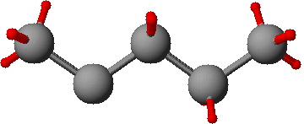
Contact 1
Contact 2
μ₁
μ₂
Γ₁/ћ
Γ₂/ћ
Rate
e⁻ / s
Figure 2: Schematic view of a molecular transistor model.

The transistor is modeled as two bulk regions with potential energy μ₁ and μ₂ ( Lurie, 2003); this potential can be seen as the electrochemical potential related with the Fermi function. Supposing a typical transistor with grounded source and an applied drain voltage V_{D}, then $μ_{1}−μ_{2}={\text{qV}}_{D}$ is valid. Γ1/ћ and Γ2/ћ are the rate at which any charge particle (electrons) can escape from or to bulk regions, and depend on coupling with the gate molecule. Broadened density of states at contacts is modeled using a Lorentzian function center at ε, as was stated on previous sections: $D(E)=\frac{1}{2π}\frac{γ}{(E−ε)^{2}+(γ2)^{2}}$.
A generic molecule forms the channel region. If contact bulk region is metallic the states distribution is continuous, but if the material is semiconductor effects like a negative differential resistance and other related effects can be present (Liu, 2005). External parameters are related to the surrounding circuit to be connected; internal parameters depend on transistor gate molecular composition; mixed parameters involve the twp previous conditions: mainly the broadening effect is depending on the modification of molecular energy levels when it makes contact with source and drain bulk.
Matlab code describing equations used in this model is presented. Similar model is tested using University of Purdue nanohub’s facilities. The larger vector distance the more exact solution will be, but computing time is larger too. This code is translated into adequate VHDL-AMS entity architecture pairs with appropriate selection of parameters (Garcia, 2000).
Next figure shows current, conductance and number of electrons variations when an external voltage is applied. Discrete quantum response of conductance is affecting electrical current variations. Energy broadening effects can be shown from smooth shapes in all the three plots.
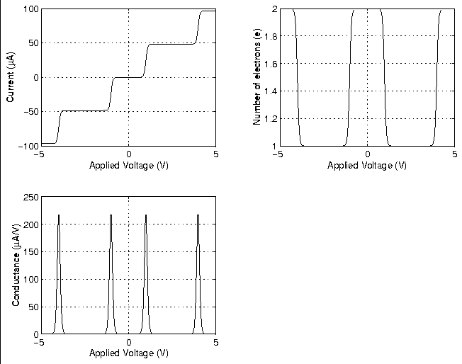
Figure 3: Plots of molecular transistor response using a simplified quantum model.

Further considerations must be taken when the device is considered as a subsystem inside a more complicated system(Sano, 2002). Applied voltage ranges are usually shorter than range chosen at nanohub’s simulations. Restricting the applied voltage to {-1v, 1v} shows a more accurate system behavior. Next figure shows a detailed view of I-V curve.
Figure 4. Detailed view of Molecular Transistor I-V characteristic.

These results show a very close agreement with those reported by Goodnick and Gerousis, from Arizona State University (Gerousis, 2000). However, they use a different simulation package called SIMON 2.0, a single-electron circuit simulator based on Monte Carlo method; it includes quantum corrections across multiple junctions, but it is a very high time and hardware consuming tool. While the simplified model simulation time is about a couple seconds running on a PC platform, SIMON takes several seconds running on a cluster with parallel computation.
An equivalent code is rewritten in VHDL-AMS and run using hAMSter Simulation System Version 2.0 from Ansoft Corporation over a PC equipped with an Intel Pentium M processor at 1.5 GHz. Simulation time according to hAMSter was 20 miliseconds. The model run applies the ballistic principle; it assumes no scattering with a constant Fermi level and uses a grounded contact 1, low bias and a minimmum broadening of molecular energy levels. Simulation results show proper results according to the quantum conductance definition. Discrete changes in conductance and its corresponding change in the transistor current. The next figure shows this behavior; the x-axis shows variations in the applied energy, which are equivalent to variations in the applied voltage as in previous Matlab and nanohub’s models. Regarding the adequate scales and the independent variable selected, these results show a proper concordance with the other models. The difference is evident in simulation time and the amount of computational resources needed.

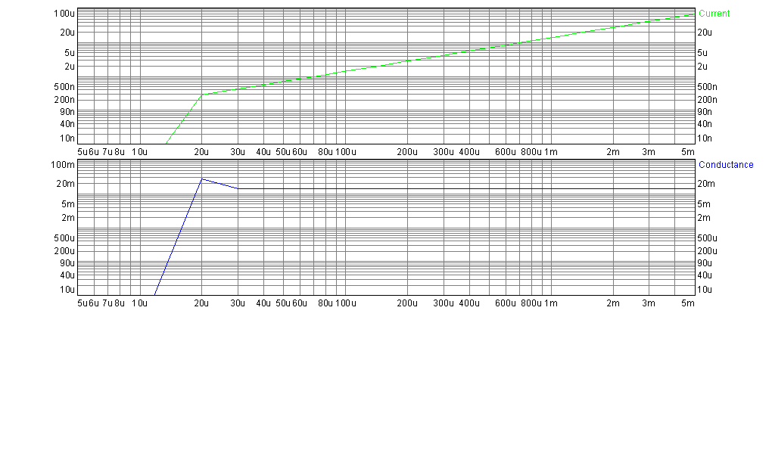
Figure 5. Conductance and current variations from VHDL-AMS model Level 0

The above explained model is then exported with a SCORM utility to be converted to a sharable learning object. From those results, more complicated structures can be modeled and simulated. Simplifications can be modified in order to obtain a more accurate response, but simulation time and computational resources can be higher, making their incorporation with other CAD tools and hardware description languages, expensive (Senturia, 2001).

Conclusions

It has been demonstrated that the applied methodology to model nanoscale devices simplifies calculations for integrated simulations environments. Results are comparable with others obtained using more complex computational facilities or experimental results.
It has been validated the application of quasi-continuum models as a middle point between quantum models and the continuum ones. “Lumped” models where small sets of electric circuit elements represent the behavior of devices, has been tested. It has been shown to be limited usage when nano-devices co-exist with microdevices, specifically when beam thickness is large compared to beam thickness.
Nanodevice models can be represented using common hardware description languages, obtaining affordable results that can be applied to common design engineering environments. Nanodevice models can be properly translated to standard object-oriented formats in order to be shareable as a web resource.

References

Damle, P. “Nanoscale device modeling: from MOSFETS to molecules. Purdue University. Ph.D. Thesis. 2003. At http://falcon.ecn.purdue.edu:8080/publications/#theses
Ferry D. and Goodnick S.. “Transport in Nanostructures”. Cambridge University Press. 1999.
Garcia S. Mixed-Mode System design: VHDL-AMS. Microelectronic Engineering 54 (2000) I7 I- I80
Gerousis et al. Nanoelectronic single-electron transistor circuits and architectures. International Journal of Circuit Theory and Applications. 2004. 32:323-338.
Kosina, H. et al. Comparison of Numerical Quantum Device Models. International Conference on Simulation of Semiconductor Processes and Devices. (SISPAD) 2003. pp- 171-174 .
Liu, W. et al. Computational Nanomechanics of Materials. Handbook of Theoretical and Computational Nanotechnology. American Scientific Publishers. 2005.
Lurie S., Belov P., Volkov-Bogorodsky D., Tuchkova N.. ‘Nanomechanical modeling of the nanostructures and dispersed composites”. Computational Materials Science 28 (2003) 529–539.
Pierret R. “Advanced Semiconductor Fundamentals”. Modular Series on Solid State Devices. Addison-Wesley. 1989.
Sano, N. et al. Device Modeling and Simulations Toward Sub-10 nm Semiconductor devices. IEEE Transactions On Nanotechnology, Vol. 1, No. 1, March 2002
Senturia, S. Microsystem Design. 2001. Kluwer Academic Publishers.
Shilkrot, L.E., Curtin W.A., Miller R.E.. “A coupled atomistic-continuum model of defects in solids.” Journal of the Mechanics and Physics of Solids. 50 (2002) 2085 – 2106
Yu Z., Dutton R., Kiehl R.. “Circuit/Device Modeling at the Quantum Level.” IEEE Transactions on Electron Devices, Vol. 47 No. 10, October 2000.

Authorization and Disclaimer
Authors authorize LACCEI to publish the paper in the conference proceedings. Neither LACCEI nor the editors are responsible either for the content or for the implications of what is expressed in the paper.

