Seventh LACCEI Latin American and Caribbean Conference for Engineering and Technology (LACCEI’2009)
“Energy and Technology for the Americas: Education, Innovation, Technology and Practice”
June 2-5, 2009, San Cristobal.

A Novel, Locally Engineered Crude Asphalt Crusher

Kenneth Roberts
Lake Asphalt of Trinidad and Tobago, kroberts@trinidadlakeasphalt.com

Kenny Cupid

Lake Asphalt of Trinidad and Tobago, kcupid@trinidadlakeasphalt.com

Kamel Singh
The University of Trinidad and Tobago, kamel.singh@utt.edu.tt

Musti KS Sastry
The University of West Indies, Trinidad and Tobago, mks_sastry@hotmail.com

Abstract
The ‘Pitch Lake’ located in Trinidad and Tobago, West Indies is perhaps the largest natural and commercial asphalt deposit in the world. The asphalt is mined continuously and processed to produce different commercial products, which are used for different purposes all over the world. The extracted crude asphalt usually will be in large crumbs and difficult to process. This paper presents a safe, low cost, locally engineered crude asphalt crusher to improve the overall processing operations.

Keywords: Crude Asphalt, Machine Design, Sustainable Technology, Innovative Solution
- Introduction
Trinidad Lake Asphalt is a natural product from the famous Asphalt or “Pitch” Lake located in La Brea, southwest Trinidad Island (southern Carribean), 90 km from the capital Port-of-Spain. This natural resource is actively mined for many years; however the first commercial operations commenced in 1888. It is from this location that refined asphalt, known as Trinidad Lake Asphalt. The lake measures approximately 40 hectares, with an estimated depth up to 76meters at the centre. This wonder holds an estimated ten million tons of pitch; a total of 150 tons of pitch is extracted from the lake per day. At the current rate of extraction the lake is estimated to have renewable reserve of pitch for the next 400 years. Trinidad Lake Asphalt, in its crude form is more accurately referred to as Trinidad Natural Asphalt and other terms are also used are Dried Asphalt (DA), Epure and Pitch. Trinidad Lake Asphalt is largely a complex emulsion of soluble bitumen with a mixture of minerals and other materials. The approximate chemical composition is as follows:
- Soluble Bitumen. - 53 - 55 %
- Mineral Matter - 36 % - 37 %
- Other - 9 % - 10 %
The Bitumen component is made up of:
- Maltenes - 63 - 66 %
- Asphaltenes : 33 - 37 %
- Acid Value: 6.9 %
- Saponification Value: 40.0 %
The lake is active and producing the pitch for centuries. The lake burbles, hisses and occasionally spits fire and its smell can be felt miles away, due to the sulphur which stinks like rotten-eggs. Figure 1 shows the burbles from the water surface of the lake. Several researchers have worked on the chemical, geographical, biological processes connected to this natural asphalt lake. The origin of this lake is linked to deep faults in the connection with subduction under the Caribbean Plate of the Barbados Arc, which allowed oil from a deep deposit to be forced up millions of years ago. The lighter elements in the oil evaporated, leaving behind the heavier asphalt. When subterranean bitumen (from which asphalt is mostly done) leaks to the surface, it creates a large puddle or lake, improperly called tar pits. Figure 2 shows the crude asphalt from the lake. Till date, only two large asphalt lakes have been found along with three smaller asphalt pits, all in the Western Hemisphere. Table 1 provides the information of these lakes.

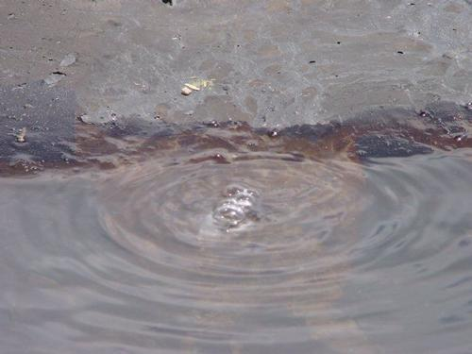
Figure 1. Burbles from the water surface of the lake

Table 1: The demographics of two major asphalt lakes in the world

Name | Location and Country | Approximate Area and Depth
Trinidad Lake Asphalt | La Brea, Trinidad | 40 Hectares and 75 Meters
Guanoco (Bermudez) Lake | Orinoco basin, Venezuela (close to Macaraibo Lake) | 445 Hectares and 9 Meters

The La Brea Tar Pits (Rancho La Brea Tar Pits) in Hancock Park, Los Angeles, California has spread over 9 Hectares and has about 100 pits. Only one pit has been in use now. There are two other asphalt pits with fossils Carpinteria, Santa Barbara County, in southern California and McKittrick, in Kern County. The pitch is used mainly for construction of highways, airports, bridges, tunnels and several other industry applications due to its properties. Trinidad Lake Asphalt has been used to build airport runways world wide.

From this discussion, it can be seen that Trinidad Lake Asphalt is a very unique, rare natural resource in the world and the appropriate technologies are not readily available. There is no possibility of adopting ready made solutions for this given its unique existence. Hence, the company developed several methodologies, processes which are unique for mining, processing and further development of crude asphalt. In this paper the two major challenges in mining and further processing are discussed and solutions are suggested.

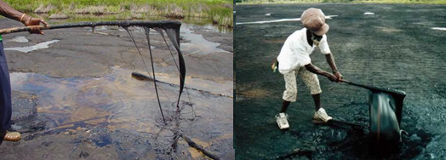
Figure 2. Crude Asphalt as seen from the surface of the pitch lake, Trinidad

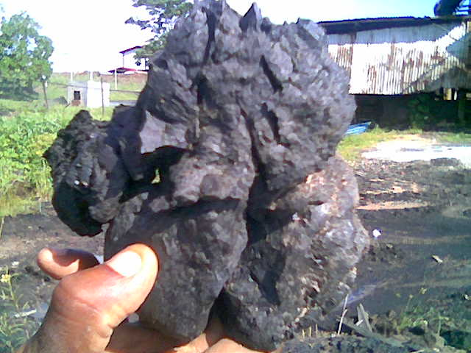
Figure 3 - Crude Asphalt
- Challenges in mining and processing of crude asphalt
The detailed discussions of mining, processing of crude asphalt are out of scope of this paper. Only few challenges in mining and processing of crude asphalt are presented. A new asphalt crusher is designed and build to counter these challenges specially to address two key areas for operational improvement (i) in its material handling of crude asphalt (ii) boiling time at its refining stills.

One of the major problems is that the crude asphalt is normally in big and odd shapes ranging from 500mm to even 2 meter sizes. Figure 4 shows the Solidworks drawings of the crude asphalt developed. It must be noted that the size of the transport buckets from the lake is approximately 1.8 x 1.5m x 1.2m. Therefore it will be difficult to use the actual lake bucket in an exercise of this magnitude. Different shapes, sizes of asphalt lumps are difficult to transport and handle with regular conveyers. This imposes challenges in overall production. This can be addressed by reducing the adhoc shaped asphalt lumps to a crumb size of 100 mm by crushing. The size is determined from the spacing between the steam coils in the refining stills, where the crumb fill the spaces between the steam coils. The 100 mm crumbs allowed a 100 tonne still to be charged with 80 rail cars of raw material (smaller voids amongst the crude asphalt) as compared to the typical 120, this leads to a saving of one hour in set up time prior to refining. A major benefit of the 100 mm crumb is to reduce the size of the voids when loaded in rail cars from approximately 45% to 10% producing more homogenous sized crude asphalt for handling and charging. The crusher is designed that it utilizes impact for soft non abrasive material as asphalt rather than pressure to crush. The crude asphalt is contained within the body of the crusher and a rotor reduces the size of the crude asphalt, the exit is fitted with a screen to allow material of 100 mm and smaller to escape to a tote box below its body.

Given the chemical composition of crude asphalt and bitumen; it is clear that this emulsion comprises a high percentage of maltenes which has a gel like structure. The factors considered in the design and development of the crusher are elasticity, stickiness, toughness, moisture, feed rate and the effect of temperature on crushing.
- Design Details of crude asphalt crusher
Careful analysis of existing crushing methods has been undertaken. Other methods like – Impact, Hammer, Jaw, Cone, Gyratory, Ball Mill have been reviewed. Keeping in view of the uniqueness of the pitch lake facility and non-availability of typical asphalt crushers, the following design objectives have been identified which are unique to this specific work.

- The crusher must be able to easily crush crude asphalt into 50 – 100 mm crumbs
- Low cost of operation, management and possibility of replication
- Should be fabricated from indigenous materials
- Portability (should able to move around as required on the lake)
- Locally engineered

The crude asphalt crusher will comprise of a crushing chamber, shaft, angle iron blade hopper, iron frame, electrical motor, gearbox, switch, bearings, and trough. The electrical motor will be used to supply torque that will crush the product. The body is made up of a set of triangular 100mm x 100mm x 6 mm blades, welded to a 300 mm diameter rotor which runs at 30 rpm. The crushing chamber is rectangular and raw material enters through a hopper. The clearance between the chamber wall and blade tip is 10 mm. To maintained the nominal crumb size a 75 mm x 75 mm wire mesh is installed in the exit chute of the crusher. The material exiting is contained in a tote box. This crusher is suitable for mild hard, sticky materials with high moisture content. It must be noted that the specifications of most of the crushers which are highlighted above are different. In addition many aspects of their operation are diverse. However, in the crushing of crude asphalt there are some challenges that must be considered. For instant T.L.A comprises Bitumen and Mineral filler. SolidWorks software has been used for the design. The top view and isometric views of the developed crusher are shown in Figure 4. Several experiments have been carried out on the crusher to test its effectiveness to re-size and adjust various parameters during the design process. This Asphalt crusher that is shown above has the capacity to produce 10 tons of crushed crude asphalt per hour. The crushed crude has the dimensions between 50 to 100 mm. It is also capable of crushing crude asphalt when afternoon temperatures are as high as 33ºC; when the asphalt is rather soft. Crushing can be accomplished as is or with the addition of a water sprinkler in the trough. The industrial water (lake water) can be used in that venture. An additional feature of the crusher is a sieve was placed in the discharge chute to ensure that the dimension of the crude is maintained between 50 – 100 mm.

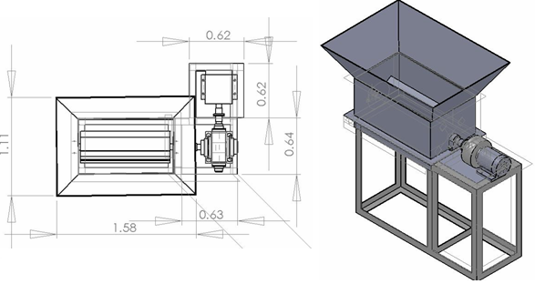

Figure 4. Top and Isometric Views of the asphalt crusher designed and developed

The sieve is made of two BRC wire pieces of gauge 65, 75 mm x 75 mm welded together. Therefore the thickness of a strand of BRC wire was doubled, and this increased its strength to withstand the rigors of the crushing operation. The fully functional crude asphalt crusher is shown in Figure 5.

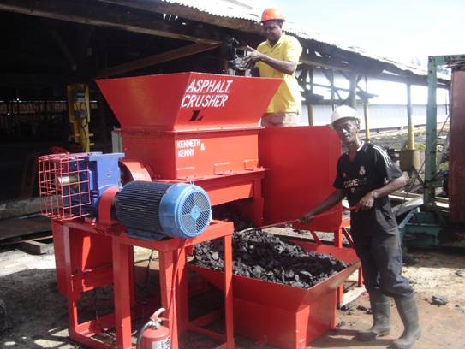
Figure 5 Fully functional crude asphalt crusher
- Challenges in development
The development of the asphalt crusher according to the specifications and requirements has been a challenge. For instance, the force required to crush the crude asphalt; is obtained after numerous trials and errors. It may be noted that this experiment is unique, as prior knowledge or information in that regard is almost non existent. Another natural difficulty is that the density of crude asphalt is 1.2 g/cm³ and the moisture content is 30 percent, which is lost in the refining of the product. The hardness of the material is measured by its resistance to penetration for the crude asphalt this was determined to be between 0 and 4mm. Also 54 percent of the material is a gel like substance (which is called maltene). Further the crushed material will tend to adhere to other pieces when exposed to the tropical ambient conditions. Another challenge is the design and calculation of the amount of torque required to crush crude asphalt. In designing of the crusher’s shaft, the force which will act upon the mechanism had to be calculated. Hence centrifugal force of cutting blade was equated with torque produce by motor. Please note that this was calculated based on the rating of the motor.

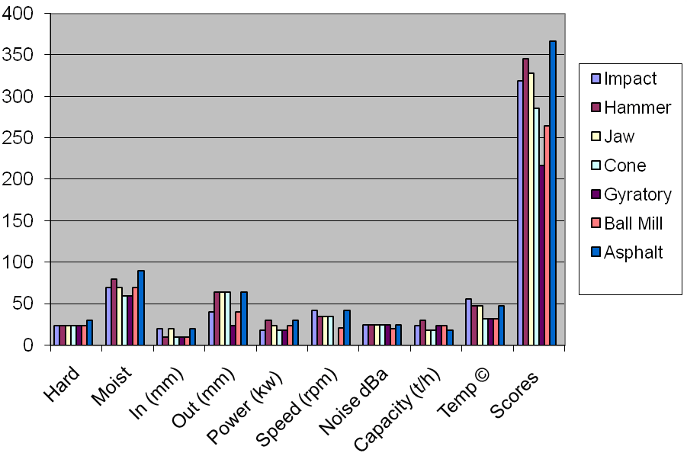
Figure 6: Performance comparison of asphalt crushers under typical criteria

The performance of the developed crushed is compared to those available. This is done with specific criterions which are critical for the successful crushing of crude asphalt. The performance scores of different types of crushers are shown on the graph in Figure 6. It is noted that four crushers have a performance score more than 300 which infer that could be modified for crude asphalt. However two of the crushers operate at high speeds which from experience has indicated that the piece of crude will be ground too fine and outside the size requirement of 50 – 100 mm and the velocity imparted to the pieces of crude asphalt will cause it to escape the confinement of machinery. The concern of the other crusher was the buildup of crude on operating parts. Also the operation of rotating parts that is, a jaw crusher will tend to squeeze the material. That action will cause the crude to ooze out or facture into a number of small pieces that are not up to specification. Overall, the performance of the designed asphalt crusher should be better than the other types and has met the design objectives and functional requirements.

- The road ahead
The potential of this crude asphalt crusher is enormous. The mass of asphalt that could now be loaded into the transport buckets and boiling stills has enhanced the material handling and production efficiencies by as much as 25 percent. Mechanization of the feeding of crude asphalt to the crusher using a drag type conveyer before and after the Asphalt Crusher will also increase the throughput of the operation. Also a watering system can be used to reduce the temperature of the crude and remove the excess content of mineral matter before and after crushing operation. Lake water which is readily available can be used for this. The benefits are sustained daily production requirement and reduction in the maintenance of heat exchangers. The addition of conveyers and the installation of a watering system will reduce operation and maintenance cost. Emphasis should now be placed on top management to carefully examine the effectiveness of the crude asphalt crusher to improve plant throughput.
- Conclusion
A successful case of design and development of a unique asphalt crusher has been presented. The crusher is indigenously developed, easy to operate with little or no training required for its safe operation. A front end loader and one maintenance worker will be needed to charge the feed hopper, until an automatic feeder is installed. The crusher has the capability of producing 10 tons per hour and consumes approximately 0.9 kW of electricity per hour. This reduces the number of buckets and time that in needed to produce 100 tons of refined asphalt from approximately 18 to 12 hours, this impacts positively on the firms bottom line as a substantial saving.
References
Asphalt Associates 2009, High Quality Natural Bitumen Products from Asphalt Associates Limited, http://www.asphaltassociates.com/html/products/tla.html, last accessed February 2009

Softpedia 2009, The Asphalt Lakes – The weirdest lakes on earth, http://news.softpedia.com/news/The-Asphalt-Lakes-44704.shtml, last accessed February 2009

The Flying Kiwi 2009, The Trinidad Pitch Lake, http://www.richard-seaman.com/Travel/TrinidadAndTobago/Trinidad/PitchLake/index.html, last accessed on February 2009

J Hannah and RC Stephens, Mechanics of machines: Elementary Theory and Example – 4th ed, Arnold Publishers

Mott, Roberts L. Machine elements in mechanical design . – 4th ed, Prentice Hall.

LATT, Lake Asphalt of Trinidad and Tobago (1978) Ltd, http://www.trinidadlakeasphalt.com/, last accessed February 2009

SolidWorks::3D CAD Design Software 2009, http://www.solidworks.com/, last accessed February 2009

Authorization and Disclaimer
Authors authorize LACCEI to publish the paper in the conference proceedings. Neither LACCEI nor the editors are responsible either for the content or for the implications of what is expressed in the paper.

